Task 1: Highly Available Web Application using ALB + EC2 Auto Scaling (AWS Free Tier)

Objective
Deploy a highly available and scalable web application using: - EC2 instances across multiple AZs - Application Load Balancer (ALB) - Auto Scaling Group (ASG) - CloudFormation (Infrastructure as Code)
The application must: - Stay online if one EC2 instance fails - Automatically scale based on CPU utilization

Architecture Overview
Flow: User → Application Load Balancer → Target Group → EC2 Instances (Auto Scaling Group)
High Availability: - EC2 instances are launched in multiple Availability Zones - ALB routes traffic only to healthy instances
Scalability: - Auto Scaling adds/removes EC2 instances based on CPU metrics

Architecture Diagram (Logical)
┌───────────────┐
│ User │
└───────┬───────┘
│
┌───────▼────────┐
│ Application LB │
└───────┬────────┘
│
┌────────────┴────────────┐
│ │
┌──────▼──────┐ ┌──────▼──────┐
│ EC2 (AZ-1) │ │ EC2 (AZ-2) │
│ Apache Web │ │ Apache Web │
└─────────────┘ └─────────────┘
↑ ↑
└──── Auto Scaling Group ──┘
📸 Screenshot: Final architecture from AWS console (optional: use AWS Architecture Icons)

AWS Services Used
Service | Purpose
EC2 | Host web application
ALB | Distribute traffic
Auto Scaling | Automatic scaling & recovery
CloudWatch | CPU-based scaling metrics
VPC | Networking

CloudFormation Template (Free Tier Safe)
⚠️ Use t2.micro (Free Tier eligible)
AWSTemplateFormatVersion: '2010-09-09'
Description: Highly Available Web App using ALB + EC2 Auto Scaling (Free Tier)

Parameters:
VpcId:
Type: AWS::EC2::VPC::Id
Description: Select VPC (use default VPC)

Subnets:
Type: List<AWS::EC2::Subnet::Id>
Description: Select at least 2 subnets in different AZs

KeyName:
Type: AWS::EC2::KeyPair::KeyName
Description: Existing EC2 Key Pair for SSH access

LatestAmiId:
Type: AWS::SSM::Parameter::Value<AWS::EC2::Image::Id>
Default: /aws/service/ami-amazon-linux-latest/amzn2-ami-hvm-x86_64-gp2

Resources:

# -----------------------------
# Security Groups
# -----------------------------

ALBSecurityGroup:
Type: AWS::EC2::SecurityGroup
Properties:
GroupDescription: Allow HTTP access to ALB
VpcId: !Ref VpcId
SecurityGroupIngress:
- IpProtocol: tcp
FromPort: 80
ToPort: 80
CidrIp: 0.0.0.0/0

EC2SecurityGroup:
Type: AWS::EC2::SecurityGroup
Properties:
GroupDescription: Allow HTTP from ALB only
VpcId: !Ref VpcId
SecurityGroupIngress:
- IpProtocol: tcp
FromPort: 80
ToPort: 80
SourceSecurityGroupId: !Ref ALBSecurityGroup

# -----------------------------
# Launch Template
# -----------------------------

LaunchTemplate:
Type: AWS::EC2::LaunchTemplate
Properties:
LaunchTemplateData:
InstanceType: t2.micro
KeyName: !Ref KeyName
ImageId: !Ref LatestAmiId # Amazon Linux 2 (update if region differs)
SecurityGroupIds:
- !Ref EC2SecurityGroup
UserData:
Fn::Base64: !Sub |
#!/bin/bash
yum update -y
yum install -y httpd
systemctl start httpd
systemctl enable httpd
echo "<h1>Welcome from $(hostname)</h1>" > /var/www/html/index.html

# -----------------------------
# Target Group
# -----------------------------

TargetGroup:
Type: AWS::ElasticLoadBalancingV2::TargetGroup
Properties:
VpcId: !Ref VpcId
Port: 80
Protocol: HTTP
HealthCheckPath: /
HealthCheckIntervalSeconds: 30
HealthCheckTimeoutSeconds: 5
HealthyThresholdCount: 2
UnhealthyThresholdCount: 2
TargetType: instance

# -----------------------------
# Application Load Balancer
# -----------------------------

LoadBalancer:
Type: AWS::ElasticLoadBalancingV2::LoadBalancer
Properties:
Name: Task1-ALB
Scheme: internet-facing
Type: application
SecurityGroups:
- !Ref ALBSecurityGroup
Subnets: !Ref Subnets

Listener:
Type: AWS::ElasticLoadBalancingV2::Listener
Properties:
LoadBalancerArn: !Ref LoadBalancer
Port: 80
Protocol: HTTP
DefaultActions:
- Type: forward
TargetGroupArn: !Ref TargetGroup

# -----------------------------
# Auto Scaling Group
# -----------------------------

AutoScalingGroup:
Type: AWS::AutoScaling::AutoScalingGroup
Properties:
VPCZoneIdentifier: !Ref Subnets
MinSize: '1'
MaxSize: '3'
DesiredCapacity: '2'
LaunchTemplate:
LaunchTemplateId: !Ref LaunchTemplate
Version: !GetAtt LaunchTemplate.LatestVersionNumber
TargetGroupARNs:
- !Ref TargetGroup
HealthCheckType: ELB
HealthCheckGracePeriod: 300

# -----------------------------
# Scaling Policies
# -----------------------------

CPUScalingPolicy:
Type: AWS::AutoScaling::ScalingPolicy
Properties:
AutoScalingGroupName: !Ref AutoScalingGroup
PolicyType: TargetTrackingScaling
TargetTrackingConfiguration:
PredefinedMetricSpecification:
PredefinedMetricType: ASGAverageCPUUtilization
TargetValue: 60.0

Outputs:
LoadBalancerDNS:
Description: Application Load Balancer DNS Name
Value: !GetAtt LoadBalancer.DNSName

Execution Steps (With Screenshot Checklist)

Step 1: Login to AWS Console
- Go to CloudFormation → Create Stack → With new resources
- Upload YAML template
- 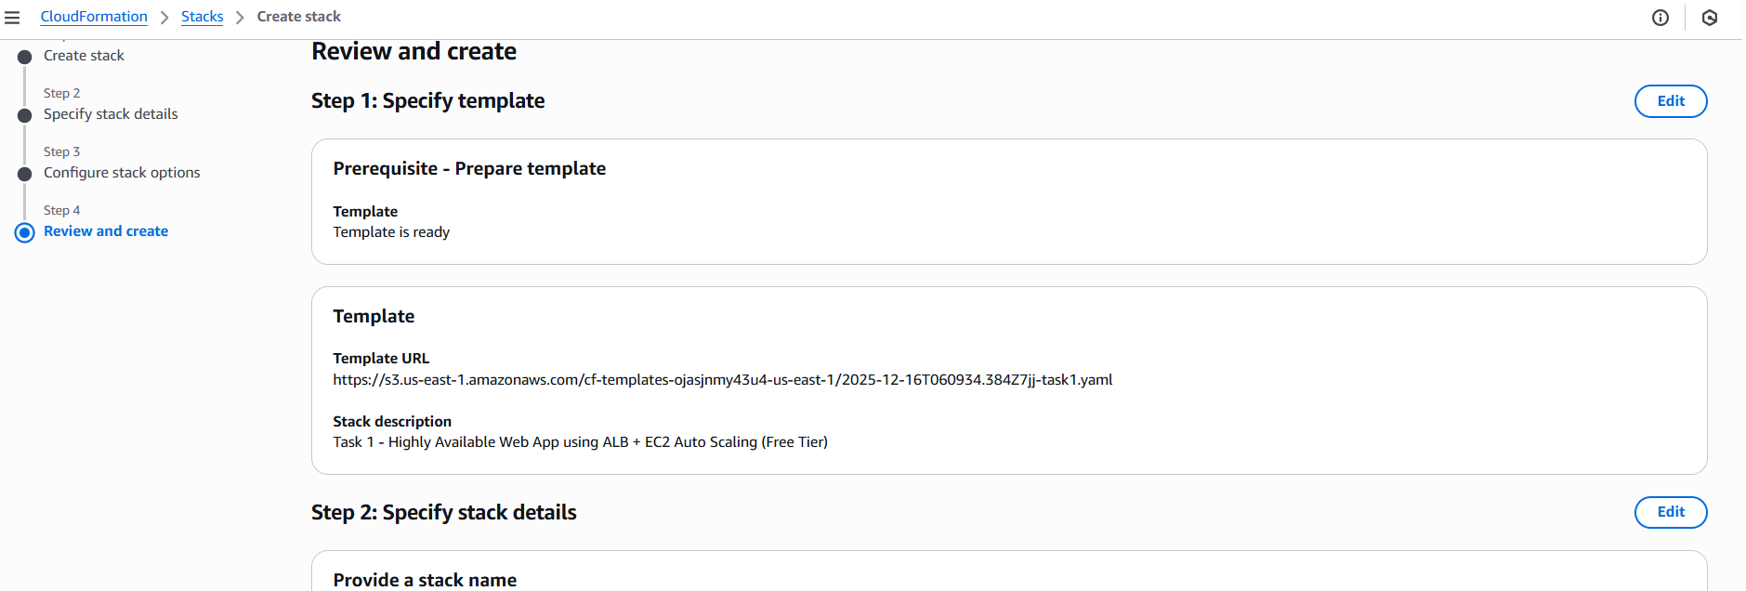

Step 2: Provide Parameters
- Select existing EC2 Key Pair
- Click Next → Create Stack
- 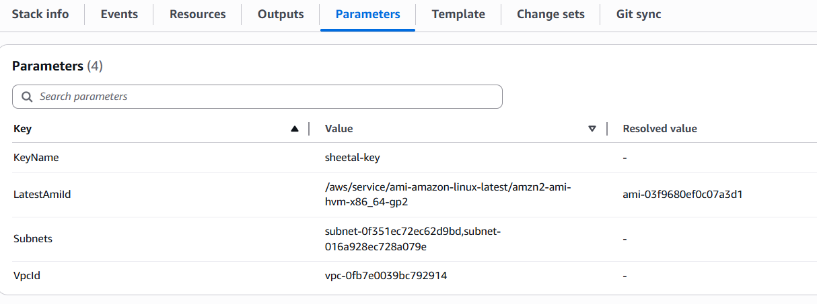

Step 3: Monitor Stack Creation
- Status: CREATE_COMPLETE
- 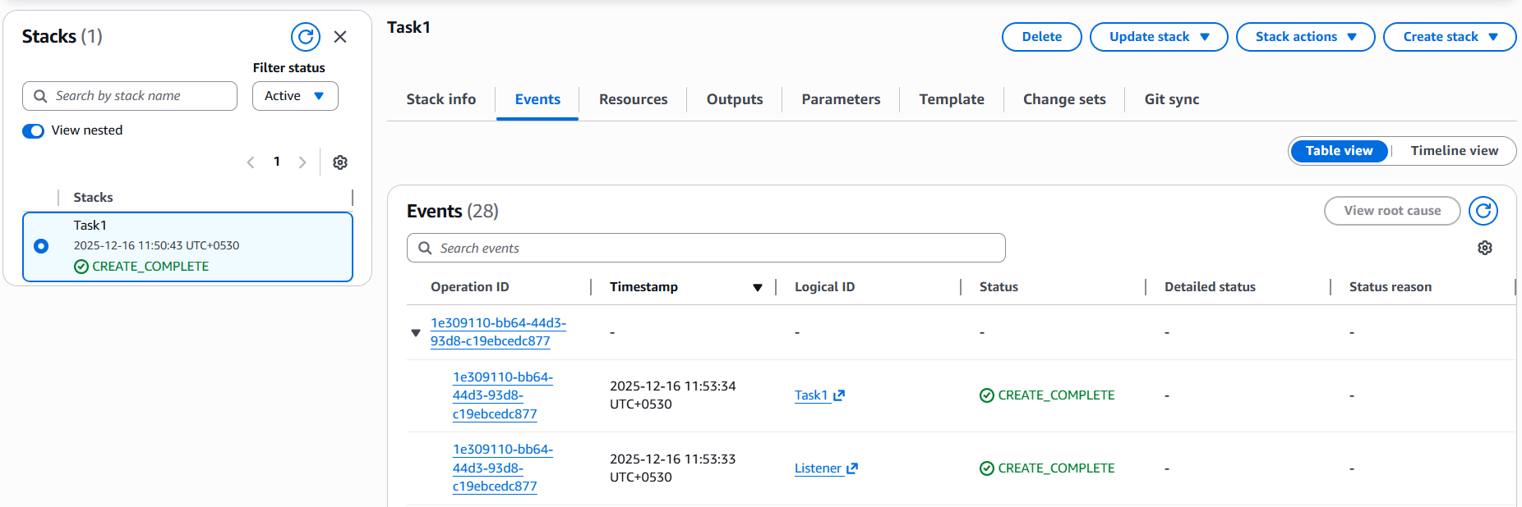

Step 4: Verify EC2 Instances
- Go to EC2 → Instances
- Instances should be in running state across AZs
- 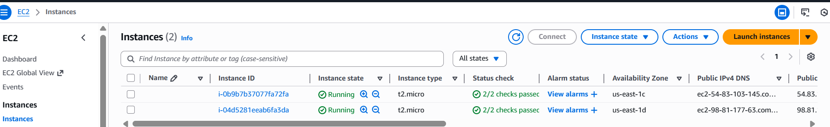

Step 5: Verify Load Balancer
- Go to EC2 → Load Balancers
- Copy DNS name and open in browser
- 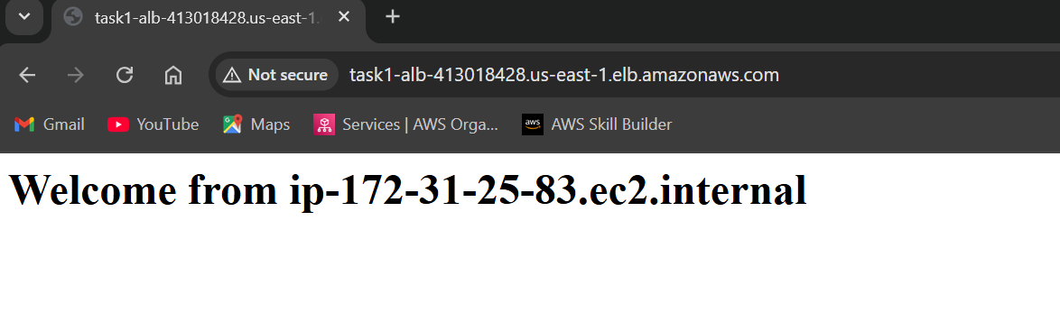
- 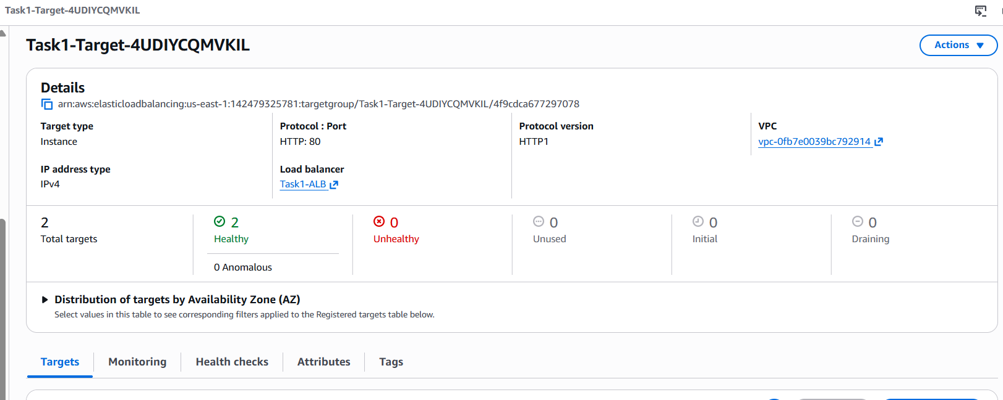
✅ Web page loads

Step 6: Test Failover
- Stop one EC2 instance manually
- Refresh browser
✅ Application still loads

Step 7: Test Auto Scaling
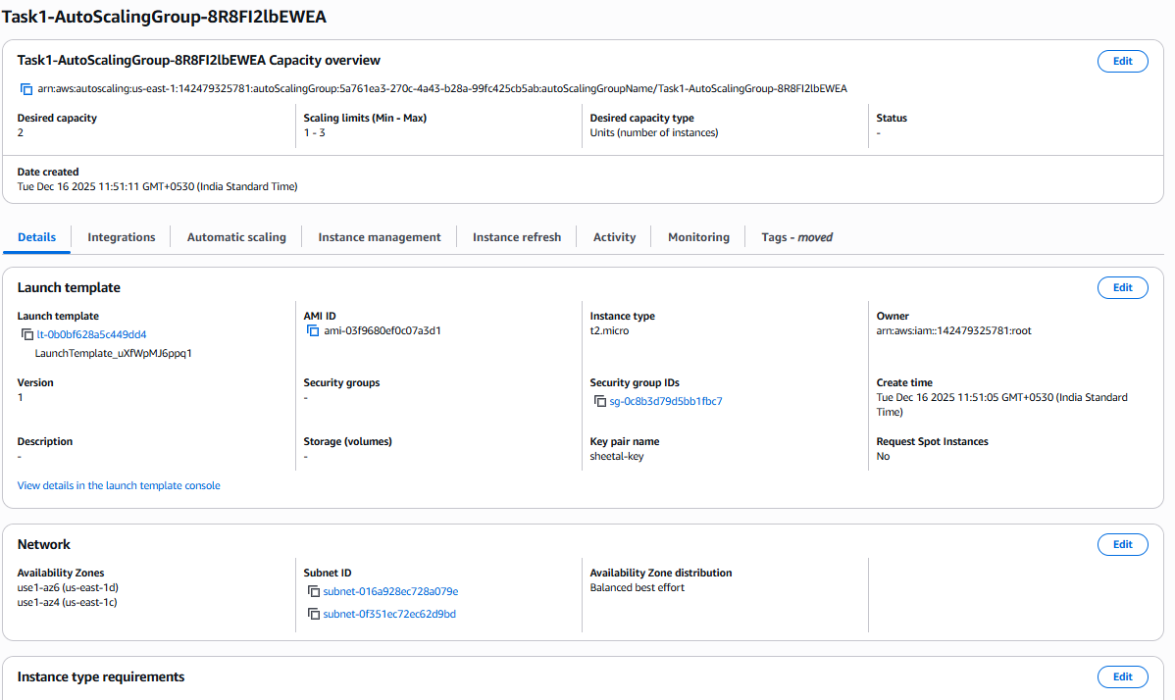
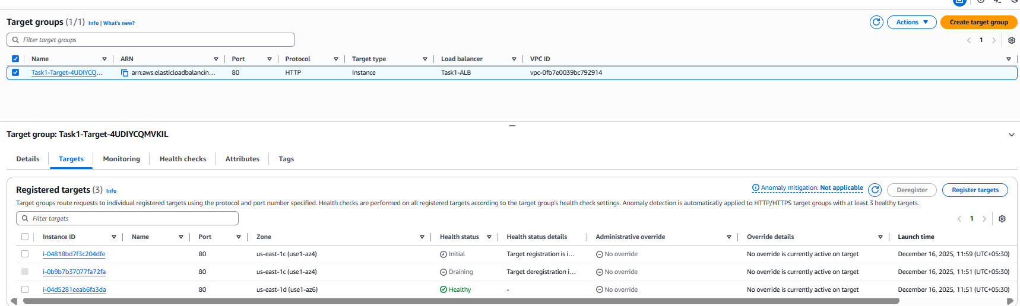
- SSH into instance
- 
- Run CPU stress:
yum install stress -y
stress --cpu 2 --timeout 300
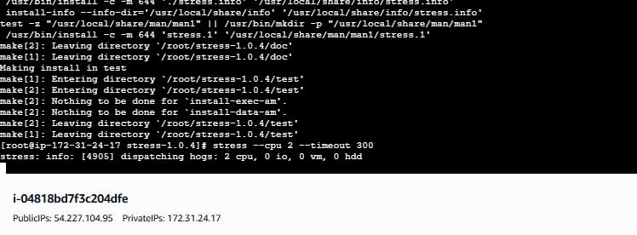
Alarm for CPU Utilization triggered
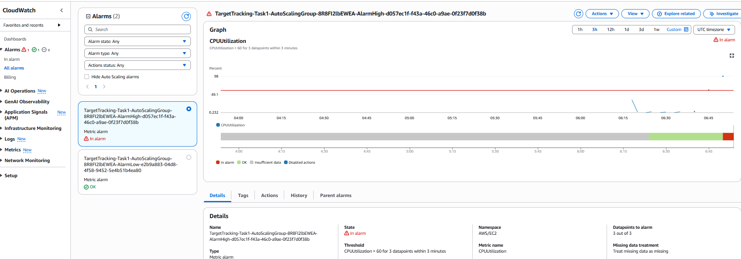
- New instance launches automatically
- 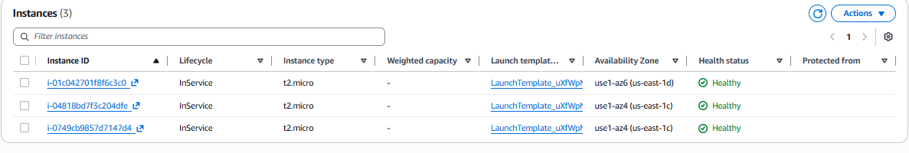
- 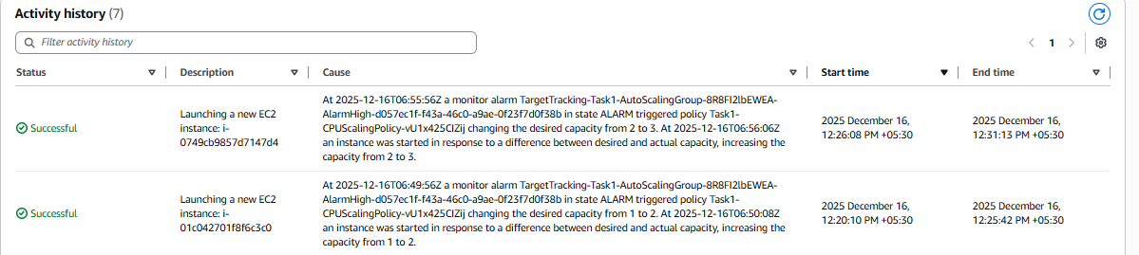
Alarm closed
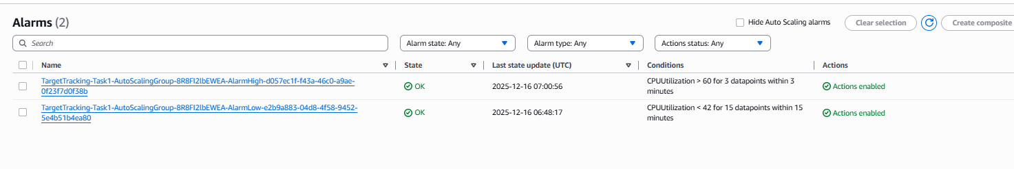

ALB




