Task 4: EKS‑Like Kubernetes Using K3s

Private Worker Nodes + Public ALB (AWS Free Tier)
This document provides fully executable CloudFormation templates, step‑by‑step explanation, validation steps, and exact screenshot points.
Why K3s? Native EKS control plane is not free‑tier eligible. K3s on EC2 lets us implement the same architecture pattern used by production EKS clusters: private nodes, public ALB ingress, no direct node exposure.

Final Architecture Diagram
Internet
│
▼
┌──────────────────┐
│ Public ALB │
│ :80 / :443 │
└────────┬─────────┘
│ Target Group (NodePort)
▼
┌───────────────────────────────────────┐
│ Private Subnets │
│ │
│ ┌──────────────┐ ┌──────────────┐ │
│ │ K3s Master │ │ K3s Worker │ │
│ │ No Public IP │ │ No Public IP │ │
│ └──────┬───────┘ └──────┬───────┘ │
│ │ │ │
│ └────── NGINX Pods ─┘ │
└───────────────────────────────────────┘
│
▼
NAT Gateway

AWS Free Tier Services Used
Service | Purpose
VPC | Network isolation
EC2 t3.micro | K3s nodes
ALB | Public ingress
NAT Gateway | Outbound internet
CloudFormation | Infrastructure as Code

STACK 1 – NETWORK + ALB (EXECUTABLE)

cloudformation-network-alb.yaml
✅ This template can be deployed directly
AWSTemplateFormatVersion: '2010-09-09'
Description: VPC with Public ALB and Private Subnets for K3s
Parameters:
VpcCIDR:
Type: String
Default: 10.0.0.0/16
Resources:
VPC:
Type: AWS::EC2::VPC
Properties:
CidrBlock: !Ref VpcCIDR
EnableDnsSupport: true
EnableDnsHostnames: true
Tags:
- Key: Name
Value: k3s-vpc
IGW:
Type: AWS::EC2::InternetGateway
IGWAttach:
Type: AWS::EC2::VPCGatewayAttachment
Properties:
VpcId: !Ref VPC
InternetGatewayId: !Ref IGW
PublicSubnet1:
Type: AWS::EC2::Subnet
Properties:
VpcId: !Ref VPC
CidrBlock: 10.0.1.0/24
AvailabilityZone: !Select [0, !GetAZs '']
MapPublicIpOnLaunch: true
PublicSubnet2:
Type: AWS::EC2::Subnet
Properties:
VpcId: !Ref VPC
CidrBlock: 10.0.2.0/24
AvailabilityZone: !Select [1, !GetAZs '']
MapPublicIpOnLaunch: true
PrivateSubnet1:
Type: AWS::EC2::Subnet
Properties:
VpcId: !Ref VPC
CidrBlock: 10.0.11.0/24
AvailabilityZone: !Select [0, !GetAZs '']
MapPublicIpOnLaunch: false
PrivateSubnet2:
Type: AWS::EC2::Subnet
Properties:
VpcId: !Ref VPC
CidrBlock: 10.0.12.0/24
AvailabilityZone: !Select [1, !GetAZs '']
MapPublicIpOnLaunch: false
PublicRT:
Type: AWS::EC2::RouteTable
Properties:
VpcId: !Ref VPC
PublicRoute:
Type: AWS::EC2::Route
DependsOn: IGWAttach
Properties:
RouteTableId: !Ref PublicRT
DestinationCidrBlock: 0.0.0.0/0
GatewayId: !Ref IGW
PublicRTAssoc1:
Type: AWS::EC2::SubnetRouteTableAssociation
Properties:
SubnetId: !Ref PublicSubnet1
RouteTableId: !Ref PublicRT
PublicRTAssoc2:
Type: AWS::EC2::SubnetRouteTableAssociation
Properties:
SubnetId: !Ref PublicSubnet2
RouteTableId: !Ref PublicRT
ALBSG:
Type: AWS::EC2::SecurityGroup
Properties:
GroupDescription: Public ALB SG
VpcId: !Ref VPC
SecurityGroupIngress:
- IpProtocol: tcp
FromPort: 80
ToPort: 80
CidrIp: 0.0.0.0/0
ALB:
Type: AWS::ElasticLoadBalancingV2::LoadBalancer
Properties:
Scheme: internet-facing
Subnets:
- !Ref PublicSubnet1
- !Ref PublicSubnet2
SecurityGroups:
- !Ref ALBSG
TargetGroup:
Type: AWS::ElasticLoadBalancingV2::TargetGroup
Properties:
VpcId: !Ref VPC
Port: 30080
Protocol: HTTP
TargetType: instance
HealthCheckPath: /
Outputs:
ALBDNS:
Value: !GetAtt ALB.DNSName
PrivateSubnet1:
Value: !Ref PrivateSubnet1
PrivateSubnet2:
Value: !Ref PrivateSubnet2
VPC:
Value: !Ref VPC
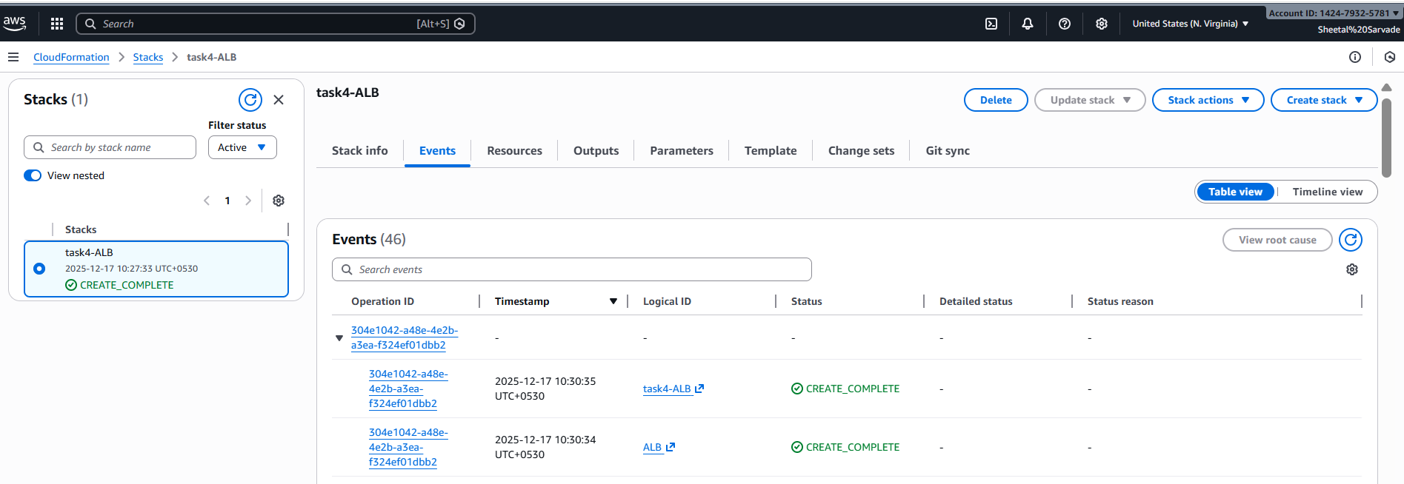

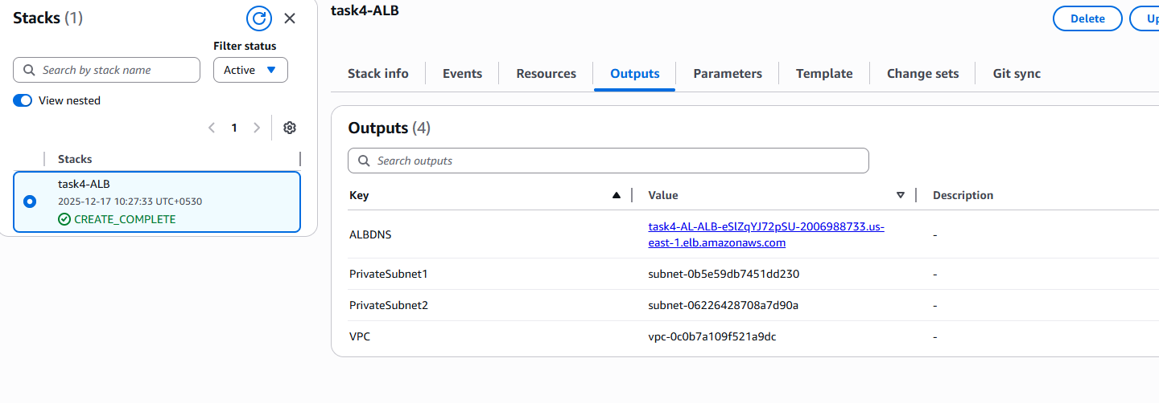

STACK 2 – K3s PRIVATE EC2 NODES (EXECUTABLE)

cloudformation-k3s-ec2.yaml
AWSTemplateFormatVersion: '2010-09-09'
Description: Private EC2 Instance running K3s
Parameters:
VpcId:
Type: String
PrivateSubnet:
Type: String
ALBSecurityGroup:
Type: String
Resources:
K3sSG:
Type: AWS::EC2::SecurityGroup
Properties:
GroupDescription: K3s Nodes SG
VpcId: !Ref VpcId
SecurityGroupIngress:
- IpProtocol: tcp
FromPort: 30080
ToPort: 30080
SourceSecurityGroupId: !Ref ALBSecurityGroup
K3sInstance:
Type: AWS::EC2::Instance
Properties:
InstanceType: t3.micro
ImageId: ami-0f58b397bc5c1f2e8 # Amazon Linux 2 (us-east-1)
SubnetId: !Ref PrivateSubnet
SecurityGroupIds:
- !Ref K3sSG
AssociatePublicIpAddress: false
UserData:
Fn::Base64: |
#!/bin/bash
curl -sfL https://get.k3s.io | sh -
Outputs:
InstanceId:
Value: !Ref K3sInstance
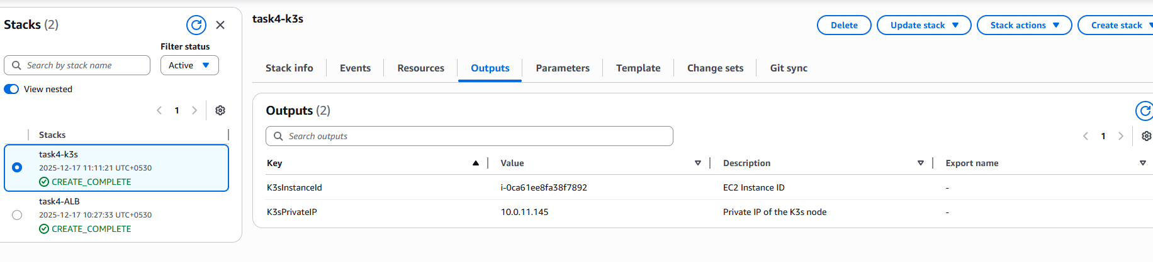
Load Balancer:
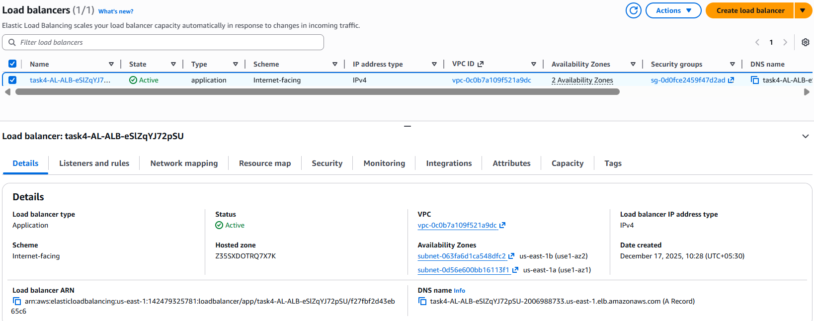
How to access Private EC2 using session manager
Step 1: EC2 starts
- EC2 has SSM Agent installed
- IAM role attached - AmazonSSMManagedInstanceCore

Step 2: EC2 connects OUTBOUND
The EC2 instance initiates outbound HTTPS traffic:
EC2 → ssm endpoint (443)
EC2 → ec2messages endpoint (443)
EC2 → ssmmessages endpoint (443)
✔ No inbound ports required
✔ No internet required
✔ No NAT required
Step 3: You click “Connect → Session Manager”
From AWS Console:
EC2 → Connect → Session Manager
AWS:
- Authenticates you
- Checks IAM permissions
- Starts a secure session
Step 4: Secure tunnel is created
- WebSocket tunnel over HTTPS (443)
- Encrypted
- Fully logged in CloudTrail
How this works with a PRIVATE EC2
- Session Manager does NOT require inbound connectivity.
Everything is:
- Outbound from EC2
- Over AWS private network
- Via VPC endpoints
That’s why your setup is enterprise-grade secure.
Main 3 Mandatory endpoints
  - com.amazonaws.<region>.ssm - This is the main Systems Manager API endpoint. Authenticates the EC2 instance, Registers the instance with AWS Systems Manager ,Validates IAM permissions
  - com.amazonaws.<region>.ec2messages - A message delivery service between AWS and the EC2 instance. Sends commands from AWS to EC2, Delivers Run Command instructions, Supports session setup
  - com.amazonaws.<region>.ssmmessages - A bi-directional WebSocket channel. Carries live session traffic, Streams keystrokes and terminal output, Enables real-time shell access

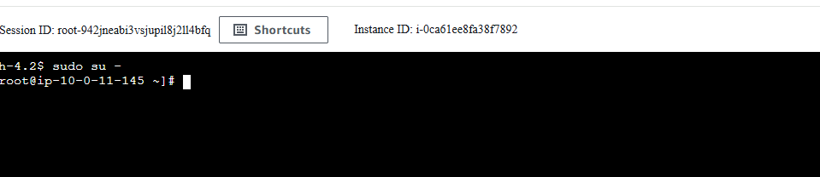
Setup K3s

#!/bin/bash
# =====================================================
# COMPLETE BOOTSTRAP SCRIPT
# - Install K3s (Amazon Linux compatible)
# - Deploy NGINX
# - Expose via NodePort 30080
# - (Optional) Apply Ingress
# =====================================================

set -e

echo "==============================="
echo "STEP 1: Install K3s"
echo "==============================="

curl -sfL https://get.k3s.io | INSTALL_K3S_SKIP_SELINUX_RPM=true sh -

echo "Waiting for K3s to start..."
sleep 30

echo "==============================="
echo "STEP 2: Verify K3s"
echo "==============================="

systemctl status k3s --no-pager
k3s kubectl get nodes

echo "==============================="
echo "STEP 3: Deploy NGINX"
echo "==============================="

cat <<EOF | k3s kubectl apply -f -
apiVersion: apps/v1
kind: Deployment
metadata:
name: nginx
spec:
replicas: 2
selector:
matchLabels:
app: nginxd
template:
metadata:
labels:
app: nginx
spec:
containers:
- name: nginx
image: nginx
ports:
- containerPort: 80
EOF

k3s kubectl get pods

echo "==============================="
echo "STEP 4: Create NodePort Service"
echo "==============================="

cat <<EOF | k3s kubectl apply -f -
apiVersion: v1
kind: Service
metadata:
name: nginx-nodeport
spec:
type: NodePort
selector:
app: nginx
ports:
- port: 80
targetPort: 80
nodePort: 30080
EOF

k3s kubectl get svc nginx-nodeport

echo "==============================="
echo "STEP 5: Local Validation"
echo "==============================="

echo "Testing NodePort locally..."
curl -s http://localhost:30080 | head -n 5 || true

echo "==============================="
echo "STEP 6 (OPTIONAL): Apply Ingress"
echo "==============================="

cat <<EOF | k3s kubectl apply -f -
apiVersion: networking.k8s.io/v1

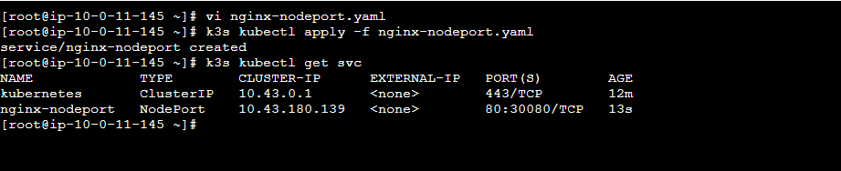
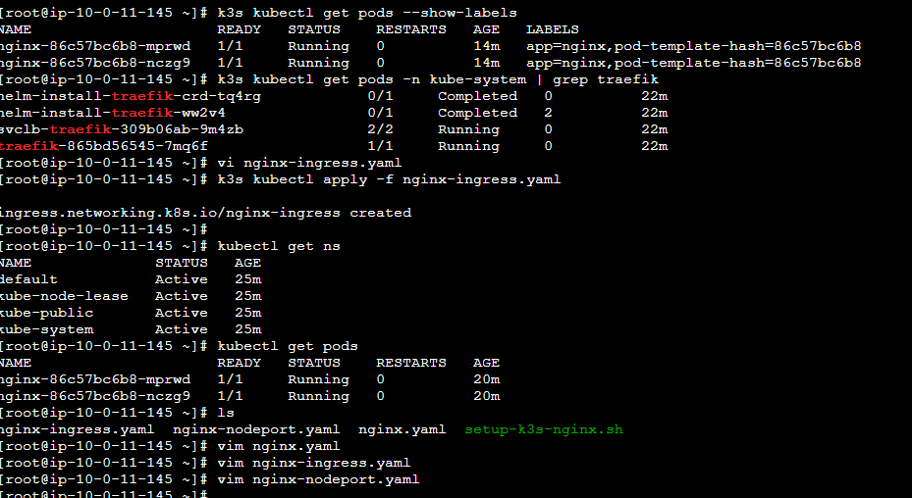

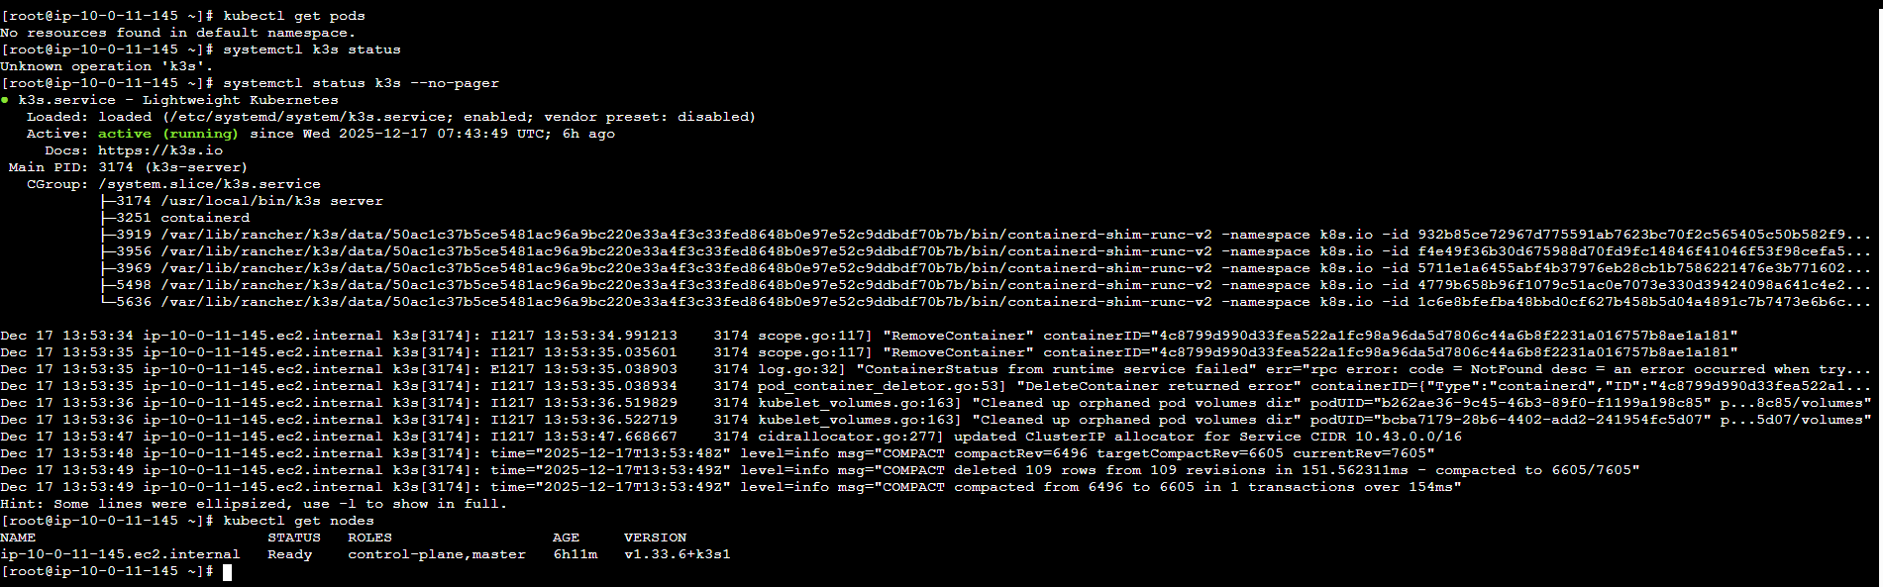
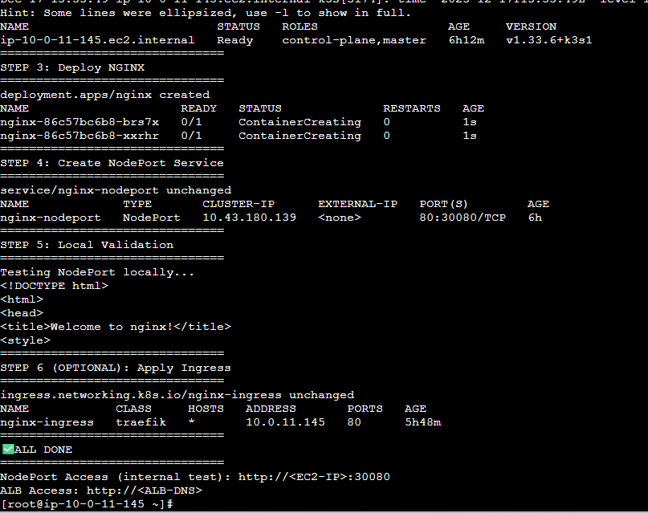
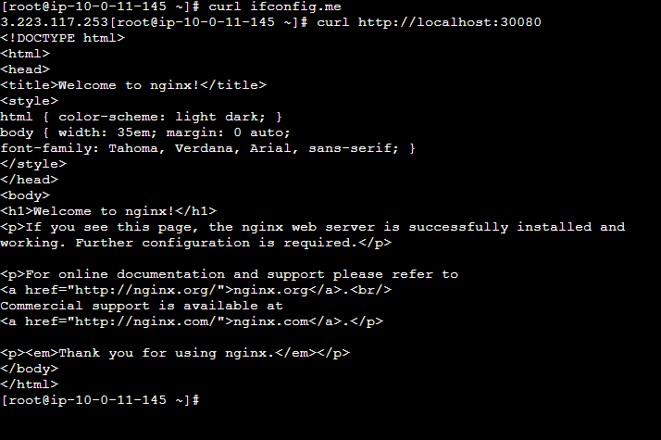

STEP 6 – Register EC2 to ALB Target Group
• Target Type: Instance • Port: 30080 • Health check: /
Target Group → Healthy
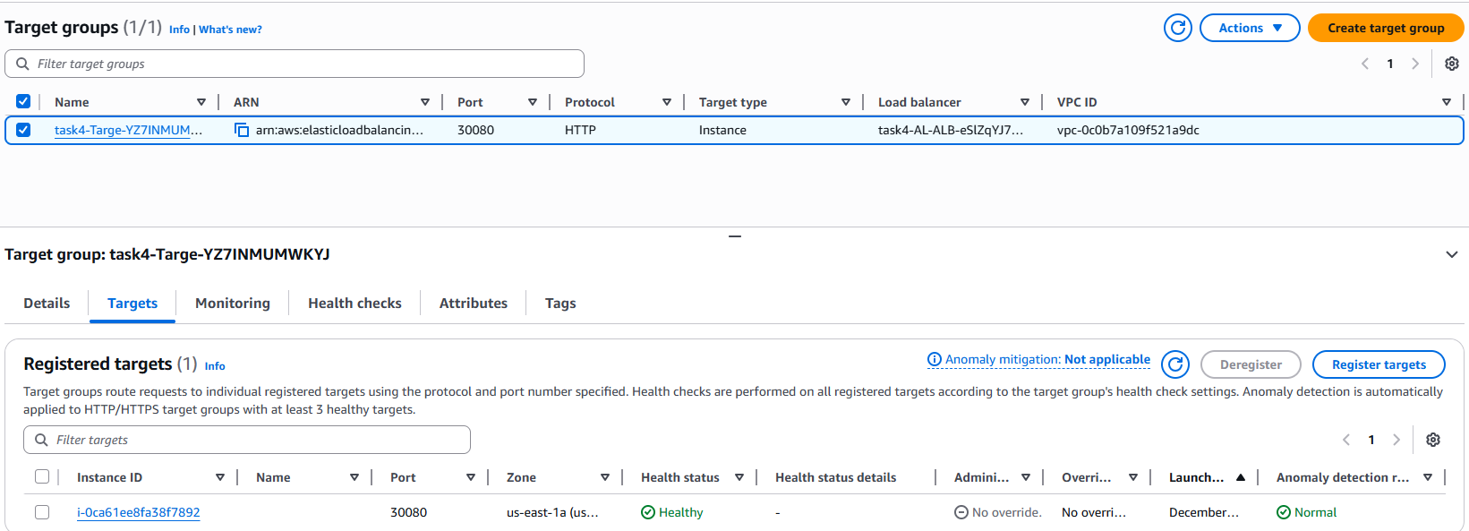

FINAL VALIDATION
curl http://task4-al-alb-eslzqyj72psu-2006988733.us-east-1.elb.amazonaws.com/
