FINAL ARCHITECTURE (START-TO-END)
AWS Account
│
├── AWS Config (collect inventory)
│ ↓
├── S3 (raw inventory data)
│ ↓
├── Athena (query inventory)
│ ↓
├── Lambda (AI metrics generator)
│ ↓
├── S3 (AI metrics JSON)
│ ↓
├── Athena (AI metrics table)
│ ↓
└── Amazon Managed Grafana (dashboard)

🔐 STEP 0: PREREQUISITES (DO THIS FIRST)
1️⃣ AWS Account
- IAM user with AdministratorAccess
- Region: ap-south-1 or us-east-1
2️⃣ Tools
- AWS Console
- AWS CLI (optional)
- Browser (Grafana is web-based)

🟢 STEP 1: CREATE S3 BUCKETS (FOUNDATION)
Bucket 1: AWS Config Data
aws-config-inventory-<ACCOUNT_ID>
Bucket 2: AI Metrics
aws-ai-inventory-<ACCOUNT_ID>
✔ Enable encryption
✔ Block public access

🟢 STEP 2: ENABLE AWS CONFIG (INVENTORY COLLECTION)
Console Path
AWS Config → Get started
Settings
✔ Record all resource types
✔ Include global resources
✔ Delivery bucket → aws-config-inventory-ACCOUNT_ID
✔ Create service-linked role (automatic)
👉 Click Confirm
⏳ Wait 15–30 minutes

🟢 STEP 3: VERIFY AWS CONFIG DATA
Go to S3 → Config bucket → confirm path exists:
AWSLogs/
└── ACCOUNT_ID/
└── Config/
└── region/
└── year/month/day/
└── *.json.gz
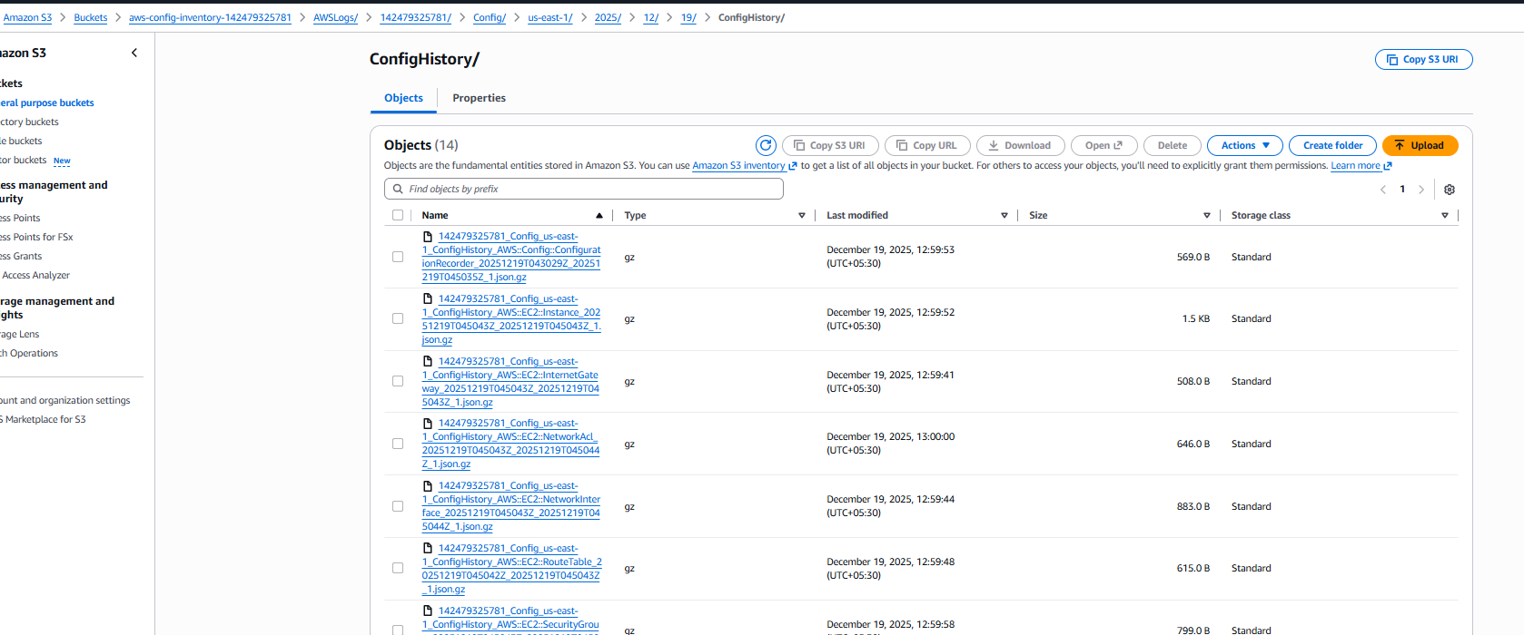

🟢 STEP 4: SET UP ATHENA (QUERY ENGINE)
1️⃣ Open Athena
Athena → Query editor
2️⃣ Set Query Result Location
s3://aws-config-inventory-ACCOUNT_ID/athena-results/

3️⃣ Create Database
CREATE DATABASE aws_inventory;

4️⃣ Create Inventory Table (IMPORTANT)
CREATE EXTERNAL TABLE aws_inventory.config_items (
configurationItemVersion STRING,
configurationItemCaptureTime STRING,
configurationItemStatus STRING,
awsAccountId STRING,
resourceType STRING,
resourceId STRING,
resourceName STRING,
awsRegion STRING,
availabilityZone STRING,
configuration STRING,
tags MAP<STRING, STRING>
)
ROW FORMAT SERDE 'org.openx.data.jsonserde.JsonSerDe'
WITH SERDEPROPERTIES ('ignore.malformed.json'='true')
LOCATION 's3://aws-config-inventory-ACCOUNT_ID/AWSLogs/ACCOUNT_ID/Config/';

5️⃣ Validate Inventory
SELECT COUNT(*) FROM aws_inventory.config_items;
✔ Must be > 0
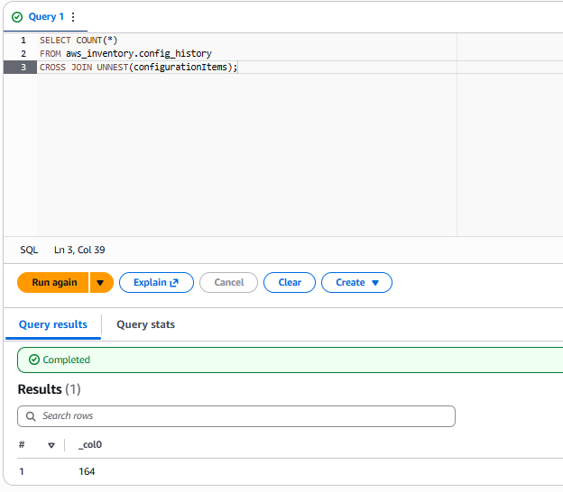

🟢 STEP 5: CREATE AI METRICS S3 STRUCTURE
Inside:
aws-ai-inventory-ACCOUNT_ID
Create folder:
metrics/

🟢 STEP 6: CREATE IAM ROLE FOR LAMBDA
Role Name
ai-inventory-lambda-role
Attach Policies
✔ AWSLambdaBasicExecutionRole
✔ AmazonAthenaFullAccess
✔ AmazonS3FullAccess
✔ AmazonBedrockFullAccess (or OpenAI equivalent)
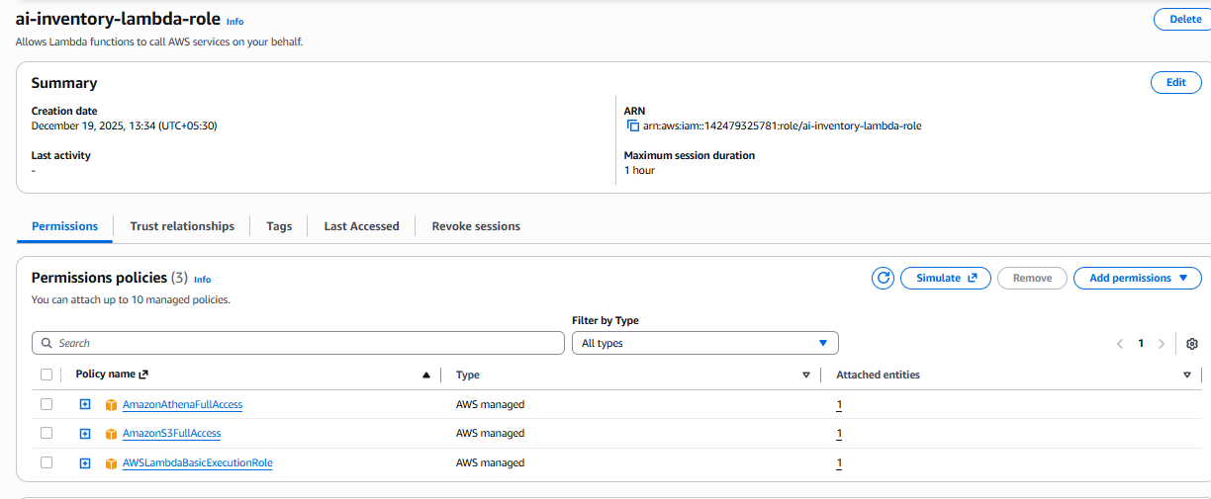

🟢 STEP 7: CREATE AI METRICS LAMBDA
Lambda Name
ai-inventory-metrics
Runtime
Python 3.11
IAM Role
ai-inventory-lambda-role
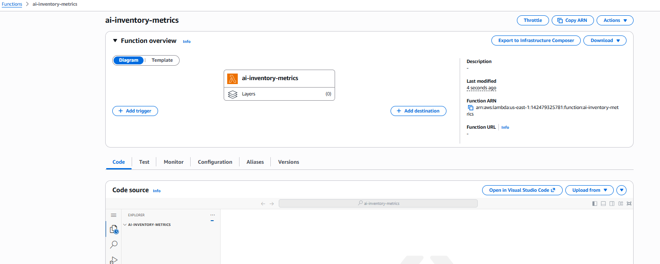

Lambda Code (PASTE THIS)
import boto3
import time
import json
import datetime

ATHENA_DB = "aws_inventory"
ATHENA_OUTPUT = "s3://aws-config-inventory-142479325781/athena-results/"
AI_BUCKET = "aws-ai-inventory-142479325781"

athena = boto3.client("athena")
s3 = boto3.client("s3")

def run_query(query):
response = athena.start_query_execution(
QueryString=query,
QueryExecutionContext={"Database": ATHENA_DB},
ResultConfiguration={"OutputLocation": ATHENA_OUTPUT}
)
qid = response["QueryExecutionId"]

while True:
status = athena.get_query_execution(QueryExecutionId=qid)
state = status["QueryExecution"]["Status"]["State"]
if state in ["SUCCEEDED", "FAILED"]:
break
time.sleep(2)

result = athena.get_query_results(QueryExecutionId=qid)
return int(result["ResultSet"]["Rows"][1]["Data"][0]["VarCharValue"])

def lambda_handler(event, context):
today = str(datetime.date.today())

total_resources = run_query("""
SELECT COUNT(*)
FROM aws_inventory.config_history
CROSS JOIN UNNEST(configurationItems)
""")

ec2_count = run_query("""
SELECT COUNT(*)
FROM aws_inventory.config_history
CROSS JOIN UNNEST(configurationItems) t(item)
WHERE item.resourceType = 'AWS::EC2::Instance'
""")

untagged_resources = run_query("""
SELECT COUNT(*)
FROM aws_inventory.config_history
CROSS JOIN UNNEST(configurationItems) t(item)
WHERE map_size(item.tags) = 0 OR item.tags IS NULL
""")

risk_score = min(100, int((untagged_resources / max(total_resources,1)) * 100))
optimization_score = max(0, 100 - risk_score)

metrics = {
"date": today,
"total_resources": total_resources,
"ec2_count": ec2_count,
"untagged_resources": untagged_resources,
"risk_score": risk_score,
"optimization_score": optimization_score
}

s3.put_object(
Bucket=AI_BUCKET,
Key=f"metrics/ai_metrics_{today}.json",
Body=json.dumps(metrics)
)

return {"status": "AI metrics generated", "metrics": metrics}

🟢 STEP 8: AUTOMATE WITH EVENTBRIDGE
Rule
Name: ai-inventory-daily
Schedule: rate(1 day)
Target: ai-inventory-metrics Lambda
✔ AI metrics generated daily

🟢 STEP 9: CREATE ATHENA TABLE FOR AI METRICS
CREATE DATABASE ai_inventory;

CREATE EXTERNAL TABLE ai_inventory.ai_metrics (
date STRING,
total_resources INT,
untagged_resources INT,
idle_ec2 INT,
risk_score INT,
optimization_score INT
)
ROW FORMAT SERDE 'org.openx.data.jsonserde.JsonSerDe'
LOCATION 's3://aws-ai-inventory-ACCOUNT_ID/metrics/';
Validate:
SELECT * FROM ai_inventory.ai_metrics;

🟢 STEP 10: SET UP AMAZON MANAGED GRAFANA
Console Path
Amazon Managed Grafana → Create workspace
Enable
✔ Athena
✔ CloudWatch
IAM Role
✔ Attach AmazonGrafanaAthenaAccess

🟢 STEP 11: ADD ATHENA DATA SOURCE IN GRAFANA
Grafana UI →
Connections → Data Sources → Athena
Databases:
- aws_inventory
- ai_inventory

🟢 STEP 12: BUILD DASHBOARD (CORE VISUALS)
📊 Inventory Panels
Total Resources
SELECT COUNT(resourceid) FROM aws_inventory.config_items;
Type: Stat

Resources by Type
SELECT resourcetype, COUNT(*)
FROM aws_inventory.config_items
GROUP BY resourcetype;
Type: Pie

Resources by Region
SELECT awsregion, COUNT(*)
FROM aws_inventory.config_items
GROUP BY awsregion;
Type: Bar

🧠 AI Panels
Untagged Trend
SELECT date, untagged_resources
FROM ai_inventory.ai_metrics;
Type: Time series

Risk Score
SELECT date, risk_score FROM ai_inventory.ai_metrics;
Type: Gauge

🟢 STEP 13: (OPTIONAL) ALERTING
Examples:
- Untagged > 20
- Risk score > 80
Send alerts → Email / Slack

