Task 1: Highly Available Web Application using ALB + EC2 Auto Scaling (AWS Free Tier)

Objective
Deploy a highly available and scalable web application using: - EC2 instances across multiple AZs - Application Load Balancer (ALB) - Auto Scaling Group (ASG) - CloudFormation (Infrastructure as Code)
The application must: - Stay online if one EC2 instance fails - Automatically scale based on CPU utilization

Architecture Overview
Flow: User → Application Load Balancer → Target Group → EC2 Instances (Auto Scaling Group)
High Availability: - EC2 instances are launched in multiple Availability Zones - ALB routes traffic only to healthy instances
Scalability: - Auto Scaling adds/removes EC2 instances based on CPU metrics

Architecture Diagram (Logical)
┌───────────────┐
│ User │
└───────┬───────┘
│
┌───────▼────────┐
│ Application LB │
└───────┬────────┘
│
┌────────────┴────────────┐
│ │
┌──────▼──────┐ ┌──────▼──────┐
│ EC2 (AZ-1) │ │ EC2 (AZ-2) │
│ Apache Web │ │ Apache Web │
└─────────────┘ └─────────────┘
↑ ↑
└──── Auto Scaling Group ──┘
📸 Screenshot: Final architecture from AWS console (optional: use AWS Architecture Icons)

AWS Services Used
Service | Purpose
EC2 | Host web application
ALB | Distribute traffic
Auto Scaling | Automatic scaling & recovery
CloudWatch | CPU-based scaling metrics
VPC | Networking

CloudFormation Template (Free Tier Safe)
⚠️ Use t2.micro (Free Tier eligible)
AWSTemplateFormatVersion: '2010-09-09'
Description: Highly Available Web App with ALB and Auto Scaling
Parameters:
KeyName:
Description: EC2 KeyPair
Type: AWS::EC2::KeyPair::KeyName
Resources:
WebSecurityGroup:
Type: AWS::EC2::SecurityGroup
Properties:
GroupDescription: Allow HTTP
VpcId: !Ref AWS::NoValue
SecurityGroupIngress:
- IpProtocol: tcp
FromPort: 80
ToPort: 80
CidrIp: 0.0.0.0/0
LaunchTemplate:
Type: AWS::EC2::LaunchTemplate
Properties:
LaunchTemplateData:
InstanceType: t2.micro
KeyName: !Ref KeyName
ImageId: ami-0f58b397bc5c1f2e8 # Amazon Linux 2 (update per region)
SecurityGroupIds:
- !Ref WebSecurityGroup
UserData:
Fn::Base64: !Sub |
#!/bin/bash
yum update -y
yum install -y httpd
systemctl start httpd
systemctl enable httpd
echo "<h1>Welcome from $(hostname)</h1>" > /var/www/html/index.html
TargetGroup:
Type: AWS::ElasticLoadBalancingV2::TargetGroup
Properties:
Port: 80
Protocol: HTTP
VpcId: !Ref AWS::NoValue
HealthCheckPath: /
LoadBalancer:
Type: AWS::ElasticLoadBalancingV2::LoadBalancer
Properties:
Subnets: [] # Use default VPC subnets
SecurityGroups:
- !Ref WebSecurityGroup
Listener:
Type: AWS::ElasticLoadBalancingV2::Listener
Properties:
LoadBalancerArn: !Ref LoadBalancer
Port: 80
Protocol: HTTP
DefaultActions:
- Type: forward
TargetGroupArn: !Ref TargetGroup
AutoScalingGroup:
Type: AWS::AutoScaling::AutoScalingGroup
Properties:
MinSize: '1'
MaxSize: '3'
DesiredCapacity: '2'
VPCZoneIdentifier: [] # Default subnets
LaunchTemplate:
LaunchTemplateId: !Ref LaunchTemplate
Version: !GetAtt LaunchTemplate.LatestVersionNumber
TargetGroupARNs:
- !Ref TargetGroup
ScaleOutPolicy:
Type: AWS::AutoScaling::ScalingPolicy
Properties:
AutoScalingGroupName: !Ref AutoScalingGroup
PolicyType: TargetTrackingScaling
TargetTrackingConfiguration:
PredefinedMetricSpecification:
PredefinedMetricType: ASGAverageCPUUtilization
TargetValue: 60
ScaleInPolicy:
Type: AWS::AutoScaling::ScalingPolicy
Properties:
AutoScalingGroupName: !Ref AutoScalingGroup
PolicyType: TargetTrackingScaling
TargetTrackingConfiguration:
PredefinedMetricSpecification:
PredefinedMetricType: ASGAverageCPUUtilization
TargetValue: 20

Execution Steps (With Screenshot Checklist)

Step 1: Login to AWS Console
- Go to CloudFormation → Create Stack → With new resources
- Upload YAML template
- 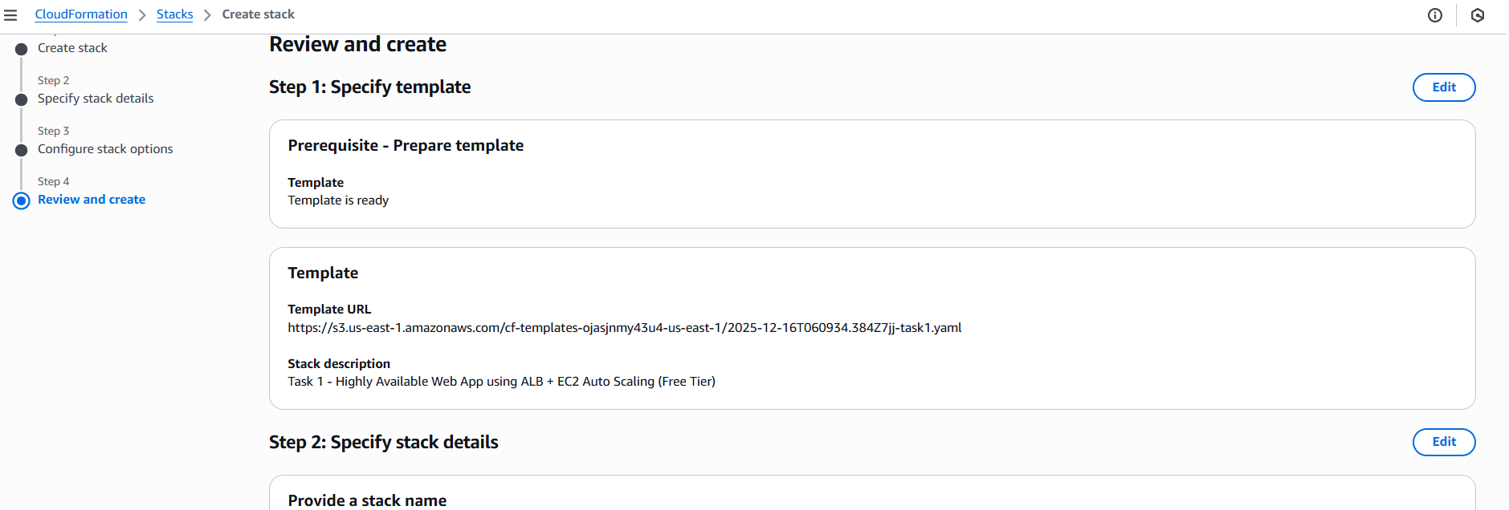
📸 Screenshot: CloudFormation stack creation page

Step 2: Provide Parameters
- Select existing EC2 Key Pair
- Click Next → Create Stack
- 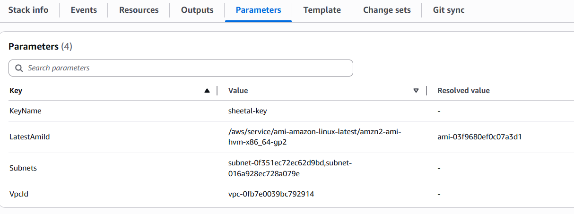
📸 Screenshot: Parameters page

Step 3: Monitor Stack Creation
- Status: CREATE_COMPLETE
- 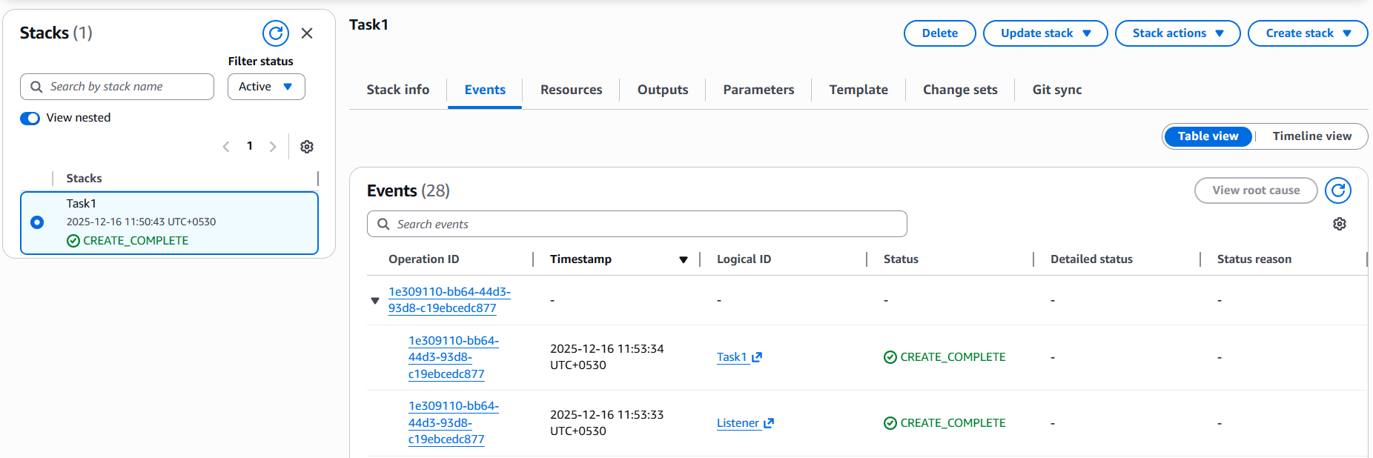
📸 Screenshot: Stack events tab

Step 4: Verify EC2 Instances
- Go to EC2 → Instances
- Instances should be in running state across AZs
- 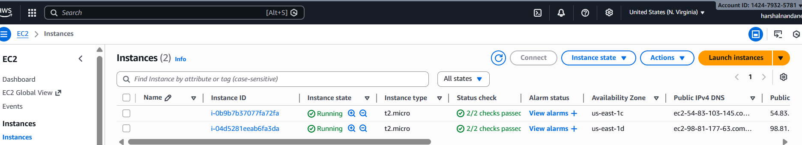
📸 Screenshot: EC2 instances list

Step 5: Verify Load Balancer
- Go to EC2 → Load Balancers
- Copy DNS name and open in browser
- 
- 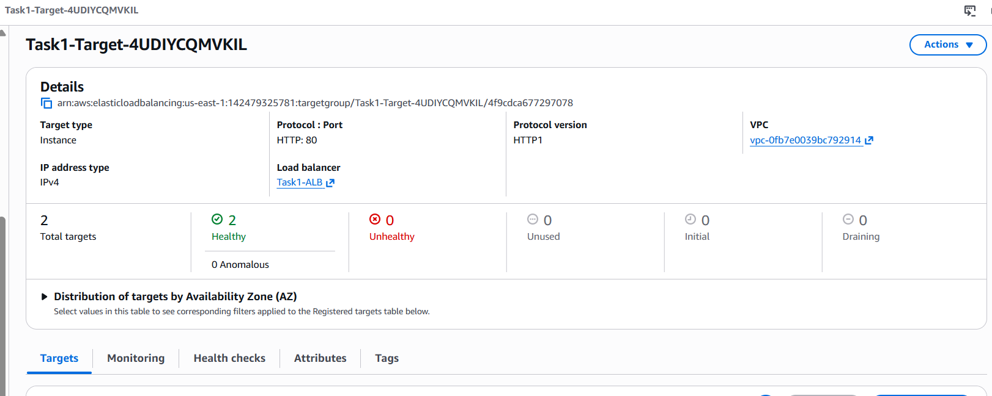
✅ Web page loads
📸 Screenshot: Browser output

Step 6: Test Failover
- Stop one EC2 instance manually
- Refresh browser
✅ Application still loads
📸 Screenshot: - One instance stopped - ALB target group health check

Step 7: Test Auto Scaling
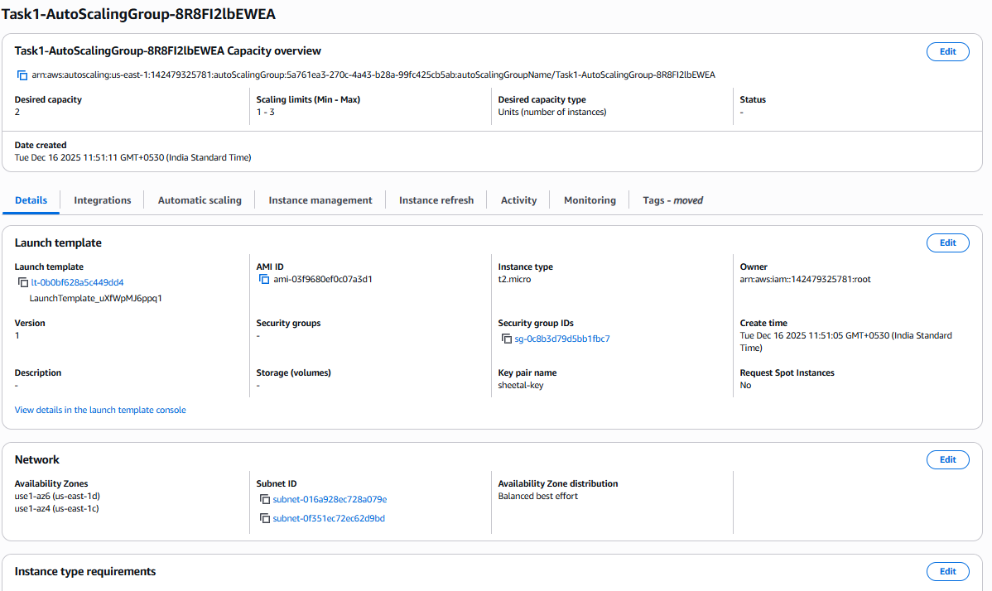
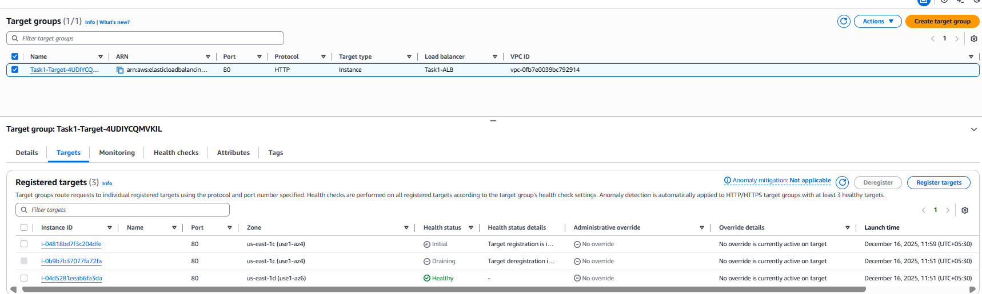
- SSH into instance
- 
- Run CPU stress:
yum install stress -y
stress --cpu 2 --timeout 300
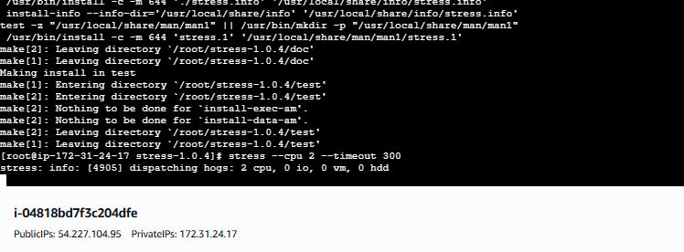
Alarm for CPU Utilization triggered
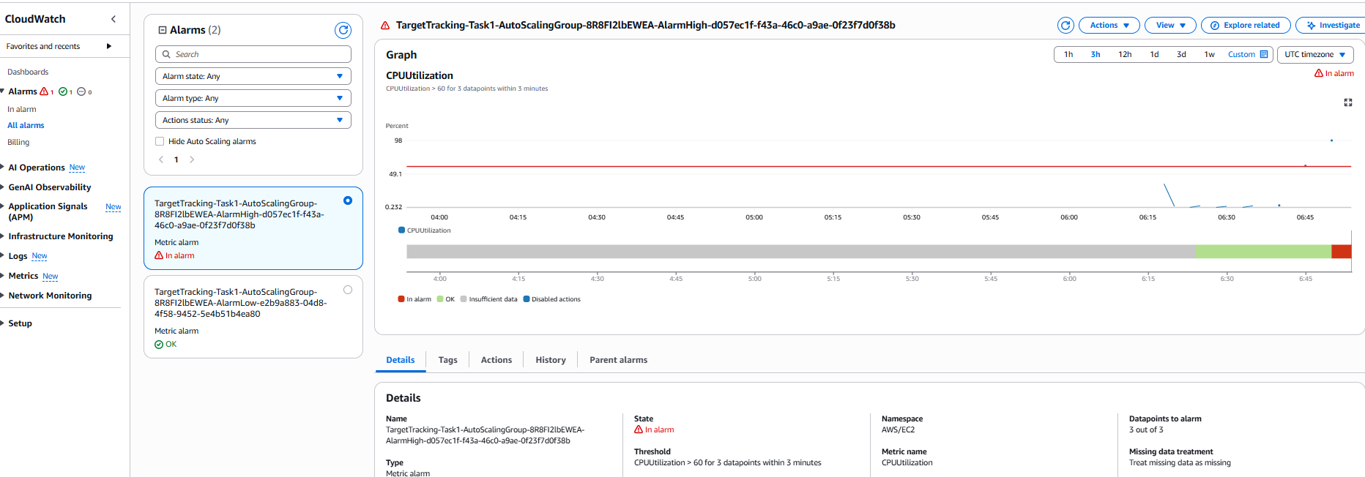
- New instance launches automatically
- 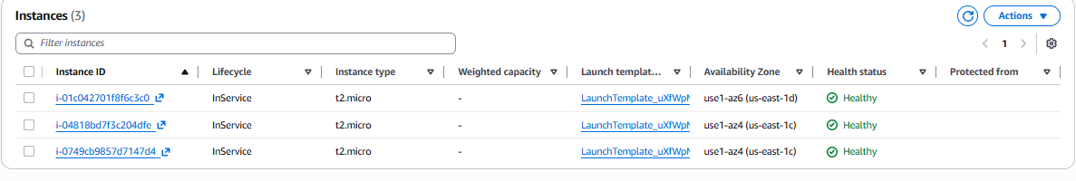
- 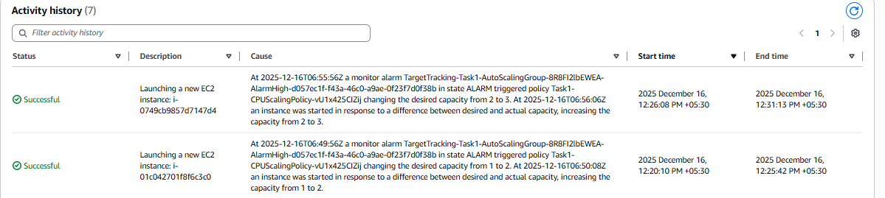
📸 Screenshot: - Auto Scaling activity - EC2 count increased
Alarm closed
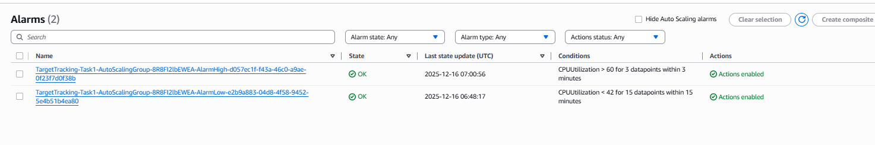

ALB




