Serverless Backend API using AWS (Lambda + DynamoDB + API Gateway)

Goal
Create a simple serverless backend API with the following features: - DynamoDB table: Products - Lambda functions: - Add Product - Get Product - List Products - API Gateway routes: - POST /product - GET /product/{id} - GET /product

Architecture Overview
Client (Postman / Browser)
|
API Gateway (REST API)
|
AWS Lambda
|
DynamoDB (Products table)

1️⃣ CloudFormation Template (Ready to Deploy)
File name: serverless-products-api.yaml

2️⃣ Deployment Steps (Document This With Screenshots)

Step 1: Upload CloudFormation Template
- Open AWS Console → CloudFormation
- Click Create stack → With new resources
- Upload serverless-products-api.yaml
- Click Next → Next → Create stack
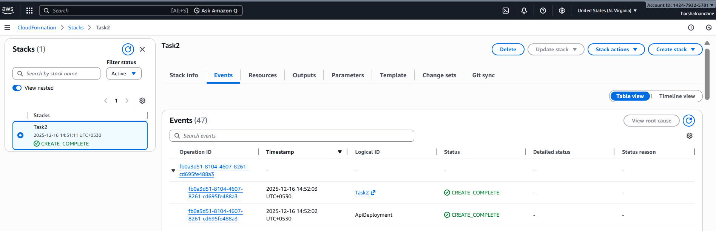

Step 2: Verify DynamoDB Table
- Go to DynamoDB → Tables
- Confirm Products table exists
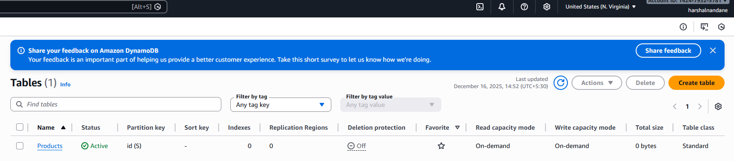

Step 3: Verify Lambda Functions
- Open Lambda → Functions
- Confirm:
  - AddProductFunction
  - GetProductFunction
  - ListProductsFunction
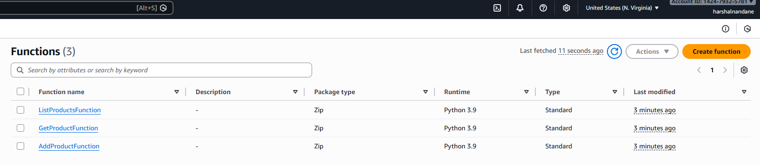

Step 4: Verify IAM Role
- Go to IAM → Roles
- Open the Lambda execution role
- Confirm DynamoDB permissions
- 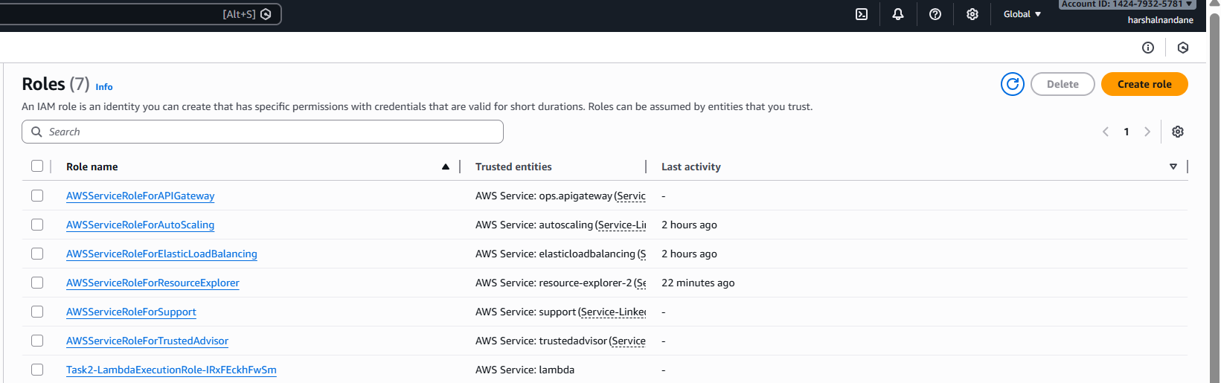

Step 5: Verify API Gateway
- Go to API Gateway → ProductsApi
- Resources:
  - /product → POST, GET
  - /product/{id} → GET
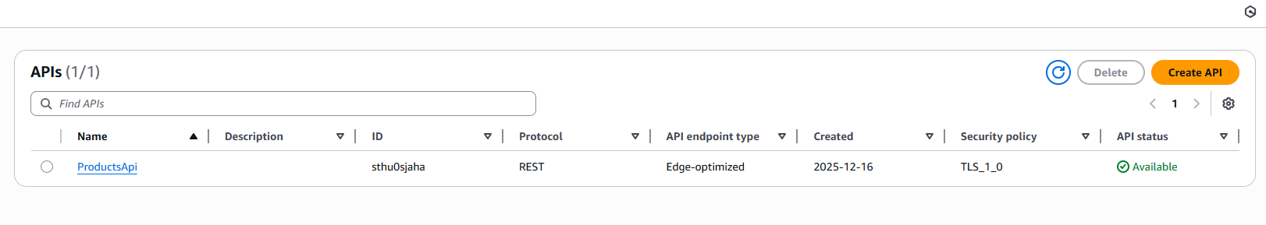
- Stage: prod
- 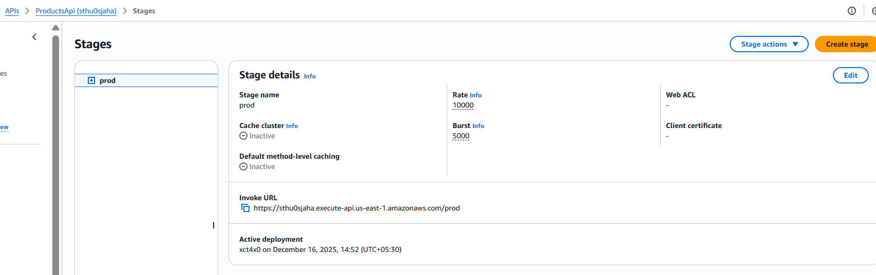

3️⃣ Testing the API

Add Product
POST /product
Body:
{
"name": "Laptop",
"price": 50000
}
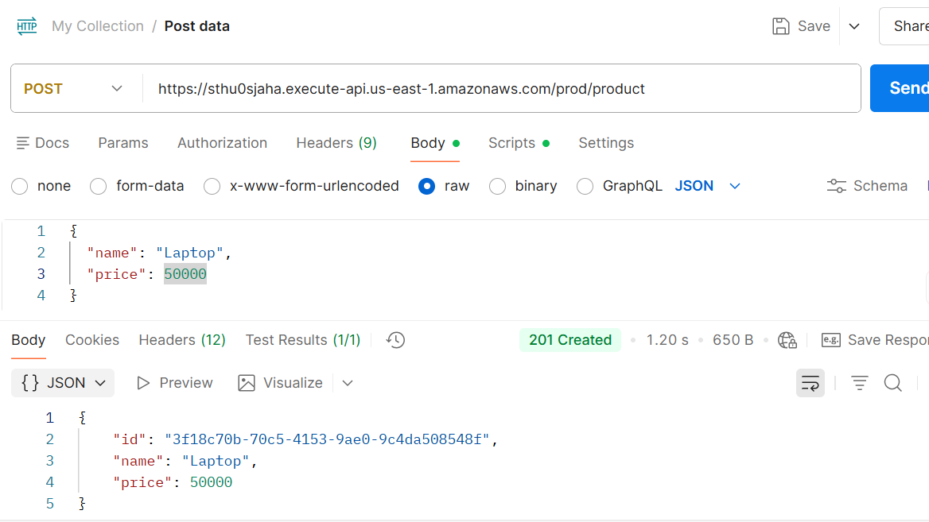

Get Product by ID
GET /product/{id}
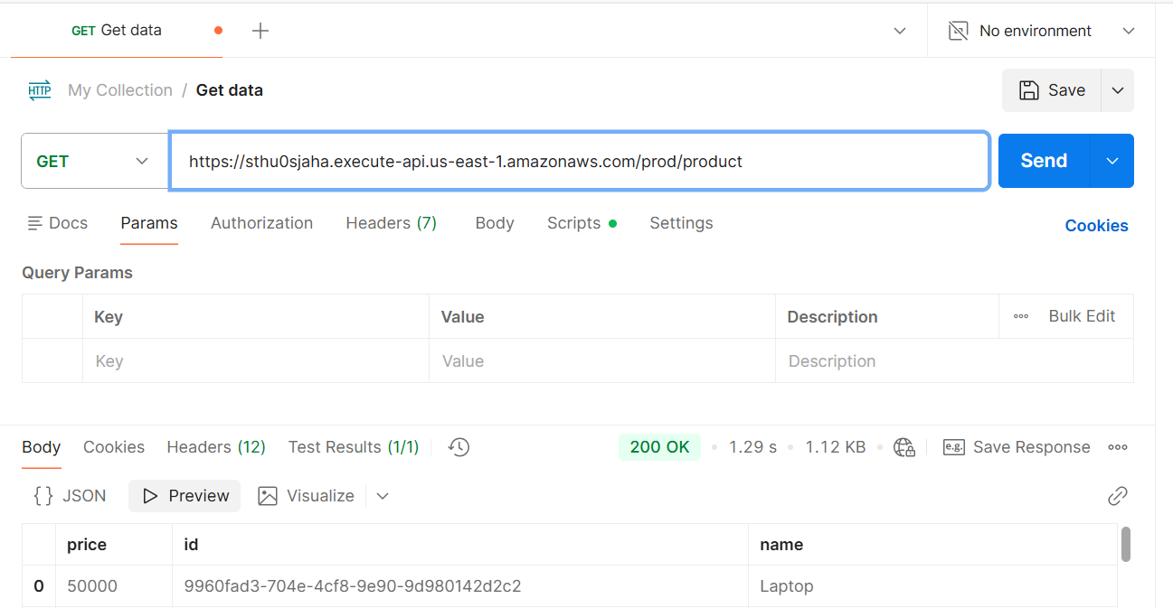
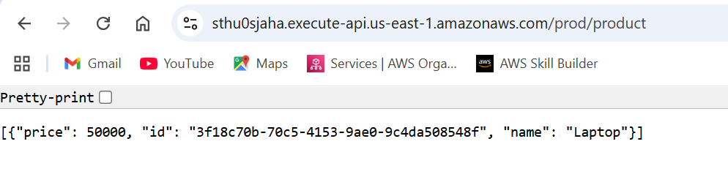

Dynamodb table
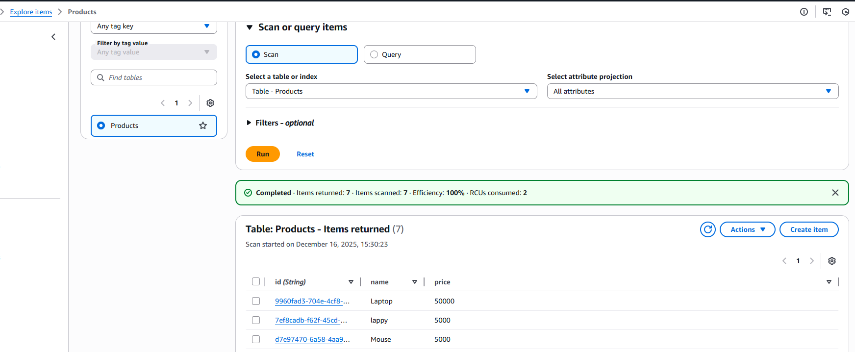
Lambda invocation
