Task 3: Build a VPC with Public & Private Subnets

Goal
Deploy AWS networking infrastructure using best practices: - 1 VPC - 2 Public subnets - 2 Private subnets - Internet Gateway - NAT Gateway - Bastion Host (Public EC2) - Private EC2 instance - SSH access to Private EC2 via Bastion

PART 1: Ready-to-Deploy CloudFormation Template

📌 Prerequisites
- AWS Account
- EC2 Key Pair (already created)
- Region: us-east-1 (N. Virginia)

✅ CloudFormation Template (YAML)

PART 2: Deployment Steps (with Screenshots Guidance)

Step 1: Upload CloudFormation Template
- AWS Console → CloudFormation
- Create Stack → With new resources
- Upload YAML file

Step 2: Enter Parameters
- KeyName: Select your existing EC2 key pair
- 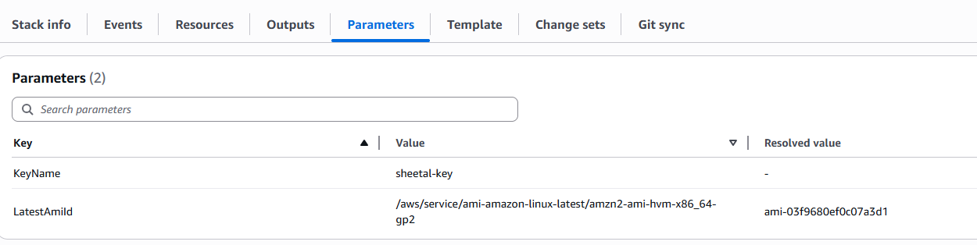

Step 3: Create Stack
- Click Next → Next → Create Stack
- Wait until status = CREATE_COMPLETE
- 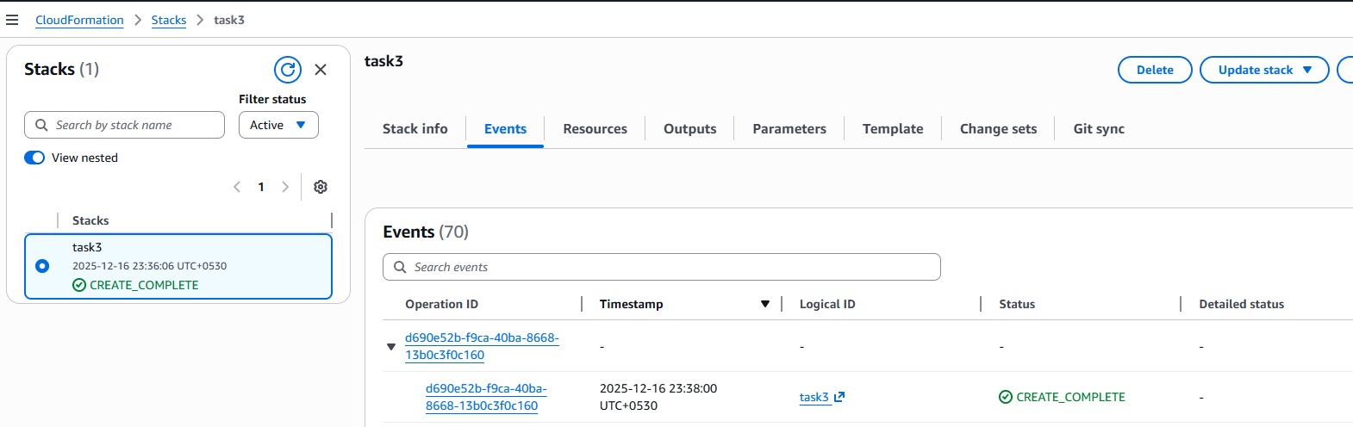

- 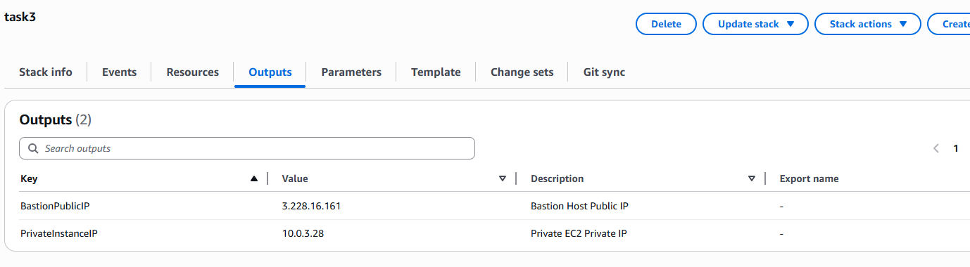

Step 4: Verify VPC Components
Check in EC2 Console: - VPC - Subnets (2 public + 2 private) - Route Tables - NAT Gateway
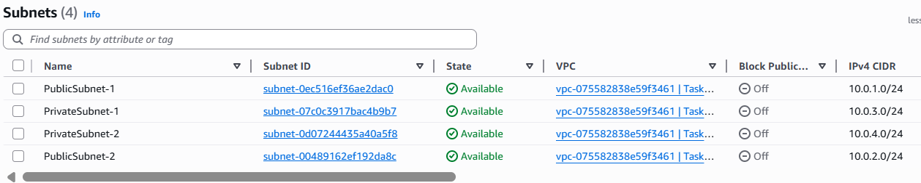

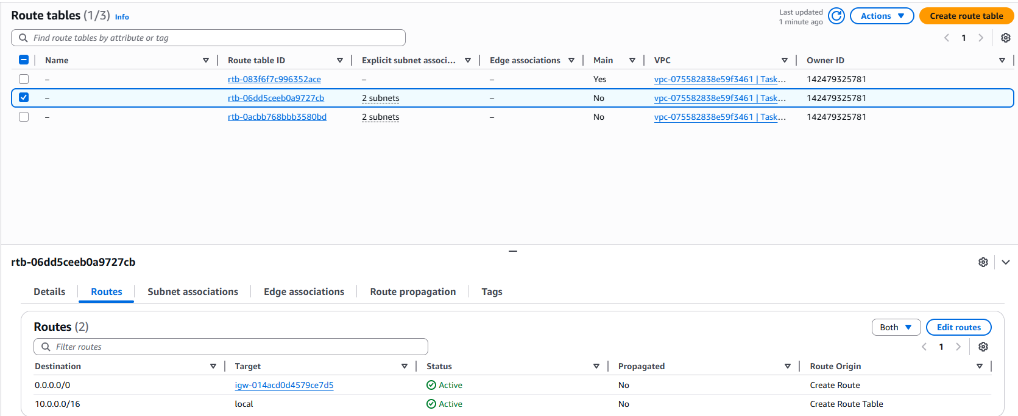

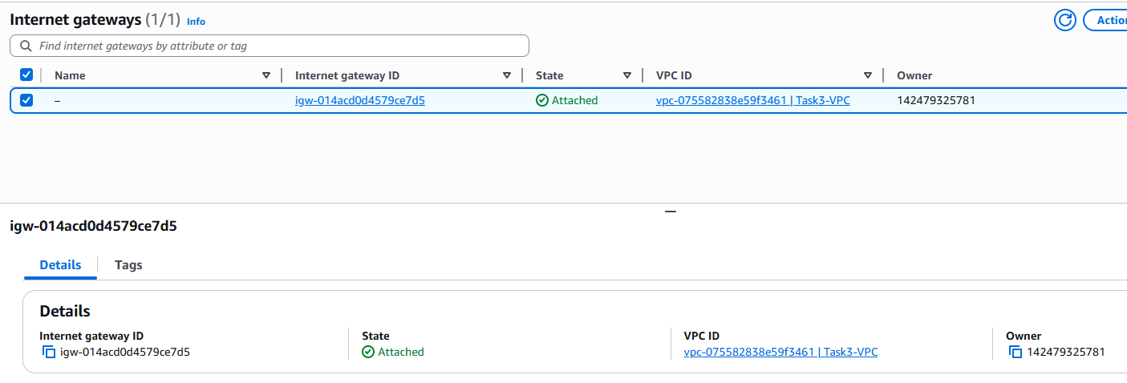
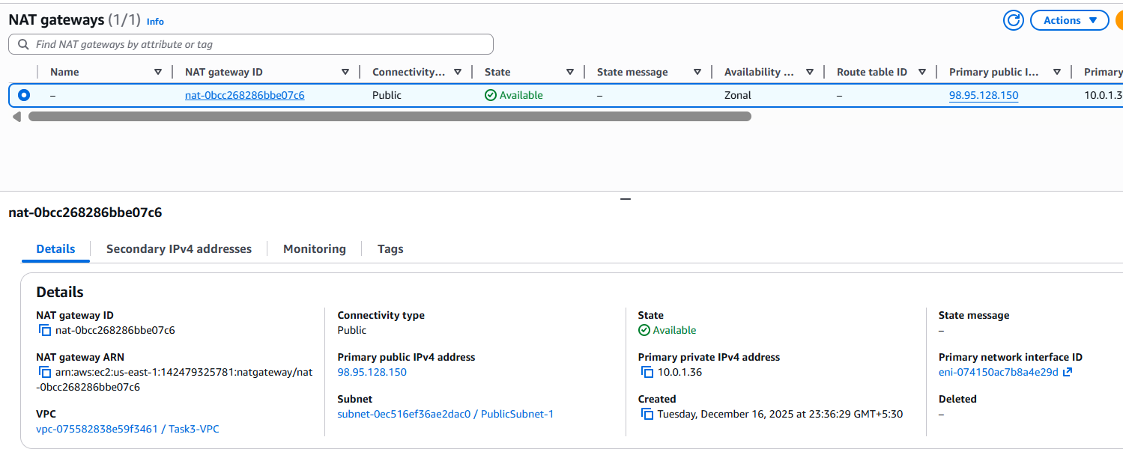
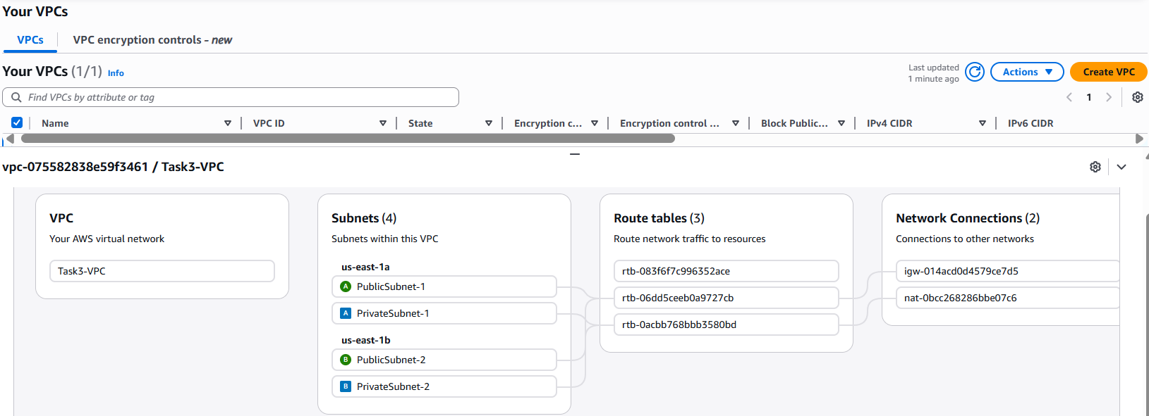

Ec2 Details
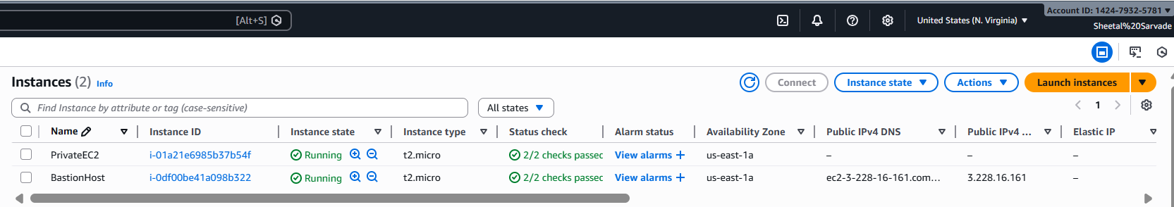

Step 5: Connect to Bastion Host
ssh -i key.pem ec2-user@3.228.16.161
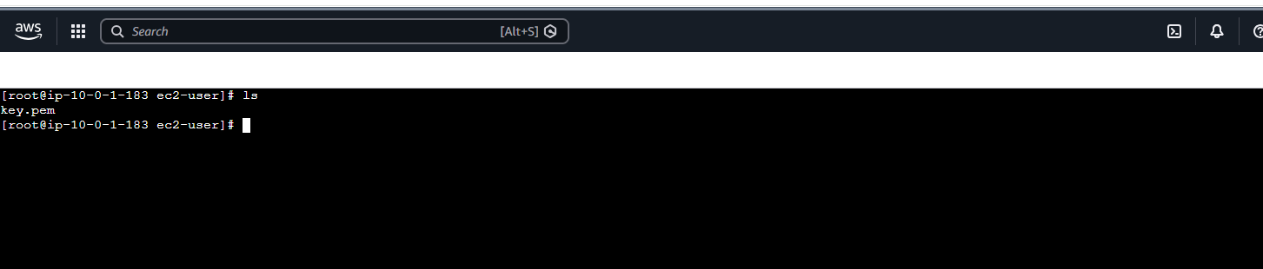

Step 6: Connect to Private EC2 via Bastion
- Copy key to bastion:
- SSH into Private EC2:
ssh -i key.pem ec2-user@10.0.3.28
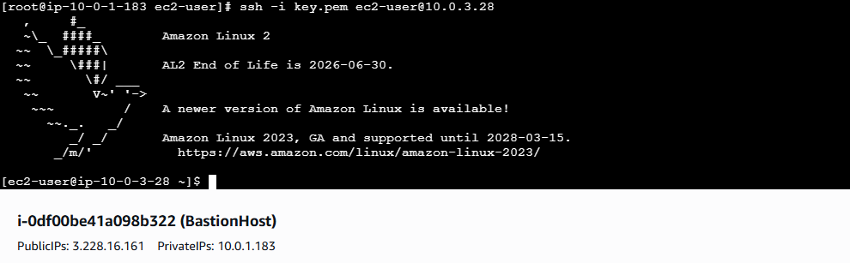

PART 3: Architecture Diagram (Logical Flow)
User → Bastion (Public Subnet) → Private EC2 (Private Subnet)
Internet → IGW → Public Subnet Private Subnet → NAT Gateway → Internet

PART 4: Interview Talking Points
- Why Bastion Host?
- Why NAT Gateway instead of IGW?
- Difference between Public & Private subnet
- Security Group chaining

PART 5: Cleanup
- Delete CloudFormation Stack
- This deletes all resources automatically

✅ Task Completed
This setup follows real-world AWS networking best practices and is production-aligned.

