**SQL Server**

Query: select year( [InvoiceDate]),sum([Total]), count([InvoiceId]),

count (distinct [CustomerId]) from [dbo].[Invoice]

group by year( [InvoiceDate]);

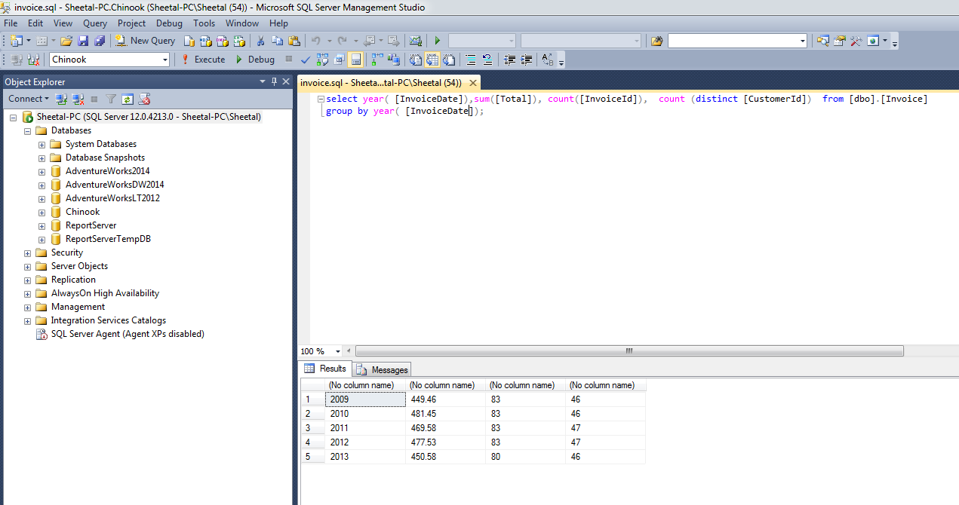

**PostgreSql**

Query: select DATE_PART('YEAR',"InvoiceDate") as Year, sum("Total") as Total_Revenue,

count("InvoiceId") as Total_Invoice, count(distinct "CustomerId")

as Customers from "Invoice"

group by DATE_PART('YEAR',"InvoiceDate");

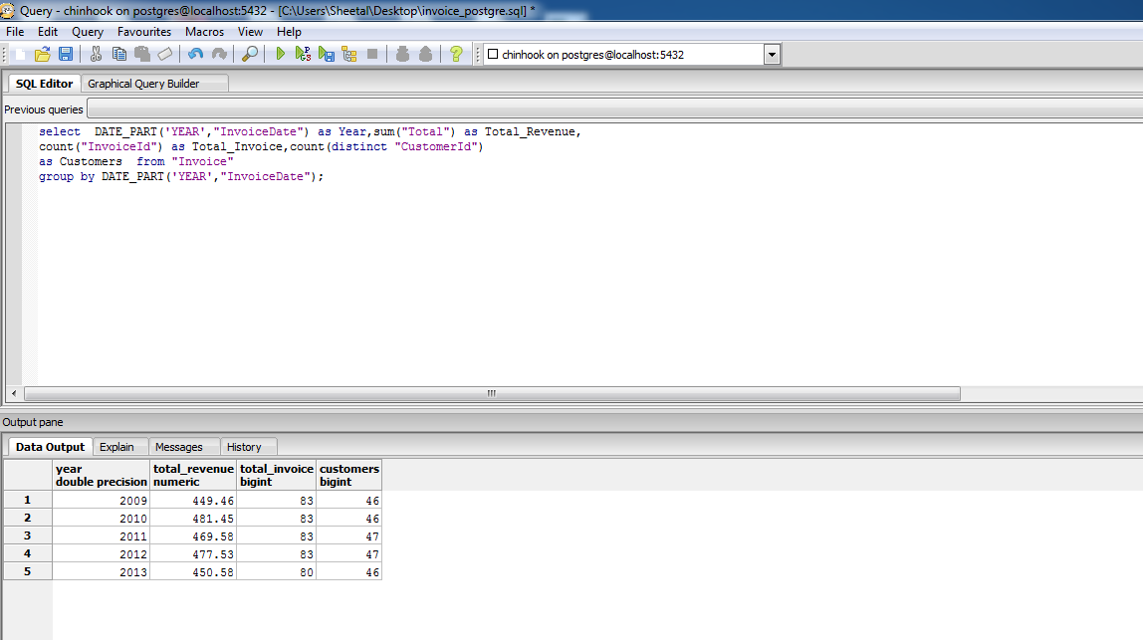

**Oracle:**

Query: select EXTRACT(YEAR from InvoiceDate) as Year,sum(Total), count(InvoiceId),count(distinct(CustomerId)) from Invoice

group by EXTRACT(YEAR from InvoiceDate);

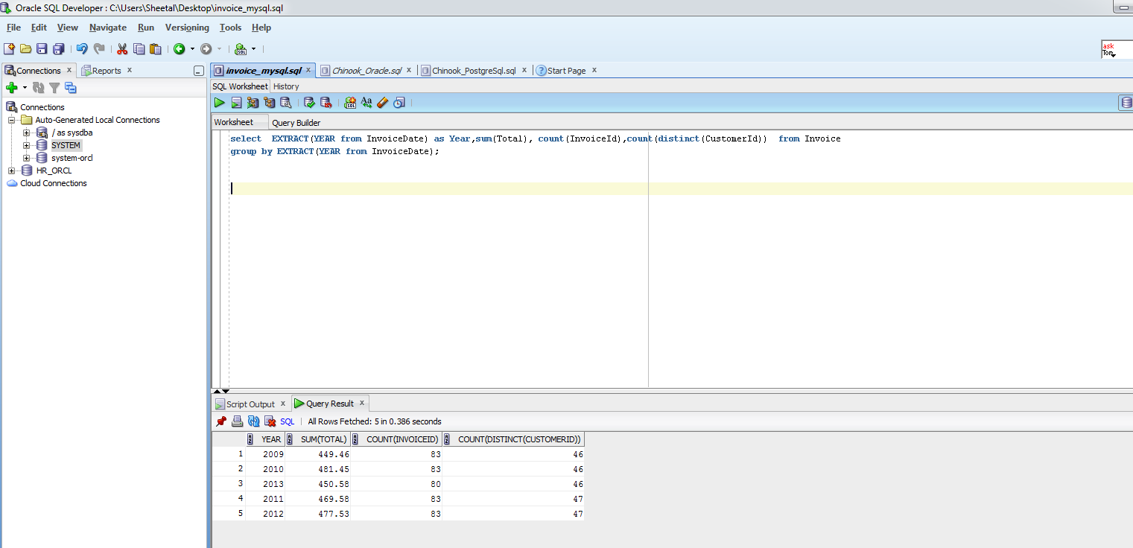

**MySQL**

Query: select EXTRACT(YEAR from InvoiceDate) as Year,sum(Total), count(InvoiceId),

count(distinct(CustomerId)) from Invoice

group by EXTRACT(YEAR from InvoiceDate);

