**ASSIGNMENT-5-sheethal yellisetty-z1853460**

(a)when the fields are left empty and proceeded to join our list the errors "this field is required" gets poped out as shown in below screenshot.

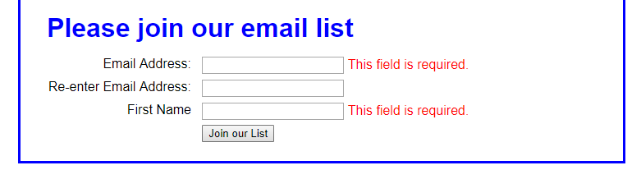

(b)when entered e-mail is not same as the re-enter email slot then the error "this entry must equal first entry" gets poped out.

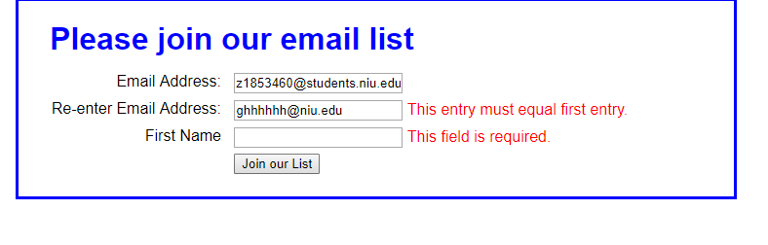

(c)when all the fields are filled correctly and clicks on the join button the below page gets poped out.

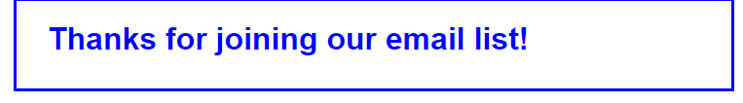

(d)when we try to reload and reset the values the window shows the following screenshot.

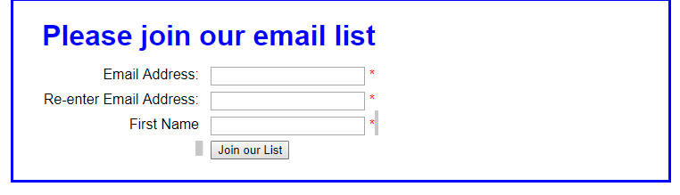

(e)In the above scenario, the console tab doesn't show any error as follow.

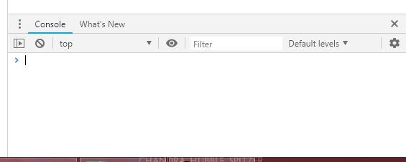

(f)this is the logic error found in the email_list application

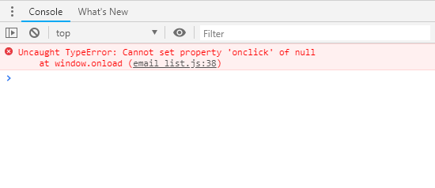

(g)debugging the code by changing it to the correct function.

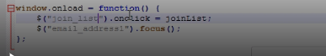

(h)This is the syntax error due to which the below alert box is displayed.

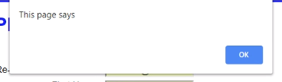

(i)setting the breakpoint at the first line of function.

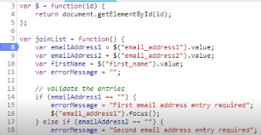

(j)debugger checks the each line in the function.

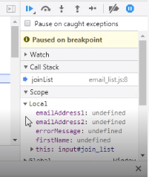

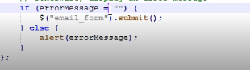

(k)changing the syntax error by inserting == ie 'comparable' operator.