**ASSIGNMENT-5-2 MPG-SHEETHAL YELLISETTY**

(a)the below page gets displayed.and if we click on the calculate MPG button an error gets displayed

in console tab.

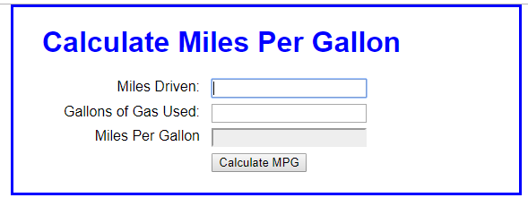

(b)This is the error described above to enter all the numeric values.

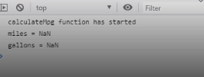

(c)If we enter all the correct values,the aanswer gets displayed in the console tab but not in the page.

C:\Users\sheethal\Desktop\Capture7.PNG

(d)to display them as alert we need to change the statement "console.log" to alert in the following program.

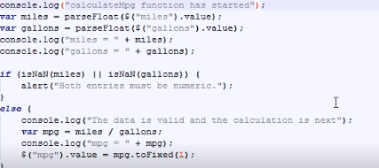

(e)This is another error stating the label value must be same with the ID.

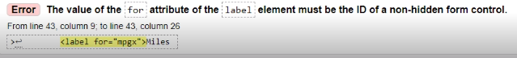C:\Users\sheethal\Desktop\Capture10.PNG