SVARA — Sub-module 1A: Audio Input and Conditioning
Member 1 (Speech Signal Processing) · implementation and design document
Table of Contents

1. What 1A is and what it promises
Sub-module 1A is the front door of the whole system. Whatever the audio source is (a microphone, a WAV uploaded from a phone, a WebM blob from a browser, an MP3), 1A turns it into one standard form that every later stage can rely on:
signal, sr = load_audio(source) → a 1-D float32 NumPy array, mono, 16 000 Hz, DC-free, peak-normalised to 0.9, values always inside [-1, 1].
This is the contract handed to 1B (clean_audio), to 1C (features and plots) and, through 1B, to Member 2’s speech-to-text. Because all of them can assume the same format, none of them needs to check sample rates or channel counts.
Item | Value
Module file | audio_io.py (≈580 lines, including documentation)
Public functions | load_audio, load_audio_with_report, record_from_mic, record_from_mic_with_report, resample_audio, normalize_amplitude, save_wav
Error type | AudioLoadError (subclass of ValueError)
Tests | 71 automated tests, all passing (tests/test_audio_io.py)
Command-line use | python audio_io.py in.mp3 out.wav prints a report and saves the result

2. Everything that was used

2.1 Software
Component | Version used | Role in 1A | Why this one
Python | 3.13 | Language | Course standard; all libraries below support it
NumPy | 2.5.3 | Arrays, mean, max, RMS, clipping | Every signal is a NumPy array; shared with librosa/Whisper later
SoundFile (libsndfile 1.2.2) | 0.14.0 | Decoding WAV, FLAC, OGG, MP3; writing WAV | Reads straight to float32, handles 16/24/32-bit PCM and float WAV, can read from memory (BytesIO)
ffmpeg (system tool) | 6.1.1 | Fallback decoder for WebM/Opus, M4A/AAC, MP4, etc. | Browsers record WebM/Opus; libsndfile cannot read it. Called with a list of arguments (no shell), 60 s timeout
soxr (libsoxr) | 1.1.0 | Primary resampler (quality="HQ") | High-quality, fast, linear-phase band-limited resampling
SciPy | 1.18.1 | Fallback resampler: signal.resample_poly (Kaiser window); also used to build synthetic test signals | Installed anyway; the module still works if soxr is missing
sounddevice (optional) | — | Microphone capture in record_from_mic | Only needed for desktop mic recording; not needed with Streamlit’s st.audio_input
pytest | 9.2.0 | Test suite
Matplotlib | 3.11.2 | Figures in this document

2.2 Dataset
1A does not learn anything, so it has no training dataset. It is deterministic signal handling, and what it needs is test material with known properties. Three kinds are used or planned:
- Synthetic signals (used for all 71 tests and all figures here). They are generated by code (scripts/synth.py), so they are exactly reproducible and carry no licensing or privacy concern:
  - Pure tones (100 Hz–10 kHz): a tone’s true frequency and amplitude are known, so we can prove the resampler keeps them, or removes them if they are above the new Nyquist limit.
  - Speech-like signal: a glottal-pulse harmonic source with a gliding pitch (110→140 Hz) passed through three formant resonators (700, 1200 and 2600 Hz) and gated into about three bursts per second with pauses. It mimics the structure of voiced speech (harmonics, formants, syllable rhythm, silences). It is not real speech.
  - Deliberately difficult variants written to sample_audio/: 48 kHz stereo, 44.1 kHz, 8 kHz “telephone”, very quiet (-40 dBFS), with a DC offset of +0.3, loud and clipped, digital silence, and MP3 / WebM-Opus / M4A encodings of the same clip.
- Real speech (not bundled, no download was done in this work). For the real end-to-end evaluation, the first source should be your own team’s recordings: short answers to form questions (name, age, phone number, address) in Malayalam, Kannada, Hindi and English, from different speakers, recorded on phones and laptops. Public corpora that cover the project’s languages are: Mozilla Common Voice (has ml, kn, hi, en), Google FLEURS (read speech, all four languages) and OpenSLR Indic speech sets. Check each licence and exact language coverage before use. 1A needs no changes for any of them; it accepts whatever sample rate and format they use.
- Noisy variants are created later by 1C (adding noise at 20/10/5 dB SNR). 1A only supplies the clean 16 kHz starting point.
Honest limitation: because the automated tests use synthetic audio, they prove the signal-processing behaviour (rates, channels, levels, formats, errors) but say nothing about how real voices sound. Before the demo, run python audio_io.py <your_recording> out.wav on a few real clips and listen to out.wav.

3. How it is done, step by step
source ──► DECODE ──► MONO ──► DC REMOVAL ──► RESAMPLE ──► NORMALISE ──► VALIDATE ──► (signal, 16000)
(soundfile (mean of (subtract (anti-alias (peak → 0.9, (finite, length,
/ ffmpeg / channels) the mean) low-pass + never boost clipping, silence
array) 16 kHz) silence) report)

Step 0 — Identify the input type
_decode_source looks at what it was given: a (array, sr) tuple (either order, so scipy.io.wavfile.read output works), a NumPy array (needs sample_rate=), a path, raw bytes, or a file-like object (Streamlit’s UploadedFile, BytesIO; .getvalue() is used so a half-read stream does not matter). Anything else gives a clear error.

Step 1 — Decode to floating point
- File/bytes → SoundFile. sf.info() reads only the header first (cheap) to reject non-audio and over-long files before decoding. Then sf.read(..., dtype="float32") returns samples already scaled to [-1, 1] whatever the original bit depth (16-bit, 24-bit, 32-bit, float).
- If libsndfile cannot read it → ffmpeg. The input is converted to a 32-bit-float WAV at its native rate in a temporary folder and read back, so everything afterwards goes through the same code path.
- NumPy arrays: int16/int32 are divided by 2^{15/2}31, uint8 is centred, floats are used as-is. Both (samples, channels) and (channels, samples) layouts are accepted.

Step 2 — Convert to mono
The channels are averaged ((L+R)/2). Averaging keeps the speech, and also averages out uncorrelated noise between channels. (If two channels were exact opposites they would cancel; real microphones never do this.)

Step 3 — Remove the DC offset
A constant offset (cheap sound cards, some phones) carries no speech information, but it wastes headroom and distorts the first filter output in 1B. The mean of the signal is subtracted. The report records the removed value (e.g. +0.300 for the test file).

Step 4 — Resample to 16 kHz
Why 16 kHz? Speech information lies mostly below ~4–5 kHz; by the Nyquist theorem a 16 kHz rate represents frequencies up to 8 kHz, which covers it with margin. Whisper and most ASR models are trained on 16 kHz audio, so giving them anything else would hurt accuracy. It also keeps data small and makes 1B’s 300–3400 Hz bandpass filter well-defined.
How: the rate change is a ratio of integers, e.g. 44 100 → 16 000 is ×160/441. The resampler conceptually inserts zeros (up-sampling by 160), applies a linear-phase low-pass FIR filter and keeps every 441st sample (down-sampling) — implemented efficiently as a polyphase filter.
Why the low-pass matters (aliasing). When the rate is lowered, any component above the new Nyquist frequency (8 kHz) is folded back into the audible band as a false tone if it is not removed first. Figure 2 shows this with a 10 kHz tone: naive decimation turns it into a strong spurious 6 kHz tone, while the resampler removes it (the interior of the output is 133 dB below the input). Tests also verify that real speech-band tones (300 Hz–6 kHz) pass with under 0.01 amplitude error. If the clip is already 16 kHz it is not touched at all (bit-exact, tested).
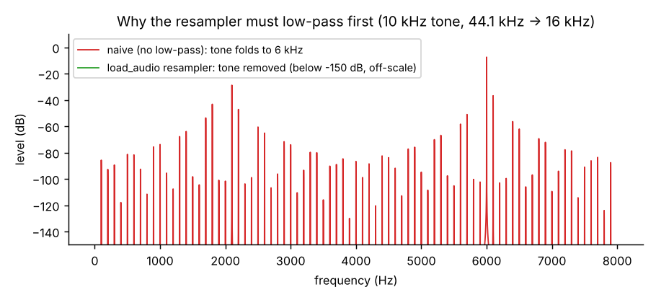
Figure 2. Aliasing: naive down-sampling vs the resampler used in 1A (10 kHz tone, 44.1 kHz → 16 kHz).

Step 5 — Normalise the amplitude
Recordings can be 60 dB apart in loudness depending on the microphone and distance. A consistent level makes the later steps (noise estimate, VAD thresholds, plots) comparable between clips. Three modes exist:
Mode | Formula | Notes
"peak" (default) | gain = 0.9 / max(\|x\|) | Loudest sample becomes 0.9 (−0.9 dBFS), leaving head-room
"rms" | gain = 0.1 / RMS(x), then gain = min(gain, 0.99/peak) | Equalises loudness; gain is limited so it never clips
None | no change | For experiments that must keep the original level
Safety rule: if the peak is below 1e-4 (−80 dBFS) the clip is treated as silence and is not amplified (otherwise a muted microphone would turn into loud hiss). The report flags it, and the UI can tell the user to check the microphone.
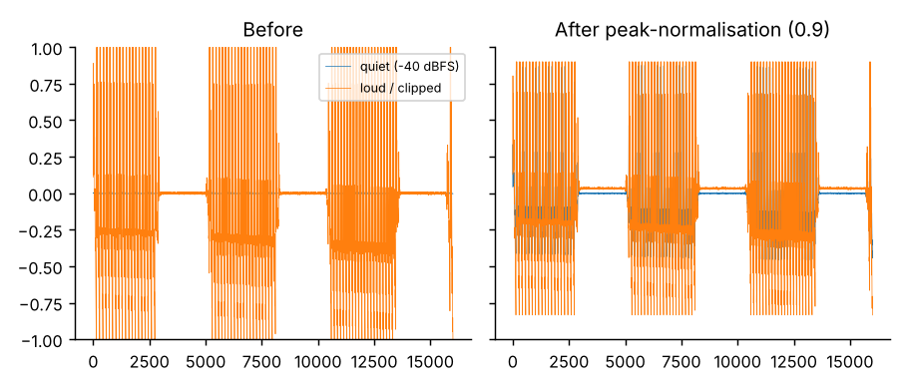
Figure 3. Quiet (-40 dBFS) and loud/clipped inputs are brought to the same level.

Step 6 — Validate and report
After processing the output is clipped to [-1, 1] (resampling filters can overshoot by a few percent on square-like signals), made contiguous float32, and an AudioReport is filled with: original rate/channels/duration, DC removed, peak and RMS before and after, gain in dB, fraction of clipped input samples, silence flag, and plain-language warnings:
- “11.19 % of samples are clipped; the recording was too loud.”
- “Input was very quiet; it was amplified by 41 dB…”
- “The recording is silent (no signal detected). Check the microphone.”
Clipping cannot be repaired afterwards, so it is reported rather than hidden.
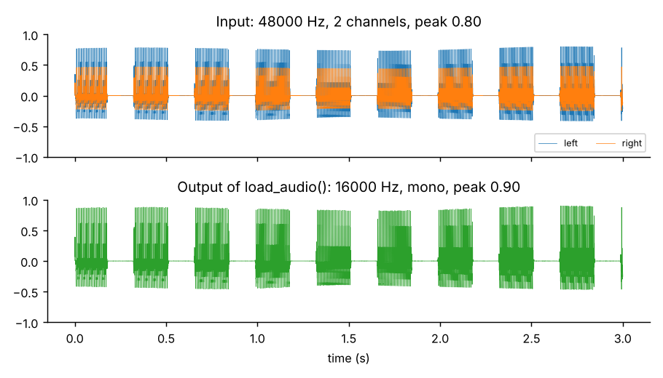
Figure 1. A hostile input (48 kHz stereo) and the 1A output.

Microphone input
record_from_mic(duration_s) records through sounddevice at 16 kHz mono; if the device refuses 16 kHz it records at its default rate, and the same pipeline resamples. For the Streamlit app the simpler route is st.audio_input(...), whose returned object can be given directly to load_audio (the browser owns the microphone there).

4. Using it (for team-mates)
from audio_io import load_audio, load_audio_with_report, record_from_mic, save_wav
signal, sr = load_audio("answer.wav") # any file path
signal, sr = load_audio(uploaded_file) # Streamlit upload / st.audio_input
signal, sr = load_audio((np_array, 44100)) # raw samples
signal, sr = record_from_mic(5.0) # microphone, 5 s
signal, sr, report = load_audio_with_report("answer.mp3")
print(report) # human-readable summary
if report.warnings: st.warning(" ".join(report.warnings))
save_wav(signal, "cleaned_input.wav", sr)
# Hand-off to 1B: cleaned = clean_audio(signal, sr)
Useful options: normalize="peak"|"rms"|None, remove_dc=True, max_duration_s=120 (a form answer is seconds long; None disables), min_duration_s=0.05, target_sr=16000.

5. Error handling
Every foreseeable problem raises AudioLoadError with a readable message the UI can show; nothing should crash the app or hang.
Situation | Behaviour
File missing / is a folder / text file named .wav / empty bytes | AudioLoadError (“File not found”, “Not a file”, “not a valid audio file”, “Empty audio data”)
Array without sample rate, or rate ≤ 0, NaN, non-integer, outside 1 kHz–768 kHz | AudioLoadError
NaN / Inf samples, complex or wrong-dtype arrays, 3-D arrays, absurd channel counts | AudioLoadError
Clip longer than 120 s (checked from the header before decoding) | AudioLoadError
Clip shorter than 50 ms after resampling | AudioLoadError
ffmpeg not installed and format needs it | AudioLoadError explaining the cause
ffmpeg hangs | 60 s timeout
sounddevice / PortAudio missing | AudioLoadError with the alternative (file or st.audio_input)
Silent, clipped or very quiet audio | Not an error: processed, and flagged in report.warnings

6. Testing and results
python -m pytest runs 71 tests, all passing (about 2 seconds). They cover:
- Output contract for eight input rates (8, 11.025, 16, 22.05, 32, 44.1, 48, 96 kHz): mono, float32, 16 kHz, length within 1 sample, peak 0.9, and a 440 Hz tone still at 440 Hz (±2 Hz).
- Resampling quality: aliased 10 kHz tone removed; 300 Hz–6 kHz tones keep their amplitude; the SciPy fallback agrees with soxr; no-op at 16 kHz is bit-exact.
- Level handling: DC removal, scale invariance (inputs scaled 100× give the same output), RMS mode hits 0.1 and never clips, silence/near-silence not amplified, clipping and very-quiet warnings, output always within [-1, 1].
- Input types: str/Path, bytes, bytearray, memoryview, BytesIO already read to the end (Streamlit-like), WAV at 16/24/32-bit and float, FLAC, OGG, MP3 (via libsndfile), WebM-Opus and M4A (via ffmpeg), int16/uint8 arrays, tuples in either order, channel-first arrays.
- Errors: 20+ invalid-input cases listed in Section 5.
- Microphone: tested with a fake sounddevice module (16 kHz path, native-rate fallback path, missing-package path).
- Every shipped sample file loads and lands at peak 0.9.
Results for the sample set (from docs/results_table.csv):
File | Decoder | In rate | In ch | Peak before | DC removed | Gain (dB) | Peak after | Warning
speech_like_44k1_mono.wav | soundfile | 44100 | 1 | 0.800 | +0.000 | +1.0 | 0.900 | –
speech_like_48k_stereo.wav | soundfile | 48000 | 2 | 0.640 | +0.000 | +3.0 | 0.900 | –
speech_like_8k_phone.wav | soundfile | 8000 | 1 | 0.800 | +0.000 | +1.0 | 0.900 | –
speech_like_dc_offset_16k.wav | soundfile | 16000 | 1 | 0.320 | +0.300 | +9.0 | 0.900 | –
speech_like_quiet_16k.wav | soundfile | 16000 | 1 | 0.008 | −0.000 | +41.0 | 0.900 | very quiet
speech_like_loud_clipped_16k.wav | soundfile | 16000 | 1 | 1.038 | −0.038 | −1.2 | 0.900 | 11.19 % clipped
silence_16k.wav | soundfile | 16000 | 1 | 0.000 | +0.000 | 0.0 | 0.000 | silent
speech_like.mp3 | soundfile | 44100 | 1 | 0.787 | +0.000 | +1.2 | 0.900 | –
speech_like.webm | ffmpeg | 48000 | 1 | 0.815 | −0.000 | +0.9 | 0.900 | –
speech_like.m4a | ffmpeg | 44100 | 1 | 0.828 | +0.000 | +0.7 | 0.900 | –
Every output has 16 000 Hz and mono; the 3-second clips yield 48 000 samples (the M4A file has 48 298 because AAC encoding adds about 19 ms of padding).

7. Design decisions (for the viva)
- Why decode to float32 in [-1, 1]? Integer formats differ (8/16/24/32 bit); float makes all later maths (filters, FFT) independent of bit depth, and avoids integer overflow.
- Why the Nyquist/aliasing argument? Down-sampling is only valid after low-pass filtering below the new Nyquist frequency; Figure 2 is the evidence.
- Why average channels instead of taking the left one? Uses all captured information and reduces uncorrelated noise.
- Why peak normalisation by default? It is the simplest, predictable, and cannot cause clipping. RMS mode exists because loudness (not peak) is what the ear and some models respond to; a single click could dominate peak normalisation.
- Why not amplify silence? Gain on near-zero input only enlarges noise; flagging is more useful.
- Why two decoders? libsndfile is fast and in-memory; ffmpeg is the universal fallback for browser/phone formats. Failures from either end in the same exception type.
- Why a report object? It feeds the Signal Lab tab and the session log and lets the UI warn users in plain words (“speak closer to the microphone”).
- Why limit to 120 s? A form answer is a few seconds; the cap protects memory and prevents someone uploading a movie.
Likely questions: What is the Nyquist theorem? What is aliasing and how is it prevented? Why 16 kHz? What is DC offset? Difference between peak and RMS normalisation? What is dBFS?

8. Known limitations (stated plainly)
- Real-speech and real-microphone testing is still to be done: the automated tests use synthetic signals and a fake sounddevice; nothing was tested on actual microphone hardware or in the Streamlit app, because neither was available in the build environment. record_from_mic is therefore the least-verified function; st.audio_input → load_audio(uploaded) is the recommended route (it uses the byte/file path, which is tested).
- Peak normalisation also raises background noise on a very quiet recording; the warning tells the user, but it cannot restore lost information.
- Clipped (too-loud) recordings cannot be repaired.
- The resampler’s transition band lies just below 8 kHz, so content between about 7.5 and 8 kHz can be slightly attenuated. This is irrelevant to speech recognition (and 1B filters at 3.4 kHz anyway).
- Mono down-mix is a plain average; a recording with two perfectly opposite channels would cancel.
- ffmpeg must be installed on the machine for WebM/M4A/etc. WAV, FLAC, OGG and MP3 work without it.

9. Files delivered
svara/
├── audio_io.py ← the 1A module (the deliverable)
├── requirements.txt
├── pytest.ini
├── tests/test_audio_io.py ← 71 tests
├── scripts/synth.py ← synthetic signal generator
├── scripts/make_sample_data.py ← creates sample_audio/
├── scripts/demo_audio_io.py ← creates figures + results_table.csv
├── sample_audio/ ← 8 WAV + MP3 + WebM + M4A test clips
└── docs/ ← this document, figures/, results_table.csv
Run the checks: pip install -r requirements.txt && python -m pytest.

