PROJECT REPORT BY GROUP 5 – EMPLOYEE ENGAGEMENT

Employee Engagement Study
Apex Writing Instruments PVT. LTD.

━━━━━━━━━━━━━━━━━━━━━━━━━━━━━━━━━━━━

Understanding the Drivers of Declining Engagement and
Building a Roadmap for a More Motivated Workforce

Institution | Indian Institute of Technology, Roorkee
Programme | Human Resources Management and Analytics
Subject | Employee Engagement
Submitted To | Prof. Rajib Dhar and Prof. Sandeep Prabhu
Academic Year | 2025-2026

GROUP MEMBERS

01 | Aakriti Chaturvedi
02 | Abijith Kumar
03 | Deepika Singh
04 | Gayatri Rajgure
05 | Kanniga Ramesh
06 | Kimaya Kharat
07 | Ravi Shanker
08 | Sakshi Kondhalkar
09 | Sheevi Saini
10 | Soumya Ghantasala
11 | Vidya Pillay

TABLE OF CONTENTS

Section 1: Executive Summary 03

Section 2: Introduction 06
2.1 About Company, Vision, Mission, Core Values and Industry Context 06
2.2 Problem Statement 09
2.3 Scope of the Study 09
2.4 Objective of the Study 09
2.5 Corporate Strategy for Apex 10
2.6 Employee Engagement Context & Relevance 10
2.7 Business Environment Analysis 12

Section 3: Methodology 13
3.1 Research Design 13
3.2 Data Collection & Structure 13
3.3 Analytical Framework and Variables Studied 14
3.4 Data Analysis Techniques 15
3.5 Interpretation of Results 15
3.6 Limitation of Studies 15

Section 4: Findings 17
  - Organisational Profile 17
4.1.1 Total Headcount 17
4.1.2 City-Wise Employee Distribution 17
4.1.3 Designation-Wise Employee Distribution 18
4.1.4 Gender Distribution 18
4.1.5 Income Group Distribution 19
4.1.6 Experience Band Distribution 19
4.2 Overall Engagement Trend (2019-2023) 20
4.2.1 5 Year Engagement Index 20
4.2.2 Shape of the Graph 21
4.2.3 Average Engagement Index by Gender 21
4.2.4 Average Engagement Index by City 22
4.2.5 Average Engagement Index by Designation 23
4.3-Dimensional Analysis 24
4.3.1 Vigor (D1, D2, D3) 25
4.3.2 Dedication (D4, D5) 26
4.3.3 Absorption (D6, D7, D8) 27
4.4 Year-on-Year Engagement Trend on all Dimensions 28
4.4.1 2019 The Baseline Year 28
4.4.2 2020 The First Decline 28
4.4.3 2021 The Crisis Point 29
4.4.4 2022 A Slight Recovery 29
4.4.5 2023 The Relapse 30
4.5 Root Cause Analysis 31

Section 5: Recommendations 34
5.1 Immediate Response (0–3 Months) 34
5.2 Short-Term Actions (3–9 Months) 36
5.3 Medium-Term Actions (9–18 Months) 38
5.4 Long-Term Actions (18+ Months) 40
5.5 Engagement Monitoring, Measurement, and Accountability 41
5.6 Impact and Effort Chart

Section 6: Conclusion 44
SECTION 01
Executive Summary

This section covers:

1.1  Context of the Report |  | 1.2  Who commissioned it |  |  | 1.3  Measurement Methodology |  | 1.4  Keys Findings
1.5
Core Recommendations

Commissioned By | Mr Rajesh, Vice President – Human Resources, Apex Writing Instruments Pvt. Ltd.

Prepared For | Board of Directors, Apex Writing Instruments Pvt. Ltd.

Scope | Production, Design & Middle Management Departments

Strategic Context | Rapid scaling drive targeting ₹1,00,000 crore revenue within two years with high quality, productivity, efficiency and employee engagement.
1.1 Context of the Report?
This report is about the employee engagement at Apex Writing Instruments Pvt. Ltd. and how it is affecting the overall business goals. Apex is a mid-sized Indian company that manufactures pens and pencils and sells both at a mass as well as a premium level. From ₹4,000 crores in 2021 to now ₹50,000 crores, Apex has grown very quickly. And now Apex wants to double its sales to ₹1,00,000 crores in the next two years. This has put a lot of stress on the employees across different departments and levels, and their engagement level has drastically gone down.
The employees feel stressed and overwhelmed with too much work and no recognition for their efforts. Lack of proper feedback and no visible career growth opportunities have only added fuel to the fire. All these things are affecting the morale of the employees, resulting in low attendance, poor quality of products and declining customer satisfaction at Apex Writing Instruments Pvt. Ltd.
We studied how the levels of employee engagement are connected to the current outcome and what solutions can help Apex achieve its business goals.
1.2 Who Commissioned This Report?
Mr Rajesh, the Vice President of Human Resources at Apex, has commissioned this report. He wants to give the Board of Directors some suggestions on what can be done. The report is meant to help the leaders of Apex Writing Instruments Pvt. Ltd. make decisions during this time of growth.
1.3 Measurement Methodology
We have used the Utrecht Work Engagement Scale (UWES) to measure employee engagement. This scale checks eight things:
- Vigour: How much energy and mental strength the employees have
- Dedication: How much the employees care about their work
- Absorption: How focused the employees are on their work

We have used a 1–7 Likert Scale to measure all of the dimensions.
A 1 is - Strongly Disagree / Never," and a 7 is "Strongly Agree / Always."
This way, we can see the problems in each department of Apex Writing Instruments Pvt. Ltd. clearly.
1.4 Key Findings
- Engagement has never reached neutral: Across all five years, no engagement dimension ever averaged above 3.5 on a 1–7 scale. The neutral midpoint is 4. This is a structural problem — not an event-driven dip.
- The 2021 crisis: All eight dimensions fell below 2.0 in 2021 — the single worst year on record. The overall average fell to 1.89, coinciding with the simultaneous impact of COVID-19 disruption and the company's aggressive growth push.
- A shallow recovery followed by relapse: The overall average rose to 2.68 in 2022 but collapsed again to 2.01 in 2023 — indicating that no systemic fix was implemented.
- Dedication and Absorption in freefall: D5 (pride in work) and D7 (time flies) — both measures of deep engagement — hit 1.62 in 2023, their all-time lowest point, with 78% of employees choosing the strongest disagreement (rating 1).
- Seniority does not protect engagement: Senior Managers — the most experienced, highest-paid group — average the lowest five-year engagement score (2.31). The longer employees stay, the less engaged they become.
- Middle management is the highest burnout-risk group: Managers (109 employees, 35% of the workforce) dropped to 1.69 in 2021 — the lowest designation score across the entire study.
- Mumbai has a structural hierarchy gap: Mumbai has zero Team Leaders, leaving 30 Associates without close supervisory support and contributing to the city's lowest-in-company engagement average (2.33).
- Gender: Only 14 of 311 employees are female (4.5%), all in Senior Manager roles. Female employees average 2.01 engagement vs. male 2.45 — despite equal or greater seniority.
- Higher pay does not produce higher engagement: The compensation paradox is confirmed — ₹61K+ earners are the least engaged; ₹21–40K earners (Team Leaders) are the most engaged.
1.5 Core Recommendations
- Workload Balance: An audit to be done, department-wise, to check workload is even or not. This will avoid burnout, create more opportunities, and enable a healthy work-life balance for all.

- Rewards Framework: A formal rewards and recognition celebration to be conducted monthly to acknowledge performance. This will make employees feel valued and appreciated.

- Leadership Communication: Townhalls to be conducted for role clarity and to receive feedback. This will ensure there are no communication gaps and all are on the same page.

- Career Development: Coach and mentor employees as per their professional goals. Set up trainings and Individual Development Plans across all levels. These upskilling opportunities will help employees become confident.

- Wellbeing Initiatives: Forums and counsellors to be arranged via an Employee Happiness Program. This will help employees get wellness check-ins and help them cope with any stress.

- Engagement Monitoring System: Continue UWES surveys to track engagement. Since prevention is better than cure, this will help eradicate disengagement before it becomes a big business problem.
Addressing employee engagement is not a peripheral concern—it is a strategic imperative. Research cited in this study demonstrates that engagement practices can account for up to 78% of variance in organisational performance outcomes. For Apex to realise its ₹1,00,000 crore ambition, it must invest in its people with the same rigour it applies to its products and markets.

SECTION 02
Introduction
Background, problem context, scope, and objectives of the study

This section covers:
2.1  About Company, Vision, Mission, Core Values and Industry Context |  | 2.2  Problem Statement |  | 2.3  Scope of Study |  | 2.4  Objectives of the Study
2.5  Corporate Strategy for Apex |  | 2.6  Employee Engagement Context & Relevance |  | 2.7  SWOT Analysis

2.1 About Apex Writing Instruments Pvt. Ltd.
The writing instruments industry in India has changed and grown significantly over the past decade. It has become one of the strongest and most demanding parts of the consumer goods and stationery market. The education sector has contributed to this growth due to various government programs that offer scholarships and improve infrastructure. These efforts aim to raise literacy rates in both urban and rural areas. Consequently, there has been a high demand for basic and advanced writing tools. By 2022, the number of writing instrument users in India exceeded 600 million. This steep growth shows the potential and competitive nature of the sector as demand shifted towards branded and higher-quality products.
Apex Writing Instruments Pvt Ltd. is a rapidly growing Indian manufacturer in the pens and pencils category, recognised for its premium and higher-quality products. Apex is a mid-sized company that has experienced remarkable growth, surging from ₹4,000 crores to ₹50,000 crores. In the next two years, Apex plans to double its turnover from ₹50,000 crores to ₹100,000 crores. The company has also joined the Government of India's Make in India initiative, offering a broad range of products from affordable mass-market pens and pencils to premium, handcrafted writing instruments for niche customers. Apex has steadily built a reputation for product reliability, aesthetic appeal, and its ability to meet diverse market needs.
Apex, along with other manufacturers, faces tough competition from Chinese brands like Jinhao, Hero, and Duke. These competitors often benefit from economies of scale, aggressive pricing, and larger distribution channels due to mass production. This situation forces Indian manufacturers to constantly innovate and differentiate their products. To address this, Apex has invested in advanced manufacturing technologies, partnered with local artisans for unique and modern designs, and strengthened its digital marketing strategy to improve customer experiences and service delivery.
Despite these efforts, the company faced several internal and external challenges that impacted operations in recent years. The COVID-19 pandemic disrupted global supply chains, leading to fluctuations in raw material prices, shortages, and delays in supply. These unexpected crises increased pressure on production timelines and cost structures, forcing the organisation to rethink its processes and improve efficiency. Additionally, the company’s leadership recognised the need to enhance internal capabilities to meet market expectations and long-term strategic goals.
During this transformation, the company had to expand its workforce, hire specialised talent, and restructure existing functions to boost productivity and market positioning. However, this transition led to new organisational challenges, most notably a decline in employee engagement.
Employee engagement is vital for any organisation's productivity, innovation, and overall morale. At Apex Writing Instruments, the sudden need for expansion and the integration of new technologies created a high-pressure environment, especially for middle management and operational teams. Employees faced overtime, increased responsibilities, and tight deadlines, which led to stress, burnout, and feelings of disconnection. As a result, absenteeism rose, morale dropped, and work quality declined.
These abrupt changes not only impacted internal operations but also affected product quality, design creativity, and customer satisfaction, which have always been the company's strengths. Management realised that without addressing the root causes of declining employee engagement, Apex's long-term strategic goals were at risk.
Vision, Mission and Core Values

Writing Instruments Industry
The pen and pencil manufacturing market has been experiencing significant growth, with a reported market size of around ₹4,000 crores in 2021. This figure reflects a considerable increase compared to the previous years.
The growth is primarily driven by the expanding education sector and rising disposable incomes. This has contributed to the user base exceeding 600 million in 2022. The Indian writing instruments industry projects a steady Compounded Annual Growth Rate (CAGR) of 10%, indicating a promising future.
The Indian writing instruments market is one of the significant drivers of the economy.

It can be classified as: Out of these, the educational sector generates the most revenue on account of rising education levels, promotion of quality education, increasing employment in the education sector and the rising number of educational institutions. Among the products, the paper segment commands a larger share in the market revenue on account of rising demand for paper both in the educational and corporate segments.
Impact of COVID-19
The COVID-19 pandemic has proved to be a setback for this industry. Before the incidence of the pandemic, the Indian writing instruments market was majorly driven by an increase in the number of students getting enrolled in various educational institutions, along with the rise of offices and banks. However, the COVID-19 pandemic had a devastating impact on this market. Closure of educational institutions and office work shifting to online and remote modes due to the nationwide restrictions and lockdowns led to a decline in demand for writing instruments. As a result, a large number of retailers and wholesalers faced supply chain disruptions and a dip in sales.

2.2 Problem Statement
Apex has seen growth and expanded in the market. However, the rapid scaling of operations has put more stress on employees. Reports from internal discussions and initial assessments highlight several key issues:
- Excessive workload and long hours
- Lack of recognition and appreciation
- Few opportunities for career development
- Communication gaps between employees and management
- Pressure from tight deadlines and multiple project responsibilities
These problems have led to decreased employee engagement, more errors, lower productivity, and a drop in product quality. The company now faces the challenge of understanding how these issues affect employee morale and figuring out how to improve engagement levels.
The problem can be summed up as follows: “Apex Writing Instruments Pvt. Ltd. is experiencing declining employee engagement due to high workloads, stress, lack of recognition, and insufficient communication, which negatively impacts performance, innovation, and overall productivity.”
2.3 Scope of Study
This project looks at the factors leading to lower engagement levels at Apex Writing Instruments Pvt. Ltd. It will develop strategies to restore employee morale, motivation, and overall well-being. The scope of the study includes:
- Assessing current engagement levels in various departments, especially production, design, and middle management.
- Identifying main drivers of disengagement, including workload, stress, leadership communication, recognition, career growth, and workplace culture.
- Evaluating organisational practices, HR policies, and management strategies that affect employee engagement.
- Analysing how low engagement impacts productivity, product quality, innovation, and customer satisfaction.
- Developing recommendations to boost engagement and create a positive and productive work environment.
- Creating data visualizations with Power BI to show trends, issues, and engagement metrics.
This study does not cover financial forecasting, external market threats unrelated to employee engagement, or any technical aspects of manufacturing.
2.4 Overview of Study Objectives
- See how involved the employees are in their work across departments
- Find out why the employees are losing interest in their work
- Show how low employee engagement affects the quality of work, the number of new ideas and customer satisfaction

- Help Mr. Rajesh write a report for the Board of Directors with recommendations
- Use charts and graphs to show trends, engagement metrics and how different departments of compare to each other
- Suggest ways to help Apex reach its goal of making ₹1,00,000 crore, in sales

2.5 Corporate Strategy for Apex

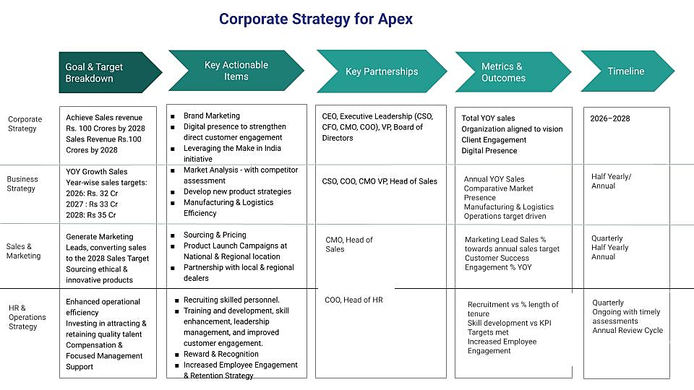

2.6 Employee Engagement Context and Relevance

What is employee engagement?
Employee engagement refers to the emotional commitment, involvement, and enthusiasm level in an employee. If employees are not emotionally present, even after being present physically they are not invested in their roles. They demonstrate high level of energy, dedication, and focus while performing their tasks.

Commonly employee engagement is understood through the Utrecht work engagement scale, which defines engagement across three key dimensions.

- Vigor: Resilience, willingness, and energy to invest effort in work.
- Dedication: Pride and enthusiasm in one’s job.
- Absorption: Full concentration and taking initiative at work.

Impact of Employee Engagement on Performance

- Employee engagement has direct and noticeable impact on employee as well as organisational performance. Employees who are highly engaged seen performing better as their motivation is high.
- Employees who have higher engagement level, demonstrate higher productivity as such employees are more willing to put extra effort, and maintain consistency while working.
- Such employees are more likely to produce better quality output, as they willingly are more attentive, focused and responsible.
- Higher engagement leads to better innovation and creativity, as motivated employees foster new and better ideas.
- On the other hand, low engagement can result, increase in errors and mistakes, increase in absenteeism, reduced efficiency, and overall performance decline. Disengaged employees often lack motivation; it affects both individual and team performance.

Relevance of Employee Engagement in the Case

Employee engagement in the given case of apex writing instruments Pvt. Ltd. is the key focus, since the organisation is experiencing challenges related to declining employee involvement and overall performance. The dataset provided shows employee responses to engagement-related questions, making engagement the main variable of analysis.

As the company is aiming for expansion and growth, employees are facing increased pressure, stress and workload. This has impacted the engagement levels negatively, which can be seen in the decreasing score across the dataset. Declining engagement is interlinked with issues such as reduced energy levels, lack of motivation, and decreased focus among employees.

By analysing employee engagement, the study aims to identify the underlying reasons behind declining performance and productivity challenges. It provides a structured way to understand and identify the problem areas or the affected factors and supports the development of targeted solutions to improve employee wellbeing and over all organisational performance.

Thus, employee engagement serves as a relevant indicator in this case, it helps by linking employee satisfaction with overall organisational outcomes.

2.7 Business Environment Analysis

SECTION 03
Methodology
Research design, measurement tools, data collection approach and analytical framework

This section covers:
3.1  Research Design |  | 3.2  Data Collection and Structure |  | 3.3  Analytical Framework and Variables Studied |  |  | 3.4  Data Analysis Techniques
3.5  Interpretation of Results |  | 3.6  Limitation of Study

3.1 Research Design
The study adopted a descriptive and analytical research design to analyse the declining employee engagement levels at Apex Writing Instruments Pvt. Ltd. It aims to study the engagement levels, trends and patterns while also examining the relationships to identify causes. The objective was to identify key factors affecting employee morale productivity and overall engagement. The descriptive aspect is used to analyse similar patterns and changing trends in engagement over time. While the analytical approach is to understand relationship between different variables used such as workload, recognition and satisfaction. Its purpose is to understand, different factors which are impacting employee engagement, productivity and employee morale.
3.2 Data collection and Structure
The data provided for the study is secondary data, data was collected through a structured questionnaire which was designed to analyse engagement levels over a period of five years (2019-2023). The data was obtained as a part of case study for the academic purposes.

The employee responses were recorded on a 7 points Likert Scale ranging from (1) Strongly Disagree to (7) Strongly Agree. This allowed us to measure employee perceptions on factors such as workload, recognition, work-life balance, etc. Rows represent an employee’s response, while columns represent multiple variables related to engagement.

Scale: 1–7 Likert (1 = Never / Strongly Disagree → 7 = Always / Strongly Agree)

3.3 Analytical Framework
As we know, The Utrecht work engagement scale is commonly and widely used rating scale, validated self-report questionnaire design, to measure employee engagement at different levels across three dimensions: Vigor, Dedication, and Absorption.

UTRECHT WORK ENGAGEMENT SCALE

DIMENSION | QUESTIONS
VIGOR | - When I get up in the morning, I feel like going to work.
 | - I can continue working for very long periods at a time.
 | - At my job, I feel strong and vigorous.
DEDICATION | - To me, my job is challenging.
 | - I am proud of the work that I do.
ABSORPTION | - When I am working, I forget everything else around me.
 | - Time flies when I am working.
 | - I feel happy when I am working intensely.

Variables Studied
- Overall Employee engagement – across years, department-wise, city-wise and gender-wise distribution of engagement.
- Recognition
- Workload
- Satisfaction

3.4 Data Analysis Technique
Data analysed using Microsoft excel, and power BI, analytical techniques used are as following: -

- Descriptive analysis: Used to calculate average of engagement.

- Comparative analysis: To understand changes in engagement in the period of 5 years.

- Percentage analysis: To compare engagement across different factors like, designation, city, gender.

- Trend analysis: To analyse pattern in distribution.

- Dimension analysis: responses were analysed in three categories Vigor, dedication, and absorption, with this for each dimension average scores were calculated.

Visual Tools
Visualizations like bar charts, pie charts, line charts, cards, and dashboards were used to highlight key insights.

3.5 Interpretation of Results

The conclusions derived from analysing data, were interpretated by understanding employee responses involving common patterns, variations over the period of 5 years. The observation focused on analysing changes in engagement level from the year 2019 to 2023, across different variables and categories.

Responses for questionnaire were observed in consideration with the Utrecht work scale framework, which classifies the questions into three categories Vigor, dedication, and absorption. Based on this method, the responses were classified and evaluated to analyse which dimensions of engagement were highly impacted.

Year wise we compared to identify trends in the engagement level of employees, while category wise collation helped in interpretating differences across employee groups. The analysis was done by linking out quantitative results, like average scores, distribution patterns, with their practical meaning, in context with employee behaviour, motivation, taking initiative, and engagement at work.
Conclusively, the analysis mechanism aimed to convert numerical data into understandable insights that could help and support in further interpretation and decision-making.

3.6 Limitation of the Study
The current study has its own limitations, that must be considered while analysing the results.

At first, the entire study and its interpretation is based on the data provided for the project. As the data was not taken independently, there are limitations over sample size, and variables included in the study.

Secondly, since the study completely relies on the questionnaire responses. Such responses are not accurate, mostly influenced by perception, bias, or individual employee circumstances. This analysis does not include external factors, such as economic environment, political environment, legal factors as well as company policies. Also, findings mentioned in this report may involve subjective bias.

Add to that, the study is subjected to data collected over specific period, (2019 - 2023). This study does not take in consideration the real- time changes or any current developments apart from this period, while the trends have been analysed.

SECTION 04
Findings
Analysis of UWES scores, engagement drivers, department comparisons and operational impact

4.1 Organisational Profile
Before studying engagement scores, it is important to understand the structural composition of the workforce at Apex Writing Instruments Pvt Ltd. This section analyses the 311 employees who participated in the annual engagement survey across five years (2019-2023).

It covers the distribution by employees by city, designation, gender, experience band, and income group. This knowledge of the organisational structure and profile lays the foundation for interpreting the findings presented in Sections x and y.
4.1.1 Total Headcount
The study covers a total of 311 employees across four office locations in India. Each employee was surveyed annually over the 5-year period, resulting in 1557 survey responses in total.

Metric | Count
Total employees surveyed | 311
Total survey responses (5years) | 1,557
Study Period | 2019-2023
Office locations covered | 4
4.1.2 City-wise Employee Distribution
Employees are distributed across 4 cities – Delhi, Mumbai, Pune and Hyderabad. The following table shows the headcount at each location:
City | Employees | % of total | 5-year Mean Engagement Score
Delhi | 152 | 48.9% | 2.46
Mumbai | 103 | 33.1% | 2.33
Pune | 36 | 11.6% | 2.56
Hyderabad | 20 | 6.4% | 2.40
Total | 311 | 100% | 2.44

- Delhi is the dominant office, housing nearly half of the employees. As the largest location, its engagement pattern affects company-wide averages. Any intervention strategy to improve engagement must prioritise Delhi.
- Pune, despite being a comparatively small office, has the highest engagement score (2.56). This serves as a benchmark for examining what conditions support relatively better engagement.
- Mumbai records the lowest average engagement score across the four offices. This trend is discussed in detail in section 4.1.3.
4.1.3 Designation – wise Employee Distribution
The company staffs employees across four levels- Associates, Team Leaders, Managers and Senior Managers. The table below shows the count of employees in each level and their five-year average engagement scores along with their corresponding experience and income bands.

Designation | Count | % of Total | Experience Band | Income Band | Mean Engagement
Associate | 78 | 25.1% | 0 to 5 years | ₹0-20 K | 2.45
Team Leader | 44 | 14.1% | 6 to 10 years | ₹21-40K | 2.66
Manager | 109 | 35.1% | 11 to 15 years | ₹41-60K | 2.40
Senior Manager | 80 | 25.7% | 16+ years | ₹61K+ | 2.31
Total | 311 | 100% |  |  | 2.44

The organisation has a top-heavy structure, with managers and senior managers being the largest groups, constituting 35.1% and 25.7% of the workforce respectively. This reveals that the organisation suffers from a structural imbalance. There are too many people managing and too few people executing the work.

A cross-tabulation of designation against city reveals a significant structural anomaly in the workforce composition that has a direct impact on engagement and operational efficiency.

City | Associate | Team Leader | Manager | Sr Manager | Total
Delhi | 39 | 33 | 58 | 22 | 152
Mumbai | 30 | 0 | 20 | 53 | 103
Pune | 4 | 8 | 20 | 4 | 36
Hyderabad | 5 | 3 | 11 | 1 | 20
Total | 78 | 44 | 109 | 80 | 311

- Mumbai has the most imbalanced workforce structure with 53 Senior Managers, 20 Managers, 30 Associates and no Team Leaders. There is a missing middle execution layer. Without a complete and efficient chain of reporting, the organisation faces serious retention and performance issues.
- Delhi also has a bloated middle management layer with 58 managers, which highlights poor role clarity.
- Pune, with only 4 Associates, has almost no execution workforce.
- Hyderabad also has a management-heavy structure, but less extreme than other locations.
4.1.4 Gender Distribution

The following tables present the gender composition of the workforce, broken down by city and designation. This dimension reveals structural concerns that have direct implications on engagement and organisational health.

City | Male | Female | Total | % female
Delhi | 142 | 10 | 152 | 6.6%
Mumbai | 99 | 4 | 103 | 3.9%
Hyderabad | 20 | 0 | 20 | 0.0%
Pune | 36 | 0 | 36 | 0.0%
Total | 297 | 14 | 311 | 4.5%

Designation | Male | Female | Total | % female
Associate | 78 | 0 | 78 | 0.0%
Team Leader | 44 | 0 | 44 | 0.0%
Manager | 109 | 0 | 109 | 0.0%
Senior Manager | 66 | 14 | 80 | 17.5%
Total | 297 | 14 | 311 | 4.5%

Female employees constitute only 4.5% of the total workforce (14 out of 311 employees). All 14 of these females are Senior Managers, meaning there is zero female representation at the Associate, Team leader and Manager levels. This fact highlights an absence of a female talent pipeline at junior and mid-levels. This poses a long-term risk to diversity and inclusion at Apex.

4.1.5 Income Group Distribution
It is noted that income group maps directly and exclusively to designation in this dataset. Every Associate earns ₹0–20K, every Team Leader earns ₹21–40K, every Manager earns ₹41–60K, and every Senior Manager earns ₹61K or above.
Income band | Designation | Employees | 5-yr avg engagement
₹0–20K | Associate | 78 | 2.45
₹21–40K | Team Leader | 44 | 2.66
₹41–60K | Manager | 109 | 2.40
₹61K+ | Senior Manager | 80 | 2.31

The data reveals that higher income does not correlate with higher engagement at Apex. The highest earning group (Senior Managers, ₹61K) records the lowest five-year average engagement (2.31), while the second lowest earning group (Team leaders, ₹21-40K) records the highest engagement (2.66). This compensation paradox highlights that the drivers of engagement at Apex are not primarily financial. Factors such as role clarity, recognition, autonomy and career progression appear to be more influential determinants.

4.1.6 Experience Band Distribution
Experience band | Designation | Employees | % of total | 5-yr avg score | 2023 avg score
0 to 5 years | Associate | 78 | 25.1% | 2.45 | 2.11
6 to 10 years | Team Leader | 44 | 14.1% | 2.66 | 2.14
11 to 15 years | Manager | 109 | 35.1% | 2.40 | 2.00
16+ years | Senior Manager | 80 | 25.7% | 2.31 | 1.85

- Employees who have invested 16+ years with Apex record the lowest five-year average engagement (2.31) and the lowest 2023 score (1.85) of any experience group. In a healthy organisation, employees with long work tenure typically serve as engagement anchors. When the most experienced group is also the least engaged, it signals that the organisation has not clearly awarded loyalty, provided career meaning or created a sense of continuing challenge for experienced employees.

- This data also highlights an important risk – the 6-10 years’ experience group, consisting of the Associates, is the smallest yet the most engaged group. If the organisation does not actively retain them as team leaders, this pipeline will shrink further. A declining team leader group removes the organisation’s most engaged layer and damages the chain of reporting between frontline workers and managers.
4.2 OVERALL ENGAGEMENT TREND (2019-2023)
4.2.1 Five- Year Engagement Index
The following table presents the mean engagement across the 8 dimensions for all five years of the study. Scores are derived from the responses of all 311 employees. The overall engagement index (mean of all eight-dimension scores) is included in the Total column.

Year | D1 | D2 | D3 | D4 | D5 | D6 | D7 | D8 | Total Mean Engagement | YoY % Change in Mean Enagagement
2019 | 2.80 | 3.06 | 3.21 | 3.16 | 3.23 | 2.90 | 3.23 | 2.90 | 3.06 | ---
2020 | 2.46 | 2.56 | 2.51 | 2.24 | 2.62 | 2.41 | 2.62 | 2.41 | 2.48 | ⬇️ 19.06%
2021 | 1.97 | 1.96 | 1.93 | 1.79 | 1.77 | 1.97 | 1.77 | 1.97 | 1.89 | ⬇️ 23.67%
2022 | 2.70 | 2.59 | 2.65 | 2.62 | 2.77 | 2.68 | 2.77 | 2.68 | 2.68 | ⬆️ 41.69%
2023 | 2.45 | 2.48 | 2.50 | 2.13 | 1.62 | 1.65 | 1.62 | 1.65 | 2.01 | ⬇️ 24.99 %

- It is noticeable that even in 2019, before the COVID-induced problems or the implementation of the ambitious sales targets, the overall engagement score was below the neutral score of 4. The highest overall engagement scores ever recorded was 3.23 on D5 and D7 in 2019. This indicates that the employees were disengaged even before COVID hit. These point towards structural issues in the organisation.
- We see a decline of 0.58 points or 19.06% in the overall engagement index in 2020 as compared to 2019.
- 2021 is the company-wise engagement crisis year, where every dimension fell below 2.0. This is the year when the COVID pandemic hit, and the company was also aggressively pushing towards the target of Rs 100 crore in sales. Two major stressors are acting upon the organisation at the same time.
- In 2022, the overall engagement index rose from 1.89 to 2.68, an improvement of 0.79 points (41.69%). This indicates a slight recovery, but most employees are still in the “Disagree” zone. We have a relief from the crisis, but no actual improvement in engagement levels.
- In 2023, there is a major crash in D5(Pride in work) and D6-D8(Absorption), with these dimensions falling to an all-time low of 1.62-1.65. This implies that the employees are not proud of what they do and are mentally detached while working. This explains why the organisation is facing a dip in design quality and an increase in production errors.

4.2.2 The Shape of the Graph
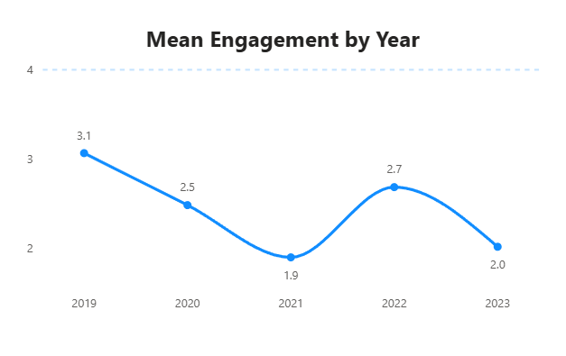
- The overall trendline of the mean engagement scores across the five years (2019-2023) can be described as a ‘double- valley pattern’ or a ‘W- shaped graph’. It is not a simple linear decline. The first valley can be attributed to the pandemic-related problems, but the second valley is the main cause of concern as it is harder to attribute to external circumstances alone. It points to systemic problems.
- IMPORTANT: The net change in the overall engagement from 2019 to 2023 is -1.06 points or 34.31% which represents a one-third decline from the already low baseline.
4.2.3 Average Engagement Index by Gender

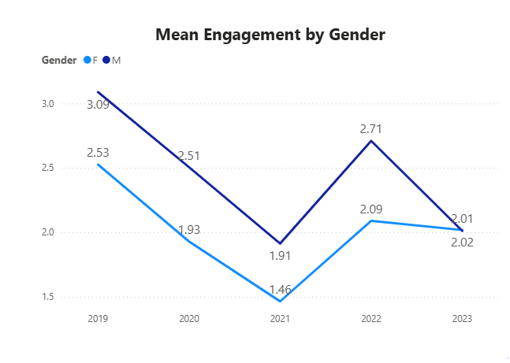

- This data indicates a consistent decline in the overall engagement from 2019 to 2023 for both male and female employees.
- The male employees have maintained slightly higher engagement levels than female employees throughout the timeline.
- The % decline in female overall engagement from 2019 to 2013 is 20.1%, while there is a sharper decline in male overall engagement of 34.9% over the same period.
- This suggests that female employees may have had comparatively lower baseline engagement, but the male employees have experienced a stronger deterioration in engagement over time.
4.2.4 Average Engagement Index by City
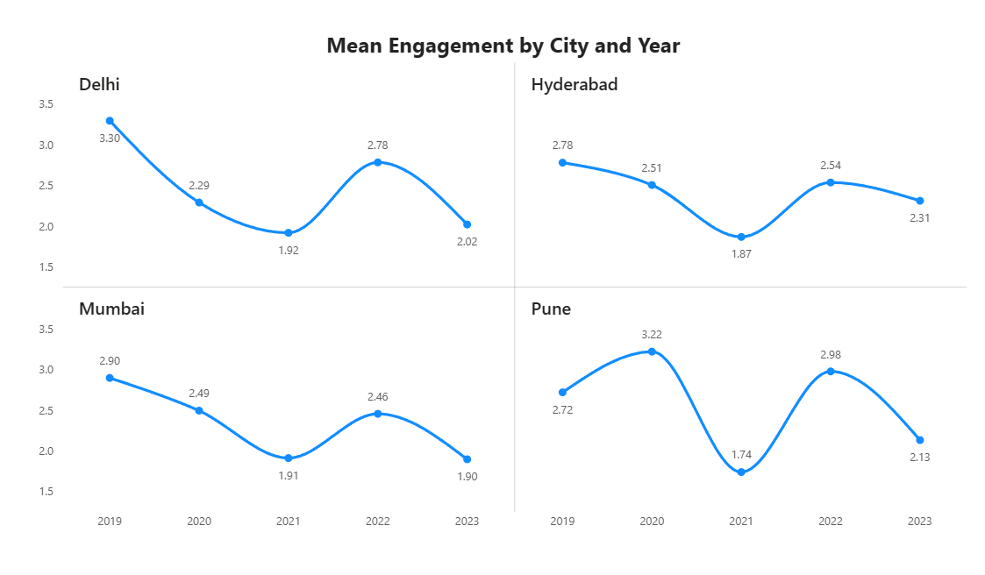

City | 2019 | 2020 | 2021 | 2022 | 2023 | Mean Engagement | % Change (2019-2023)
Delhi | 3.30 | 2.29 | 1.92 | 2.78 | 2.02 | 2.46 | -38.7%
Hyderabad | 2.78 | 2.51 | 1.87 | 2.54 | 2.31 | 2.40 | -16.9%
Mumbai | 2.90 | 2.49 | 1.91 | 2.46 | 1.90 | 2.33 | -34.5%
Pune | 2.72 | 3.22 | 1.74 | 2.98 | 2.13 | 2.56 | -21.6%

- Delhi has experienced a decline in engagement levels from 2019-2023 (38.7%), followed by Mumbai (34.5%), Pune (21 %) and Hyderabad (16.9%).
- Hyderabad demonstrates a relatively stable engagement level as compared to other cities, indicating the presence of effective work practices or a better work environment.
- All cities exhibit a common pattern of decline from 2019 to 2021, a slight recovery in 2022, and another drop in 2023. This suggests that external and organisational factors affected all locations, but the intensity varied.

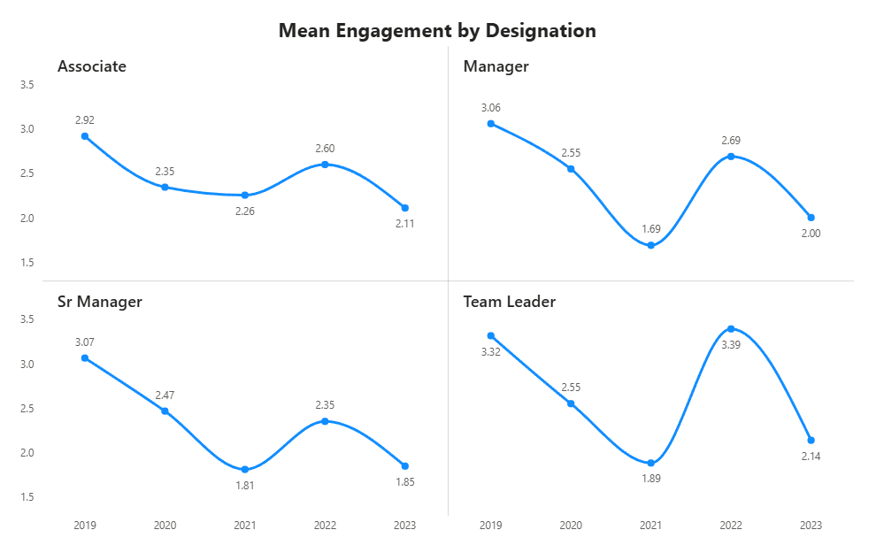
4.2.5 Average Engagement Index by Designation

Designation | 2019 | 2020 | 2021 | 2022 | 2023 | Mean Engagement | % Change in Mean engagement (2019-2023)
Associate | 2.92 | 2.35 | 2.26 | 2.60 | 2.11 | 2.45 | -27.7%
Manager | 3.06 | 2.55 | 1.69 | 2.69 | 2.00 | 2.40 | -34.5%
Senior Manager | 3.07 | 2.47 | 1.81 | 2.35 | 1.85 | 2.31 | -39.6%
Team Leader | 3.32 | 2.55 | 1.89 | 3.39 | 2.14 | 2.66 | -35.4%

- Engagement levels across all designations show a declining trend from 2019 to 2023. The largest drop is observed among Senior Managers (39. %), followed by Team Leaders (35.4%), Managers (35.4%), and Associates (27.7%). This trend suggests growing disengagement at the leadership level. Since leadership plays a crucial role in productivity and team morale, this trend is particularly concerning.
- The relatively smaller decline in overall engagement among Associates suggests that junior employees are more stable, but they are still affected by the broader organisational trend.
- Managers and Senior Managers have a steady decline in their engagement since 2020 with the lowest recorded score in 2023- 2.00 and 1.85, respectively.

Section 4.3 - Dimensional Analysis
This section analyses each of the eight engagement dimensions, along with yearly trend analysis and distribution of responses. The dimensions are examined in correspondence to the three sub-constructs – Vigor, Dedication and Absorption.

Vigor | 1. When I get up in the morning, I feel like going to work | Physical Motivation
 | 2. I can continue working for very long periods at a time. | Stamina and resilience
 | 3. At my job I feel strong and vigorous. | Physical and Mental Energy
Absorption | 4. To me, my job is challenging. | Challenging job
 | 5. I am proud on the work that I do. | Pride and ownership
Dedication | 6. When I am working, I forget everything else around me. | Deep concentration
 | 7. Time ﬂies when I am working. | Immersion in work
 | 8. I feel happy when I am working intensely. | Positivity derived from focused work
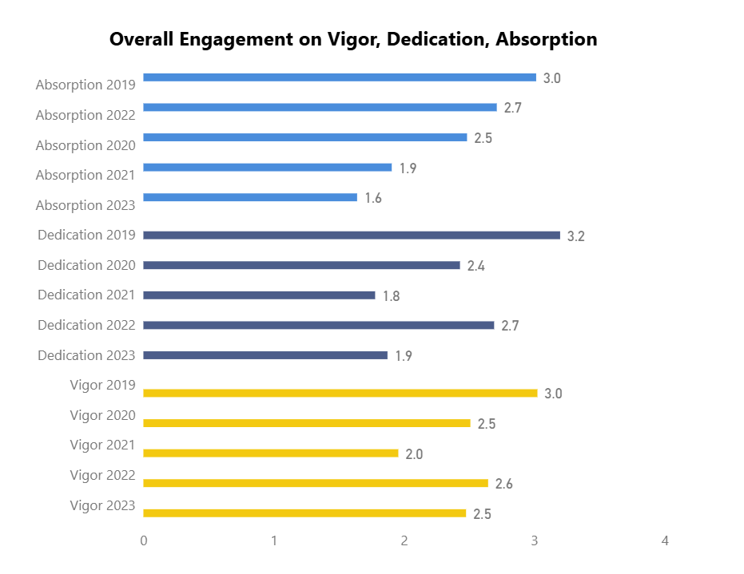
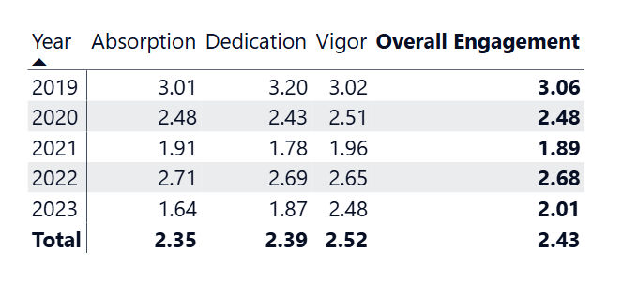
4.3.1 Vigor (D1, D2 and D3)

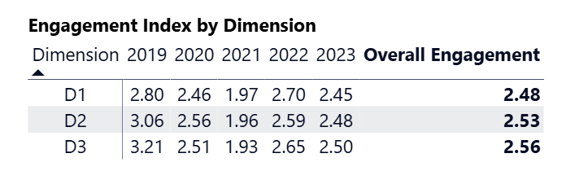
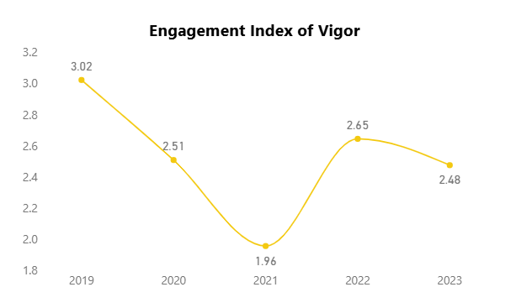
Vigor measures the physical and mental energy, resilience and readiness to put effort in work. It includes morning motivation(D1), stamina & resilience(D2), and physical & mental energy(D3).

- D3 (Physical and Mental energy) was the strongest dimension in 2019, scoring 3.21 with 29% employees giving a rating of 5 or higher. By 2023, this group had disappeared with D3 dropping down to 2.50 and the responses getting distributed between the ratings 1,2 and 3.
- D1(Morning Motivation) has 81% percent of employees in rating 2(Disagree) which is the most concentrated response on any Vigor dimension, suggesting that the employees have settled in a low energy state. Vigor affects all other dimensions. Without energy and willingness to show up, no amount or role design or recognition will restore the falling disengagement.
4.3.2 Dedication (D4, D5)

Dedication measures the employee's sense of meaning, challenge, inspiration and pride associated with work. It represents the value that the employees see in what they do and how good they feel about their work and achievements. Dedication has a direct link to employees' creativity and intellectual contribution.
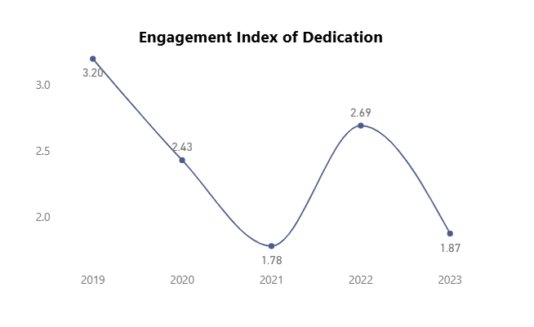

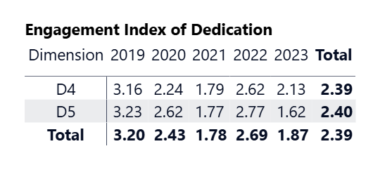
- D5(Pride in Work) is the most significant dimension in the dataset. In 2019, 34% of the employees have given a rating between 5-7 on D5 which is the highest positive cohort observed on any of the eight dimensions throughout the entire study period.
- By 2023, the percentage of employees agreeing on D5 decreased to only 5% and 78% gave rating 1(Strongly Disagree).
- In 2022, only 1% gave rating 1 (Strongly Disagree) implying that for a brief period the company returned to circumstances that allowed the employees to take pride in their work. The relapse in 2023 shows that nothing permanent or structural had been done to restore dedication.
- On D4(Challenging Job), the highest concentration of response happens with 83% of the employees choosing 2(Disagree) in 2023.This highlights the fact that despite the company entering a highly ambitious period, the employees have more work, but they find it less meaningful. The boundary between challenge and overload has been blurred, which explains the declining creativity of the design department.
4.3.3 Absorption (D6, D7, D8)

Absorption reflects the level of involvement employees experience while working. To achieve greater absorption, employees should be highly focused, concentrated and efficient. This atmosphere is lacking at Apex.
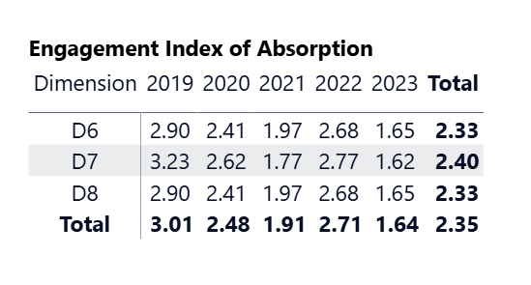
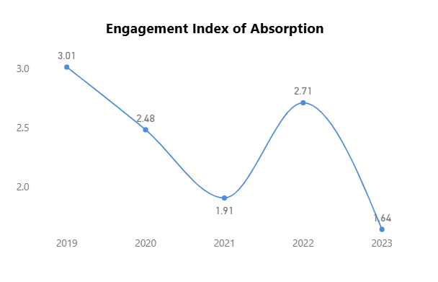

- On dimensions D6(Deep Concentration) and D8(Positivity derived from focused work), 12 % of the employees chose rating 5(Slightly Agree) despite 78% of the employees choosing rating 1(Strongly Disagree). This indicates that the employees are divided into two groups during the same conditions - one that is highly absorbed and the other that is not.
- Employees working in higher flow states produce products with fewer defects, fewer quality complaints and better designs. Low levels of absorption in D6.D7(Immersion in work) and D8(Positivity derived from focused work) explain why Apex is facing a higher number of production defects, quality complaints and design problems.
Section- 4.4 YoY Engagement trend on all Dimensions
4.4.1 2019 – The Baseline Year

The study begins with an average engagement score of 3.06 in 2019, which, despite being below the neutral midpoint (4), represents the strongest period of engagement in the entire survey. D5(Pride in Work) and D7(Immersion in Work) scored best with 3.23, and 34% of the employees in the positively engaged category.

This baseline score indicates that even before the disruptions related to the pandemic struck, the organisation was not in a state of strong engagement. Employees were not actively unhappy, but they were not motivated or connected either.

The company followed a robust and actionable growth strategy, which includes:
1. Revenue target of ₹100 crores in the coming 2 years
2. Extensive market analysis
3. Expanding organisational structure – recruit new personnel
4. Improve operational efficiency

But this growth strategy slowly eroded organisational framework by creating a quiet friction beneath the surface and led to further deterioration in engagement scores.
4.4.2 2020 – The First Decline

In 2020, the overall engagement score dropped from 3.06 to 2.48, which is sharp drop of nearly 0.58 points from the previous year. This decrease affected all dimensions with D4(Challenging Job) suffering the greatest decline down to 2.24, indicating confusion and load as opposed to challenge.

This decline in overall engagement score is owing to the global pandemic of COVID-19 which disrupted global and Indian operations simultaneously. For a mid-sized manufacturing company like Apex Instruments, the consequences were immediate and multifaceted:

- Uncertainty in raw material availability
- Disruption in supply chains
- Adoption of new ways of working
- Quick implementation of new technologies
- Stressed workforce
The disengagement was largely external in origin. The decline reflects fear, uncertainty and disruption. Employees were surviving the pandemic alongside the company. This context highlights the main cause of decline of overall employee engagement in 2020.
4.4.3 2021 – The Crisis Point
2021 is the most alarming year in the dataset. The overall engagement score collapsed to 1.89 which is the lowest point across the five years. 2021 reflects a drop of 0.59 in the overall score as compared to 2020. This year was characterized by decline in all eight dimensions, with all of them below 2.0.

Specifically, the Dedication sub-construct consisting of D5(Pride in Work) and D7(Immersion in Work) scored 1.77 with 67% employees selecting “Strongly Disagree”. Managers performed the poorest of all in the five years surveyed with overall score of 1.69. This low score is not just a statistical dip. It reflects that the workforce was actively disagreeing on the dimensions they were questioned on in the engagement survey. Employees were not indifferent, but they were signalling a deep dissatisfaction.

By 2021, the temporary disruptions owing to the pandemic began to consolidate into structural problems:

- The ambition growth plans had not slowed down. In fact, the management was pushing harder than ever to recover lost ground. The middle management, which was already managing daily operations, was simultaneously being asked to adopt new technologies, oversee new hirings, manage new projects and implement strategic initiatives.
- With the pressure to deliver higher productivity and implement new technologies quickly, the employees were working late nights and weekends. This overburdening of workforce led to many employees feeling disconnected and demotivated.
- The high-stress environment led to increased absenteeism and a noticeable drop in overall morale.
- The lack of engagement began to take a toll on performance and productivity
- Errors in production became more frequent, and the quality of the final products started to suffer
- Customer complaints about defects and delayed shipments increased, which impacted the company’s reputation and customer satisfaction levels.
2021 reveals that the problem was not just the pandemic, but the organisation’s response to it. The pressure to deliver results without adequate support and recognition pushed engagement into the crisis zone.
4.4.4 2022 – A Slight Recovery
2022 shows a rebound to 2.68, an improvement in the overall engagement score. There is a rise of 0.79 points in the score as compared to the previous year. All eight dimensions showed improvement, but the decline of rating 1 among the answers was especially noteworthy. D5 declined from 67% rating 1 in 2021 to just 1% in 2022. It should be noted that these improvements did not lead the employees to become engaged (ratings 5-7). Rather, it appears as though employees who were at 1 in 2021 moved to rating 2 in 2022. This recovery is meaningful and suggests that the corrective measures taken by

Apex Instruments Ltd. as a response to the pandemic were successful.
However, an overall engagement score of 2.68 is still comfortably below neutral, as well as the baseline year. The recovery happened, but partially. The underlying drivers of disengagement had not been fundamentally resolved. The 2022 numbers represent a workforce that is less miserable than before but not genuinely engaged.

4.4.5 2023 – The Relapse
This year appears to be the most concerning among the others. After the recovery of 2022, scores again fell to just 2.01, nearly as low as 2021. Vigor remained fairly high (2.48) but Dedication (1.87) and Absorption (1.64) reached their all-time low scores. This second decline is more troubling than the first, because it happened without a pandemic-scale external event to justify it. This shows that the interventions that led to the 2022 recovery were just surface-level improvements. The real problem lies in the deeper structural problems within the organisation. The organisation did not fix the problems, it just managed a crisis, stabilized briefly and the deeper dissatisfaction among the employees was left unaddressed.

Following the analysis of employee engagement data, the study aims to uncover the primary causes affecting employee engagement. It becomes important to identify the reasons behind the trends. Though The findings discuss the decline in engagement levels over the period of five years, they do not fully explain why these changes are occurring. Therefore, root cause analysis is important to conduct, to understand and identify the factors affecting employee productivity and reducing overall productivity.
Root cause analysis is a structured approach used to highlight the fundamental problems that lead to such issues, instead of focusing on only its symptoms. In context of this study, we understand the main reasons behind the declining energy levels, reduced motivation, and lower involvement among employees.
The observation consists of both patterns observed in the dataset and the case study. Identifying the root problem enables us with more effective and efficient solutions for improving employee engagement and overall organisational performance.

4.5 Root Cause Analysis
This study uses a fishbone diagram for root cause analysis which is a common practice in the manufacturing sector. Multiple causes for declining employee engagement have been discussed.



Workload & Operations
Motivation & Pride
Culture & Environment
Leadership
Organisational Structure
Low Employee Engagement
Top-Heavy Hierarchy
Missing Team Leaders
Lack of Associates
Weak Support
Poor Role Clarity
Leadership engagement dropped above 3.0 (2019) to below 2.0(2023)

Low inclusion with 4.5 % female workforce
Crisis driven culture
Mental detachment & lack of pride increased in 2023
Poor recognition
Career stagnation
Role Overload
Aggressive Target
Uneven Workload
Low Manager Engagement

Weak belonging

- Organisational Structure

- Top-heavy hierarchy – 1. Decision-making is concentrated at top-level
2. Slows down communication
3. Employees feel less empowered

- Missing team leaders- 1. Lack of immediate guidance for associates.
2. No support for employees in operational task
3. Reduces coordination and accountability.

- Lack of associates- 1. Impacts efficiency.
2. Overburden on existing employees.
3. At operational level staff is insufficient.
B. Leadership

- Low manager engagement- 1. Managers themselves are not engaged
2. Poor direction and team motivation
3. Weak employee manager relationships

- Poor role clarity- 1. no clarity in responsibility
2. Leads to confusion.
3. Increase in stress and frustration

- Weak support- 1. Lack of guidance from top-level.
2. Employees feel neglected
3. Decline in performance

- Low inclusion (4.5% female workforce)- 1. limited diversity
2. Employees feel excluded
3. Affects workplace environment

Culture and Environment

- Crisis driven culture- 1. Focus only on short- term problem- solving
2. Continuous pressure environment
3. Ignorant towards employee well-being

- Weak belonging- 1. Lack of feeling of belongingness to company
2. Low emotional attachment
3. Reduces commitment

- Drop in Leadership engagement (3.0 < 2.0)- 1. Significant leadership fall
2. Employees lose trust in management
3. Impacts overall organisational ethics.

D. Workload & Operations

- Uneven workload- 1. Unequal distribution of work
2. Overloaded employees
3. Dissatisfaction and burnouts created

- Aggressive targets- 1. Expectations are unrealistic
2. increase in pressure and stress
3. job satisfaction reduced

- Role overload- 1. Employees over worked
2. Leads to fatigue and efficiency decline
3. work quality is affected
E. Motivation & Pride
- Poor recognition- 1. Efforts are unrecognized
2. Motivation declined.

- Mental detachment & lack of pride- 1. Employees are unable to connect
2. Work feels uninspiring
3. Significant drop in engagement

- Career stagnation- 1. Growth opportunities reduce
2. Employees are feeling stuck
3. Reduction in long- term goals

The root cause analysis highlights that drop in engagement cannot be reduced to single factor but a combination of organisational, cultural, operational and management issues. All factors combined contributes to declining motivation, and lower overall engagement levels.

SECTION 05
Recommendations
A phased strategic roadmap to restore engagement and support Apex's ₹1,00,000 crore ambition

Four-Phase Implementation Roadmap
PHASE 1  Immediate Response  0–3 Months  Acknowledge · Audit · Clarify · Listen |  | PHASE 2  Short-Term Actions  3–9 Months  Recognise · Communicate · KPIs |  | PHASE 3  Medium-Term Actions  9–18 Months  Develop · Grow · Diversify |  | PHASE 4  Long-Term Actions  18+ Months  Structure · Succeed · Sustain

Our goal is not just to improve the numbers on a survey but also to build a workplace where employees feel belonged and appreciated. Rebuilding engagement with these recommendations will ensure that our employees want to happily contribute to Apex’s ₹1,00,000 crore big audacious projection. As much as we want to achieve these numbers, we also want our employees to see and believe in their own growth along with the organisational growth.

1. Immediate Response (0–3 Months)

1.1 Conduct team huddles – Department wise

The biggest mistake any organisation makes when engagement scores come back poor is conducting a town hall where leadership comes and talks about the problems, business impact shares decided strategies and moves on. When employees have already felt unseen and unappreciated another event where managers will only talk and not listen can only make things work worse. This is why our first recommendation in the immediate response section is something different. We recommend conducting small huddles online and offline inviting all the employees and acknowledging the problem openly.

This will make sure that the employees know that the leaders have heard them via the surveys, that the message has reached the right people. The leadership will need to act and speak without defensiveness they will need to understand that poor engagement is something that can be fixed rather than punished. The leadership in this meeting will need to sound like someone who cares about the growth of the employees, their work life balance and if they feel an overall job satisfaction.

Our recommendation is that Mr. Rajesh together with the Vice President of Operations and Vice President of Design should address each department head and their teams in groups of 20-30 people.
The idea of this communication is not to blame the employees or promise the impossible. The idea is to invite employees to speak and share their ideas without any deflection.

1.2 Deploying Pulse Surveys Without Delay

The UWES study provided a baseline. What it has not provided is department-specific, real-time intelligence on which issues are most urgent- and where. Before any intervention is designed, that data is needed. So, a short pulse survey with 8-10 questions will be shared across all teams, Delhi and Mumbai being the first ones to complete this on priority. These surveys will be anonymous.

Once the survey results are back, they will be shared with all so that the employees know that this process was not just a formality. They will also know that their feedback is heard because it matters. That signal alone begins to shift the engagement needle before a single structural change has been made.

From this point forward, monthly pulse surveys should become a fixed part of HR's operating rhythm. The purpose is not to generate data for its own sake — it is to build a habit of listening and to catch emerging problems before they compound into the kind of crisis that is now being addressed.

1.3 Conducting an Urgent Workload Audit

The problem statement from the engagement study identified excessive workload and extended working hours as the most prominent reason of disengagement — and this is fully consistent with the broader pattern seen across Indian manufacturing during periods of rapid organisational scaling. Our report also shows that middle managers and ops team members absorb more work without any formal acknowledgement or delegation.

HR and every department heads should jointly conduct a workload audit across departments, and middle management within the first month. This audit will compare current responsibilities vs role descriptions and identify individuals who are effectively covering for unfilled vacancies without any formal intimation. These findings will empower us to act on immediately.

Managers who have been silently absorbing the work of two or three roles need to hear clearly that this is seen and that a plan is being put in place to address it. This will make a lot of difference in how engaged managers are.

1.4 Role Clarity for Every Manager

People not knowing clearly what they are responsible for, who they report to, or how their work connects to what the organisation is trying to achieve are bound to feel lost.

In the first month itself every manager should participate in a Role Clarity exercise which will be facilitated by HR. After this exercise every manager will walk away with absolute clarity with a written and mutually agreed and signed Role Clarity Charter - a document mentioning their primary responsibilities, decision rights, and the two or three outcomes they are personally accountable for in the next quarter. This will give them a stable foundation and reason to trust the process.

For junior staff, their immediate supervisors will give them clarity. Brief individual check-ins that reconfirm expectations and acknowledge any concerns should be conducted within the first month.

2. Short-Term Actions (3–9 Months)

Once the immediate stabilisation measures are in place and employees can see that their concerns have been heard and acted on — however partially — the organisation moves into a phase of deliberate structural repair. The short-term window is where habits get set.

This is where most organisations quietly abandon any issues and move on to the next big project. But we will set new ways of people appreciation and recognition.

2.1 Building a Recognition Framework That Actually Lands

Recognition is consistently identified as one of the most cost-effective engagement forces available to any organisation, and yet it is the one that most companies get wrong. The most common error is equating recognition with financial reward — assuming that if the pay packet is competitive, people feel valued.

This misunderstands what recognition is. Financial compensation meets a baseline expectation. Recognition addresses something deeper: the human need to know that one's effort has been seen that it mattered, and that someone with authority noticed and said so.

Apex should design and launch a multi-tiered Recognition Framework within the first quarter of this phase. The framework should operate at 3 levels.

At the team level, managers should offer immediate, specific, verbal/email appreciation. A simple word of thanks goes a long way. A genuine 'well done' coming from the manager is worth far more than a performance certificate handed out six months later.

At the department level, a monthly R&R meeting where two or three best employees or teams are applauded in front of their peers should be held.

At the company level, a quarterly R&R should be conducted where standout work across departments is awarded/rewarded by senior leadership.

2.2 Strengthening Internal Communication Structures

In a scaling organisation like Apex — where new hires, restructured teams, and shifting reporting lines are being introduced simultaneously — communication gaps grow faster than they can be managed.
There will be 3 ways in which communication gaps will be fixed.

The first is a monthly town hall where leadership shares business updates, acknowledges challenges honestly, and invites questions. The format matters enormously here. There will be no stages, in fact leaders will sit and walk amongst employees to invite honest questions and concerns.

The second way is the Team Huddle, a weekly check-in for every team. Fifteen to twenty minutes, standing if necessary, covering: what we are working on today, what is blocking us, and anything from last time that needs follow-up. The research on frontline manufacturing engagement is consistent on this point: frequent, brief, regular touchpoints with an immediate manager are among the highest-impact engagement practices available.

The third way is an Employee Voice Form, an anonymous and safe mechanism voice survey where employees can raise ideas or flag concerns without necessarily going through their immediate manager.

2.3 Targeted Intervention in Delhi and Mumbai

The engagement study and the team's own recommendations are explicit: Delhi and Mumbai represent the most urgent intervention priorities. These locations appear to be carrying structural burdens — missing supervisory layers, unclear reporting chains, and workload concentrations — that require targeted action rather than company-wide generalisations.

For Mumbai: The absence of enough first-line supervisors has created a situation where associates lack daily direction and managers are forced to compensate by stepping into a supervisory role for which they were not designed for. The Mumbai HR team and Operations Head should identify 2-3 most capable and respected associates, put them through a training program for leadership (6 weeks max) and promote them no later than 6 months.

For Delhi, the challenges we identified were about unnecessary work load and communication gaps from leadership. Tasks should be reassigned with clear ownership with all employee groups. No one should perform any work that falls outside the scope of their role without getting a compensating adjustment, or a title change.

2.4 Introducing Engagement-Linked KPIs for Managers

One of the most direct signals an organisation can send about the seriousness of its engagement agenda is to include team engagement outcomes in the formal performance evaluation of every manager. If managers are evaluated purely on output targets - units produced, defect rates, turnaround times - the implicit organisational message is that how people feel is not the manager's concern. This is commercially short-sighted, because the evidence on this point is not ambiguous: team engagement and team performance are not in tension. They are correlated, and the manager's behaviour accounts for most of the variance in engagement within any given team.

From month four onward, engagement-linked KPIs should constitute approximately 20% of the annual performance rating for all Team Leaders and Managers. The input data should come directly from the monthly pulse surveys — specifically sub-scores on team Vigour, perceived communication quality, and Dedication — supplemented by team absenteeism rates and voluntary attrition figures. Senior Manager bonuses should include an explicit component tied to the engagement trajectory of their respective functions over the review period.

This will face pushback. Some managers will argue that they cannot be held accountable for how employees feel. The response — grounded in three decades of management research — is straightforward: a manager's daily behaviour is the single largest determinant of team engagement, accounting for up to 70% of the variance in engagement scores within a team. Holding managers accountable for this outcome is not unfair. It is accurate.

3: Medium-Term Actions (9–18 Months)

This phase will have stabilised a lot of employee engagement with regular recognition, structured communication, role clarity, and honest workload management. But this is also where the work deepens by building a strong leadership pipeline, career growth opportunities and ambitious and appreciative work culture.

3.1 Investing in Training and Leadership Development

Training combined with a visible and credible connection to career progression will improve employee engagement. Most trainings become irrelevant when they do not get desired outcomes for trainees – like a promotion or a skills certificate and project implementation. The lesson is that development only works as an engagement lever when it is part of a broader career architecture.

Apex should design and roll out a three-tier Training and Leadership Development Framework over this phase.

For Associates and Team Leaders, the training will cover functional skill enhancement with in-depth product knowledge, quality control and improvement techniques, higher productivity methods and team collaboration and communication skills. Practical one day trainings with in real workplace scenarios should be used.

For Managers and Senior Managers, the investment needs to be substantially deeper. This cohort is the most at risk of burnout and attrition, and it is also the cohort whose capability most directly shapes the engagement experience of every person who reports to them. A structured six-month leadership development programme — covering emotional intelligence, change management, cross-functional collaboration, managing in a scaling manufacturing environment, and handling the particular pressures of being caught between executive demands and frontline needs — should be delivered for all managers and senior managers by month twelve.

External facilitators can be used for portions of the programme, but the core of it should be internally anchored, drawing on the real challenges Apex is navigating, with peer learning and structured coaching embedded throughout.

Research on HR practices in Indian manufacturing finds that structured reskilling and development programmes positively correlate with employee performance (r = 0.63) and retention (r = 0.57), and that HR's strategic involvement in skill development explains up to 41% of the variance in perceived organisational performance. Development is not a cost to be managed down — it is a return-generating investment.

3.2 Establishing Clear Career Progression Pathways

One of the most consistent findings in engagement research is that employees — particularly those in the 25 to 35 age bracket that constitutes most of most manufacturing workforces — do not leave organisations because of pay alone. They leave because of lack of clarity in growth plans.

A career progression document should be shared for all job functions, detailing the growth path. Requirements, performance standards, timelines, and assessment roles should be specified clearly. This information must be provided during annual development conversations and made available on the intranet.

Individual Development Plans should be introduced as standard practice for all Managers and above and made available as a voluntary option for Associates and Team Leaders who express interest. An IDP

is not a complicated document — it is a simple, co-created agreement between an employee and their manager that maps out where the employee wants to go, what they need to develop to get there, and what concrete support the organisation will provide. When done with genuine intent rather than as a compliance exercise, an IDP transforms career development from a vague aspiration into a personal contract.

A soft launch of HI-PO trainings can also be done where high potential employees are identified and trained for bigger projects and growth.

3.3 Launching the Employee Happiness Programme

The medium-term phase is where Apex formalises its wellbeing approach through a structured Employee Happiness Programme (EHP). The naming is deliberate — 'happiness programme' is warmer and more inviting than 'Employee Assistance Programme', and in the Indian cultural context, where stigma around seeking mental health support remains significant, the language used to describe the programme affects whether people use it.

The EHP should operate through several strands. The first is access to confidential counselling — either through a part-time in-house counsellor at the larger offices or through a tie-up with an external EAP provider. The structural guarantee of anonymity is non-negotiable here. Employees in Indian manufacturing settings are frequently reluctant to access mental health support because they fear it will be visible to their manager or used against them in performance conversations.

The second strand is a set of structured wellness sessions covering stress management, physical health, financial literacy (especially for blue collar employees) and work-life balance.
The third strand addresses the physical working environment. Apex should audit overall working conditions like shifts, breaks, refreshment facilities, ergonomic workstations etc. and make improvements wherever required.

3.4 Improving Gender Diversity

Ensure that recruitment actively sources talent from women's colleges and polytechnics; establishes a Women's Leadership Forum that meets quarterly to surface challenges and design solutions; and identifies visible female leaders within the organisation who can serve as mentors to new hires.
Unconscious bias hiring training for all hiring managers and recruiters should be delivered in this phase.

4: Long-Term Actions (18+ Months)
The long-term phase is where strategy becomes culture. Everything done in the first eighteen months — the audits, the recognition programmes, the development frameworks, the communication cadences — has been building toward a state where engaged, well-led, well-developed teams are not the result of a special initiative but the normal way things work at Apex. That normalisation is the hardest thing to achieve and the most valuable thing to possess. Organisations that reach it find that recruitment improves, retention costs fall, innovation accelerates, and quality problems shrink — not because of any single programme but because people who feel genuinely valued and supported simply do better work, more consistently.

4.1 Building a Leaner, Better-Balanced Organisational Structure

The team's long-term recommendations correctly identify structural reform as a sustained priority. The current architecture at Apex — characterised by a concentration of managerial roles at senior levels relative to the frontline execution and Team Leader layers — is a structural engagement risk.

In this phase, Apex should move towards an organisational structure with a broader base and a shorter, cleaner reporting chain. This does not mean indiscriminate restructuring. It means that as natural attrition creates vacancies at senior levels, those vacancies should be assessed carefully before being refilled at the same grade. Where a Senior Manager role can be replaced by strengthening a manager and promoting two Team Leaders, that should generally be the preferred path — both for cost efficiency and for engagement. Flatter structures with stronger first-line supervision consistently outperform top-heavy ones on both quality and employee morale in manufacturing environments.

The Pune and Hyderabad offices, identified as having execution capacity gaps, should be prioritised for Associate-level expansion during this phase. The fast-track programme for high-potential Associates, initiated in the medium term, will by now have produced a pipeline of promotion-ready individuals. The long-term phase is where that investment pays off as a more resilient and self-sustaining workforce structure.

4.2 Formalising Succession Planning as a Core Discipline

Succession planning is one of those practices that organisations almost universally agree is important and almost as universally fail to invest in until something goes wrong. The typical trigger is losing a critical leader unexpectedly — and by that point, the organisation is already in crisis mode. The goal of the long-term phase is to make succession planning a proactive and systematic practice rather than a reactive scramble.

A formal Succession Planning Framework should be in place by month twenty-four. It should identify, for every Manager-level role and above, a primary and secondary internal candidate who could step into that role within twelve to eighteen months with appropriate support. For each of those candidates, a tailored development plan should be active and reviewed quarterly — not a generic training list but a specific set of experiences, responsibilities, and coaching relationships designed to close the gap between where they are and where the role requires them to be.

The act of naming someone as a succession candidate — done thoughtfully and without over-promising — is itself a powerful engagement intervention. It communicates that the organisation sees the person's potential, is investing in their development, and wants them to stay and grow. Research on talent retention in Indian organisations consistently shows that high-potential employees who receive no explicit signal of recognition or a visible development trajectory are among the most likely to leave — and they are precisely the people the organisation can least afford to lose.

The broader signalling effect of internal succession also matters. When teams observe that leadership vacancies are filled from within rather than always from outside, they draw a conclusion that is deeply positive for engagement: that this organisation rewards loyalty, development, and performance. That conclusion is worth more than most formal engagement initiatives.

4.3 Embedding Continuous Learning as Organisational Identity

The aspiration to build a culture of continuous learning and ongoing improvement — as articulated in the long-term recommendations — is not a programme that can be rolled out in a quarter. It is an identity shift. It means reaching a point where learning is not something that happens in a training room twice a year but something woven into how work gets done every day — through structured reflection on process, cross-functional knowledge sharing, access to external learning content, and leadership that models curiosity and growth as values rather than just stating them in a mission document.

By the long-term phase, learning and development should be formally embedded in performance evaluations — not as a compliance checkbox but as a genuine criterion.

5. Engagement Monitoring, Measurement, and Accountability
A recommendations report without a monitoring system is a set of good intentions on paper. What makes the difference between intention and outcome is whether Apex builds in the mechanisms to track progress, identify where things are working and where they are not, and course-correct in real time. The engagement improvement programme should be governed with the same rigour that the business applies to its production efficiency targets or its sales pipeline — it needs metrics, review cadences, and named owners.

Continuing UWES-Based Measurement

The UWES eight-dimension framework used in this study should remain the core measurement instrument for Apex's engagement tracking. The results should feed a live Power BI dashboard reviewed monthly by Mr. Rajesh and HR leadership and presented quarterly to the Board as part of the operational performance review.

Linking Engagement Data to Business Performance Metrics

This data should be presented to the Board as an integrated element of the performance narrative — not as a separate 'people report' that sits alongside the financial review but as part of the same picture. Engagement is not a human resources issue that runs parallel to the business. At Apex's growth ambitions and at the stage of scaling it is navigating, it is a core business issue that belongs at the centre of the conversation.

Impact and Effort Chart

Areas of Improvement | Definition of the Identified Problem + Root Causes | Potential Solutions | Task Owners | Timeline
Current Org structure is imbalanced and traces of unconscious bias in workforce across levels and locations | Uneven structure where 75% of workforce are management and less than 5% of Female employees | Design a hiring strategy to address the imbalanced workforce by increasing associate staff across all locations.  Focus on locations with higher workload demand so workload is distributed effectively | VP of HR, Head of Business Management, CEO | Within 2 – 3months Monitor progress every month.
High stress levels and high disengaged scores noted at senior management levels | Senior management surveys results show unusually higher stress levels and below neutral scores of disengagements | L&D and HR to develop trainings focused for managers on workload management, train the trainer program, coaching discussions, psychological safety, conducting supportive 1 on 1.  Conduct an analysis of current and expected resources vs deliverables | Head of L&D, VP of HR, CEO | Within 3 months. Monitor every month and report quarterly
Create clear KPIs, processes and growth strategies | Roles & responsibilities and goals are not clear creating high stress levels at management levels | Define clear roles, responsibilities and expectations. Clearly document KPI's and methods to track regularly, by goal setting, regular check-ins, one on one etc. define and measure success metrics and set a deadline /target. | Team Leaders, Managers, Sr. Managers | New system to be implemented by end of Q1. Reported every month
Provide training opportunities | Scattered and distributed teams can feel isolated, create a system or schedule so employees feel supported and feel appreciated | Create training programs within the next 3 months and refreshers set-up in 6 months for all levels of staff. Embed learning into work and create plans to allocate time for learning.  Incorporate learning achievements into performance cycles | Head of L&D, Sr. Managers | Within 3 months and report quarterly from there on
Reward and Recognition is not competitive | The pay grade shows the pay range has been at the same range for 4 years | Design reward and incentives programs that are manager driven to sustain performance and notable contributions (sport awards, cash rewards like coupons, gift cards, development opportunities) | VP of HR, CEO, Managers, Sr. Managers | 3 – 6 months. Track half yearly and yearly

SECTION 06
Conclusion
The Path Forward for Apex Writing Instruments
1. What the Case Data Tells us
After going through the full case and all the data, it feels like Apex is doing well in terms of business growth, but internally things are not stable.

The company is in a good industry which is growing continuously because of education demand and increasing usage. Apex also has strong goals like reaching ₹100 crore, and they are investing in technology and expansion.

So, from outside, everything looks quite positive. But internally, the situation is different.

Employees are not very engaged in their work. The data clearly shows that engagement levels have been low for years and even dropped significantly during certain periods. This means employees are working but not really feeling connected or motivated.

Also, the company structure is uneven. Delhi has too many employees and workload pressure, while Pune and Hyderabad are underutilized. Mumbai has too many senior managers but not enough team leaders, which creates confusion in responsibilities.

Another important issue is gender imbalance. Almost the entire workforce is male, and very few female employees are present. This affects diversity of ideas, workplace culture, and even innovation.
So overall, the data tells us that growth is happening, but employees are under pressure, structure is not balanced and the engagement and motivation is declining

2. How the Problems are Addressed
The solutions given in the report are quite practical and cover different areas.
Firstly, they try to fix the structure by adding more team leaders and balancing roles across locations. This will help in better work distribution and reduce confusion.

Secondly, they focus on employees by introducing recognition programs, career growth paths, and mentorship opportunities. This is important because employees were feeling undervalued and stuck.
They also suggest improving the work culture by giving employees a chance to share their opinions, reducing unrealistic workload pressure, creating a more supportive environment.

In addition, methods like psychological testing, one-to-one sessions, and regular engagement tracking are suggested to better understand employees and their needs.

So overall, the problems are addressed not just at one level, but across structure, culture, and employee development.

3. Significance of Recommendations
These recommendations are very important because the problem is not small or temporary, low engagement is already affecting are, Product quality, Employee morale, Innovation and Creativity and Overall performance.

If these issues are not solved, the company may struggle to achieve its growth targets, even if the market is growing.

Also, the company is planning rapid expansion. If internal issues are not fixed, growth will only increase pressure on employees and make the situation worse.

So, these recommendations are necessary to build a strong internal system before expanding further.
4. Call for the Board of Directors
- The Board of Directors needs to take this situation seriously and act quickly.
- They can implement the following calls:
- Focus on fixing the organisational structure
- Make managers responsible for both performance and employee well-being
- Improve gender diversity through better hiring practices
- Invest in employee engagement and development
- Reduce overworking culture and create a balanced work environment
- Most importantly, they need to understand that employee engagement is not just an HR issue. It directly affects productivity, quality, and long-term success of the company.
5. Why This Cannot Be Deferred
There is a question that Apex's leadership will inevitably ask when they read this report: where do we find the bandwidth for all of this when we are simultaneously trying to double our revenue in two years?

It is the right question. And the honest answer is that the bandwidth framing has it backwards. The question is not whether Apex can afford to invest in its people while chasing growth. The question is whether Apex can afford not to. The data from this study — and from the broader body of research on manufacturing engagement in India and globally — makes the stakes clear. Disengaged workforces do not simply underperform. They actively erode the things Apex has worked hard to build product quality, design reputation, customer trust, and the institutional knowledge that takes years to accumulate and weeks to lose when the people carrying it walk out the door.

Every recommendation in this report is ultimately in service of a single outcome: ensuring that those people show up with energy, purpose, and the genuine conviction that what they do matters and that the organisation they do it for deserves their best.

A 2024 study on Indian manufacturing firms found that structured engagement practices explained up to 78% of the variance in organisational performance outcomes across the sample studied. For Apex, employee engagement is not a parallel track to the growth strategy. It is the growth strategy.

The path to ₹1,00,000 crore runs through the people in Apex's workshops, design studios, and sales teams. Engagement is not a support function for the strategy — it is the strategy.

