**Computer Networks**

**(Project Report)**



**Submitted To:** Hina Alam

**Submitted By:**

Arshman Shahbaz         (F2019376001)

Nimra Muzammal        (F2019376049)

Shaleeza Alamgeer       (F2019376008)

Muhammad Ozair Attiq     (F2019376036)

Sheeza Waheed             (F2019376032)

# Abstract

In this world of fast-paced communication, data is expected to be transmitted from source to destination as fast as possible with almost zero loss. There are many protocols for making this communication possible. Routing protocols choose the best path between any given two nodes. They allow computer routers to communicate with one and another and let traffic from one network to be exchanged with the other’s intelligently. But do we always need routers to get traffic of one network to the other?

The aim of our project is to demonstrate that we can design a virtual local area network making use of Cisco Packet Tracer in which we logically divide one local area network into three virtual area networks only using one switch. Doing so also cuts down the additional cost of a router and trunk and helps segregate the traffic of the three LANs as well. A university has three LANs with wired connectivity between various end devices connected to a switch. The inter-communication with LANs and intra-communication of LANs is discussed in detail. We start by providing an insight to what Virtual Area Networks are to distinguishing switch from router, which is then followed by network design and implementation, configuration of IP Addresses and concluded with simulation results from Cisco Packet Tracer.

Contents

*Abstract* 2

*Introduction:* 5

*Aim* 5

*Project Plan* 6

*Work completed* 6

*Cisco Packet Tracer Software* 6

*Router* 6

*Switch* 7

*Commands in Cisco Packet Tracer* 7

*Requirement Analysis* 7

*Gather Requirements* 7

*Selecting network design* 7

*Selecting network structure* 7

*Selecting network topology* 8

*Designing the network* 8

*Network Design Requirements* 8

*Network Specifications* 8

*Network Scenario* 9

*VLAN* 9

*Topology specs* 10

*VLAN specs* 11

*Construction of VLAN in Cisco Packet Tracer* 11

*VLAN interface commands* 12

*Ping in the Same VLAN* 17

*Ping in a Different VLAN* 17

*Configuration of PCs* 19

*Configuration of Gateways* 19

*Testing* 20

*Conclusion* 21

Figure 1 9

Figure 2 11

Figure 3 12

Figure 4 13

Figure 5 13

Figure 6 14

Figure 7 15

Figure 8 16

Figure 9 17

Figure 10 18

Figure 11 19

Figure 12 19

Figure 13 19

Figure 14 20

Figure 15 20

# Introduction:

Two or more devices grouped on a network results into a LAN. VLAN is a virtual LAN, a subgroup in a local network. Virtual Area Networks were developed as an alternative solution to using routers to contain broadcast traffic. In computer networks broadcast traffic is a type of data sent to all computers and devices on a network or subnetworks.

VLAN makes it easy for the network administration to separate a single switched network into multiple groups to match the functional and security requirements of their systems. VLANs are entirely virtual. They can be easily implemented without having to run new cables or make major changes in the network infrastructure.

For multiple VLANs to communicate with each other, a router is required. Which filter broadcast traffic, perform address summarization, enhance network security and recover network congestion. If a user works in a new physical location VLAN helps to make the devise management easier. By the user location changing, the physical workstation of that user does not need to be reconfigured and if user does not change its location but changes its work only VLAN membership of workstation needs to be changed. VLAN adds additional layers to security. For example, a specific VLAN can be created for users with specific security.

VLANs reduces the size of broadcast domain and results in improvement of the performance of network. Routers require more processing of incoming traffic as compared to switches. When the volume of traffic passing through the routers increases, so does the latency in the routers which results in reducing performance. So VLANs reduces the number of routers needed so VLAN create broadcast domains using switches instead of routers.

## Aim

The project aims to design a virtual network using Cisco Packet Tracer virtual environment and to create interactive environment for learning networking concepts and protocols.

## Project Plan

We planned to implement the VLAN in Cisco Packet Tracer which will make multiple VLANs by connecting them through switches and routers. Where router will communicate with multiple LANs and switches will assign multiple ports to each LANs which will transfer data to multiple LANs.

## Work completed

The work done till now includes the initial study to understand the concepts of working on the network. Some steps been completed as following:

* Learned and understood the idea of requirements and documented them.
* Explained the idea of how the network will be working physically.
* Designed the network accordingly.
* Decided what kind of physical topologies can work onto our network.
* Calculation of network topology according to devices needed for connectivity.
* Tested the network.

# Cisco Packet Tracer Software

Cisco packet tracer is a tool used to build and visualize complex network systems, it is built by Cisco corporate. It was specifically designed for students to explore networking and do hands on experience. Moreover, Cisco is used by engineers to do testing for products before implementing them. It is a great tool for stimulating networks. There are many perks of Cisco few of which are these. You can add boundless devices, learn & explore multiple devices by e-learning, visualize, stimulate and much more. We used some major essentials devices in our implementation of intervlan routing, here are these: -

## Router

They are used to store and forward your data, we communicate and browse internet through routers; moreover, they play important role in connecting our LANs with each other to send and receive packets.

## Switch

Switch is used to connect multiple devices through Ethernet cable. They connect devices with each other forming a LAN which is further connected with router to send data outside.

## Commands in Cisco Packet Tracer

We used command line interface in our switch to construct intervlan routing. The entire implementation of our project was implemented through commands from assigning IP addresses to start communication between different VLANs.

# Requirement Analysis

The first step in creating a network is to identify the actual requirements of a network. The network requirements are mentioned below: -

## Gather Requirements

This step should be thoroughly discussed because the first step is the hardest.

* Our main requirement was to make 3 VLANs on a single Switch device.
* Our requirements were very flexible and we were given complete freedom in designing.

## Selecting network design

Our project was only required to make 3 Virtual LANS and no number of clients were specified. Therefore, for best demonstration of this network structure. We decided to use 2 client PCs per network. Our network identifies as a small company network with logical divisions only. This makes for a network which is inexpensive, provides easier management and ensures network flexibility.

## Selecting network structure

The network is a Flat structure with only a single switch which is very suitable for small networks with no hierarchical structures.

## Selecting network topology

The topology which we will be using in this project is a star topology in which the client devices are connected to a central device which is a switch in our case.

Ethernet which is the most prevalent wired local area network protocol which we will use in this project.

# Designing the network

In this section, we will discuss the various elements (links, nodes, etc.) of our network. Mapping the logical data flow between the components will determine the logical topology of the network.

## Network Design Requirements

We were required to make 3 VLANs but were given freedom to choose however many devices within those networks.

|  |  |
| --- | --- |
| **VLAN name** | **Hosts #** |
| Student | 2 |
| Professor | 2 |
| Project | 2 |

Keeping in view these requirements, a network design has been developed and a topology has been selected. The next step is to use the correct equipment to implement the network and provide reliable and efficient communication.

## Network Specifications

To keep this project simple, we used a limited number of computers for the understanding of this type of LAN structure. Copper straight-through wire is used to connect the PCs with the switch. All the terminals and the interfaces (ports) are administratively shut down by default until they are configured. This prevents unnecessary errors and potential damage to the equipment.

|  |  |
| --- | --- |
| **Name of Device** | **Specifications** |
| Switch | 3560-24 PS Multilayer Switch |
| End device | PC, Laptop |
| Connections | Copper straight through |

## 

## Network Scenario

Since we had VLANs, the network consists of only a single Switch which virtually connects multiple networks. The three networks are still considered to be on “separate LANs”.

# VLAN

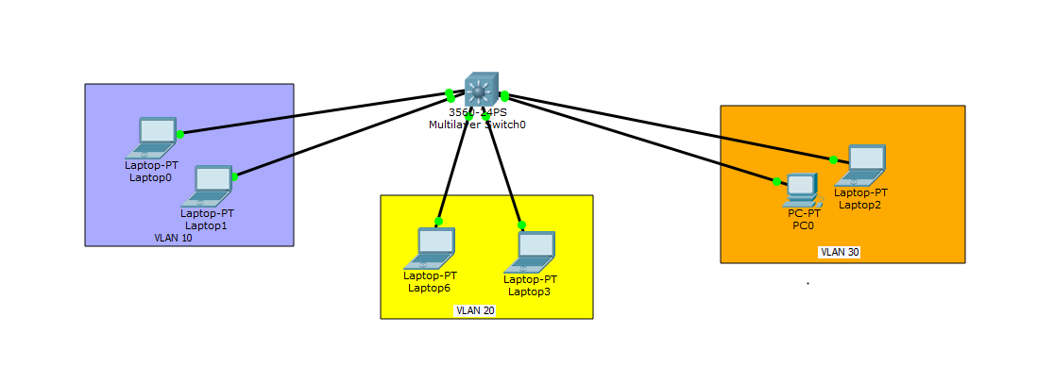

Figure 1

We implemented intervlan routing by making three virtual VLANS. Each VLAN is distinguished from each other by a unique IP address. These IP addresses further act as a subnet for the devices under each VLAN. We named our VLANs to distinguish them from each other visually, each VLAN has two devices working under it. The above figure shows all the VLANs connecting to switch 365024PS which is a multilayered switch, it is a switch which enhances the feature of the layers of OSI model. The individual PCs/devices were connected through copper cables.

## Topology specs

|  |  |  |  |  |
| --- | --- | --- | --- | --- |
| PC NAME | IP ADDRESS | SUBNET MASK | GATEWAY | VLAN |
| Laptop-PT Laptop0 | 192.168.10.2 | 255.255.255.0 | 192.168.10.1 | VLAN 10 |
| Laptop-PT Laptop1 | 192.168.10.3 | 255.255.255.0 | 192.168.10.1 | VLAN 10 |
| Laptop-PT Laptop6 | 192.168.20.2 | 255.255.255.0 | 192.168.20.1 | VLAN 20 |
| Laptop-PT Laptop3 | 192.168.20.3 | 255.255.255.0 | 192.168.20.1 | VLAN 20 |
| PC-PT  PC0 | 192.168.30.3 | 255.255.255.0 | 192.168.30.1 | VLAN 20 |
| Laptop-PT Laptop2 | 192.168.30.3 | 255.255.255.0 | 192.168.30.1 | VLAN 20 |

The above figure illustrates the important information related to each VLAN. We have three VLANs which are VLAN 10, VLAN 20 and VLAN 30. The first column displays devices connected to each VLAN, each VLANs device's IP are under their respective VLANs subnet. Moreover, the default gateway of each VLANs is different, and that is how switches and devices distinguish each other.

## VLAN specs

|  |  |  |
| --- | --- | --- |
| VLAN | Fast Ethernet | IP assigned |
| VLAN 10-> Students | Fa0/1, Fa0/2 | 192.168.10.1 |
| VLAN 20-> Professor | Fa0/3, Fa0/4 | 192.168.20.1 |
| VLAN 30-> Project | Fa0/5, Fa0/6 | 192.168.30.1 |

The above information was obtained through a command-> *show vlan brief* in cisco packet tracer. It debriefed us which fastEthernet are connected to which VLAN and we can verify of total how many devices are connected to our VLANs.

## Construction of VLAN in Cisco Packet Tracer

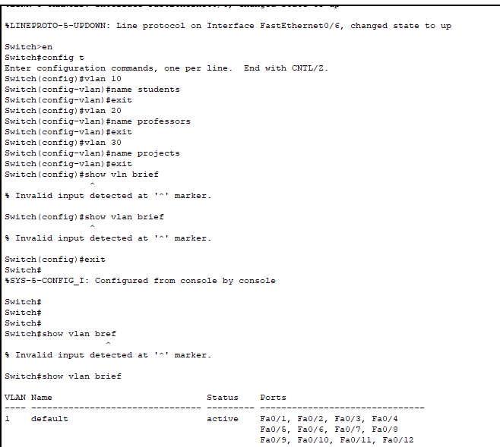

Figure 2

We implemented our logical segment of intervlan routing through CLI of our router through commands. We can determine that our first few commands initialize VLANs after which we named them to distinguish one from each other. The **show vlan brief** command is used to display information related to VLAN such as names, ports, etc.

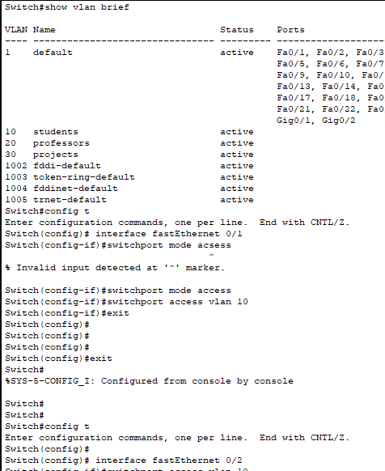

Figure 3

We have assigned each port to each VLAN through switch ports command to identify each VLAN. **switchport mode access** is used to communicate between devices in each VLAN.

## VLAN interface commands

We assign IPs to the VLANs just created by using interface command. VLAN interface mode lets the commands define or modify the configuration of a VLAN interface. In order to enter configuration mode, use the Global VLAN command with the name of the VLAN interface.

VLAN 10

By giving the command *interface vlan 10* and then ip *address 192.168.10.1 255.255.255.0* we assigned 192.168.10.1 to vlan 10

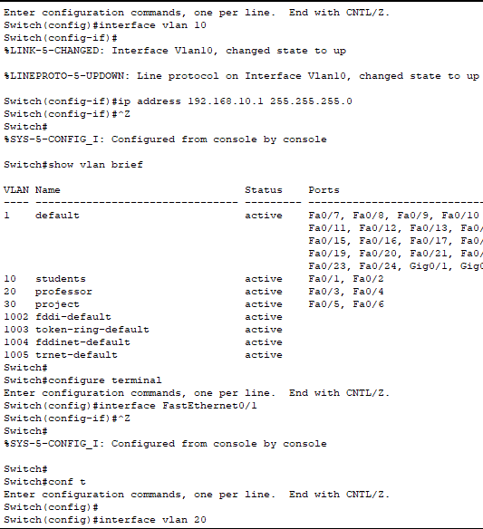

VLAN 20

*interface vlan 20* followed by *ip address 192.168.20.1 255.255.255.0* we assign 192.168.20.1 to vlan 20

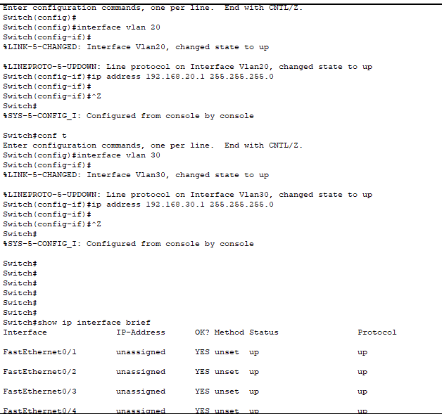

Figure

VLAN 30

Similarly, *interface vlan 30 -> ip address 192.168.30.1 255.255.255.0* we assign 192.168.30.1 to vlan 30



Figure 5

By using command *ip interface brief* we can see the IPs we assigned to our vlans.

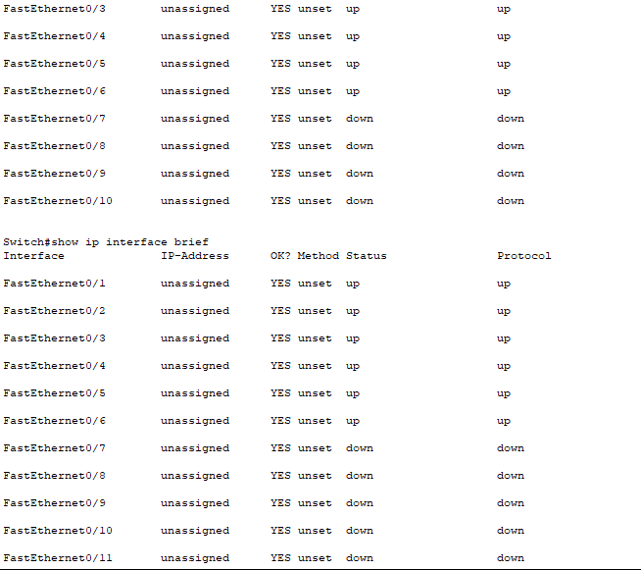

Figure 6

The VLANs we just configured are all shown with a protocol status “up”. We have 2 devices in each VLAN and 3 VLANs which makes it a total of six devices running.

VLAN interface command provides the commands to modify the configuration of VLAN interface. to use the configuration mode, we use the global VLAN command with the name of VLAN interface.

the IP interface shows the best summary of the protocols, statuses and IP addresses of our interfaces. VLAN requires the routing between subnet, IP address needed in the interface to route the traffic between subnets as it acts as gateway for all the hosts in that VLAN.

while we use configuration mode we can use following commands to configure the VLAN interface.

current configuration can be viewed by show command.

reset command helps to restore the default values.

we use cancel command to exit the configuration.

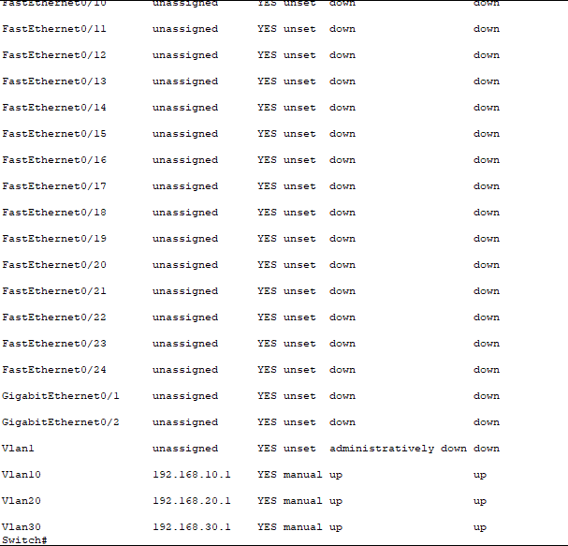

Figure 7

For the routers to be reachable, router interfaces must be configured. We can enable the specific interface by entering the configuration commands using the interface “type-end-number global configuration mode command. different types of interfaces are available on cisco routers. In our configuration we can see two interfaces.

GigabitEthernet 0/1

GigabitEthernet 0/2

The interface for VLAN 1 shows the status of administratively down; it means if we look at the configuration we will see a line that says shut. so just go in configuration mode and interface, do a “no shut” this can bring the interface administratively up.

Switch is used to set IP addresses on interface level. the IP address assigned on the interface is used to manage that particular interface. to manage the entire switch, we have assigned an IP address to VLAN.

switch VLAN configure t is used to enter the global configuration mode.

The switches are referred to as routing switches. when IP routing is enabled on our switch it behaves like any other ip router configuration consists of adding IP addresses, enabling IP routing and enabling a route exchange protocol.

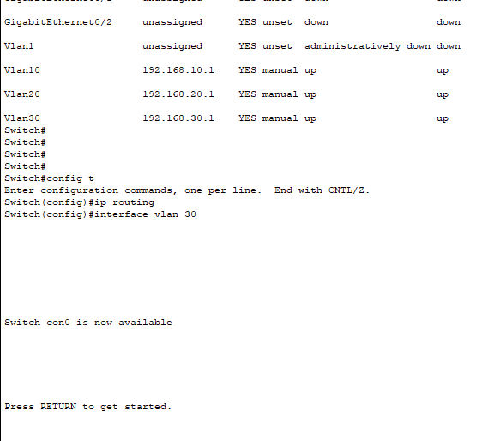

Figure 8

# 

# Ping in the Same VLAN

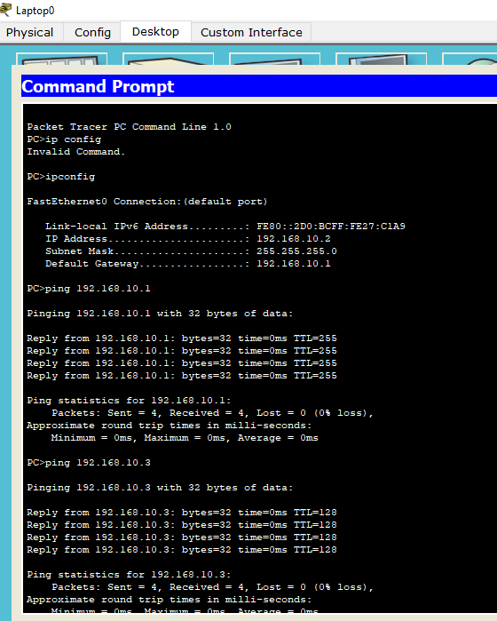

Figure

*After we had set up our VLAN we pinged a device from VLAN 10(the first VLAN) to a device in the same VLAN to check. This is the quickest way to learn if all the devices connected in the network are alive and are correctly connected/configured to send a reply back.*we pinged a device with **IP Address:192.168.10.1** in VLAN 10

It was a success and the reply was received with 0% loss. 4 packets sent and 4 received.

we pinged another PC in the same VLAN of **IP Address 198.168.10.3**  
it was also a success with 0% loss with a roundtrip of milliseconds

# Ping in a Different VLAN

*our next step was to ping a device from 1 VLAN to a pc in a different VLAN. This is usually the tricky step because chances of packet loss first time around is confirmed.*

we pinged a device with **IP:192.168.20.3** in **VLAN 20**. At first our request timed out. This message was displayed three times.

We repeated our request by pinging the device again; the first packet was lost. We received a total number of 3 packets successfully and lost 1 packet with 25% loss. The round trip time was in milliseconds.

After this whenever we sent a packet, it was always with 100% success.

Initially the data tables were empty and the switch broadcasted the packet to all the devices however later it only sent the packet to the designated receiver hence the 100% success.

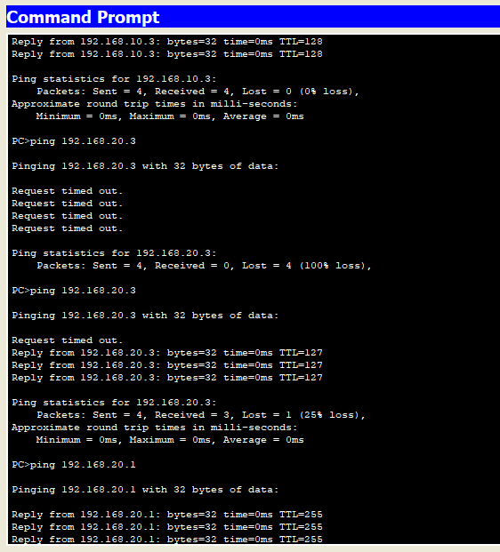

Figure

# 

# Configuration of PCs

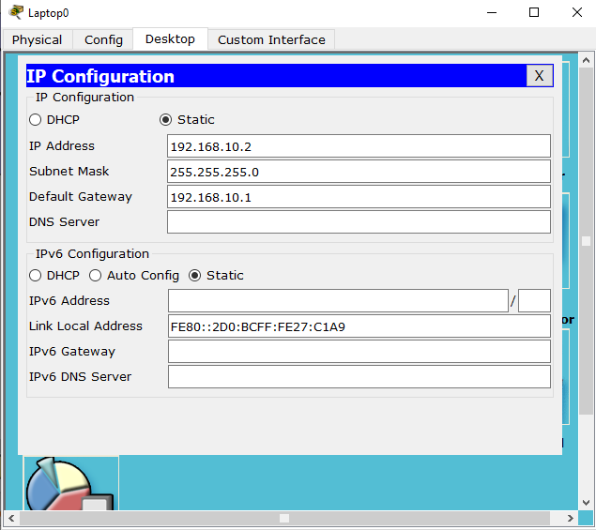

Figure 11

# 

Figure 12

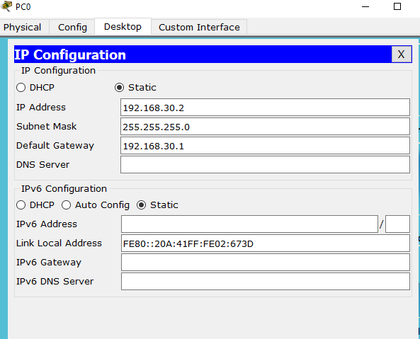

Figure 13

## Configuration of Gateways

We configure the PCs into their respective VLANs with the **gateway** address of the VLAN itself. Two PCs are connected to one VLAN and so they will have the same gateway. All the gateways are hosted on the same switch.

We cannot assign them with the IP address of 192.168.XXX.1 because that is the network address and so we use the next 2 IP addresses.

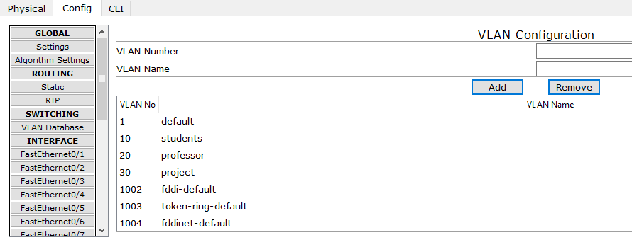

Figure 14

Here we can see in the GUI interface of the switch that we have added 3 new VLANs with the numbers of 10, 20, 30 respectively.

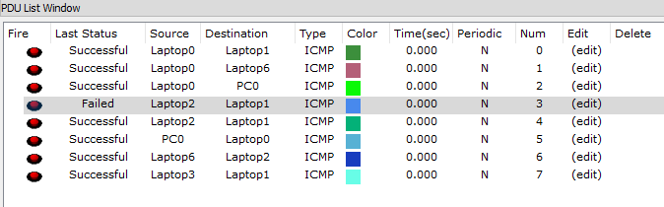

Figure 15

## Testing

We tested the network with various ICMP protocol message sharing tests and all had successful results. The tests were as follows:

* From the PCs to the **switch**.
* From one PC to another within the **same** VLAN.
* From one PC to another on a **different** VLAN.

One of the tests failed where the first ICMP message was lost because the PC had not yet been discovered in the network as this was considered the “first ping”. However, after another test, it was successful again.

# 

# Conclusion

We have successfully made 3 working VLANs on a single switching device. This can hence increase performance of switched networks over shared media devices by decreasing the number of collision domains. One of the biggest benefits of forming logical networks in switching devices is that it reduces the broadcast traffic within individual workgroups.

In a switched VLAN-based network, frames are delivered only to the intended recipients, and broadcast frames only to other members of the VLAN. This enables network managers to segment users requiring access to sensitive information into separate VLANs from the general user community regardless of physical distance.