LabEase allows users (students/lab staff) to log in, report issues by selecting a category, and provide details. The lab engineers receive these reports, update the status, and resolve them. The system logs timestamps for issue reporting and resolution. Additionally, it generates a monthly digital report summarizing all problems, their resolution times, and the engineers involved. **LabEase** is a website where users can report problems related to PCs, furniture, circuits, or internet issues in labs.

**User Side**

1. ***LogIN Page:***

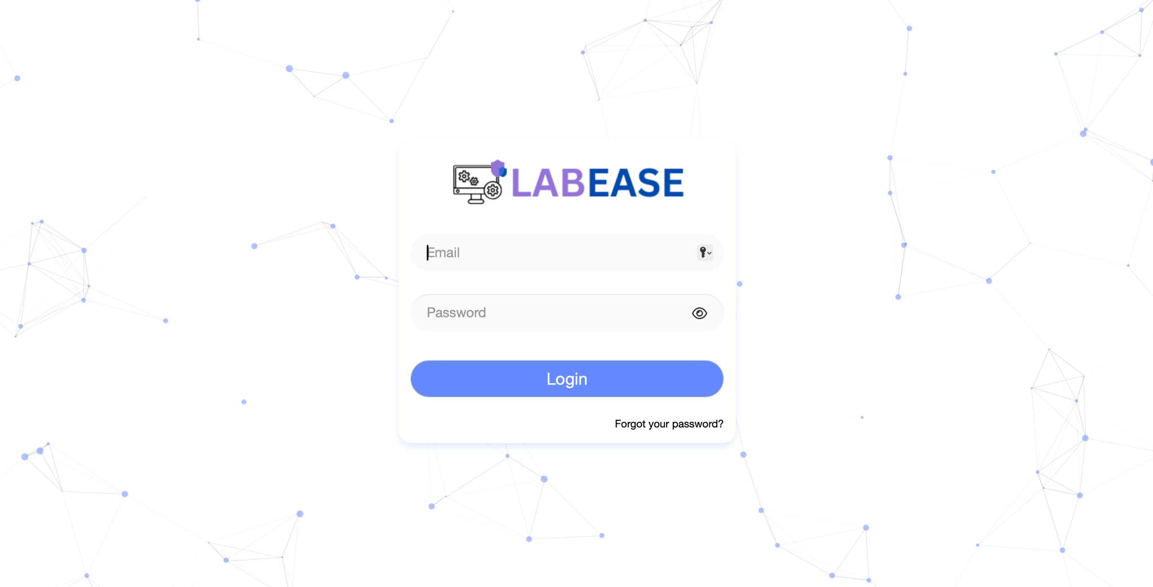

If a student forgets their password, **they cannot reset it themselves**. They must go to the **admin, who will manually change it**, similar to how it works in Qalam.

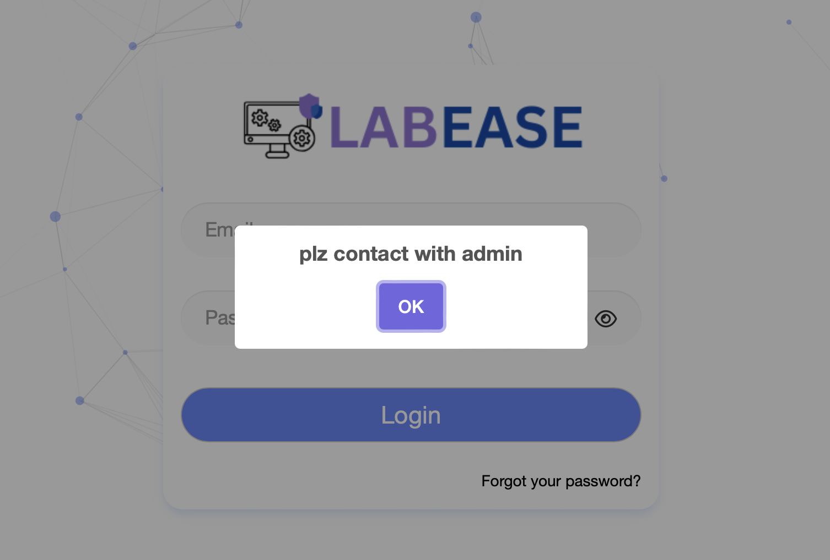

1. ***Home page of user side***

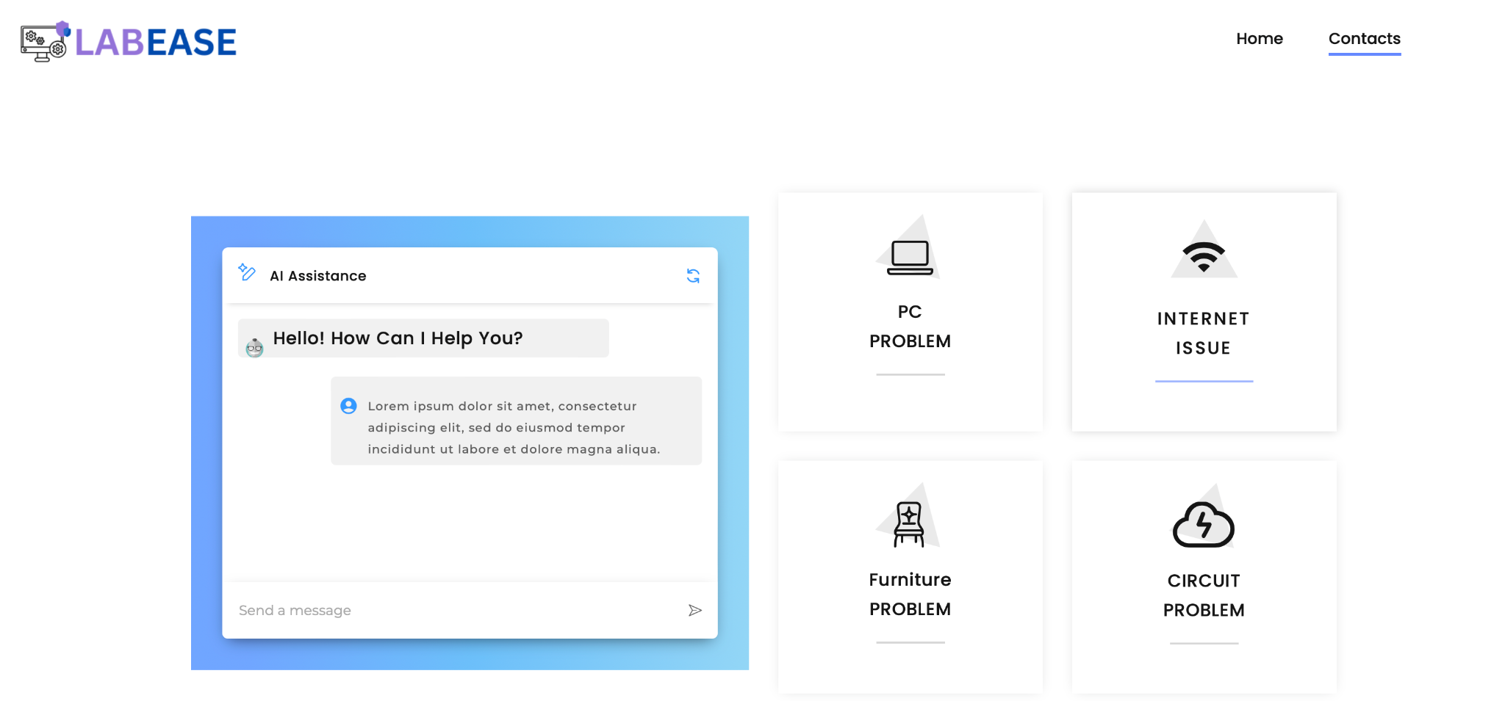

The chatbot on the **homepage** of LabEase will act as a **virtual assistant**, helping users navigate the platform efficiently. It will **guide users on how to report issues** by providing step-by-step instructions on logging in, selecting an issue category, and submitting a report. For example, if a user asks, *"How do I report a PC problem?"*, the chatbot will respond with clear steps to follow.

Additionally, it will **answer common queries**, such as how the system works, who resolves issues, estimated response times, and password reset policies. For instance, if a user asks, *"How long does it take for an issue to be resolved?"*, the chatbot can provide an estimated timeframe based on issue type and past resolution trends.

To improve usability, the chatbot will also **enhance accessibility** by directing users to relevant sections like user guides, policies, and troubleshooting tips.

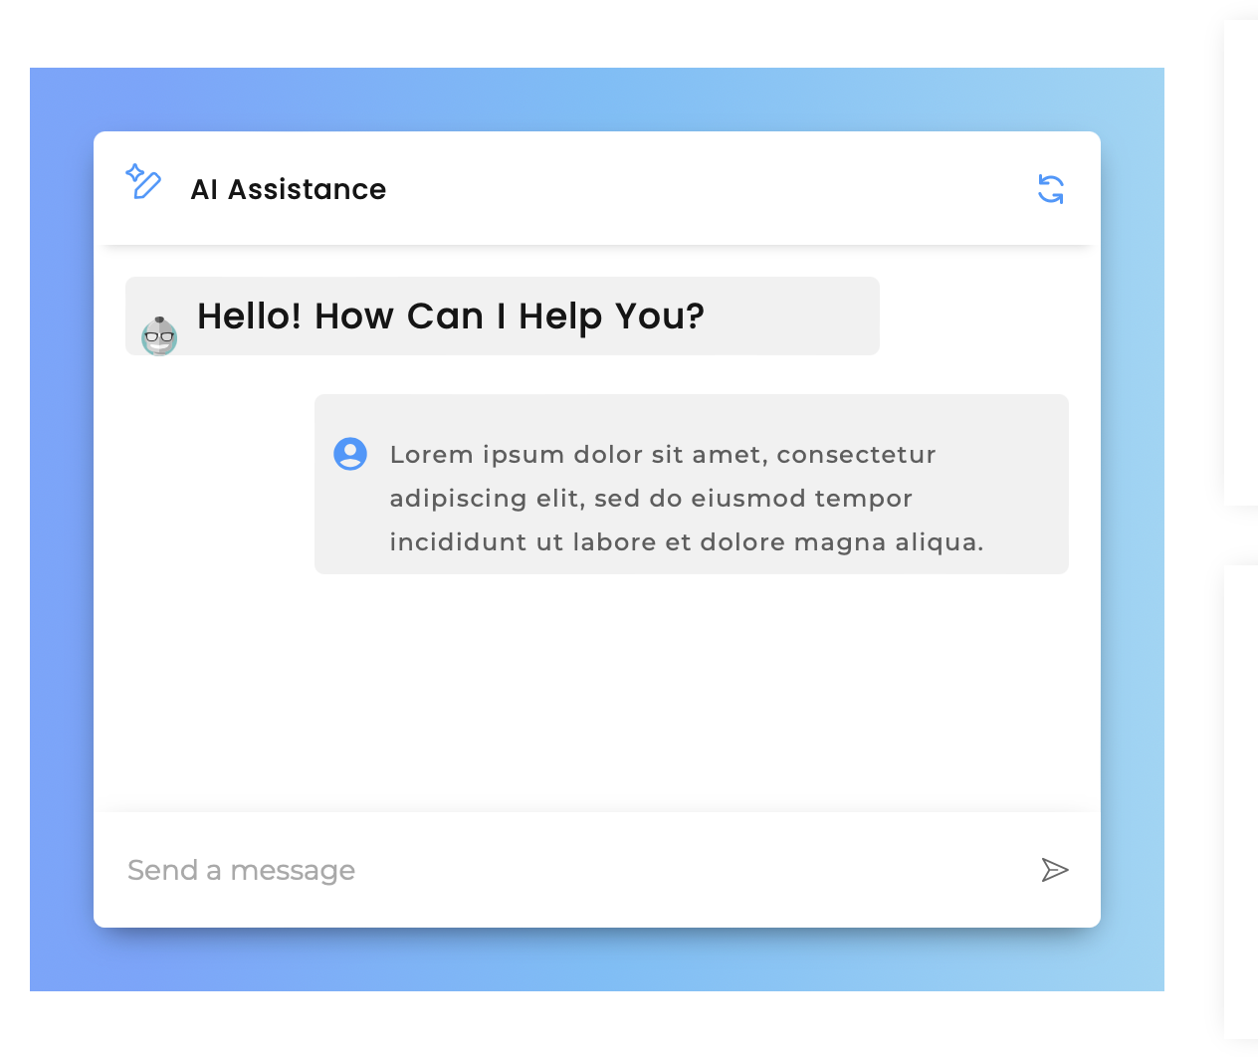

In HomePage, below these modules there is a feedback where user can enter any problem they are facing regarding using the website or if technician cant resolve the problem accurately etc its like feedback which is directly sent to Admin(Sir Shakeel)

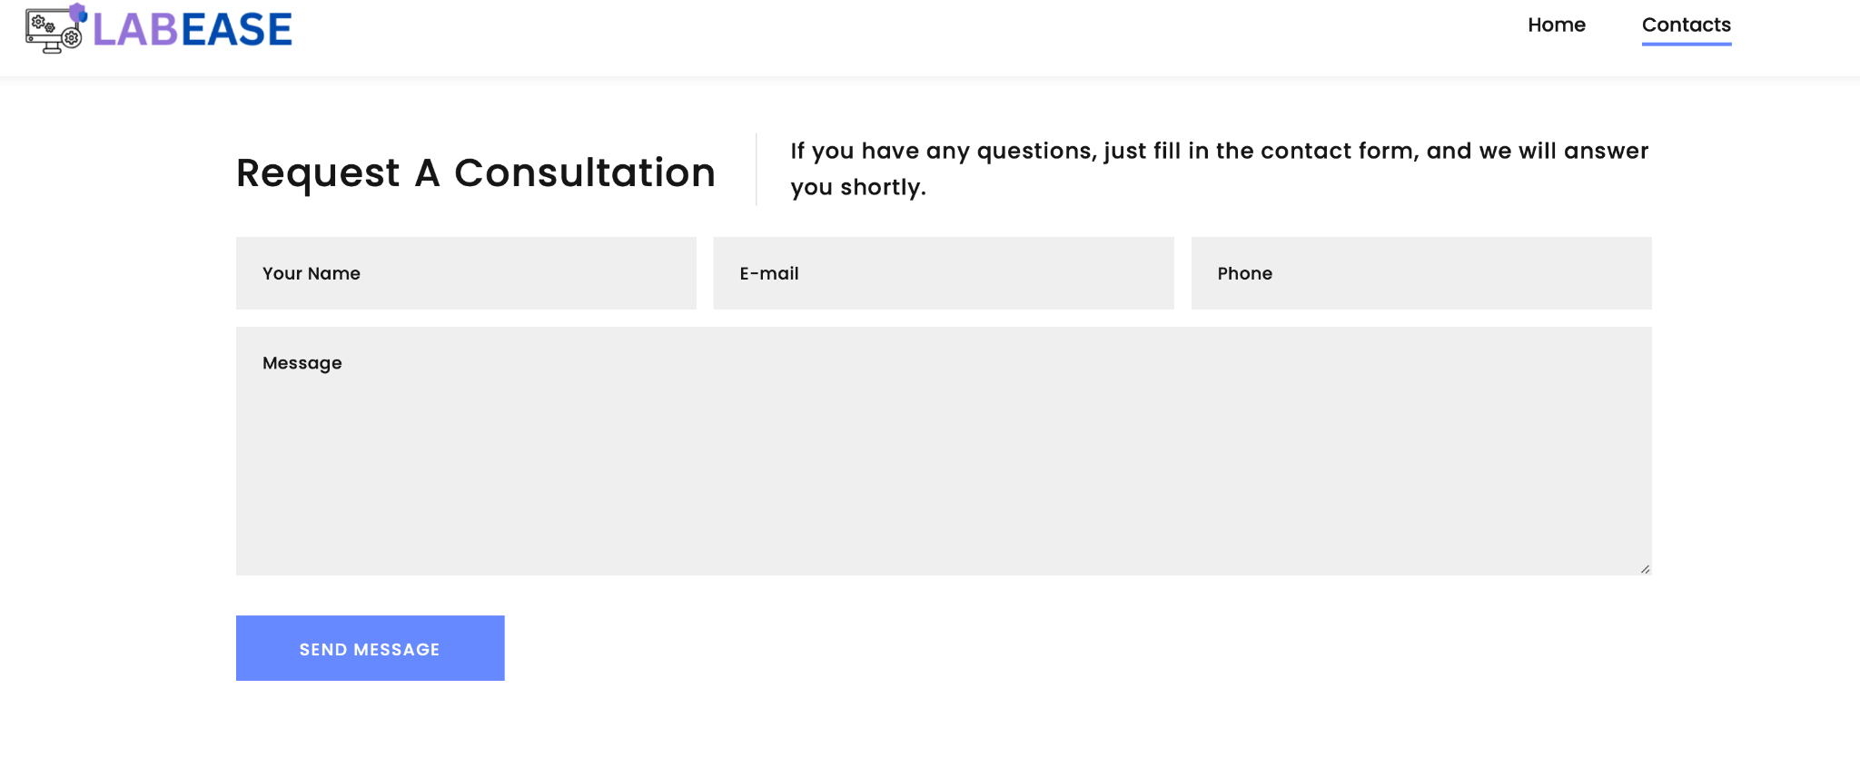

1. ***Report page of user side***

By clicking on any of these problems of 4 modules(pc, circuit, furniture, internet) , a new page will open containing a form where the user/student can provide a detailed description of the issue they are facing. This description will be the same information viewed by the technician when they are notified of the problem.

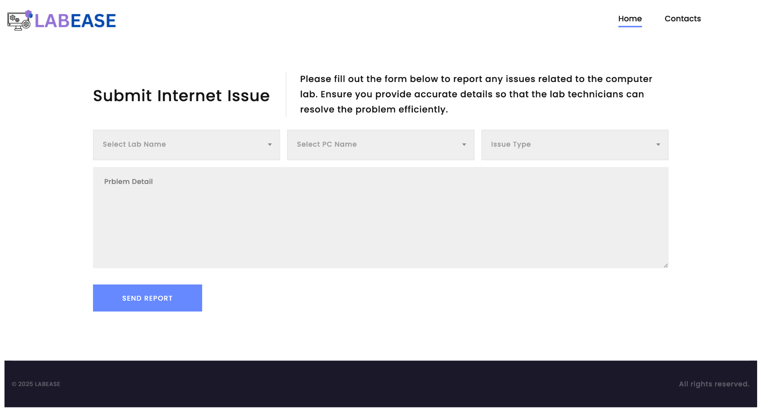

1. ***Thank You page of user side***

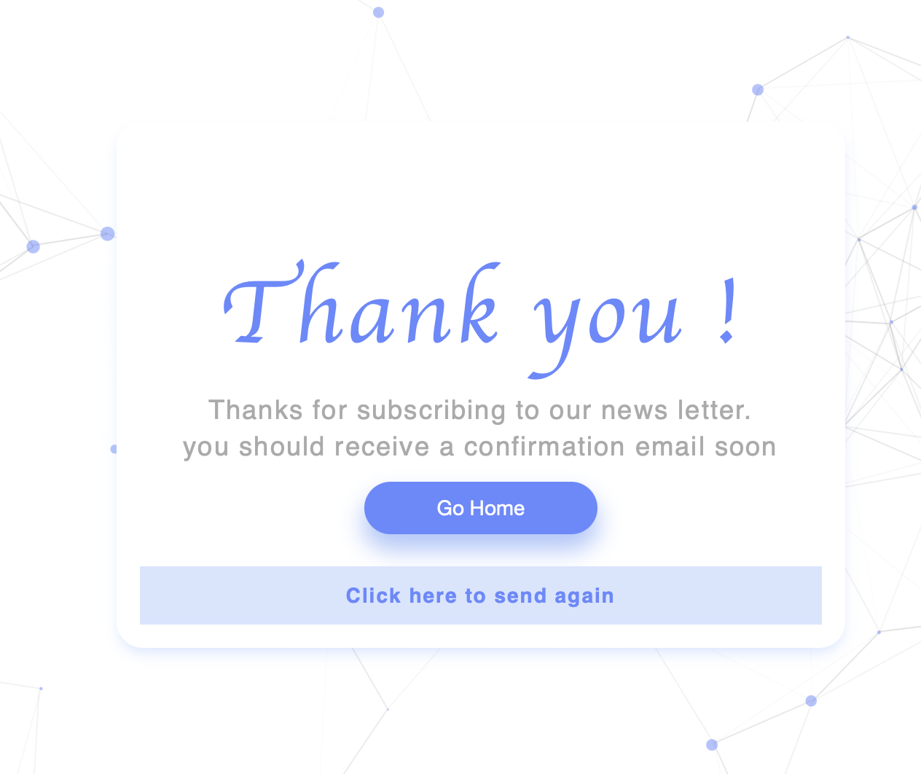

**Admin side**

1. Dashboard of Admin side

In the line chart, it will be shown which of the 8 labs in the department had the highest number of reported issues last month.

In the bar chart, it will be shown which of the **four modules** (Internet, PC, Circuit, or Furniture) had the **highest number of reported issues last month**.

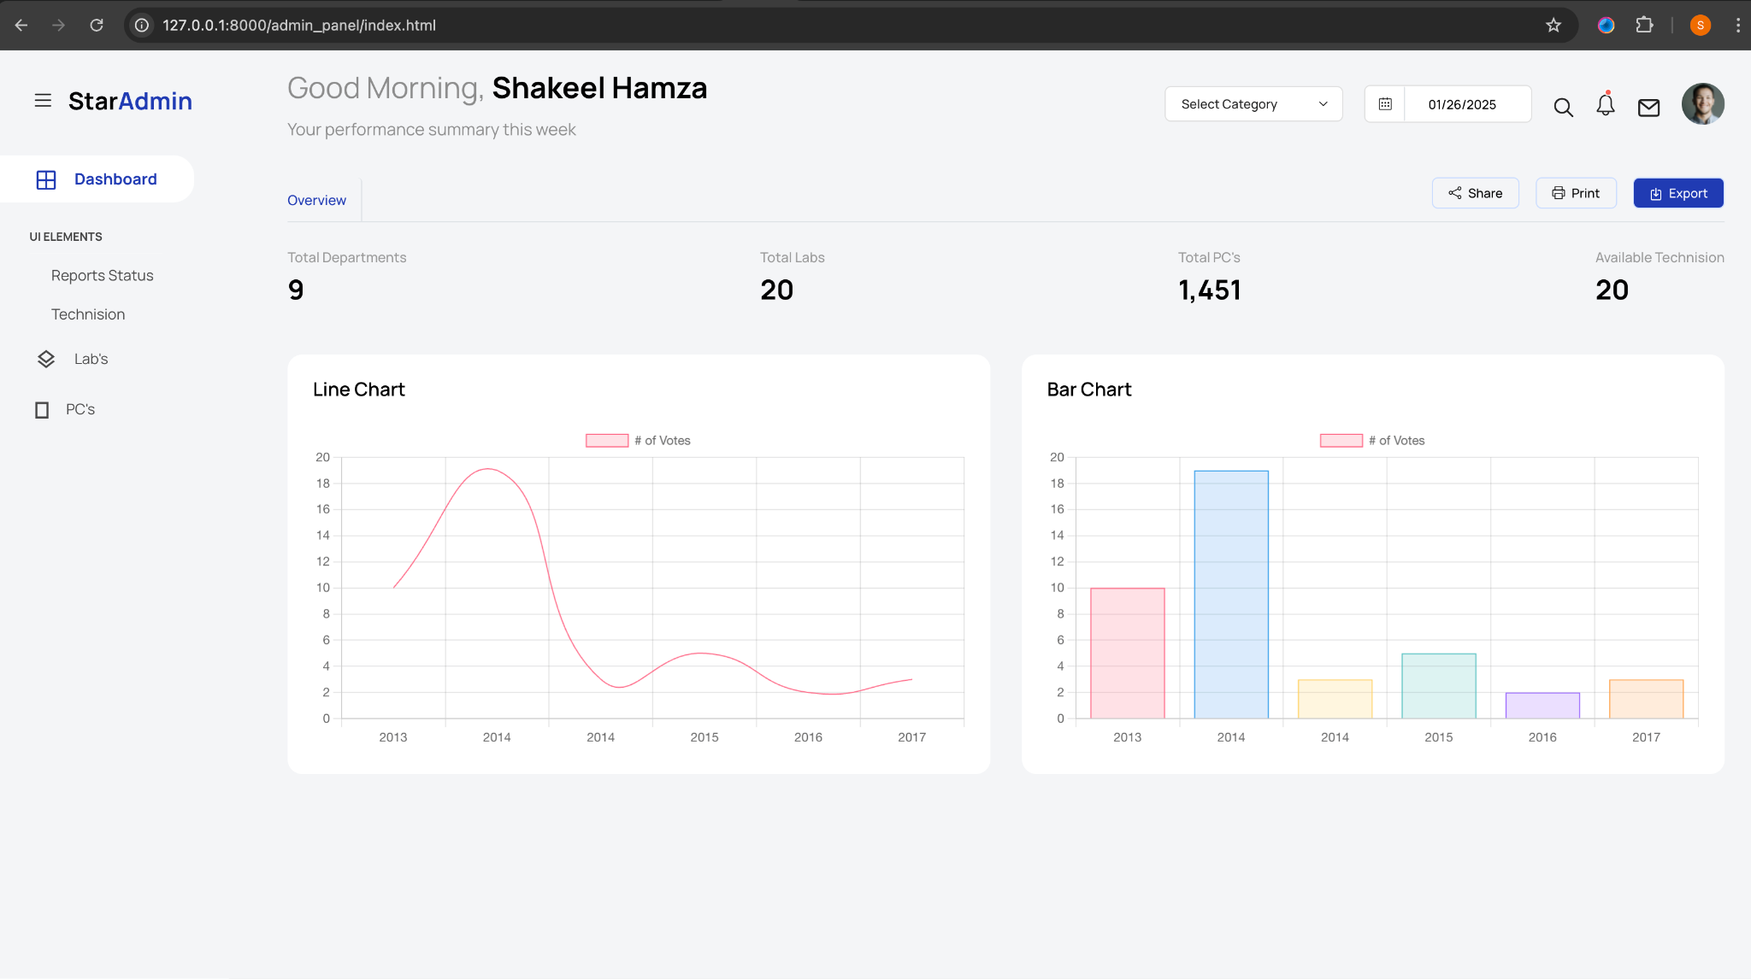

This below will be the unread or recent emails by the user(student)

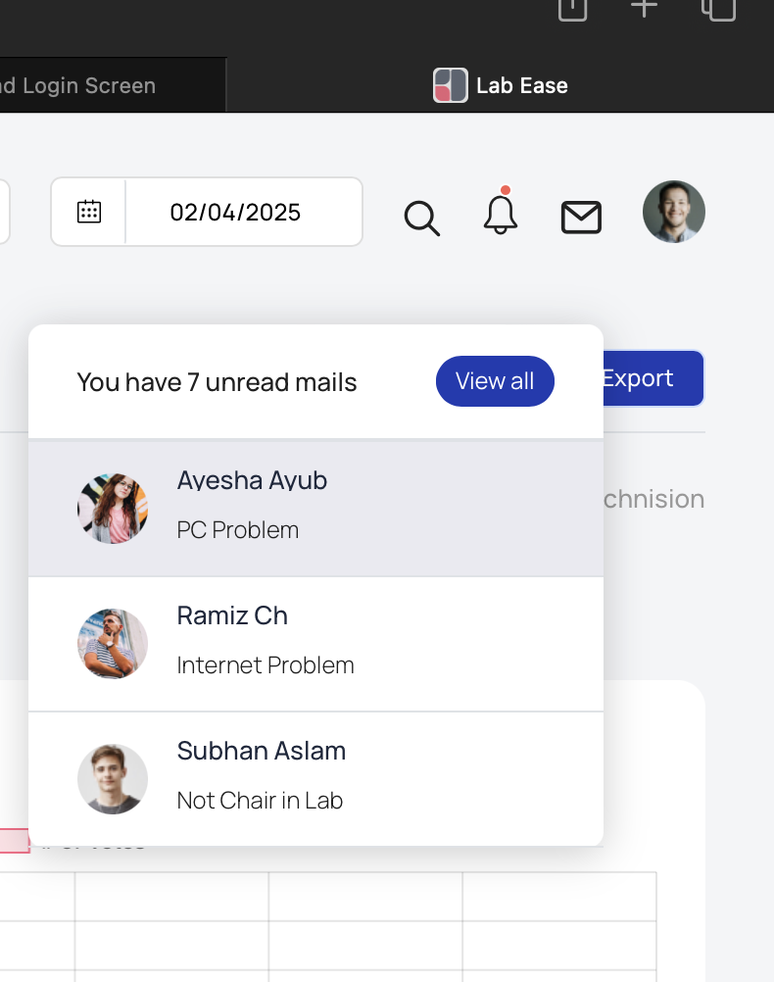

1. Add a CRUD feature for the student field, where the students' email addresses and passwords will be managed. Passwords can only be changed by the admin, and the admin will have the authority to add, delete, or edit student records.

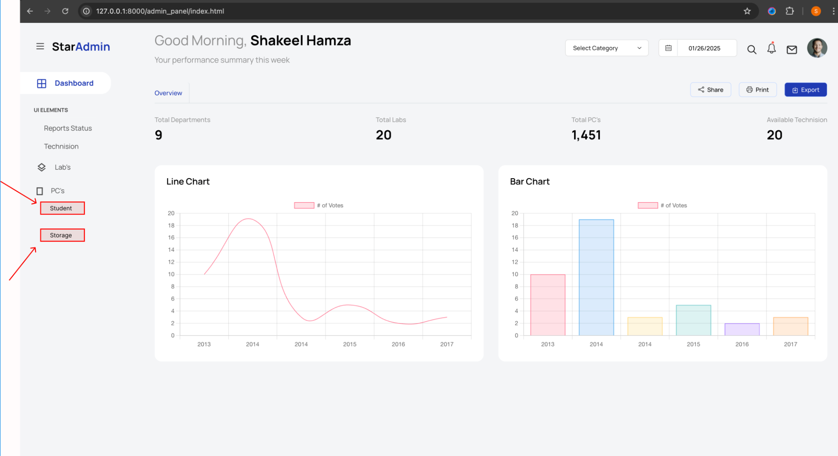

1. In the same way, add a CRUD feature for the labs field, where the admin will have the authority to add, delete, or edit lab records.

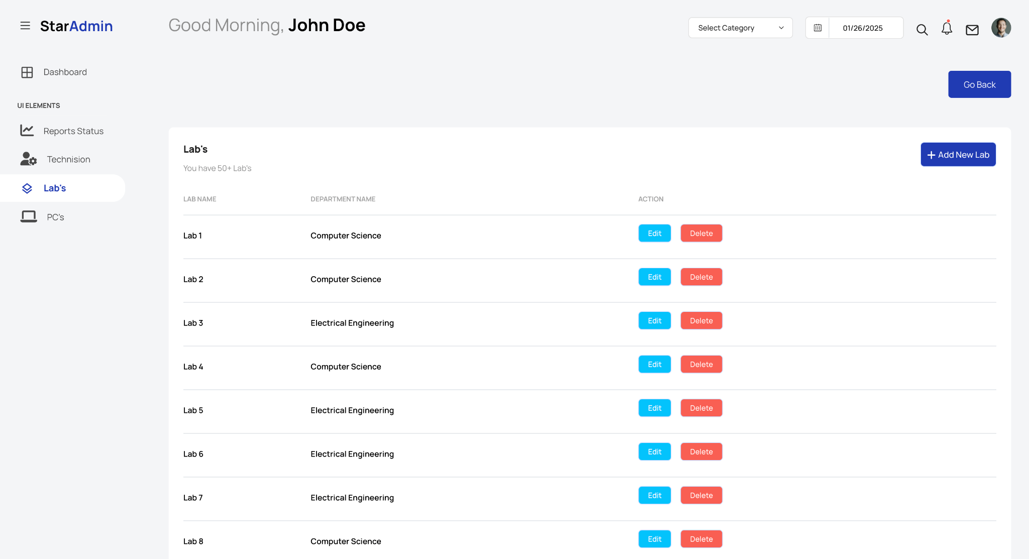

And while clicking the +Add New Lab these are the columns to fill then it will add to list of labs

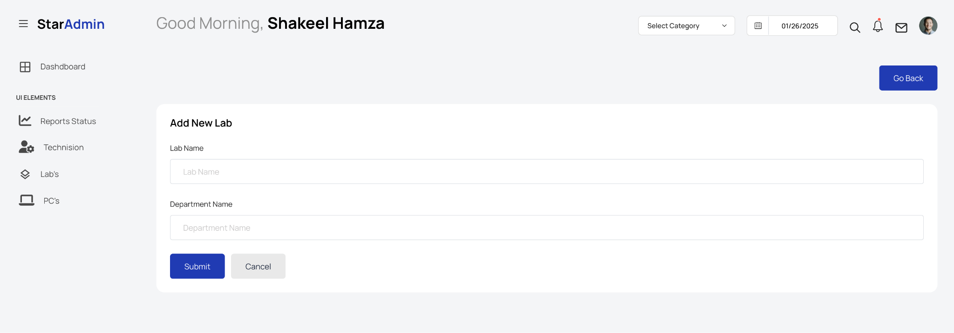

1. In the same way, add a CRUD feature for the Pc field, where the admin will have the authority to add, delete, or edit pc records.

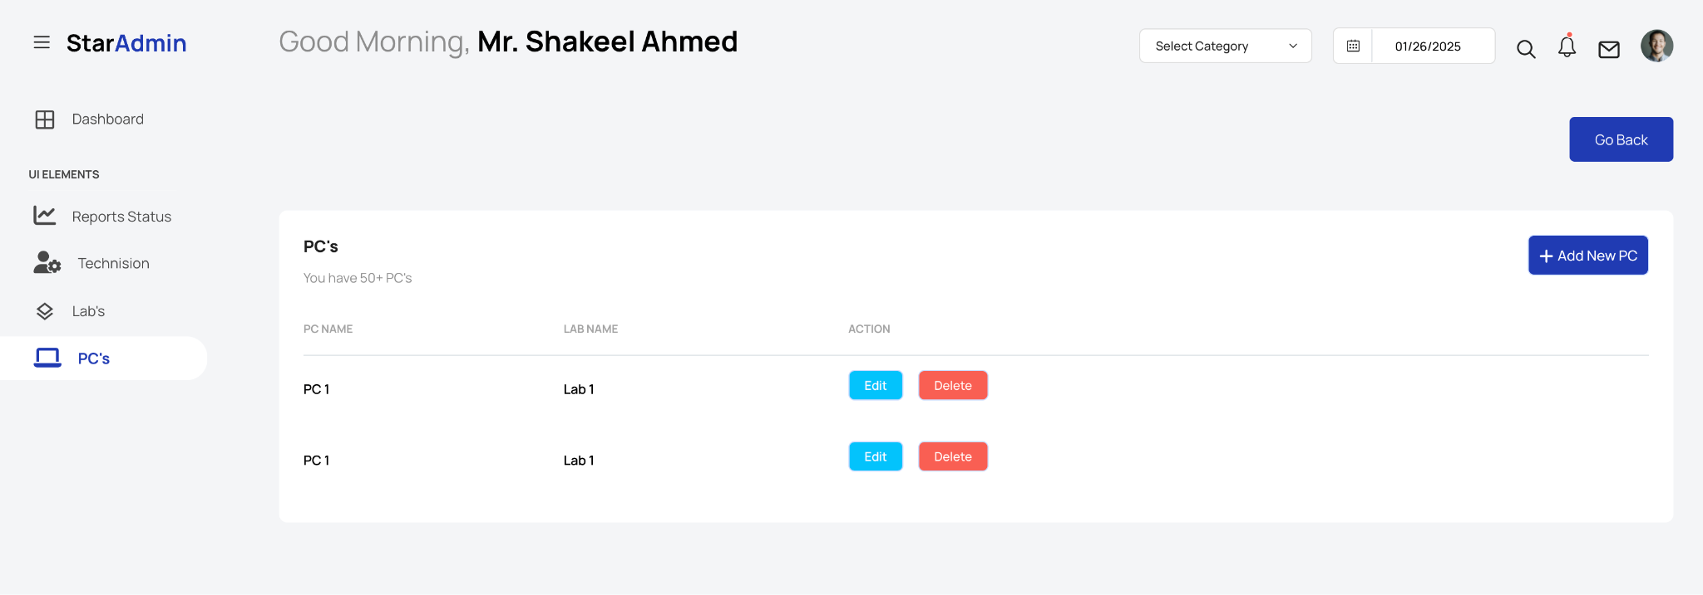

And while clicking the +Add New PC these are the columns to fill then it will add to list of PCs

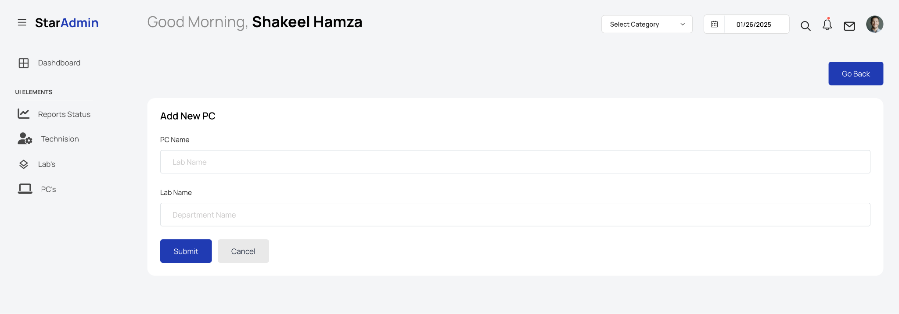

1. In the same way, add a CRUD feature for the Technision field, where the admin will have the authority to add, delete, or edit pc records.

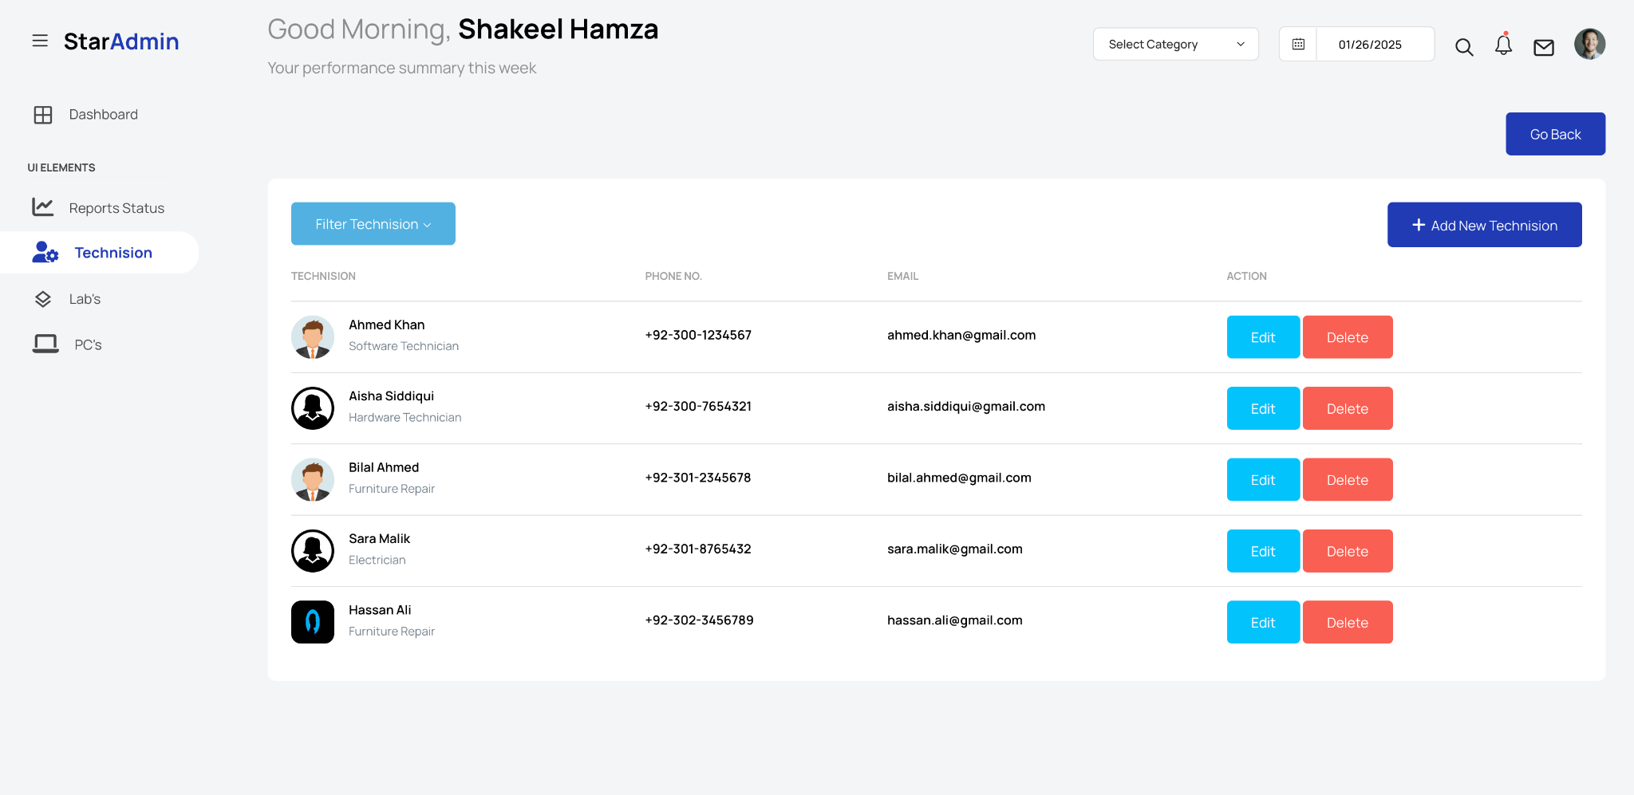

And while clicking the +Add New Technision these are the columns to fill then it will add to list of Technisions

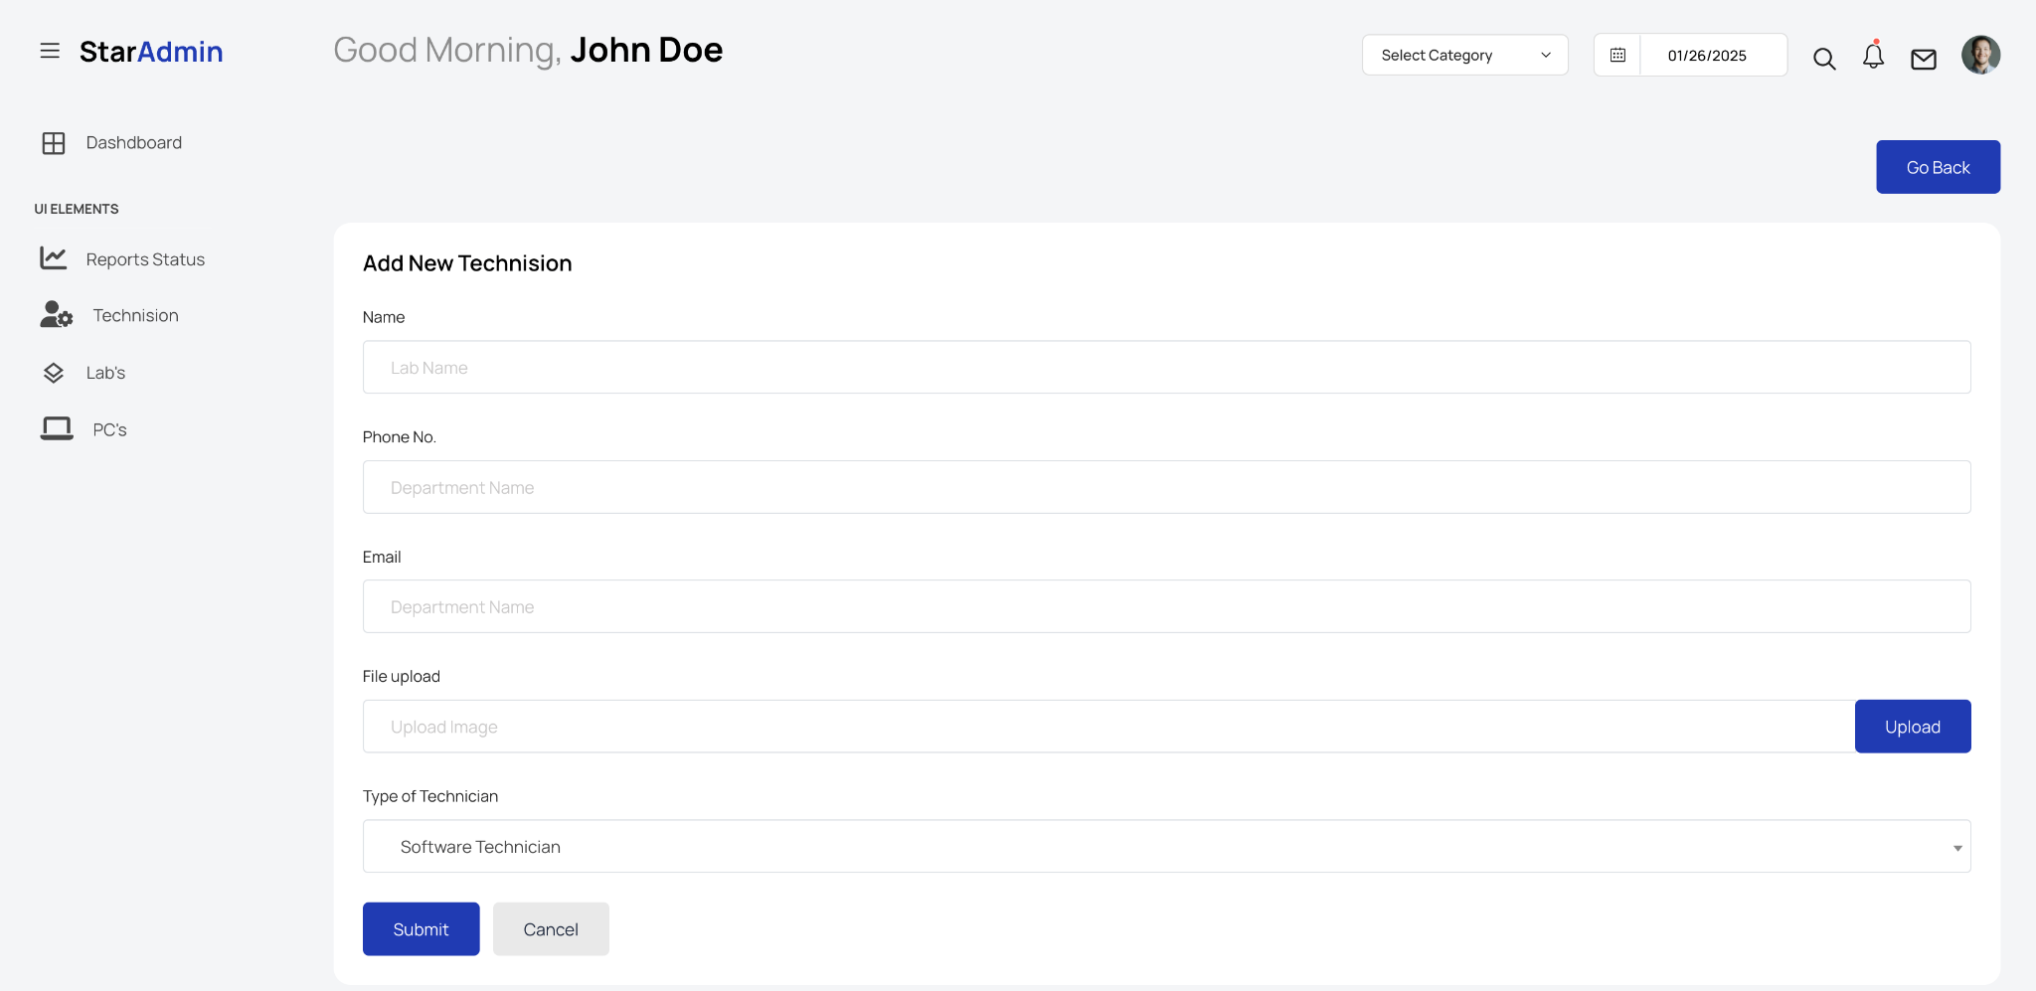

1. The Reports Status section will display the main problem along with the key keywords from the description field. This page will only be visible to other technicians once an issue has been reported. Apart from this page, the entire admin website is accessible only to the admin, Shakeel Ahmed. Additionally, there will be status options such as 'In Progress,' 'Pending,' and 'Completed.' Once a problem is resolved and marked as 'Completed,' a 'Move to Storage' option will appear. By clicking this option, the issue, along with the time and date it was reported and resolved, will be moved to the 'Storage' field, ensuring that all completed files are stored in the storage page for record-keeping.

Beside the status, there will also be a 'View' option. Clicking on 'View' will open a pop-up window displaying the details of the reported problem, including the lab name, PC number, issue type, and description as filled out by the student/user.

