**Online shopping**

1. Admin
2. Customer
3. Retailer
4. Delivery partner
5. Admin

No of Users

No of Retailers

Collections: payment management

Add New Retailer / Delete the Retailer

Reports - Financial

Reports - General

Daily In and Out Delivery List

Receives order

Add new Users / Delete the Users

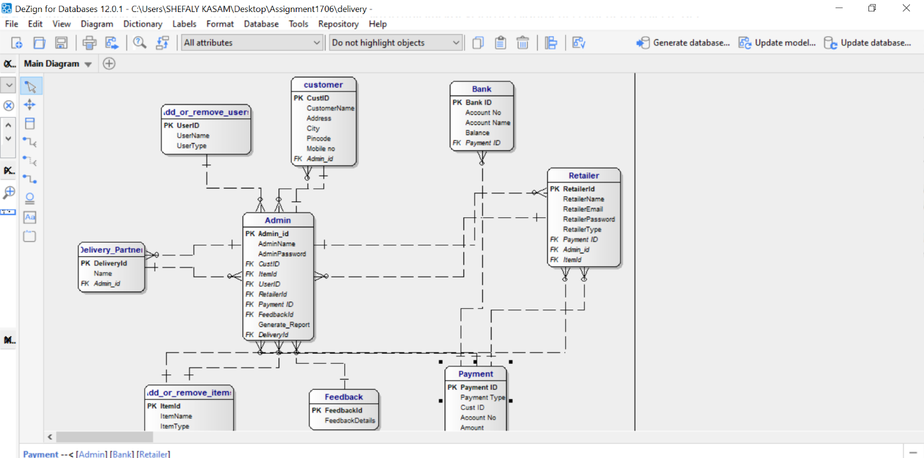

1. Customer

Order

Add items to wishlist

Login

Payment

Check delivery status

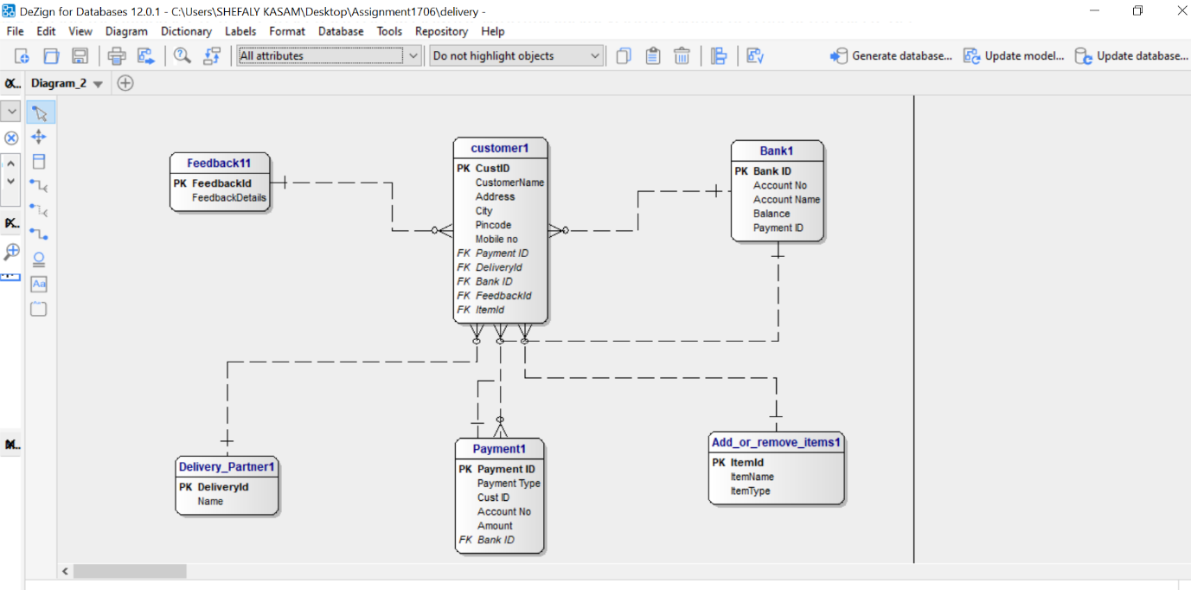

1. Retailer

Add or remove items

Receives orders

Checks products in stock or not

Login

Amount received

Payment status

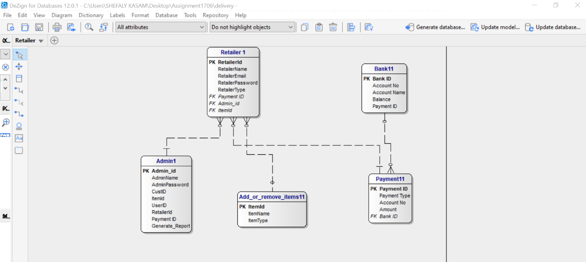

1. Delivery partner

Receives orders

Delivers products

