**DEVELOPMENT OF WEBSITE FOR MY MARKET**

**Agenda for the application:**

My Market's online store offers a variety of products across various categories: Fresh Fruits & Vegetables, Grocery & Staples, Beverages, Bread, Dairy & Egg products, Branded Foods, Meat, Personal Care and Household products. My Market is committed to making life simpler and grocery shopping a breeze!

Data to be captured:

1. Name
2. Telephone number
3. Email id
4. Date of birth
5. Address

The following data are captured from users.

**Uml Diagrams:**

**Class diagram:**

The class diagram is the main building block of object-oriented modelling. It is used for general conceptual modelling of the structure of the application, and for detailed modelling translating the models into programming code. Class diagrams can also be used for data modelling.[[1]](https://en.wikipedia.org/wiki/Class_diagram#cite_note-1) The classes in a class diagram represent both the main elements, interactions in the application, and the classes to be programmed.

.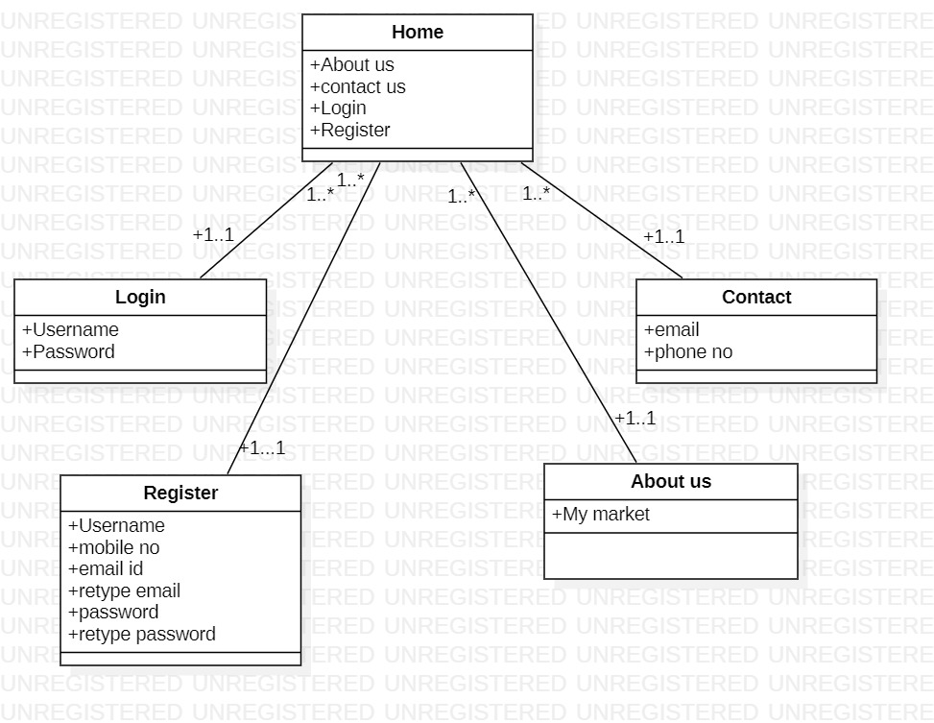

**Classes in above diagram are:**

1. **Home**
2. **About**
3. **Login**
4. **Contact us**
5. **Feedback**
6. **Registration**

**Use Case Diagram:**

A **use case diagram** at its simplest is a representation of a user's interaction with the system that shows the relationship between the user and the different use cases in which the user is involved. A use case diagram can identify the different types of users of a system and the different use cases and will often be accompanied by other types of diagrams as well. The use cases are represented by either circles or ellipses

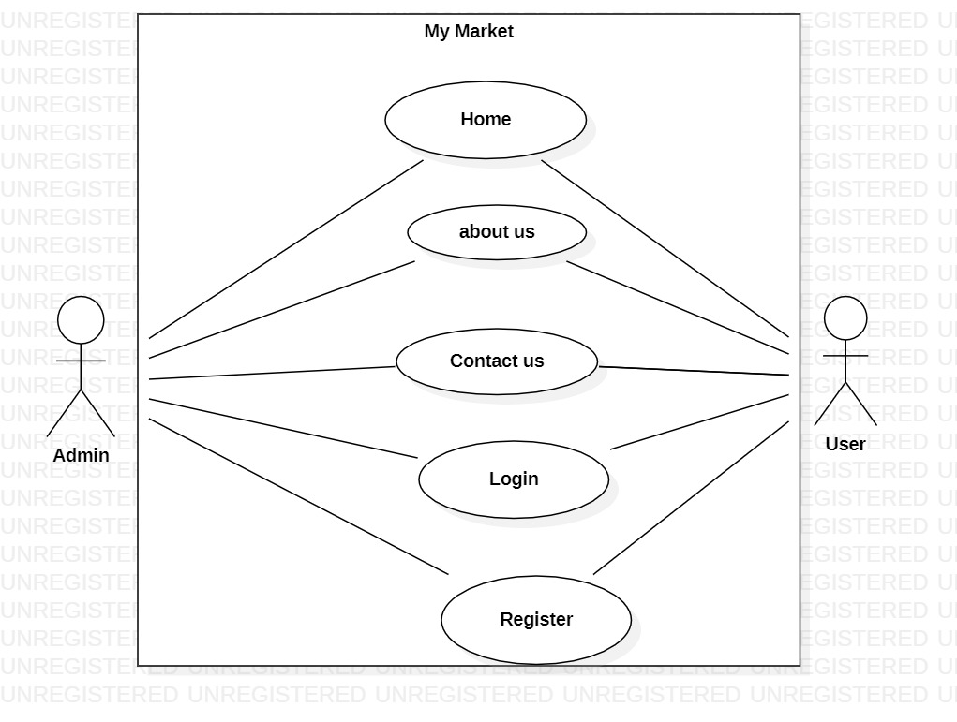

**Use Cases in above diagram are:**

1. Home
2. About
3. Login
4. Contact us
5. Feedback
6. Registration

**Actors in the above Diagram are:**

1. Admin
2. Student

**Wireframes:**

A wireframe is a schematic or blueprint that is useful for helping you, your programmers and designers think and communicate about the structure of the software or website you're building.

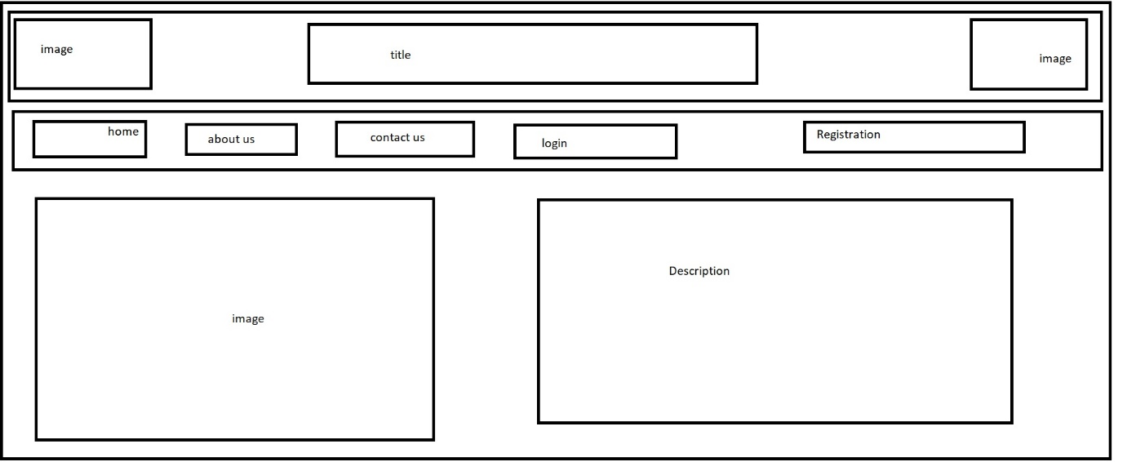

The following wireframe is having a title and image bars at the tops and we have a nav bar at the bottom of it where it has several subpages like about, home, login, feedback, registration, contact us pages.

RESULT: Home page

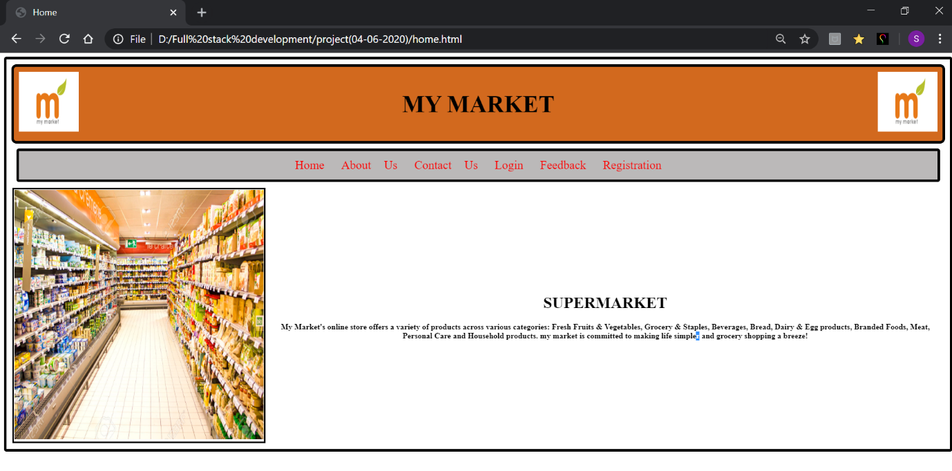

About us:

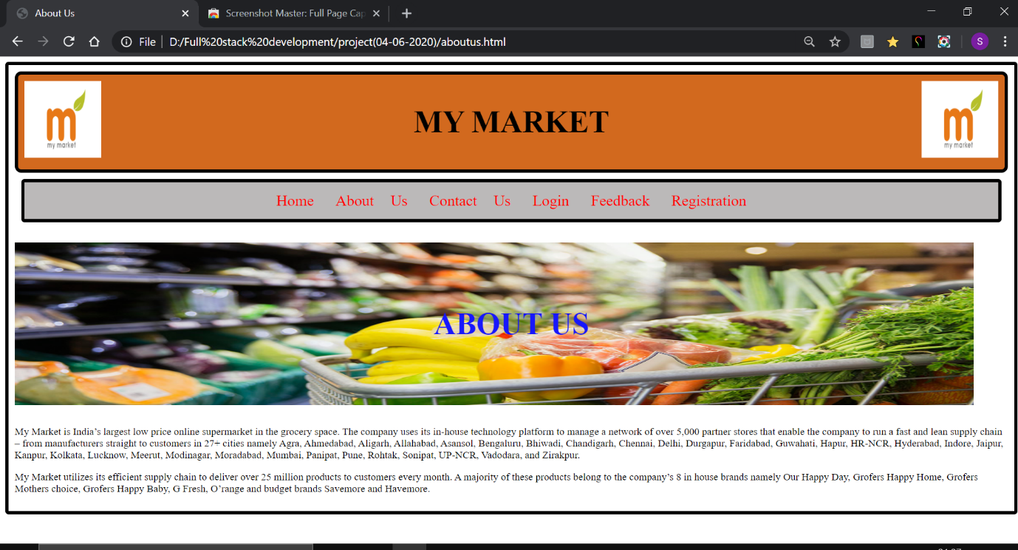

Contact us:

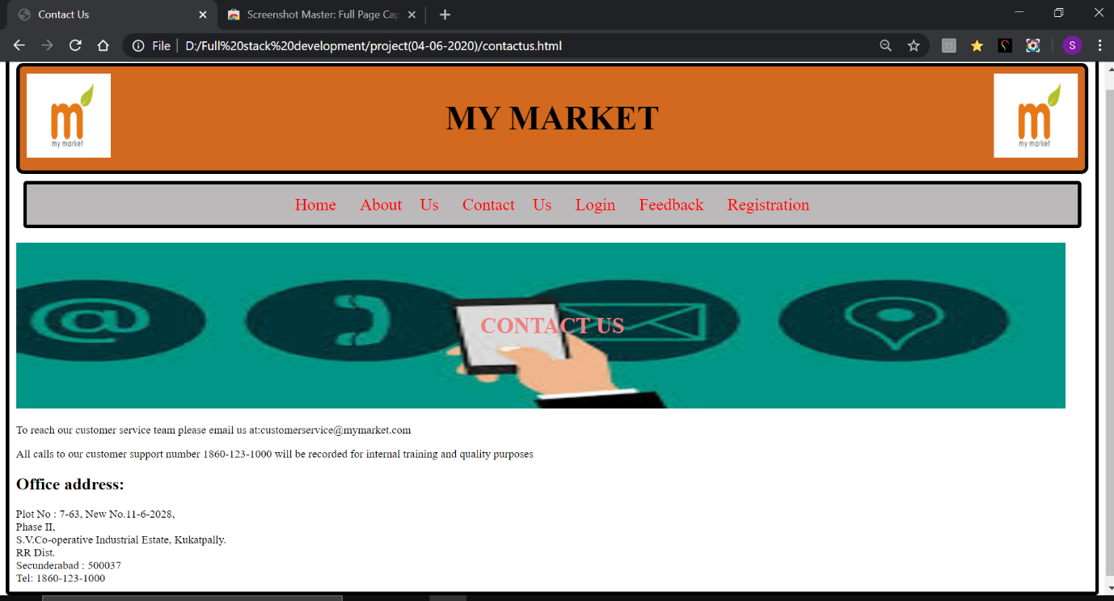

Login :

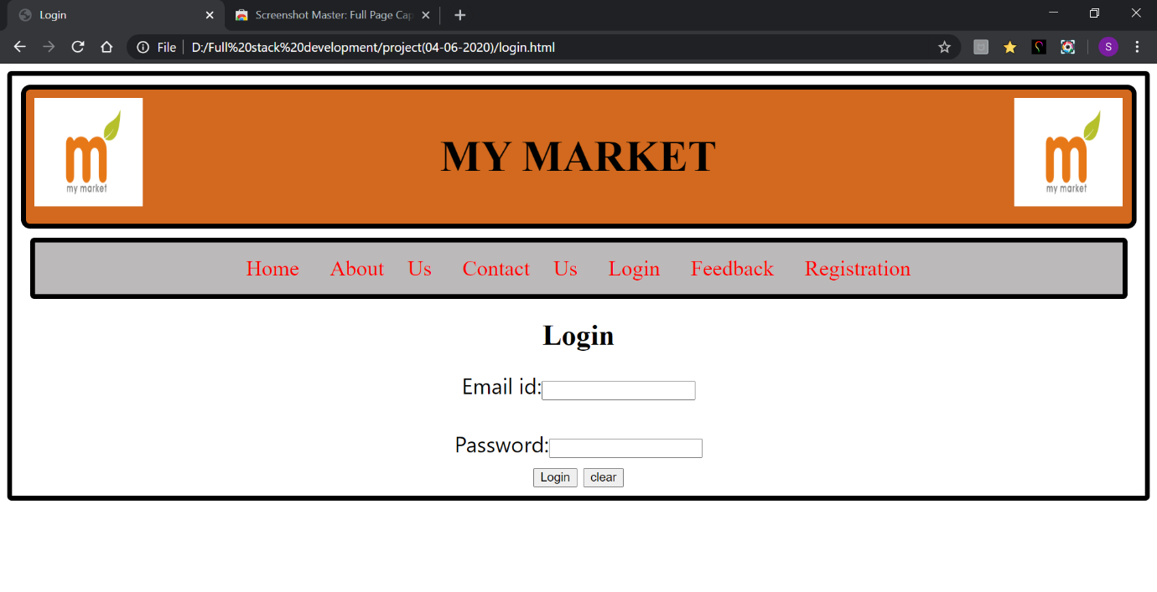

Registration:

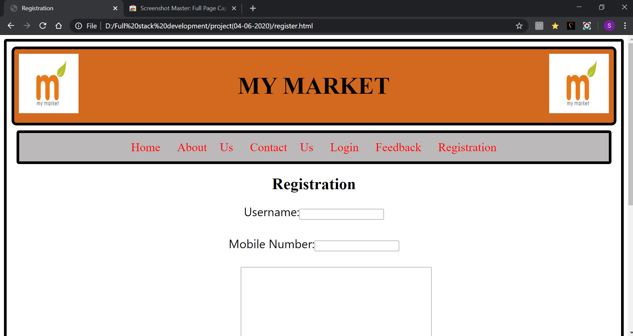

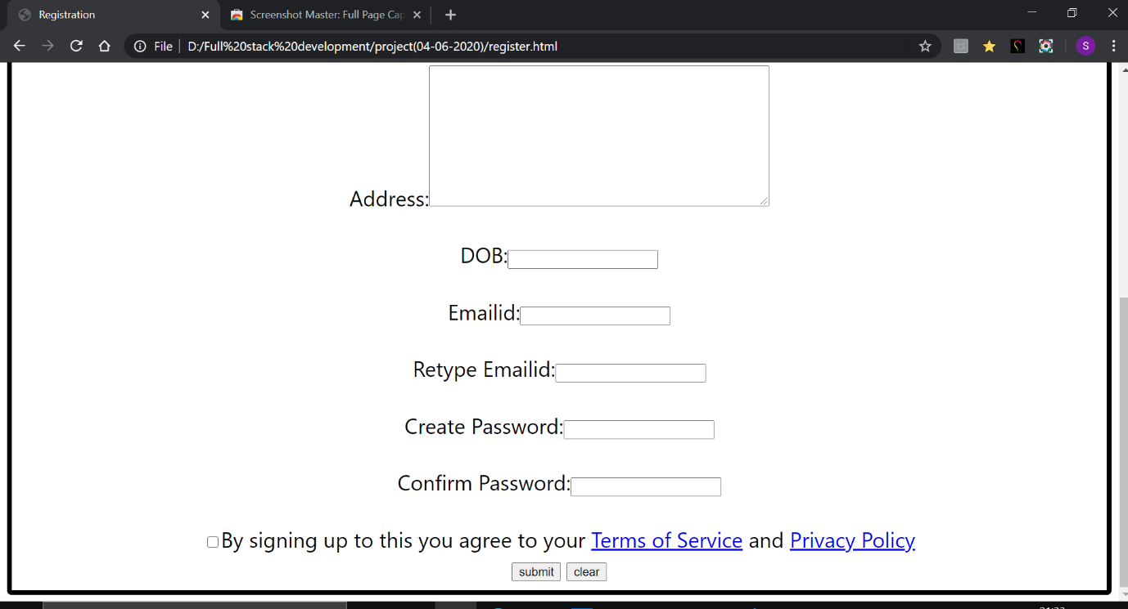

Feedback:

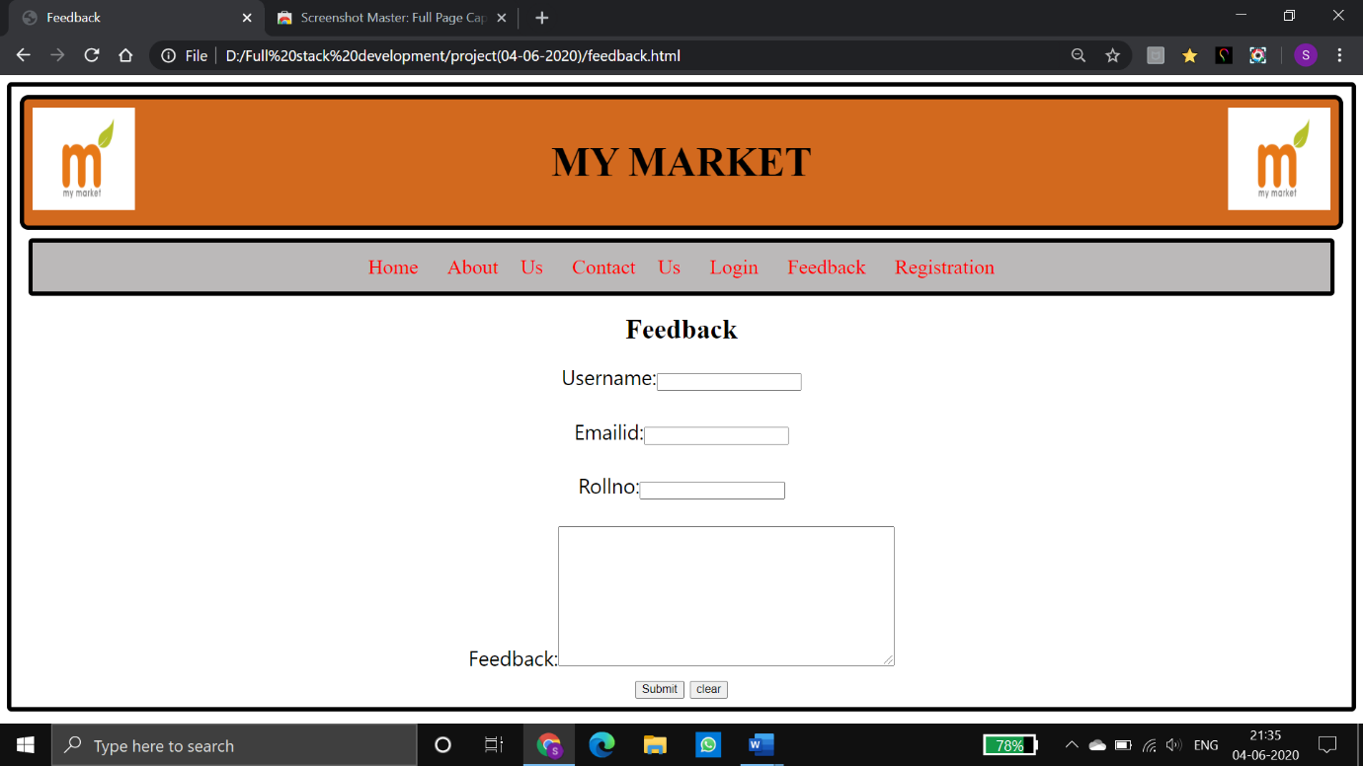

Conclusion: This page is useful for buying groceries online especially for people who are living far away from supermarkets.