**Name: Shefany Shanavas**

**Roll No: 37**

**Batch: B Batch**

**Date:25-03-2022**

**DATABASE MANAGEMENT SYSTEM**

**Experiment No.: 1**

**Aim:**

To understand and study various DDL commands

**Question:**

Create the following Tables and insert values

#### Table 1: DEPOSIT

ACTNO VARCHAR2(5) PRIMARY KEY, FIRST LETTER MUST START WITH ‘D’ CNAME VARCHAR2(15) FOREIGN KEY REFERENCES CUSTOMER

BNAME VARCHAR2(20) FOREIGN KEY REFERENCES BRANCH AMOUNT NUMBER (8,2) NOT NULL, CANNOT BE 0

ADATE DATE

**Table 2: BRANCH**

BNAME VARCHAR2(20) PRIMARY KEYCITY VARCHAR2(30) NOT NULL , any one of NAGPUR, DELHI, BANGALORE, BOMBAY

#### Table 3: CUSTOMER

CNAME VARCHAR2(15) PRIMARY KEY CITY VARCHAR2(20) NOT NULL ,

#### Table 4: BORROW

LOANNO VARCHAR2(8) PRIMARY KEY / FIRST LETTER MUST START WITH ‘L’ CNAME VARCHAR2(15) FOREIGN KEY REFERENCES CUSTOMER

BNAME VARCHAR2(20) FOREIGN KEY REFERENCES BRANCH AMOUNT NUMBER(8,2) NOT NULL, CANNOT BE 0

**INSERTION OF VALUES:**

1. **Inserting values to Branch**
2. **Inserting values into Customer table**
3. **Inserting values into Deposite table**
4. **Inserting values into borrow table**

**Procedure:**

create database BANK;

use BANK;

create table BRANCH(BNAME VARCHAR(20)primary key,city varchar(30)check (city in('NAGPUR','DELHI','BANGALORE','BOMBAY')) NOT NULL);

create table BORROW(LOANNO VARCHAR(8) CHECK (LOANNO LIKE 'L%') PRIMARY KEY,CNAME VARCHAR(15)REFERENCES CUSTOMER(CNAME),BNAME VARCHAR(20)REFERENCES

BRANCH(BNAME),AMOUNT FLOAT(8)CHECK(AMOUNT>0) NOT NULL);

CREATE TABLE CUSTOMER(CNAME VARCHAR(15) PRIMARY KEY,CITY VARCHAR(20)NOT NULL );

create table DEPOSIT(ACTNO VARCHAR(5) CHECK (ACTNO LIKE 'D%') PRIMARY KEY ,CNAME

VARCHAR(15)REFERENCES CUSTOMER(CNAME),BNAME VARCHAR(20)REFERENCES

BRANCH(BNAME),AMOUNT FLOAT(8) CHECK (AMOUNT>0) NOT NULL, ADATE DATE);

INSERT INTO CUSTOMER VALUES('ANIL','CALCUTTA');

INSERT INTO CUSTOMER VALUES('SUNIL','DELHI');

INSERT INTO CUSTOMER VALUES('MEHUL','BARODA');

INSERT INTO CUSTOMER VALUES('MANDAR','PATNA');

INSERT INTO CUSTOMER VALUES('MADHURI','NAGPUR');

INSERT INTO CUSTOMER VALUES('PRAMOD', 'NAGPUR');

INSERT INTO CUSTOMER VALUES('SANDIP','SURAT');

INSERT INTO CUSTOMER VALUES('SHIVANI','BOMBAY');

INSERT INTO CUSTOMER VALUES('KRANTI','BOMBAY');

INSERT INTO CUSTOMER VALUES('NAREN','BOMBAY');

INSERT INTO BRANCH VALUES('VRCE','NAGPUR');

INSERT INTO BRANCH VALUES('AJNI','NAGPUR');

INSERT INTO BRANCH VALUES('KAROLBAGH','DELHI');

INSERT INTO BRANCH VALUES('CHANDNI','DELHI');

INSERT INTO BRANCH VALUES('DHARAMPETH','NAGPUR');

INSERT INTO BRANCH VALUES('MG ROAD','BANGALORE');

INSERT INTO BRANCH VALUES('ANDHERI','BOMBAY');

INSERT INTO BRANCH VALUES('NEHRU PALACE','DELHI');

INSERT INTO BRANCH VALUES('POWAI','BOMBAY');

INSERT INTO DEPOSIT VALUES('D100','ANIL','VRCE',1000.00,'1995-03-1');

INSERT INTO DEPOSIT VALUES('D101','SUNIL','ANJNI',500.00,'1996-01-4');

INSERT INTO DEPOSIT VALUES('D102','MEHUL','KAROLBAGH',3500.00,'1995-11-17');

INSERT INTO DEPOSIT VALUES('D104','MADHURI','CHANDNI',1200.00,'1995-12-17');

INSERT INTO DEPOSIT VALUES('D105','PRAMOD','MG ROAD',3000.00,'1996-03-27');

INSERT INTO DEPOSIT VALUES('D106','SANDIP','ANDHERI',2000.00,'1996-03-31');

INSERT INTO DEPOSIT VALUES('D107','SHIVANI','VIRAR',1000.00,'1995-09-5');

INSERT INTO DEPOSIT VALUES('D108','KRANTI','NEHRU PLACE',5000.00,'1995-05-2');

INSERT INTO DEPOSIT VALUES('D109','MINU','POWAI',7000.00,'1995-08-10');

INSERT INTO BORROW VALUES('L201','ANIL','VRCE',1000.00);

INSERT INTO BORROW VALUES('L206','MEHUL','AJNI',5000.00);

INSERT INTO BORROW VALUES('L311','SUNIL','DHARAMPETH',3000.00);

INSERT INTO BORROW VALUES('L321','MADHURI','ANDHERI',2000.00);

INSERT INTO BORROW VALUES('L371','PRAMOD','VIRAR',8000.00);

INSERT INTO BORROW VALUES('L481','KRANTI','NEHRU PLACE',3000.00);

**Output Screenshot:**

1. **Table deposit**

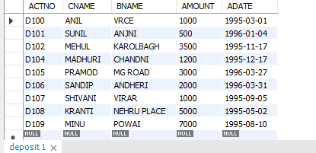

1. **Table branch**

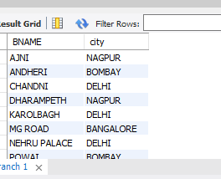

**3.Table customer**

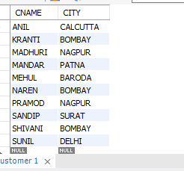

**4.Table borrow**

