**Name: Shefany Shanavas**

**Roll No:37**

**Batch: RMCA B**

**Date: 8-04-2022**

**ADVANCED DBMS LAB**

**Experiment No.: 2**

**Aim**

To familiarize with selecting data from single table

**Question:**

using lab cycle 1, perform the question below:

**Procedure**

1. List all data from table deposite 2.
2. List all data from borrow
3. List all data from customer
4. List all data from branch
5. Give account no and amount of deposite
6. Give customer name and account no of depositors
7. Give name of customers
8. Give name of branches
9. Give name of borrows
10. Give names of customer living in city Nagpur
11. Give names of depositors having amount greater than 4000
12. Give account date of Anil
13. Give name of all branches located in Bombay
14. Give name of borrower having loan number l205
15. Give names of depositors having account at VRCE
16. Give names of all branched located in city Delhi
17. Give name of the customers who opened account date ‘1-12-96’
18. Give account no and deposit amount of customers having account opened between dates ‘1-12-96’ and ‘1-5-96’
19. Give name of the city where branch KAROLBAGH is located 20. Give details of customer ANIL

**Output Screenshot:**

SELECT*FROM DEPOSIT;

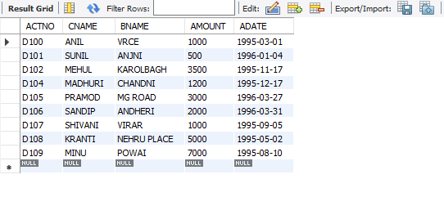

SELECT*FROM BORROW;

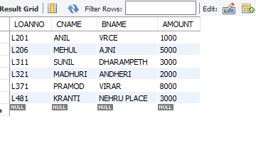

SELECT*FROM CUSTOMER;

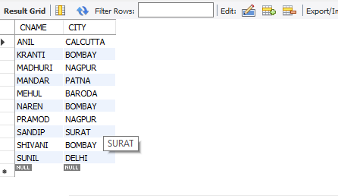

SELECT*FROM BRANCH;

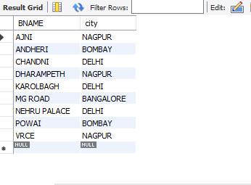

SELECT ACTNO,AMOUNT FROM DEPOSIT;

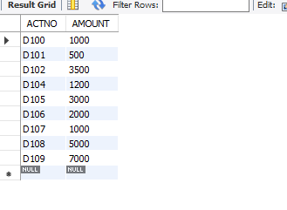

SELECT CNAME,ACTNO FROM DEPOSIT;

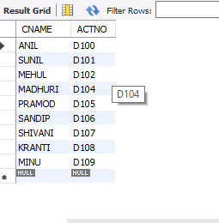

SELECT CNAME FROM CUSTOMER;

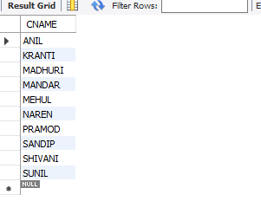

SELECT BNAME FROM BRANCH;

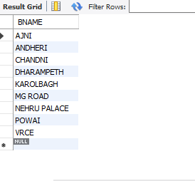

SELECT CNAME FROM BORROW;

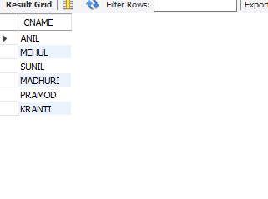

SELECT CNAME FROM CUSTOMER WHERE CITY='NAGPUR';

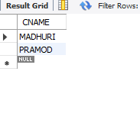

SELECT CNAME from DEPOSIT where AMOUNT>4000;

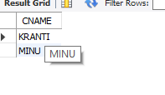

SELECT ADATE FROM DEPOSIT where CNAME='ANIL';

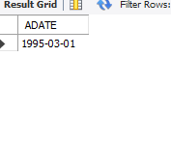

SELECT BNAME from BRANCH where CITY='Bombay';

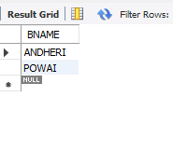

SELECT CNAME from BORROW where LOANNO='L205

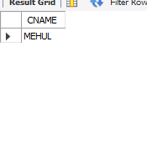';

SELECT CNAME from DEPOSIT WHERE BNAME='VRCE';

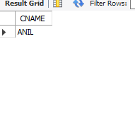

SELECT BNAME from BRANCH WHERE CITY='Delhi';

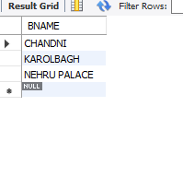

SELECT CNAME from DEPOSIT WHERE ADATE='1996-04-1';

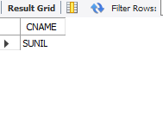

SELECT ACTNO,AMOUNT from DEPOSIT WHERE ADATE BETWEEN '1996-12-1' AND '1996-05-1';

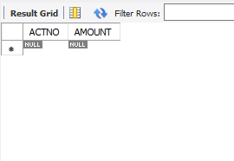

SELECT CITY from BRANCH WHERE BNAME='KAROLBAGH';

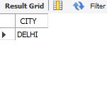

SELECT * from customer join borrow on customer.cname=borrow.cname join deposit on deposit.cname=borrow.cname WHERE customer.cname='ANIL';

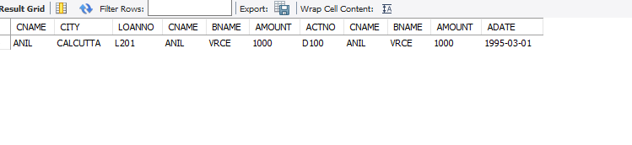

**EXPERIMENT NO. 3**

**AIM**

To familiarize DDL Commands- ALTER,DROP,TRUNCATE,RENAME

**Questions**

1.Create a table emp with attributes empno number(4)as primary key, ename char(10),hiredate,  salary, commission

insert 5 rows of data

|  |  |  |  |  |
| --- | --- | --- | --- | --- |
| 101 | Ramesh | 17-Jan  1980 | 5000 |  |
| 102 | Ajay | 05-Jul  1985 | 5000 | 500 |
| 103 | Ravi | 12-Aug  1981 | 1500 |  |
| 104 | Nikesh | 03-Mar  1983 | 3000 | 700 |
| 105 | Ravi | 05-jul  1985 | 3000 |  |

2.Modifying the structure of tables

a. Add new columns: sal number(7,2)

b. Dropping a column from a table: sal

c. Modifying existing column :ename varchar2(15)

d. Renaming the tables: emp to emp1

e. truncating the tables:emp1

f. Destroying tables:emp

3.Create a table stud with sname varchar2(20) primary key , rollno number(10) not null,dob  date not null

4.Create a table student as regno number (6), mark number (3) check constraint (mark >=0 and  mark  <=100));

5.Create a table cust with(custid number(6) constraint unique, name char(10)

**Procedure& Output Screenshot:**

CREATE Database Employee;

use Employee;

CREATE TABLE emp(EMPNO INT(4) PRIMARY KEY, ENAME CHAR(10),HIREDATE DATE, SALARY INT(5),COMMISSION INT(5));

INSERT INTO emp(EMPNO,ENAME,HIREDATE,SALARY) VALUES

(101,'RAMESH','1980-01-17',5000),(102,'AJAY','1985-07-05',5000),

(103,'RAVI','1981-08-12',1500),(104,'Nikesh','1983-03-03',3000),

(105,'Ravi','1985-07-05',3000);

ALTER TABLE emp ADD sal int;

SELECT * FROM emp;

ALTER TABLE emp DROP COLUMN sal;

SELECT * FROM emp;

RENAME table emp to emp1;

TRUNCATE TABLE emp1;

DROP TABLE emp1;

CREATE TABLE stud(sname varchar(20) PRIMARY KEY, rollno int NOT NULL, dob

date NOT NULL);

INSERT INTO stud(sname,rollno,dob)VALUES('Aamii','37','2000-01-18');

INSERT INTO stud(sname,rollno,dob)VALUES('Abyy','1','2001-01-12');

INSERT INTO stud(sname,rollno,dob)VALUES('afuu','2','1999-12-20');

INSERT INTO stud(sname,rollno,dob)VALUES('shamjadhikka','36','2000-06-20');

SELECT * FROM stud;

Create table student (regno int, mark int(3) constraint b check (mark >=0 and mark<=100));

SELECT * from STUDENT;

CREATE TABLE CUST(CUST_ID INT PRIMARY KEY,NAME VARCHAR(10));