**Name: Shefany Shanavas**

**Roll No: 37**

**Batch: MCA-B**

**Date: 08-04-2022**

**ADVANCED DATABASE MANAGEMENT LAB**

**EXPERIMENT NO. 3**

**AIM**

To familiarize DDL Commands-

ALTER, DROP, TRUNCATE,RENAME

**Questions**

1.Create a table emp with attributes emp no number(4)as primary key, ename char(10),hiredate, salary, commission

insert 5 rows of data

|  |  |  |  |  |
| --- | --- | --- | --- | --- |
| 101 | Ramesh | 17-Jan  1980 | 5000 |  |
| 102 | Ajay | 05-Jul  1985 | 5000 | 500 |
| 103 | Ravi | 12-Aug  1981 | 1500 |  |
| 104 | Nikesh | 03-Mar  1983 | 3000 | 700 |
| 105 | Ravi | 05-jul  1985 | 3000 |  |

2.Modifying the structure of tables

a. Add new columns: sal number(7,2)

b. Dropping a column from a table: sal

c. Modifying existing column :ename varchar2(15)

d. Renaming the tables: emp to emp1

e. truncating the tables:emp1

f. Destroying tables:emp

3.Create a table stud with sname varchar2(20) primary key, rollno number(10) not null,dob  date not null

4.Create a table student as regno number (6), mark number (3) check constraint (mark >=0 and  mark  <=100));

In table student add check constraint(length(regno<=4))

5.Create a table cust with(custid number(6) constraint unique, name char(10)

6. Refer the table “stud” in table “student”

**Procedure & Output**

1. CREATE TABLE emp(EMPNO INT(4) PRIMARY KEY, ENAME CHAR(10), HIREDATE  DATE, SALARY INT(5),COMMISSION INT(5));

INSERT INTO emp(EMPNO,ENAME,HIREDATE,SALARY)

VALUES (101,'RAMESH','1980-01-17',5000),(102,'AJAY','1985-07-05',5000),

(103,'RAVI','1981-08-12',1500),(104,'Nikesh','1983-03-03',3000),

(105,'Ravi','1985-07-05',3000);

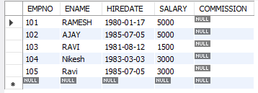

a) ALTER TABLE emp ADD column sal int ;

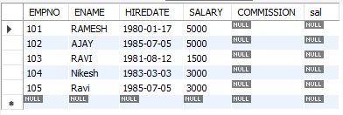

b) ALTER TABLE emp DROP COLUMN sal;

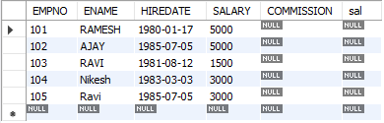

c) ALTER TABLE emp MODIFY ename VARCHAR(15);



d) RENAME table emp to emp1;



e) TRUNCATE TABLE emp1;



f) DROP TABLE emp1;



3. CREATE TABLE stud(sname varchar(20) PRIMARY KEY, rollno int NOT NULL, dob date  NOT NULL);

    SELECT * FROM stud;



4. Create table student (regno int, mark int(3) constraint b check (mark >=0 and mark <=100));

 SELECT * from student;

.https://lh6.googleusercontent.com/C3hoH1amOZjrJ1UcecrXtCMK9XEJ0kzi8ilNgvhQ0EFSWEdCe2mdfP60sUp-v413ej4dclk8t0Tn6x-8pZjKj90X9lyI3do3RCnGab4CTdjg7SFsghfIPfAu2bjQnkdeTEPaOzBA

5. CREATE TABLE cust (custid int  UNIQUE, name char(10));

