**Validation of the block**

**Radiation_on_Inclined_Surface**

Table of contents

1 Software versions 2

2 Description of the model 2

2.1 Block 2

2.2 Model File 5

2.3 Incidence angles 6

3 Results 7

3.1 Annual Solar Radiation 7

3.2 Incidence angles 8

4 Literature 8

**Author**

Bernd Hafner, Viessmann Werke, Germany

**Complete path of the block in the Carnot Library**

Carnot/weather/radiation_on_inclinded surface

**Changes in the document**

11/04/2012 created

19/04/2012 added incidence angles verification

# Software versions

Meteonorm Version 6.1

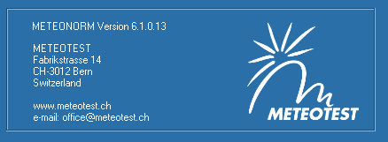

**Version of Model, Carnot, Matlab and Operation system**

surfrad.c (V 5.1.0), Carnot 5.2, Matlab R2010b, Windows XP

surfrad.c V 7.0 , Carnot 7.0, Matlab R2018b, Windows 10

# Description of the model

## Block

Detailed description of the equations is given by Duffie (2006).

Model for the comparison:

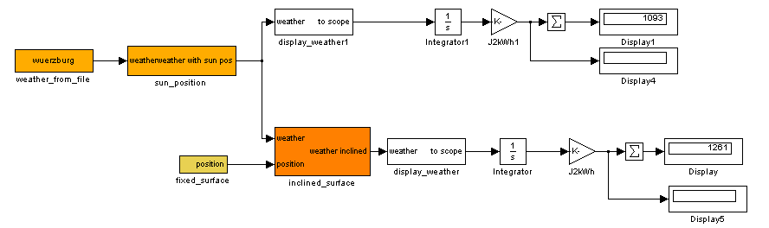

“Look under Mask” of the Block:

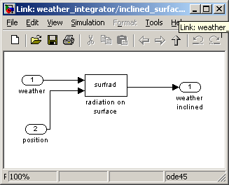

Block parameters:

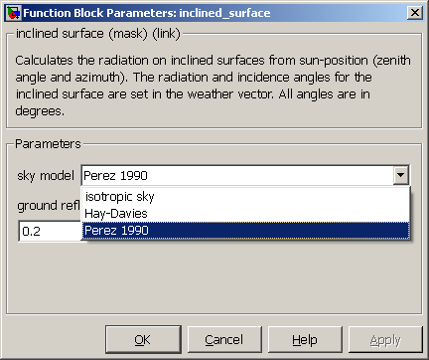

The Position is varied:

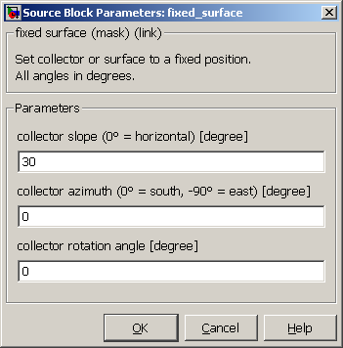

## Model File

Comparison of horizontal and inclined solar radiation for the location Wuerzburg (Germany), results of Meteonorm and Carnot are compard. The input for Carnot is the Meteonorm weather data file generated for the same location using the 5.x Carnot weather data format (including direct normal radiation).

Solver parameters:

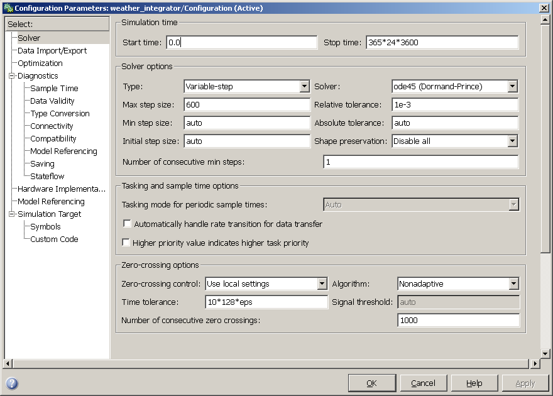

## Incidence angles

According to ISO 9806:2017 the longitudinal and transversal incidence angles are:

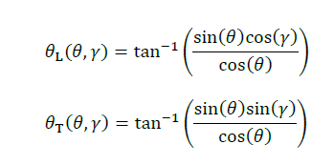

With





The calculation of the incidence angle θ can be taken from literature (e.g. Duffie, Beckmann: Solar Engineering of Thermal Processes, 2006).

The validation was done with the calculation results of Meteonorm.

# Results

## Annual Solar Radiation

Annual sum of solar radiation in kWh/m²

Perez Sky Model, ground reflectance 0.2

|  |  |  |  |  |  |
| --- | --- | --- | --- | --- | --- |
| Azimut | Inclination | **Meteonorm**  **Global** | CARNOT  Global | **Meteonorm**  **Diffuse** | CARNOT  Diffuse |
| 0 | 0 | **1093** | 1092 | **594** | 593 |
| 0 | 30 | **1257** | 1255 | **628** | 629 |
| 0 | 60 | **1178** | 1178 | **583** | 585 |
| 0 | 90 | **882** | 883 | **471** | 474 |
| 45 | 30 | **1192** | 1190 | **614** | 614 |
| 45 | 60 | **1102** | 1101 | **565** | 567 |
| 45 | 90 | **846** | 846 | **461** | 464 |
| -90 | 30 | **1041** | 1044 | **574** | 576 |
| -90 | 60 | **906** | 912 | **511** | 516 |
| -90 | 90 | **699** | 707 | **421** | 427 |
| 120 | 30 | **903** | 901 | **545** | 544 |
| 120 | 60 | **715** | 715 | **470** | 471 |
| 120 | 90 | **547** | 548 | **388** | 391 |
| -180 | 30 | **775** | 774 | **512** | 512 |
| -180 | 60 | **484** | 486 | **414** | 415 |
| -180 | 90 | **373** | 376 | **350** | 351 |

## Incidence angles

Results of verify_RadiationInclinedSurface



# Literature

Duffie, J., Beckman, W.: Solar Engineering of thermal processes, John Wiley & Sons Inc, 2006

ISO 9806:2017 Solar energy – Solar thermal collectors – Test methods (ISO 9806:2017)