Verification of the battery block with electric bus connectors

Table of contents
1 Data used for verifcation 1
2 Description of the model 2
2.1 Block 2
2.2 Model File 2
3 Results 2
4 Literature 4

Author
Manuel Koch, Institute Energy in Building, University of Applied Sciences and Arts Northwestern Switzerland (FHNW) in Muttenz

Version of Model, Carnot, Matlab and Operation system
Battery_EB (Version 1.0), Carnot 7.0, Matlab R2018b, Windows 10

Complete path of the block in the Carnot Library
\branches\carnot_7_00_01\public\library_simulink\Storage\Electric\Battery_EB

Data used for verifcation
The verification does not use real data. A power input is defined and the outputs are compared to calculated expected values.

Description of the model

Block
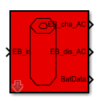
The model represents a simple battery, based on one integrator. Inputs and outputs are in the “Electric bus (power only)” format. It takes capacity, power limits, conversion efficiencies and stand-by power into account.

Model File
ModelVerification.slx: The model file containing all the input data.
MasterVerification.m: The master file running the model and plotting the results.

Results
The following parameters are used:
Parameters
Capacity in kWh | 5e6/3.6e6  = 1.388
Charging efficiency | 0.9
Discharging efficiency | 0.9
Initial charge condition (0…1) | 1
Maximal SOC [-] | 1
Minimal SOC [-] | 0
Maximal input power | 1000
Maximal output power | 1000
Standby power consumption [W] | 10

The following zero-order hold power inputs are fed to the battery model:
Time [s] | 0 | 5e5 | 6e5 | 7e5 | 8e5 | 9e5
Power [W] | 0 | 100 | -100 | 10000 | -10000 | 10000

From these values and the battery parameters, the following charging and discharging durations are calculated:
Stand-by discharge: 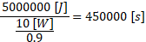
Charge with 100 W: 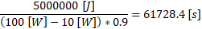
Discharge with 100 W: 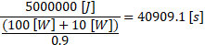
Charge and discharge with 10000 W 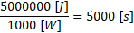
(over the power limit):

This results in the following energy levels should be reached at the specified times:
Time [s] | Energy [J]
0.0 | 5'000’000
450'000.0 | 0
500'000.0 | 0
561'728.4 | 5'000’000
600'000.0 | 5'000’000
640’909.1 | 0
700'000.0 | 0
705'000.0 | 5'000’000
800'000.0 | 5'000’000
805'000.0 | 0
900'000.0 | 0

As the plot generated by the MasterVerification.m file shows, calculated and simulated values match:
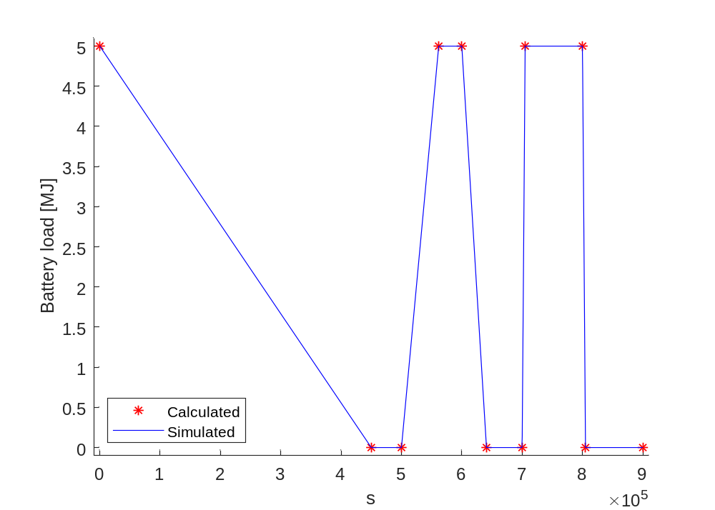

Literature

