storage_multiport   
Path: CARNOT/storage

Purpose : Multiport model for storage with heat exchanger(s).

c-files: storage_Tnodes.c, storage_heatexchanger

# Description

The basic concept is a multiport one-dimensional model. The storage is connected to other CARNOT components by a variable number of port blocks.



Figure 1: Storage model example with 2 heat exchangers and 1 pipe connection, a typical domestic hot water cylinder for solar applications.

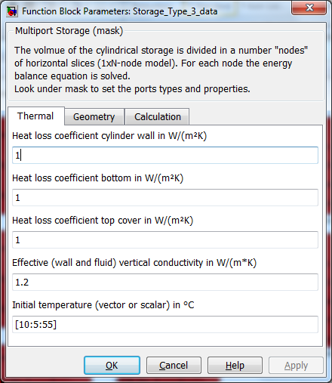

Figure 2: Storage mask: Thermal parameters

The initial temperature can be a scalar value which means one temperature for all nodes. It may also be a vector with the length “nodes”. In this case each node is initialized with its individual temperature. The first element in the vector is the temperature for the bottom node.

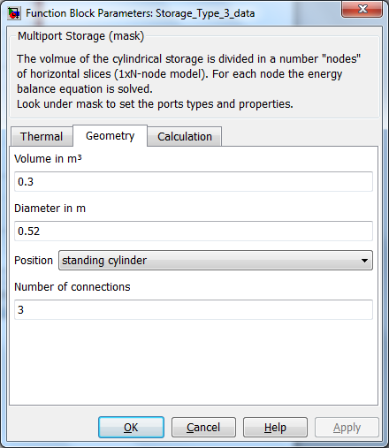

Figure 3: Storage mask: Geometry parameters

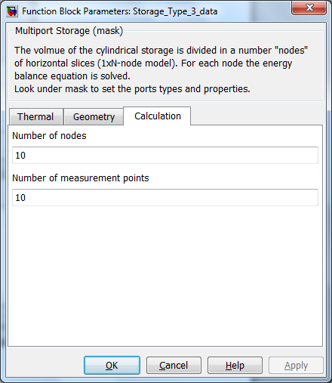

Figure 4: Storage mask: Calculation parameters

The type of port can be a simple pipe, ending at the storage wall and releasing the fluid in the storage or a heat exchanger.



Figure 2: “Look under Mask” of the storage model in figure 1. The pipe connection and the heat exchangers can be seen.

The port blocks define the type and properties of supporting elements and their position relative to the storage.

Figure 3: Pipe mask: Geometry parameters

The port block takes the information from the entering Thermo-Hydraulic Bus (THB) and gives a vector to the storage model.



Figure 2: Principle of a port, example of a pipe connection

The vector from the port to the storage has the following elements. The node 1 is the bottom node of the storage.

|  |  |  |
| --- | --- | --- |
|  | [T_in_1, T_in_2, … T_in_N] | Vector with N elements: temperatures of mass flows entering nodes |
|  | [mdot_in_1, T_mdot_in_2, … mdot_in_N] | Vector with N elements: mass flows entering nodes |
|  | [mdot_up_1, mdot_up_2, … mdot_up _(N-1)] | Vector with N-1 elements: internal mass flows upwards due to pipe connections |
| Port2Storage = | [mdot_down_1, mdot_down_2, …  mdot_down _(N-1)] | Vector with N-1 elements: internal mass flows downwards due to pipe connections |
|  | [Qdot_1, Qdot_2, … Qdot_N] | Vector with N elements: power entering node (negative for cooling) due to heat exchangers |
|  | pressure | Pressure of fluid (relevant only for pipe connections, -9999 for heat exchangers) |
|  | Fluid type | Fluid type (relevant only for pipe connections, -9999 for heat exchangers) |
|  | Fluid mixture | Fluid mixture (relevant only for pipe connections, -9999 for heat exchangers) |

Inputs:

Port 1: ambient temperature in [°C]

Port 2: Port2Storage Vector 1

…

Port N+1: Port2Storage Vector N

Outputs:

Port 1: Energy balance of the storage:

1 - internal change of energy in J

2 - thermal losses in J

Port 2: vector with the node temperatures (first temperature is bottom node, last temperature is the top node)

**Mathematical Model**

The storage is divided into N nodes. An energy balance for every node is done using the following differential equation:

(rho*cp) * dT/dt =   
(Uwall * Aloss_wall + Utop * Aloss_top + Ubot * Aloss_bot) / Vnode * (Tamb - Tnode)  
+ condup / dh2 * (Tnode_above - Tnode) + conddown / dh2 * (Tnode_below - Tnode)   
+ mdot_up * cp / Vnode * (Tnode_below - Tnode) + mdot_down * cp / Vnode * (Tnode_above - Tnode)   
+ m dot_in * cp / Vnode * (Tin - Tnode)  
+ Uhx * Ahx / Vnode * (Thx_node - Tnode)

|  |  |  |  |
| --- | --- | --- | --- |
| **symbol** | **used for** | **unit** | |
| Aloss_bot | Additional surface for losses of bottom node (top cylinder surface) | m2 | |
| Aloss_top | Additional surface for losses of top node (bottom cylinder surface) | m2 | |
| Aloss_wall | Wall surface for losses of one storage node (cylinder wall) | m2 | |
| Ahx | surface area of heat exchanger per storage node | m² | |
| conddown | effective vertical thermal conduction downwards (=0 for bottom) | | W/(m*K) |
| condup | effective vertical thermal conduction upwards (=0 for top) | W/(m*K) | |
| cp | heat capacity | J/(kg*K) | |
| dh | distance between two nodes | m | |
| mdot | Mass flow ("up" or "down" is zero according to sum of flowrates) | kg/s | |
| mdot_in | Mass flow entering the node (from a pipe connection) | kg/s | |
| rho | density | kg/m3 | |
| T | temperature | K | |
| t | Time | [s] | |
| Uloss_bot | heat loss coefficient of bottom surface | W/(m2K) | |
| Uloss_top | heat loss coefficient of top surface | W/(m2K) | |
| Uloss_wall | heat loss coefficient of wall surface | W/(m2K) | |
| Uhx | heat transfer coefficient of heat exchanger | [W/(m2K)] | |
| Vnode | node volume | [m3] | |

For this node-scheme you have to obey the following boundary condition for the Courant number when using fixed timestep solvers:

      c = Dt*v/Lnode< = 1   
For most exact results, the maximum time step should be 300 seconds.

The effective axial thermal conductivity is calculated by means of the equation:

|  |  |  |
| --- | --- | --- |
| symbol | used for | Unit |
| AC,wall | cross-section area of wall | [m2] |
| AC,storage | cross-section area of storage | [m2] |
| AC,heatex | cross-section area of heat exchanger | [m2] |
| wall | thermal conductivity of wall material | [W/(m*K)] |
| fluid | thermal conductivity of fluid in storage | W/(m*K) |
| heatex | thermal conductivity of heat exchanger material | W/(m*K) |

As we need to know the temperature at fixed places inside the storage, a number of measurement points are placed at equidistant locations inside the storage, no matter how many nodes are used for the calculation. The first temperature in the output vector "Tnode" corresponds to the lowest measurement point, rising numbers in upwards.

Inversed Thermocline

From the differential equation it may occur that some lower nodes have a higher temperature than the upper nodes. This is a typical situation when heating the storage with an immersed heat exchanger at the lower part. To avoid this unrealistic situation, an algorithm for the elimination of the inversed thermocline is included in the model. Two nodes are mixed if the lower one has a 1e-4 K higher temperature than the upper one.

The storage consists of different subsystems, e.g. ports for connecting the elements. The subset "ports for storage" in the CARNOT library contains the possible connections.

Das Speichermodell ist ein 1-dimensionales Mehrknotenmodell. Folgende Abbildung zeigt beispielhaft eine Umsetzung des Modells mit 5 Knoten (bei der Modellierung realer Speicher werden typischerweise 50 bis 100 Knoten gerechnet).

Direct charge

Direct discharge

**5**

**4**

**3**

**2**

**1**

Bilanzierung der Massenströme über die einzelnen Volumen-Scheiben, es wird zwischen eintretendem (Mdot_in), aufströmendem (Mdot_up) und abströmendem (Mdot_down) Massenstrom unterschieden. Der Index N der Volumen-Scheibe bezieht sich bei den Massenströmen immer auf die Trennfläche zum nächsten oberhalb liegenden Scheibe (Index N+1).

**5**

**4**

**3**

**2**

**1**

Mdot_in

Mdot_in

Tout = T(3)

Tout = T(1)

Mdot_down(4)=0

Mdot_up(1)

Mdot_up(2)

Mdot_down(3)=0

Mdot_down(2)

Mdot_down(1)

Mdot_up(3)=0

Mdot_up(4)=0

Im c-code des Speichers storage_Tnodes.c wird für alle Knoten n außer dem obersten Knoten bewertet, ob von oben Massenstrom (Index n) in den Knoten einströmt. Wenn ja, dann wird der eintretende Massenstrom mit der Temperatur des Knoten oberhalb bewertet.

*if (n < TOP && MDOTUP(n) < MDOTDOWN(n))*

*uhx += CP_NODE(n)*(MDOTDOWN(n)-MDOTUP(n))*(T(n+1)-T(n));*

Weiterhin wird für alle Knoten n außer dem untersten Knoten bewertet, ob von unten Massenstrom (Index N-1) in den Knoten einströmt. Wenn ja, dann wird der eintretende Massenstrom mit der Temperatur des Knotens unterhalb bewertet.

*if (n > BOTTOM && MDOTUP(n-1) > MDOTDOWN(n-1))*

*uhx += CP_NODE(n)*(MDOTUP(n-1)-MDOTDOWN(n-1))*(T(n-1)-T(n));*

******** alter Text *************

the masked block of the storage to define the parameters

The parameters are the geometric and thermodynamic data of the storage. The multiport storage block determines the calculations of the storage. In this block the number of ports, (i.e. the number of external elements), the number of temperature sensors (measurement points inside the storage to know the temperature at defined points) and the number of nodes are defined. The calculation itself is performed in this block by an S-function. Finally, the port blocks define the type of entry components by an identifier, the geometry and the thermodynamic properties which are passed to the multiport storage inlet ports. Moreover the Thermo-Hydraulic Vector is split before the calculation in the port block, and after the calculation the THV is reassembled with the new value in the port blocks and passed to the next block. Parameters also include the position relative to the store.

Characteristics   
Direct Feedthrough   Yes   
Sample time              Inherited from driving block   
States                       corresponding to the number of nodes   
Vectorized                No

Validation

nn

*Bernd Hafner, 26.08.13*