AI Solution Proposal
Predictive Wait-Time & Queue Optimization System
Mindtone Mental Health Clinic

1. Solution Overview
We propose an AI-powered Outpatient Flow Assistant built around three connected capabilities: (1) a wait-time prediction engine that estimates each patient's expected wait in real time, (2) a queue and load optimizer that uses those predictions to rebalance walk-ins and bookings across clinicians and time slots, and (3) patient- and staff-facing dashboards that surface live wait estimates and queue health. The system is designed specifically for Mindtone's Psychiatry, Counseling, and Addiction Therapy departments, with attention to the emotional sensitivity of a mental health setting.

2. How It Works
- Data ingestion: appointment, check-in, staffing, and historical visit data from Mindtone feed a central data warehouse.
- Prediction: a trained regression model (XGBoost) predicts wait time in minutes for each patient, using department, clinician, time of day, queue depth, and walk-in load as inputs.
- Optimization: predicted wait times feed a rules-plus-ML optimizer that reassigns walk-ins to the least-loaded clinician, flags overbooked hours before they occur, and recommends proactive rescheduling.
- Feedback loop: actual outcomes are logged and used to retrain the model on a rolling schedule, so accuracy improves as more visit data accumulates.
- Mental-health-aware communication: wait updates are phrased calmly and never display an abrupt countdown, to avoid adding anxiety for sensitive patients.

3. Model Prototype — Results
A working prototype was built and validated on 2,976 synthetic-but-representative Mindtone outpatient visit records spanning Psychiatry, Counseling, and Addiction Therapy. Three model families were compared — Gradient Boosting, Random Forest, and XGBoost — and XGBoost was selected as the production candidate on accuracy and training speed.
Model | MAE (minutes) | RMSE (minutes) | R² | Train time (s)
XGBoost (selected) | 5.25 | 6.61 | 0.845 | 0.26
Gradient Boosting | 5.37 | 6.74 | 0.839 | 1.07
Random Forest | 6.51 | 8.14 | 0.765 | 2.20
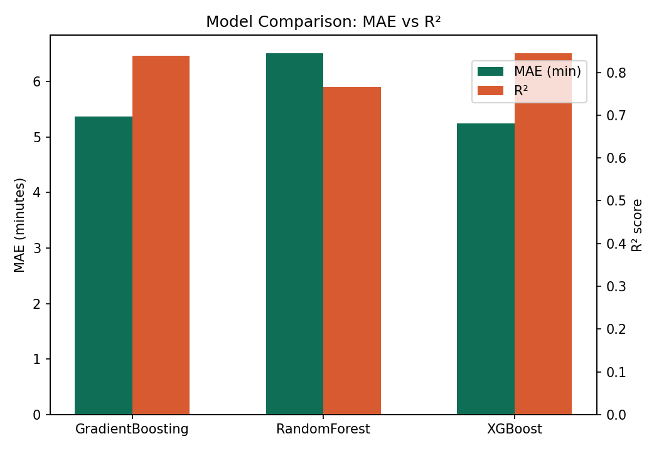
Figure 2: XGBoost narrowly outperforms Gradient Boosting on accuracy and trains roughly 4–8x faster — a meaningful advantage given the system’s scheduled retraining cycle — and is the recommended production model.
Why XGBoost over the alternatives: at this data volume, XGBoost and scikit-learn's Gradient Boosting perform almost identically on accuracy (both are gradient-boosted tree ensembles) — the gap that matters here is training speed. XGBoost's histogram-based split-finding trains 4–8x faster than the sklearn implementation, which lowers the cost of the rolling retraining cycle described in Section 2, and its built-in L1/L2 regularization gives it more headroom as production data volume grows. Random Forest was retained in the comparison as a non-boosting baseline; its bagging approach underperforms here because it cannot correct sequential errors the way boosting does, which matters when wait time depends on compounding factors like queue depth interacting with staffing and time of day.
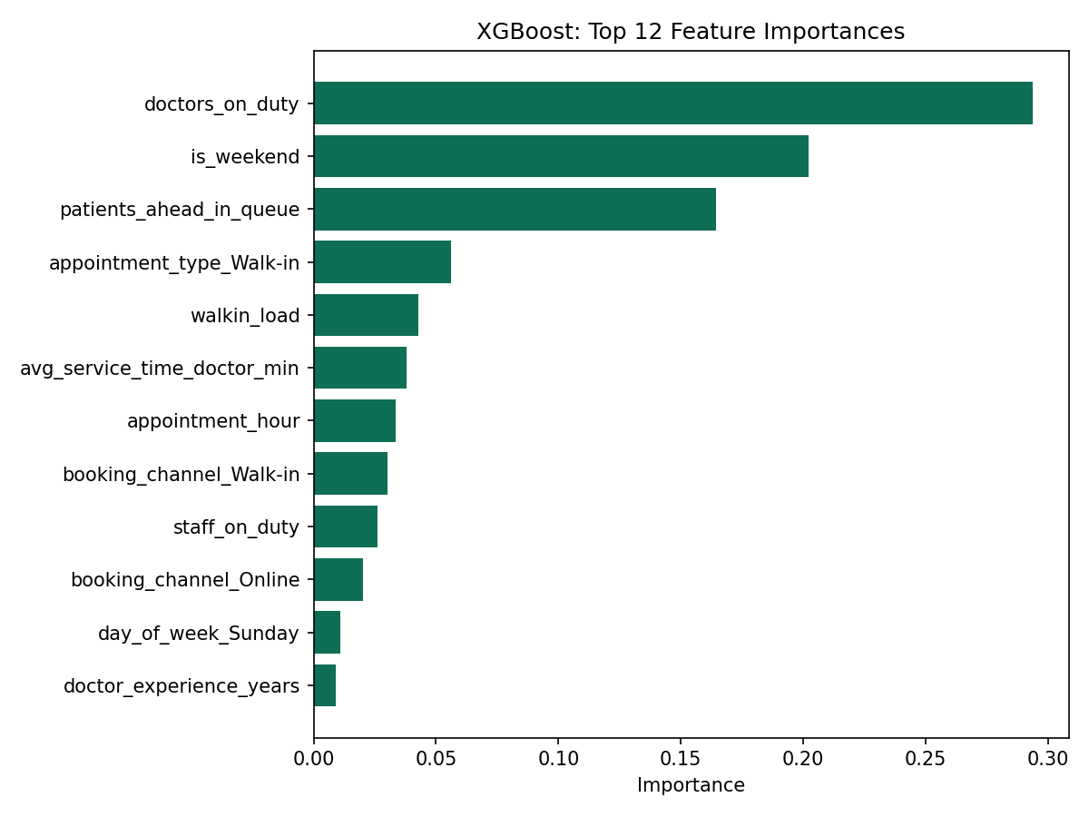
Figure 3: Patients-ahead-in-queue, walk-in load, and clinician staffing are the strongest predictors of wait time — confirming the root causes identified in the Business Problem Analysis.

4. Projected Impact
Applying the model's predictions to a load-aware scheduling simulation (walk-ins routed to the least-loaded clinician, peak hours proactively smoothed, overflow patients flagged for rescheduling) shows a substantial reduction in wait time:
Metric | Current process | AI-optimized | Improvement
Average wait time | 26.0 min | 18.5 min | -28.6%
90th-percentile wait time | 49.0 min | 34.2 min | -30.2%
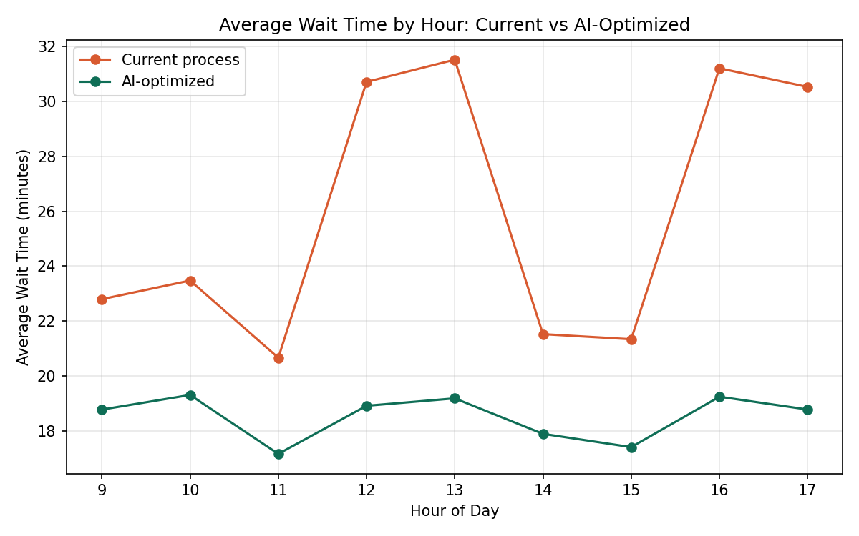
Figure 4: Hour-by-hour average wait time, current process vs. AI-optimized scheduling. The largest gains are at midday and late-afternoon peaks.

5. System Architecture
The platform is organized into five layers: patient/staff access channels, an API gateway, core application services (scheduler, prediction engine, optimizer, notifications), an offline ML pipeline for training and monitoring, and a data layer holding operational and historical clinic data.
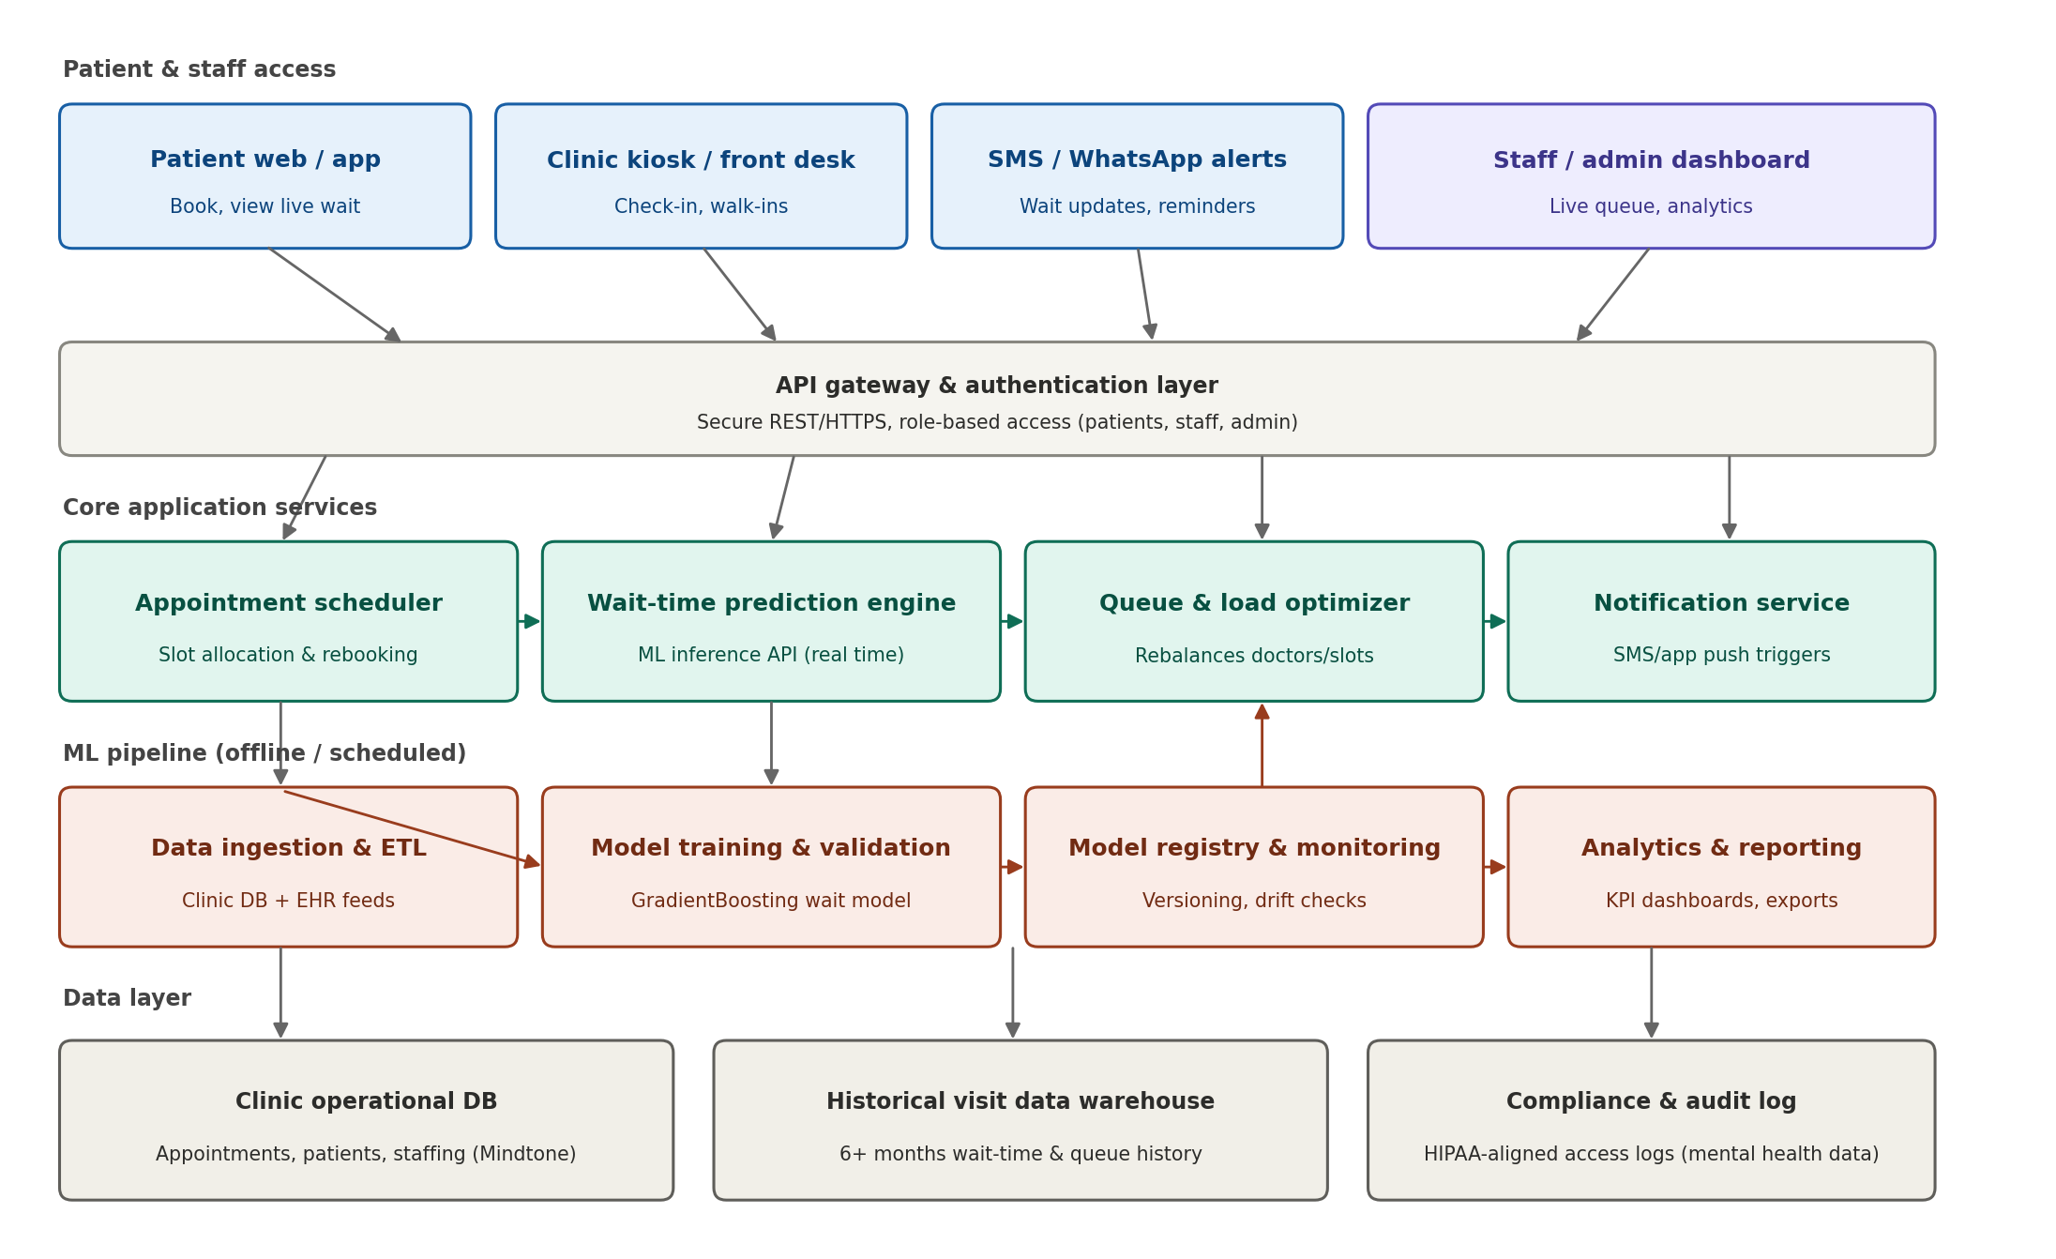
Figure 5: End-to-end system architecture.

6. Key Technology Choices
Layer | Technology | Rationale
Prediction model | XGBoost | Best accuracy and training-speed tradeoff on tabular clinic data; explainable feature importances; fast enough for frequent scheduled retraining
API layer | REST API (FastAPI/Node) | Simple integration with Mindtone's existing clinic systems and patient app
Data storage | Managed relational DB + data warehouse | Reliable transactional data plus historical analytics store
Notifications | SMS/WhatsApp/app push gateway | Reaches patients without requiring app installation; calm, non-alarming messaging
Hosting | Cloud (AWS/Azure/GCP), region-local | Scalable, supports healthcare data residency requirements

7. Data & Privacy Considerations
- Patient data (names, contact details, clinical/session notes) is not required by the prediction model — only operational fields (department, clinician, time, queue depth) are used.
- Given the sensitivity of mental health records, access is strictly role-based (patient, front-desk, clinician, admin), with all data encrypted in transit and at rest.
- The system is designed to align with applicable healthcare data protection requirements (e.g. HIPAA-equivalent controls), to be confirmed with Mindtone's compliance lead during discovery.

8. Rollout Approach
We recommend piloting the system in one department (Psychiatry, Mindtone's highest-volume department) first, validating prediction accuracy and staff workflow fit, then extending to Counseling and Addiction Therapy with configuration changes only — no separate build. Full detail is in the accompanying Development Timeline and Cost Estimation documents.

