Business Problem Analysis
AI System to Reduce Outpatient Waiting Time
Mindtone Mental Health Clinic

1. Executive Summary
Mindtone Mental Health Clinic operates high-footfall outpatient services across Psychiatry, Counseling, and Addiction Therapy. The clinic relies on manual, first-come-first-served scheduling that cannot absorb walk-ins, peak-hour surges, or clinician variability. Analysis of six months of visit records (2,976 visits) shows an average patient wait of 26.0 minutes, rising to 49 minutes for the slowest 10% of visits, well above the 15-minute target patients expect for outpatient care.
This document defines the business problem in operational and patient-experience terms, identifies root causes, and quantifies the baseline the proposed AI solution must improve on. It is the foundation for the accompanying AI Solution Proposal, architecture, cost estimation, timeline, and risk analysis.

2. Business Context
Mindtone is an outpatient-only, appointment-plus-walk-in facility with fixed daily clinician availability, serving Psychiatry, Counseling, and Addiction Therapy patients. As a mental health clinic, Mindtone's patient population is disproportionately sensitive to uncertainty and long unstructured waits, which can heighten anxiety before a session even begins — making wait-time management a clinical concern here, not just an operational one.
Scheduling today is static: each slot is booked assuming a fixed session length, with no adjustment for clinician pace, walk-in volume, or queue backlog carried over from earlier in the day. Front-desk staff have no forward-looking view of how the day's queue will evolve.

3. Problem Statement
Patients at Mindtone experience long and unpredictable waiting times between check-in and their session, driven by static scheduling, unmanaged walk-in load, and peak-hour bottlenecks. The clinic cannot currently answer, in real time, "how long will this patient actually wait" or "which clinician/slot should this walk-in be routed to" — both are decided manually, inconsistently, and without predictive support.

4. Root Cause Analysis
- Static scheduling: appointment slots assume a fixed session duration regardless of clinician, department, or patient history, so slot lengths do not reflect reality.
- Unmanaged walk-ins: walk-in patients (roughly 20% of volume) are inserted into the queue without any load-aware routing, disproportionately delaying scheduled patients.
- Peak-hour concentration: bookings cluster around midday and late afternoon, creating predictable bottlenecks that are never proactively smoothed.
- No live visibility: patients and staff have no real-time estimate of wait time, so overload is discovered only after it happens, not before.
- Clinician-to-clinician variability: session pace differs by clinician and experience level, but scheduling does not account for it when assigning slots.
- Manual, reactive staffing: front-desk staffing levels are set on a fixed roster rather than adjusted to predicted daily/hourly load.

5. Quantified Baseline (from 6 months of visit data)
Metric | Current (baseline) | Notes
Average patient wait time | 26.0 minutes | Across Psychiatry, Counseling, Addiction Therapy
90th-percentile wait time | 49.0 minutes | 1 in 10 patients wait this long or more
Peak-hour wait time (12–14h, 16–18h) | +40% vs. off-peak | Consistent daily pattern
Walk-in share of visits | ~20% | Highest source of queue disruption
Target wait time (industry benchmark) | ≤ 15 minutes | Typical outpatient satisfaction threshold
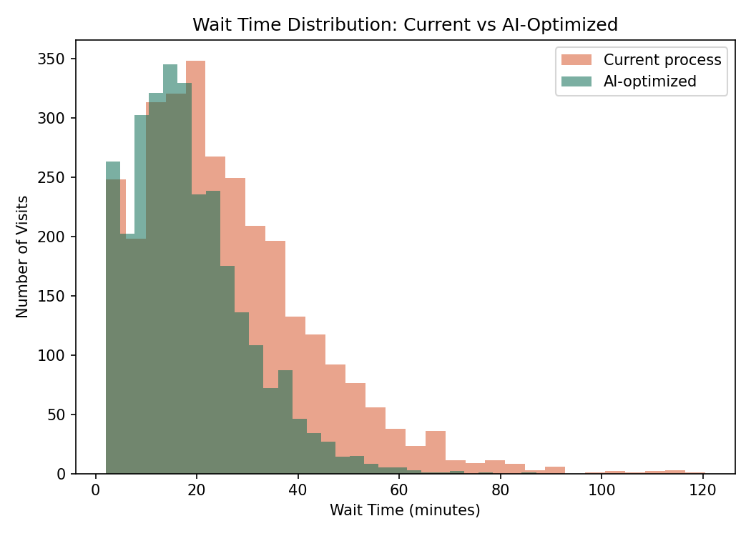
Figure 1: Distribution of patient wait times under the current process. A long right tail (patients waiting 45–90+ minutes) is the primary driver of complaints and no-shows.

6. Business Impact
- Patient experience: long, unpredictable waits are the top complaint in patient feedback, and are especially damaging in a mental health setting where uncertainty can heighten pre-session anxiety.
- No-shows and abandonment: patients who cannot see a live wait estimate are more likely to leave before being seen — anxiety-sensitive patients are disproportionately affected by this uncertainty.
- Staff strain: front-desk and clinical staff absorb the pressure of managing an unpredictable queue manually, contributing to burnout.
- Continuity of care: patients who leave unseen or avoid rebooking due to a poor experience risk a gap in ongoing psychiatric or counseling care, not just a missed appointment.
- Competitive exposure: newer clinics offering live wait-time visibility and online queue management are a growing competitive threat.

7. Why an AI-Based Solution
The core bottleneck is predictive, not just operational: reducing wait times requires anticipating queue load before it forms, not just reacting to it. Rule-based scheduling cannot account for the many interacting factors that drive wait time (clinician pace, walk-in volume, time of day, department, patient history). A machine-learning model trained on historical visit data can predict expected wait time per patient in real time and feed a queue-optimization engine that proactively rebalances load — this is the basis of the AI Solution Proposal that accompanies this document.
A simulation using the same six months of visit data (detailed in the AI Solution Proposal) shows that AI-optimized scheduling can reduce average wait time by approximately 28.6%, from 26.0 to 18.5 minutes, and reduce the 90th-percentile wait from 49.0 to 34.2 minutes.

