Technical Presentation Notes
15-Minute Trainee Presentation — Outpatient Wait-Time Prediction
This is the speaking outline for the 15-minute technical presentation, covering problem statement, dataset, model, results, challenges, and future scope. Suggested timing is shown for each section; adjust to fit your own pace.

1. Problem Statement
Suggested time: 2 minutes
- Mindtone Mental Health Clinic suffers from long, unpredictable outpatient wait times — averaging 26.0 minutes, with a 90th-percentile of 49 minutes.
- Root cause: static, first-come-first-served scheduling that can't adapt to walk-ins, peak-hour load, or doctor-to-doctor variability.
- Goal: predict each patient's expected wait time in real time, and use that prediction to actively rebalance the queue rather than just report it.

2. Dataset
Suggested time: 2–3 minutes
- 2,976 outpatient visit records from Mindtone Mental Health Clinic across three departments (Psychiatry, Counseling, Addiction Therapy), spanning ~6 months.
- 20 features per visit: department, clinician experience, day/hour, appointment type (new / follow-up / walk-in), booking channel, patient age, staffing levels, clinicians on duty, patients ahead in queue, walk-in load, and each clinician's historical average service time.
- Target variable: actual_wait_time_min, the minutes between patient check-in and being seen.
- Data was generated synthetically with realistic operational relationships (queue depth, staffing, peak hours, walk-in disruption) for this prototype; the production system will train on the clinics' real historical records once available.

3. Model
Suggested time: 3–4 minutes
- Framed as a regression problem: predict wait time in minutes from operational and scheduling features.
- Compared three tree-based ensemble models: Gradient Boosting Regressor and Random Forest Regressor (scikit-learn), and XGBoost.
- Categorical features (clinic, department, day of week, appointment type, booking channel) were one-hot encoded; numeric features passed through directly.
- 80/20 train/test split, evaluated on held-out data the model never saw during training.

4. Results
Suggested time: 3–4 minutes
- XGBoost was selected: MAE 5.25 minutes, RMSE 6.61 minutes, R² 0.845, training in ~0.26 seconds — narrowly ahead of Gradient Boosting (MAE 5.37, R² 0.839, ~1.1s) and well ahead of Random Forest (MAE 6.51, R² 0.765, ~2.2s).
- XGBoost's edge here is training speed, not just accuracy — 4–8x faster than scikit-learn's Gradient Boosting, which matters for the system's rolling retraining schedule.
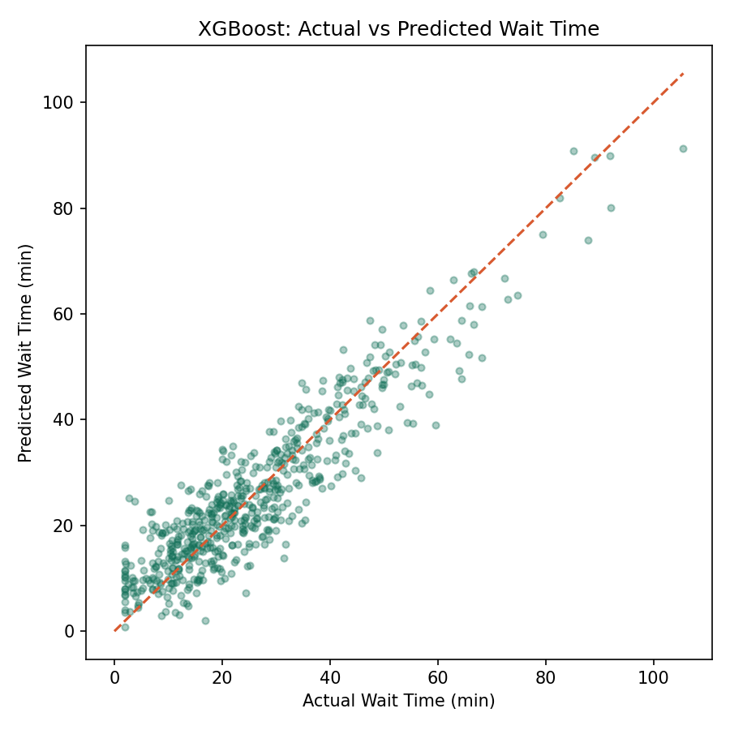
Predicted vs. actual wait time on the held-out test set — points cluster tightly around the diagonal, indicating good fit.
- Feature importance confirms the business hypothesis: patients ahead in queue, walk-in load, and staffing levels are the strongest predictors — not patient demographics.
- Applying the model to a load-aware scheduling simulation projects a 28.6% reduction in average wait time (26.0 → 18.5 minutes) and a 30.2% reduction at the 90th percentile (49.0 → 34.2 minutes).

5. Challenges
Suggested time: 2 minutes
- Synthetic data risk: results on synthetic data may not fully transfer to real clinic data, which is likely noisier and less complete.
- Feature availability in production: some features used here (e.g. doctor's live queue depth) require real-time integration with clinic check-in systems that doesn't exist yet.
- Class imbalance in appointment types: walk-ins are a minority of visits but a majority of the variance in wait time, requiring careful evaluation beyond a single aggregate metric.
- Model interpretability for staff trust: front-desk staff need to understand *why* the model recommends a particular action, not just receive a number.

6. Future Scope
Suggested time: 1–2 minutes
- Incorporate no-show prediction to further optimize slot allocation.
- Add real-time model monitoring and automatic retraining as production data accumulates.
- Extend the queue optimizer to a true reinforcement-learning based scheduler once enough production data exists.
- Add explainability output (e.g. SHAP values) to the staff dashboard so recommendations are transparent, not a black box.

