**1 INSTALLATION AND CONFIGURATION GUIDE**

This guide describes the steps for manually installing software as all the configurations required

(Service Templates, Service Plans, etc).

1. Import the APS ZIP, and create an instance of the application, setting APS Endpoint URL

and User Portal URL.

2. Create Resource Types as presented below:

|  |  |  |  |
| --- | --- | --- | --- |
| [**Resource Class**](javascript:void(0)) | **Resouce name** | [**Service**](javascript:void(0)) | **Autoprovisioning** |
| Application Service Reference | [isitup application](javascript:void(0)) | IsItUp Application | - |
| Application Service | [isitup context](javascript:void(0)) | IsItUp Services Management | yes |
| Application Service | [isitup domain](javascript:void(0)) | IsItUp domains | no |

3. Create and activate a Service Template (in POA), setting **“Autoprovisioning”** and “Custom” type. All resources created above must be added into service template.

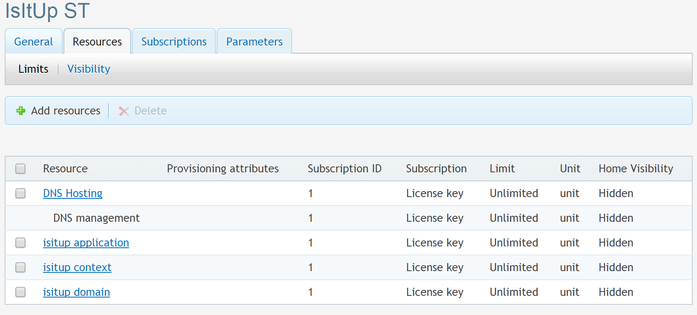

4. Create a new customer and subscription based on previously created Service Template.

5. Login as a customer in CCP and add create a couple of domains (CCP > Home > Hosted Domains > Add New Domain)

6. Switch to **‘IsItUp Management’** tab where you can add created domains for monitoring.