|  |  |  |
| --- | --- | --- |
| G:\nsu-logo.png  **North South University**  Department of Electrical & Computer Engineering    **LAB REPORT**  Course Name: **CSE332L- Computer Organization and Architecture Lab**  Experiment Number: 01     |  | | --- | | Experiment Name: Design of a 2-bit Logic unit |     Experiment Date: 27-02-2021  Report Submission Date: 03-03-2021  Section: 07  Group Number: Not form yet | |
| Student Name:Rofiqul Alam Shehab | Score |
| Student ID:1831185042 |  |
| Remarks: |

TITLE: Design of a 2-bit Logic unit

OBJECTIVE:

* Using a 2 bit logic machine, learn how to deal with an ALU(Arithmatic Logic Unit)
* Using the Logisim program, build a two-bit logic unit
* To maintain control over certain microoperations. As an example (AND,OR,XOR,NOT).

LIST OF EQUIPMENT:

* Trainer board
* Breadboard
* Wires for connection
* IC 7404(six NOT gates),7408(Quad Two-input AND gate),7432(Quad Two-input OR gate),7486(Quad Two-input XOR gate), 74F153(Dual 4:1 mux).

THEORY:

The primary goal of this Expriment is to examine the Design and Implementation of a Two-Bit Logic Unit.That is a one portion of arithment logic unit. AND(IC:7408), OR(IC:7432), XOR(IC:7486), and NOT(IC:7404)

operations are among the four micro-operations available in this logic unit. Individual bits or a portion of a word stored in memory may be manipulated using logic micro operations.

a register They can be used to alter bit values, remove a group of bits, or add a new collection of bits.We will have two outputs since we are designing a 2-bit logic unit in a register. For each of the two bits, there is one output.

LOGIC CIRCUIT DIAGRAM:

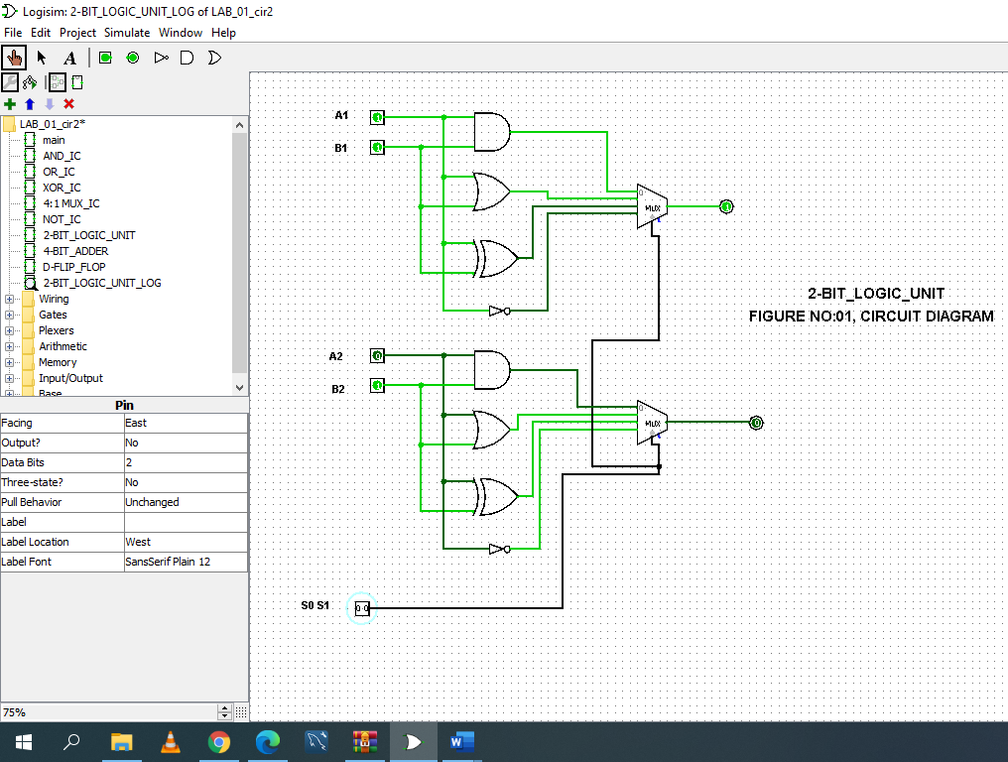

FIGURE: OUTPUT FOR AND

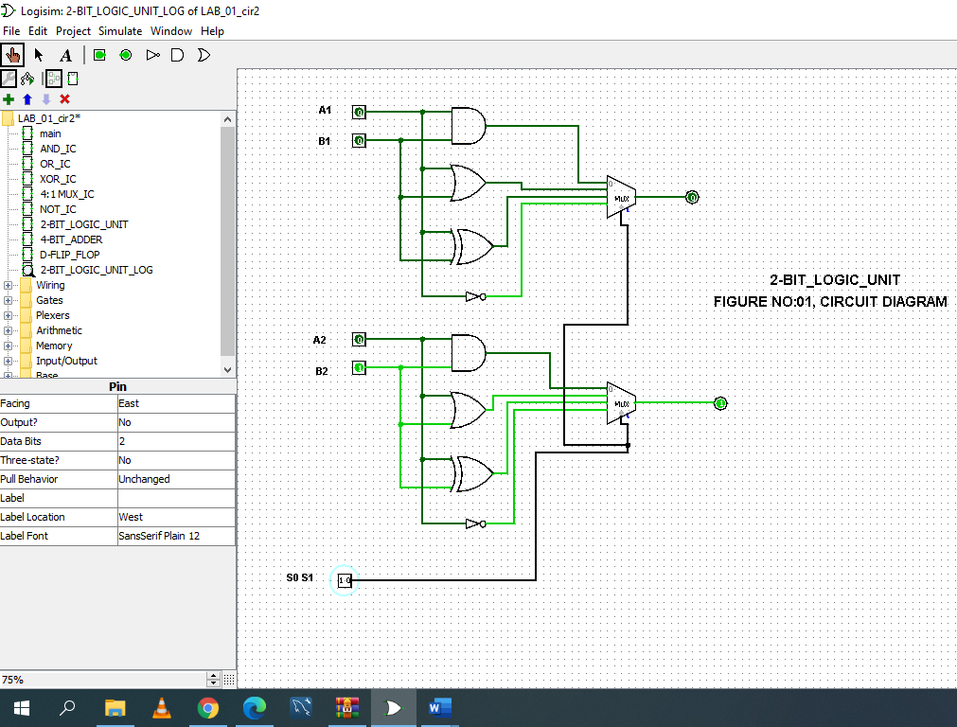

FIGURE: OUTPUT FOR OR

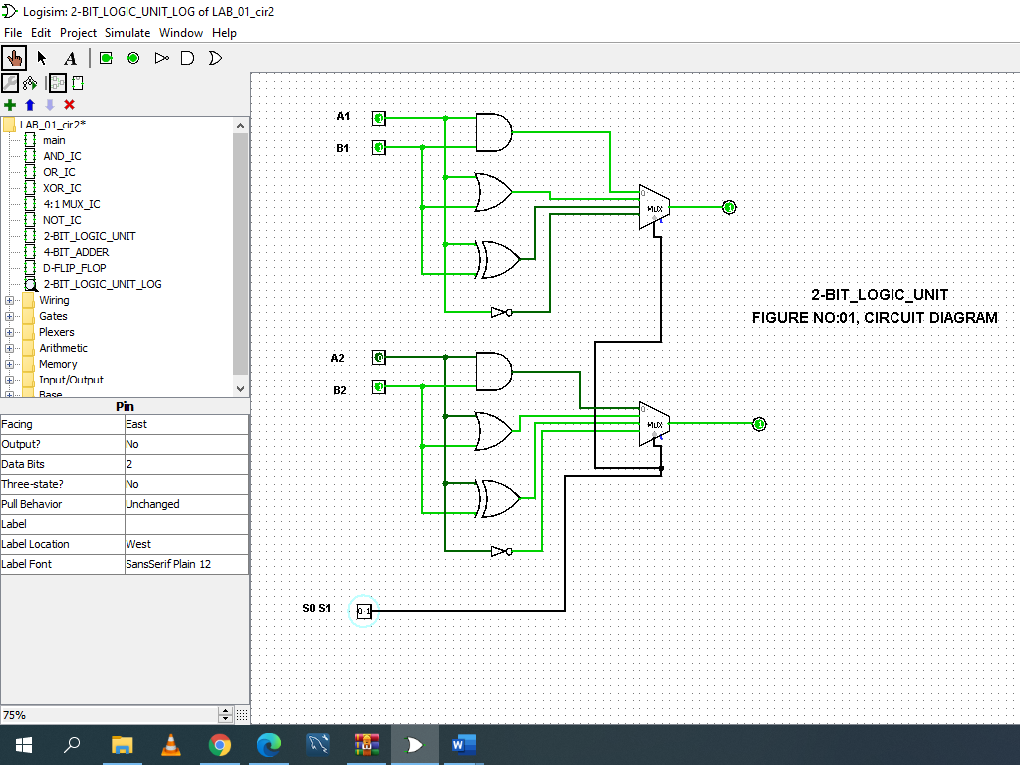

FIGURE: OUTPUT FOR XOR

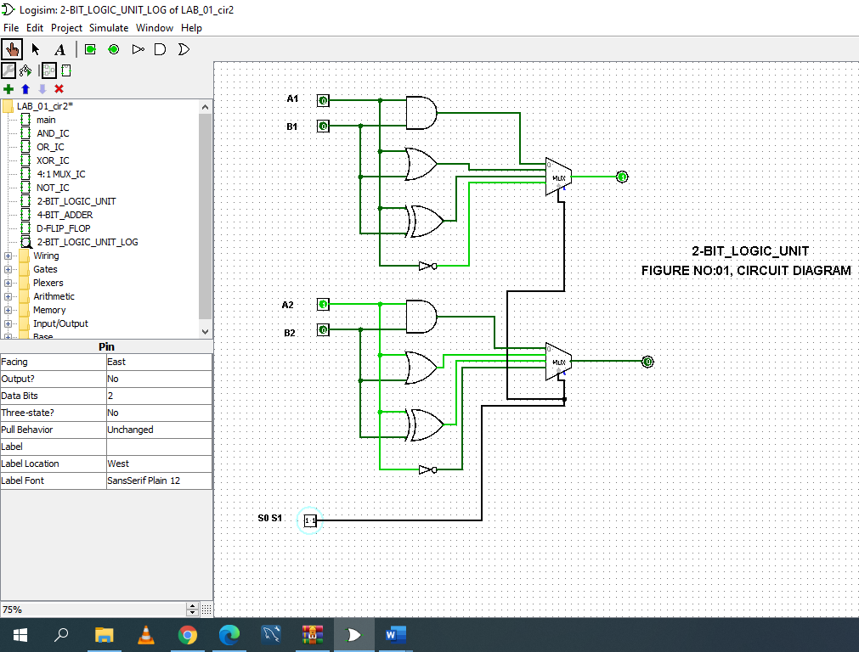

FIGURE: OUTPUT FOR NOT

TRUTH-TABLE:

|  |  |  |  |  |  |  |  |  |  |  |  |
| --- | --- | --- | --- | --- | --- | --- | --- | --- | --- | --- | --- |
| A1 | A2 | B1 | B2 | AND1 | AND2 | OR1 | OR2 | XOR1 | XOR2 | NOT A1 | NOT A2 |
| 0 | 0 | 0 | 0 | 0 | 0 | 0 | 0 | 0 | 0 | 1 | 1 |
| 0 | 0 | 0 | 1 | 0 | 0 | 0 | 1 | 0 | 1 | 1 | 1 |
| 0 | 0 | 1 | 0 | 0 | 0 | 1 | 0 | 1 | 0 | 1 | 1 |
| 0 | 0 | 1 | 1 | 0 | 0 | 1 | 1 | 1 | 1 | 1 | 1 |
| 0 | 1 | 0 | 0 | 0 | 0 | 0 | 1 | 0 | 1 | 1 | 0 |
| 0 | 1 | 0 | 1 | 0 | 1 | 0 | 1 | 0 | 0 | 1 | 0 |
| 0 | 1 | 1 | 0 | 0 | 0 | 1 | 1 | 1 | 1 | 1 | 0 |
| 0 | 1 | 1 | 1 | 0 | 1 | 1 | 1 | 1 | 0 | 1 | 0 |
| 1 | 0 | 0 | 0 | 0 | 0 | 1 | 0 | 1 | 0 | 0 | 1 |
| 1 | 0 | 0 | 1 | 0 | 0 | 1 | 1 | 1 | 1 | 0 | 1 |
| 1 | 0 | 1 | 0 | 1 | 0 | 1 | 0 | 0 | 0 | 0 | 1 |
| 1 | 0 | 1 | 1 | 1 | 0 | 1 | 1 | 0 | 1 | 0 | 1 |
| 1 | 1 | 0 | 0 | 0 | 0 | 1 | 1 | 1 | 1 | 0 | 0 |
| 1 | 1 | 0 | 1 | 0 | 1 | 1 | 1 | 1 | 0 | 0 | 0 |
| 1 | 1 | 1 | 0 | 1 | 0 | 1 | 1 | 0 | 1 | 0 | 0 |
| 1 | 1 | 1 | 1 | 1 | 1 | 1 | 1 | 0 | 0 | 0 | 0 |

IC CIRCUIT DIAGRAM:

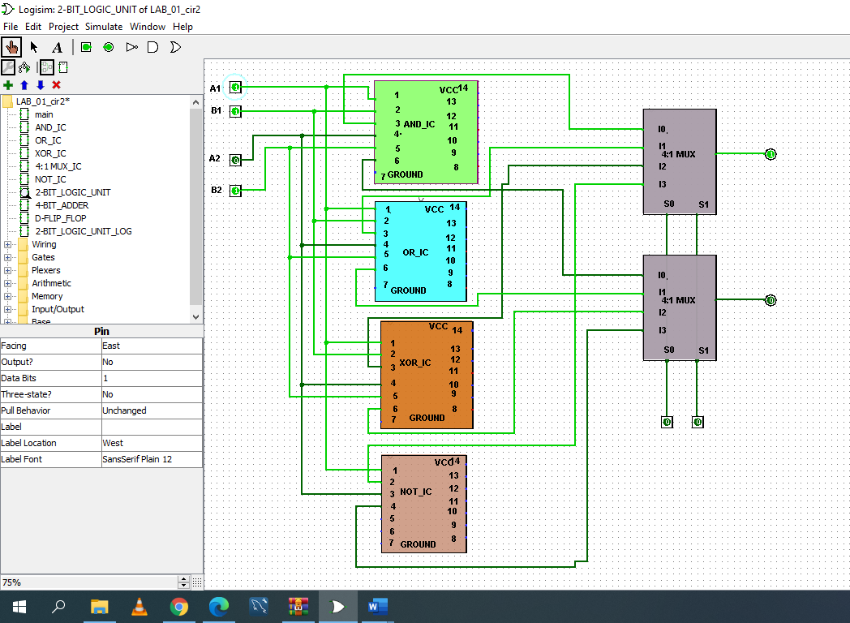

FIGURE: OUTPUT FOR AND

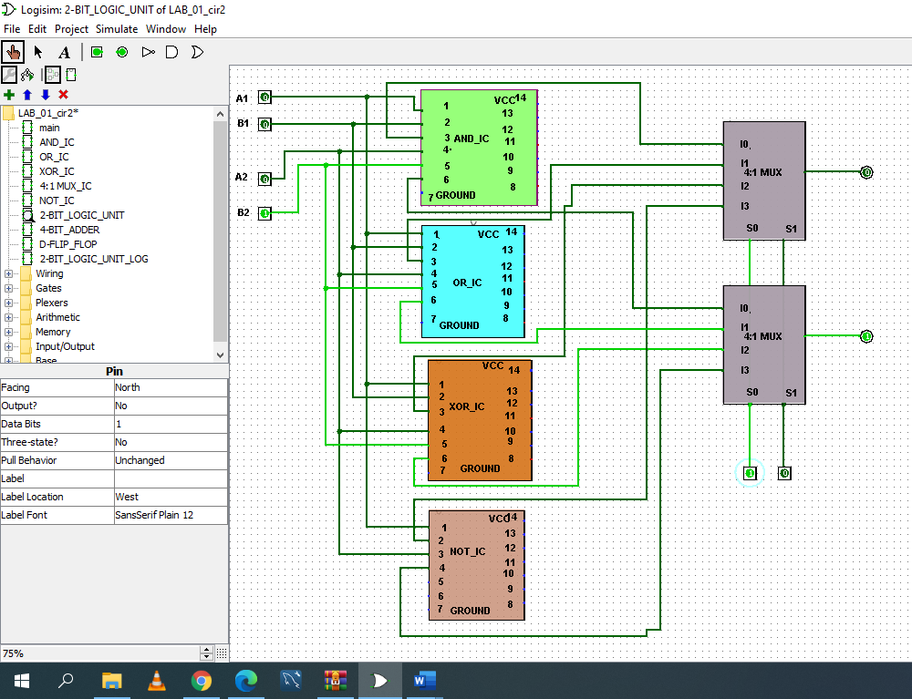

FIGURE: OUTPUT FOR OR

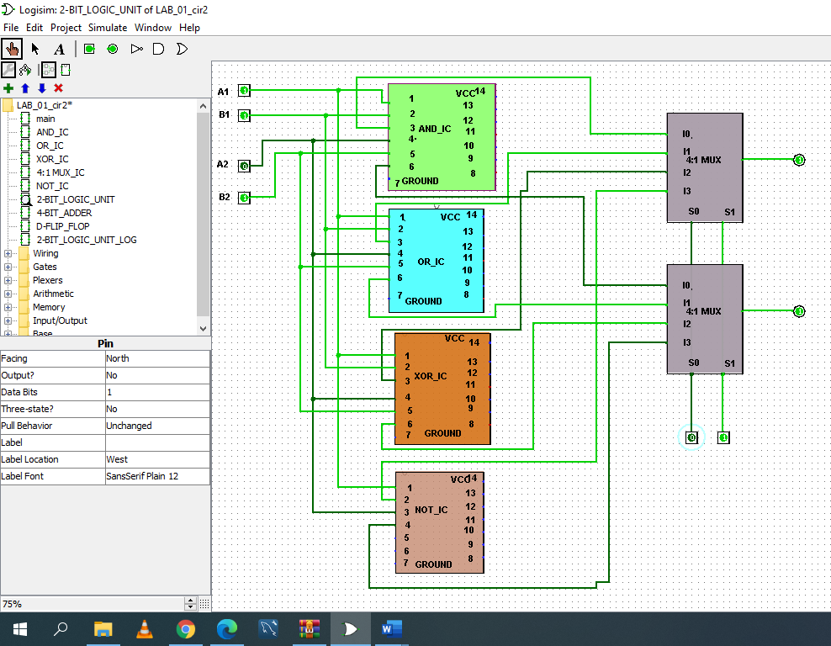

FIGURE: OUTPUT FOR XOR

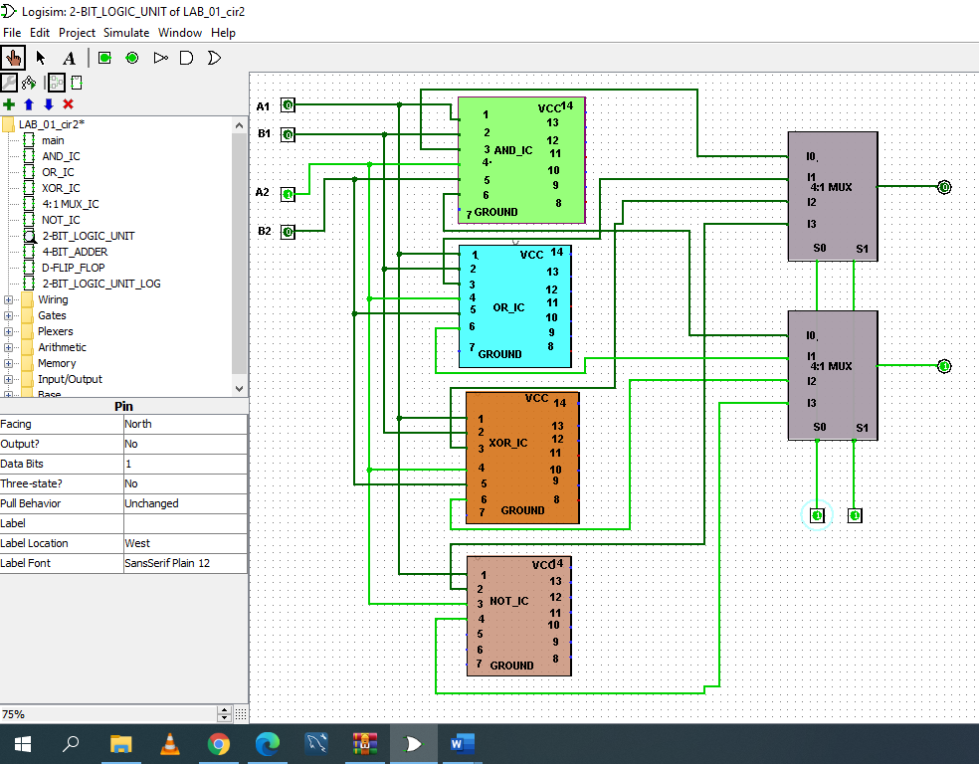

FIGURE: OUTPUT FOR NOT

DISCUSSION:

The main purpose of this experiment is how to design a 2-bit logic unit which is one portion of the arithmetic logic unit. Here we have used different kinds of IC Such as AND IC(7404), OR IC(7432), XOR IC(7486), NOT IC(7404),4:1 MULTIPLEXER IC. AND, OR, XOR, NOT are four micro-operations that are used in this experiment. Therefore, we have used 2 multiplexers (4:1),2 input two AND gate,2 input two OR gate,2 input two XOR gate,1 input two NOT gate for logic diagram as well as for circuit diagram have used one AND, OR, XOR, NOT IC Also used 2 MULTIPLEXER IC. After that, the most important thing that we have used selection bits for the multiplexer. It has work changing the output result. Here I have shown one picture below which is represent that how selection bits work.

|  |  |  |  |  |  |  |
| --- | --- | --- | --- | --- | --- | --- |
| A1 | A2 | B1 | B2 | S1 | S2 | GATES |
| 1 | 0 | 1 | 1 | 0 | 0 | AND |
| 0 | 0 | 0 | 1 | 0 | 1 | OR |
| 1 | 0 | 1 | 1 | 1 | 0 | XOR |
| 0 | 1 | 0 | 0 | 1 | 1 | NOT |

Now we can say that when we put value in selection bit 0 , 0 get AND . for 0,1 we will get OR .For 1,0 we will get XOR and last,for 1,1 we will get NOT .

At the end ,we can say that those IC will help us to create a 2 bit logic unit.we hope that ,we can use what we have learn from this experiment we can use in our real circuit design.