Heaven's Light is Our Guide
RAJSHAHI UNIVERSITY OF ENGINEERING & TECHNOLOGY
DEPARTMENT OF COMPUTER SCIENCE & ENGINEERING
1st Year Odd Semester Examination 2021
COURSE NO: Hum 1113 | COURSE TITLE: Functional English
FULL MARKS: 60 | TIME: 3 Hours
―――――――――――――――――――――――――――――――――――――――――――――――――――――――
COMPLETE EXAMINATION SOLUTIONS & QUESTION PAPER
SECTION A
QUESTION 1 (a) [CO1 | Marks: 3]
Categorize sentence in terms of structure.

Solution / Answer:
In English grammar, sentences are categorized into four structural types based on the number and type of clauses (independent and dependent) they contain:
1. Simple Sentence: Contains exactly one independent clause (a single subject and predicate) and expresses a complete thought without any subordinate clauses.
• Example: The students completed their software engineering project on time.
2. Compound Sentence: Contains two or more independent clauses joined by a coordinating conjunction (FANBOYS: for, and, nor, but, or, yet, so), a conjunctive adverb, or a semicolon.
• Example: The algorithm processed the dataset quickly, BUT the output required manual verification.
3. Complex Sentence: Contains one independent clause and at least one dependent (subordinate) clause introduced by a subordinating conjunction (e.g., because, although, since, while, if) or a relative pronoun (who, which, that).
• Example: ALTHOUGH the initial test failed, the team persisted until they achieved optimal efficiency.
4. Compound-Complex Sentence: Contains at least two independent clauses and at least one dependent clause.
• Example: BECAUSE the server experienced a power surge, the main system shut down, AND the network administrator spent hours recovering data.
QUESTION 1 (b) [CO1 | Marks: 3]
Illustrate with proper example how word is different from and similar to morpheme.

Solution / Answer:
A morpheme is the smallest meaningful unit of language that cannot be further divided, while a word is a standalone linguistic unit that can occur independently in speech or writing. Below is an illustration of their similarities and differences:

Similarities Between Word and Morpheme:
• Both function as fundamental units of meaning in linguistics.
• A free morpheme can function independently as a single word (e.g., 'cat', 'run', 'happy'). In such cases, the word and the morpheme are identical.
Differences Between Word and Morpheme:
• Autonomy & Independence: Bound morphemes (e.g., prefixes 'un-', 're-' or suffixes '-ness', '-ed') cannot stand alone as words, whereas all words are independent.
• Composition: A single word can be composed of multiple morphemes, but a morpheme cannot be broken down into smaller morphemes.
Illustrative Example: Consider the single English word "unhappiness":
• Word Level: It is ONE single standalone word.
• Morpheme Level: It consists of THREE distinct morphemes:
1. 'un-' → Bound prefix (meaning 'not')
2. 'happy' → Free root morpheme (core semantic meaning)
3. '-ness' → Bound suffix (turns adjective into noun)
QUESTION 1 (c) [CO1 | Marks: 4]
Form new meaningful words with the following root words using prefix/suffix of your choice and make sentences with them:
i) eager, ii) fly, iii) communicates, iv) care, v) mercy.

Solution / Answer:
i) Root: eager
• New Word: eagerness (Suffix: -ness)
• Sentence: "Her eagerness to master competitive programming impressed the entire faculty."
ii) Root: fly
• New Word: flight (Derivational suffix/noun form)
• Sentence: "The autonomous drone completed its inaugural test flight without any navigation errors."
iii) Root: communicates
• New Word: communication (Suffix: -ion)
• Sentence: "Effective communication between developers and project managers ensures smooth deployment."
iv) Root: care
• New Word: careless (Suffix: -less)
• Sentence: "A careless syntax error in the source code caused the entire compilation process to fail."
v) Root: mercy
• New Word: merciless (Suffix: -less)
• Sentence: "The intense summer heat in Rajshahi was merciless during the examination week."
QUESTION 2 (a) [CO2 | Marks: 5]
Transcribe the following English text into IPA symbols:
Alick: What's that you're saying, David?
David: The thing I'm speaking about is Love.
James: Do you stand there and say you're in love, David?
David: Me! what would I do with the thing?
James: I see no necessity for calling it a thing.

Solution / Answer:
Alick: /ælık: wɒts ðæt jʊə seııŋ, deıvıd?/
David: /ðə θıŋ aım spiːkıŋ əbaʊt ız lʌv./
James: /dʊ juː stænd ðeəɹ ænd seı jʊəɹ ın lʌv, deıvıd?/
David: /miː! wɒt wʊd aı duː wıð ðə θıŋ?/
James: /aı sıː nəʊ nəsɛsıtı fɔː kɔːlıŋ ıt ə θıŋ./
QUESTION 2 (b) [CO2 | Marks: 5]
Change the following transcription into English orthography:
pīstər: haləu 'rabərt // ju: sim tə bi veri bizi ðis æftərnu:n //
rabərt: haləu pi:tər // du: kam ænd sit daʊn // veri bizi indid // aɪ æm prɪpeərɪŋ a buk ɒn draɪdən ænd hɪs pəʊətrɪ //
pi:tər: draɪdən // hu: ɪz hi: //
rabərt: riəli pi:tər // ju: dəʊnt nəʊ hu: draɪdən ɪz //
pi:tər: aɪ dəʊnt nəʊ hu: draɪdən ɪz //

Solution / Answer:
Peter: Hello, Robert. You seem to be very busy this afternoon.
Robert: Hello, Peter. Do come and sit down. Very busy indeed. I am preparing a book on Dryden and his poetry.
Peter: Dryden? Who is he?
Robert: Really, Peter! You don't know who Dryden is?
Peter: I don't know who Dryden is.
QUESTION 3 (a) [CO1 | Marks: 5]
Write a short note on intensive and extensive reading.

Solution / Answer:
Reading techniques are broadly categorized into Intensive Reading and Extensive Reading, depending on the depth, speed, and objective of the reading process.
Feature | Intensive Reading | Extensive Reading
Primary Goal | Detailed comprehension of syntax, grammar, vocabulary, and specific factual data. | Global comprehension, overall plot/gist, fluency, and reading pleasure.
Text Length & Depth | Short, dense, complex texts (e.g., technical papers, legal docs, comprehension passages). | Long, extended texts (e.g., novels, non-fiction books, full magazines).
Reading Speed | Slow, deliberate, analytical, with frequent pauses and re-reading. | Fast, fluent, continuous, without stopping for individual unknown words.
Dictionary Use | Frequent dictionary lookups to decipher precise meanings. | Minimal dictionary use; unknown words are inferred from surrounding context.
Cognitive Focus | Linguistic structures, micro-details, critical analysis, and inference. | Macro-understanding, main ideas, engagement, and general knowledge expansion.

QUESTION 3 (b) [CO1 | Marks: 5]
Discuss the importance of the reading techniques in preparing yourself for any competitive examinations.

Solution / Answer:
In competitive examinations (such as GRE, TOEFL, IELTS, BCS, and University Entrance Tests), time constraints are severe. Mastering systematic reading techniques—Skimming, Scanning, Intensive Reading, and Extensive Reading—is essential for achieving top scores. Key reasons include:
1. Skimming for Quick Overview: Allows candidates to rapidly identify the central argument, paragraph organization, and overall theme of long comprehension passages within 30–60 seconds, saving precious time.
2. Scanning for Specific Data: Enables candidates to locate targeted facts, dates, technical terms, or numbers instantly without reading unnecessary filler text.
3. Intensive Reading for Analytical Questions: Vital for answering complex critical reasoning, tone identification, and inference-based questions where exact sentence structure matters.
4. Effective Time Management: Prevents candidates from burning time reading word-by-word, allowing them to allocate appropriate time to difficult mathematical or analytical sections.
5. Vocabulary Expansion & Reading Stamina: Regular extensive reading prior to exams builds vocabulary contextual recognition and develops the mental endurance required for long multi-hour exams.
QUESTION 4 (a) [CO2 | Marks: 2]
Distinguish between Meeting Minutes and Memo in terms of structure, importance and purpose.

Solution / Answer:
Feature | Meeting Minutes | Memorandum (Memo)
Purpose | To record an official, permanent historical account of discussions, decisions, and action items from a formal meeting. | To communicate internal announcements, policy updates, short instructions, or operational requests within an organization.
Structure | Formal structured layout: Header (Date, Venue, Chair), Attendance, Agendas, Deliberations, Resolutions, Action Items (Assignee & Deadline), and Signatures. | Concise block structure: Standard Header (TO:, FROM:, DATE:, SUBJECT:), Brief Introduction/Purpose, Task Details, and Action/Conclusion.
Importance | Serves as a legal and institutional record for corporate accountability, compliance auditing, and progress tracking. | Serves as an efficient internal communication tool to maintain institutional transparency and document operational directives.

QUESTION 4 (b) [CO4 | Marks: 8]
Suppose you are the coordinator of CSE department. A meeting was held on 17th August, 2022 at the conference room of CSE department, RUET. Every faculty member was present there and it was about organizing 'RUET APA signing ceremony 2022'. Draft the minutes of the meeting where there will be at least three agendas and two actions for each agenda.

Solution / Answer:
MINUTES OF THE FACULTY MEETING
DEPARTMENT OF COMPUTER SCIENCE & ENGINEERING
RAJSHAHI UNIVERSITY OF ENGINEERING & TECHNOLOGY (RUET)
• Date: August 17, 2022 | Time: 10:30 AM – 12:30 PM
• Venue: Conference Room, Department of CSE, RUET
• Chair: Head of Department, Department of CSE, RUET
• Coordinator / Recorded By: Coordinator, Department of CSE, RUET
• Attendance: 100% Present (All faculty members of CSE department were in attendance). Absentees: None.
Agenda 1: Event Scheduling, Venue Selection, and Stage Setup
Discussion: The Chairman initiated the meeting outlining the objectives for organizing the upcoming 'RUET Annual Performance Agreement (APA) Signing Ceremony 2022'. The committee evaluated logistics and venue capacity.
Action 1.1: Mr. A. Rahman was assigned to reserve the Central Auditorium by August 20, 2022, and finalize audiovisual equipment and stage banners.
Action 1.2: Ms. S. Sultana will prepare the detailed program itinerary and ushering protocol by August 22, 2022.
Agenda 2: Guest Coordination and Invitation Management
Discussion: The committee reviewed the list of dignitaries, including the Honorable Vice-Chancellor, Deans of Faculties, Department Heads, and UGC representatives.
Action 2.1: Dr. M. K. Hasan will draft, print, and dispatch formal invitation letters to all guests by August 21, 2022.
Action 2.2: Dr. T. Islam was appointed to lead the Guest Reception Subcommittee to manage VIP arrival and hospitality on the event day.
Agenda 3: Budget Allocation, Catering, and Media Coverage
Discussion: The financial requirements for venue decoration, media coverage, sound management, and post-ceremony refreshments for 150 participants were presented.
Action 3.1: The Department Coordinator will finalize the itemized budget proposal (BDT 50,000) and submit it to the University Accounts Office by August 19, 2022.
Action 3.2: Mr. R. Karim will oversee the catering vendor selection to ensure high-quality lunch and refreshment management.
Recorded By: Approved By:
_______________________ _______________________
Coordinator, Dept. of CSE, RUET Head, Dept. of CSE, RUET

SECTION B
QUESTION 5 [CO4 | Marks: 10]
You are a student of CSE department and your department proposes to conduct a survey on how CSE dominates the STEM disciplines through 2021 in Bangladesh and you have found there was a huge downturn in the Tech industry in the middle of the last decade, caused in large part by the bursting of the Dot Com bubble, but the computer industry has recovered, prospered and grown. You are asked to compose a report on 'How CSE dominates the STEM disciplines through 2021 in Bangladesh' where there will be a Heading, Abstract and Discussion based on the survey result.

Solution / Answer:
SURVEY REPORT: HOW CSE DOMINATES THE STEM DISCIPLINES THROUGH 2021 IN BANGLADESH
ABSTRACT
This report examines the structural dominance of Computer Science and Engineering (CSE) among Science, Technology, Engineering, and Mathematics (STEM) job sectors in Bangladesh through 2021. Following the historical downturn of the tech sector in the mid-2000s post-Dot Com bubble, the industry has experienced an extraordinary revival. Based on nationwide empirical survey data conducted by the Department of CSE at RUET, computing disciplines now command a towering 71% of all newly created STEM job openings in Bangladesh. Within this computing sector, Software Engineering leads with 27%, followed by Computer Networking (21%), Systems Analysis (10%), and Computer Support (7%). This report analyzes the drivers behind this expansion, contrasting computing growth against traditional engineering (16%), physical sciences (7%), life sciences (4%), and mathematics (2%).
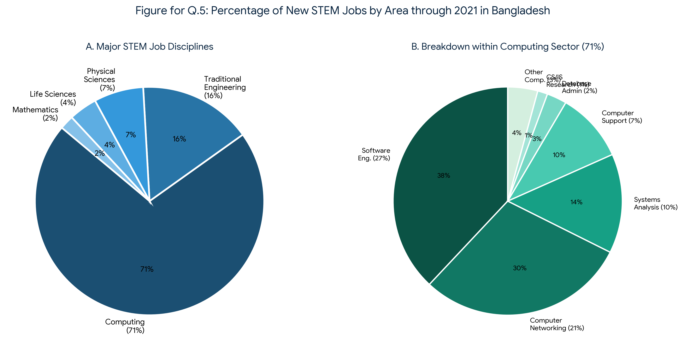
Figure 5.1: Distribution of New STEM Jobs & Computing Sub-Sectors through 2021 in Bangladesh
DISCUSSION
1. Historical Recovery & Industry Resilience: The global tech slump of the mid-2000s, triggered by the collapse of the Dot-Com bubble, created temporary stagnation in computing investments. However, the subsequent decade witnessed a massive transformation. In Bangladesh, government initiatives under the 'Digital Bangladesh' vision, alongside rapid mobile internet expansion and financial technology (FinTech) integration, fueled a resilient recovery. Computer Science transitioned from a niche academic discipline into the primary engine of national economic growth.
2. Sectoral Dominance Breakdown (71% Market Share): The survey results vividly illustrate that Computing accounts for 71% of total new STEM jobs through 2021. Traditional engineering fields (Civil, Electrical, Mechanical) represent 16%, Physical Sciences account for 7%, Life Sciences 4%, and Mathematics 2%. The overwhelming preference for CSE graduates stems from the rapid digitalization of banking, telecommunications, government services, and expanding software export houses.
3. Granular Analysis of Computing Specializations: Within the 71% computing share, market demands are distributed across critical specialization tracks:
• Software Engineering (27%): Dominates job creation due to massive demand for full-stack web applications, mobile apps (e.g., bKash, Nagad), and custom enterprise software.
• Computer Networking & Security (21%): Driven by cloud infrastructure migrations, data center setups, and telecommunication network expansions.
• Systems Analysis & IT Management (10%): Essential for bridging business requirements with technical architecture in corporate organizations.
• Computer Support & Database Administration (9% combined): Required for maintaining uninterrupted enterprise database systems and IT helpdesk infrastructure.
• CS/IS Research & Emerging Tech (4% combined): Represents growing R&D investments in Artificial Intelligence, Machine Learning, and Data Science.
4. Conclusion & Strategic Outlook: The empirical survey confirms that CSE is not merely one of many STEM options, but the dominant pillar of Bangladesh's modern workforce. Academic institutions like RUET must continue adapting curricula to emphasize Software Engineering, AI, and Cloud Architecture to sustain this momentum.
QUESTION 6 (a) [CO2 | Marks: 4]
Demonstrate the importance of Press Release and classify the different ways of sending a Press Release.

Solution / Answer:
1. Importance of a Press Release:
• Official Media Communication: Provides news agencies with accurate, verified information directly from the source, eliminating rumors and misquotes.
• Brand Visibility & Public Relations: Helps institutions build brand authority and gain free publicity across major national newspapers and digital portals.
• SEO & Online Reach: Digital press releases published online generate quality backlinks, boosting search engine visibility.
• Crisis Management: Serves as an authoritative channel to clarify public misunderstandings or issue formal institutional statements.
2. Classification of Distribution Channels:
• Direct Email Pitching: Sending personalized emails with media kits directly to specialized news editors and journalists.
• Wire Distribution Services: Utilizing commercial distribution networks (e.g., PR Newswire, BSS, UNB) for nationwide media broadcasting.
• Corporate Newsroom / Website: Publishing press releases directly on the official university/organization web portal under the 'Media Center' tab.
• Social Media Channels: Distributing summarized announcements via official LinkedIn, Facebook, and Twitter pages for immediate public engagement.
• Press Conferences: Distributing printed press releases to journalists during live press briefings.
QUESTION 6 (b) [CO4 | Marks: 6]
Team RUETopia secured 5th position at IUPC: RUET CSE FEST 2K22. A total of seven teams participated in this event of IUPC. It was held in June 08, 2022. Write a press release to the editor of The Daily Star about the achievement.

Solution / Answer:
FOR IMMEDIATE RELEASE
Date: June 09, 2022
To: The Editor, The Daily Star, Dhaka, Bangladesh
Subject: Team RUETopia Secures 5th Position at IUPC: RUET CSE FEST 2K22
RAJSHAHI, BANGLADESH — Team 'RUETopia' from the Department of Computer Science & Engineering (CSE), Rajshahi University of Engineering & Technology (RUET), achieved a remarkable milestone by securing the 5th position in the Inter-University Programming Contest (IUPC) at RUET CSE FEST 2K22, held on June 08, 2022.
The national-level programming contest brought together seven top-tier finalist university teams from across the country. Over an intense 5-hour algorithmic coding battle, Team 'RUETopia' demonstrated superior problem-solving acumen, efficient code optimization, and exemplary team collaboration to clinch 5th position.
Speaking on the achievement, the Head of the CSE Department stated: 'This achievement reflects the analytical dedication of our students and highlights RUET's commitment to nurturing world-class competitive programmers.'
RUET CSE FEST is an annual flagship event designed to foster innovation, algorithmic thinking, and technical excellence among future software leaders in Bangladesh.
Media Contact:
Department of CSE, RUET | Email: press@cse.ruet.ac.bd | Web: www.ruet.ac.bd/cse
### END ###

QUESTION 7 (a) [CO4 | Marks: 8]
See the flowchart below, which shows the impact of learning coding. Develop a paragraph with a title describing this sequence.

Solution / Answer:
From Foundational Syntax to Technovation: The Cognitive and Collaborative Impact of Learning Coding
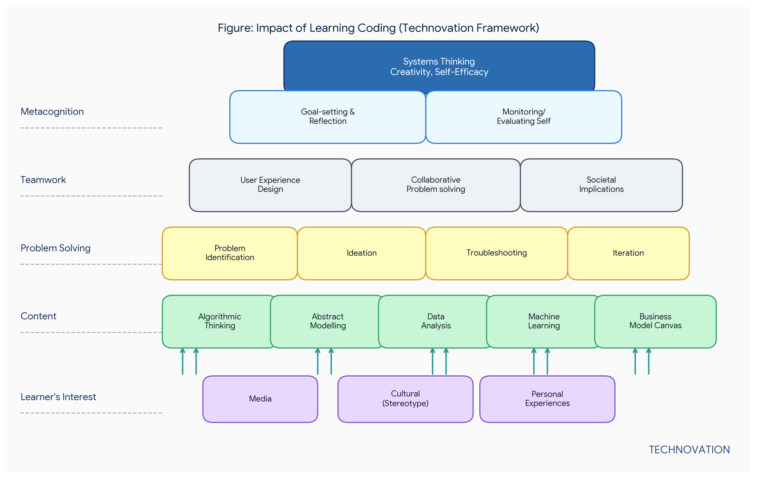
Figure 7.1: Sequential Pyramid Framework of Coding Impact (Technovation Framework)
Learning to code is far more than mastering syntax; it is a progressive cognitive journey that transforms a novice student into a technological innovator, as depicted in the Technovation framework. The sequence initiates at the foundational level of Learner's Interest, where media exposure, cultural perceptions, and personal experiences spark an initial curiosity to program. This curiosity drives engagement with essential Content, enabling students to grasp algorithmic thinking, abstract modeling, data analysis, machine learning concepts, and business model canvas applications. As theoretical knowledge takes root, learners advance to Problem Solving, actively identifying challenges, generating ideas, troubleshooting logic errors, and iteratively refining solutions. This individual competence naturally extends into Teamwork, where students learn user experience design, collaborative problem-solving, and evaluate the broader societal implications of their code. At the higher tier of Metacognition, students develop self-awareness through goal-setting, reflection, and self-evaluation. Ultimately, this structured progression culminates in Systems Thinking, Creativity, and Self-Efficacy—empowering students to achieve true Technovation by converting technical knowledge into impactful real-world innovations.
QUESTION 7 (b) [CO4 | Marks: 2]
The paragraph below needs specific details to back up its supporting points. In the spaces provided, add sentences of realistic details for each supporting points. The more specific you are, the more convincing your details are likely to be. Underline the sentences you are adding.
Helping a parent in college
There are several ways a family can help a parent who is attending college. First, family members can take over some of the household chores that the parent usually does.
[Sentence 1]
Also, Family members can make sure that the student has some quiet study time.
[Sentence 2]
Last, Families can take an interest in the student's problems and accomplishments.
[Sentence 3]

Solution / Answer:
Helping a parent in college
There are several ways a family can help a parent who is attending college. First, family members can take over some of the household chores that the parent usually does. For instance, teenage children can wash the dinner dishes and pack school lunches, while the spouse handles weekly grocery shopping and laundry. Also, Family members can make sure that the student has some quiet study time. This can be achieved by keeping the television volume low after 7:00 PM and designating a quiet bedroom corner as a dedicated, distraction-free study space. Last, Families can take an interest in the student's problems and accomplishments. Family members can ask about upcoming exam topics during dinner, offer words of encouragement during tough study weeks, and celebrate high quiz scores with a special home-cooked meal.
QUESTION 8 (a) [CO4 | Marks: 8]
Suppose you have to write a complete essay on 'Your Experiences of Living Away from Home'. First write an effective introduction stating your thesis and establishing your focus. Then skip the body of the essay and write a conclusion bringing your main ideas to a logically satisfying end.

Solution / Answer:
Essay Title: Embracing Independence: My Experience of Living Away from Home
INTRODUCTION
Leaving the familiar comfort of one's family home to live independently is one of the most defining milestones in a young adult's life. Transitioning from a structured home environment to university dormitory life in a new city brings both exhilarating freedom and daunting responsibilities. When I moved to Rajshahi to pursue my engineering degree at RUET, I was suddenly confronted with self-reliance, financial budgeting, domestic chores, and cultural adaptation. Although living away from home initially presents significant emotional homesickness and personal management challenges, it ultimately serves as a vital catalyst for personal growth, resilience, emotional maturity, and lifelong independence.
[ . . . BODY PARAGRAPHS SKIPPED AS INSTRUCTED . . . ]
CONCLUSION
In conclusion, living away from home is a transformative journey of self-discovery that bridges adolescence and adulthood. While the initial months are characterized by nostalgic longing for family comfort and the challenge of managing daily life independently, the experience builds unwavering confidence and adaptive life skills. Navigating interpersonal relationships with housemates, mastering financial management, and managing academic stress independently mold a student into an autonomous individual. Ultimately, the lessons learned while living away from home extend far beyond academic achievements—they lay a permanent foundation for self-sufficiency and emotional strength.
QUESTION 8 (b) [CO4 | Marks: 2]
Briefly discuss the importance of 'perspective' in writing a good essay.

Solution / Answer:
Perspective is critical in essay writing for three primary reasons:
1. Establishes Thesis & Stance: Perspective gives the essay a clear point of view and purpose, ensuring the document presents a coherent argument rather than an unorganized collection of facts.
2. Engages the Audience: A distinct, well-defined perspective allows readers to connect with the author's voice, values, and logical reasoning.
3. Drives Critical Analysis: Adopting a focused perspective forces the writer to evaluate counterarguments, select relevant evidence, and structure paragraphs logically to convince the reader.

