RAJSHAHI UNIVERSITY OF ENGINEERING & TECHNOLOGY
DEPARTMENT OF COMPUTER SCIENCE & ENGINEERING
1st Year Odd Semester Examination 2023
COURSE NO: HUM 1113 | COURSE TITLE: Functional English
Full Marks: 60 | Time: 3 Hours
―――――――――――――――――――――――――――――――――――――――――――――――――――――――
COMPLETE MODEL SOLUTIONS & EXAMINATION GUIDELINES
SECTION A

QUESTION Q.1. (a):
Rewrite the following passage correctly:
"A language does not never stand still. It is always change and develop. These changes rapidly in primitive societies and slowly in advance ones. The only major change that the English has undergo since the sixteen century is a very large increasing in its vocabularies."

► Solution & Model Answer
Corrected Passage:
“A language never stands still. It is always changing and developing. It changes rapidly in primitive societies and slowly in advanced ones. The only major change that English has undergone since the sixteenth century is a very large increase in its vocabulary.”

Grammatical Errors Identified & Corrected:
• 1. Double Negative Correction: Original 'does not never' was corrected to 'never stands still' (or 'does not stand still') to eliminate the ungrammatical double negative.
• 2. Aspect / Verb Tense: Original 'is always change and develop' was changed to progressive aspect 'is always changing and developing' to express continuous action.
• 3. Subject & Adjective Form: Original 'These changes rapidly... in advance ones' was corrected to 'It changes rapidly... in advanced ones' ('advanced' serves as the correct adjectival modifier).
• 4. Article Usage & Verb Participle: Original 'the English has undergo' was corrected to 'English has undergone' (languages do not take the definite article 'the' unless specified as 'the English language', and present perfect requires the past participle 'undergone').
• 5. Ordinal Number: Original 'sixteen century' was corrected to the ordinal form 'sixteenth century'.
• 6. Word Choice & Countability: Original 'a very large increasing in its vocabularies' was corrected to 'a very large increase in its vocabulary' ('increase' as a noun and 'vocabulary' as an uncountable collective noun).

QUESTION Q.1. (b):
Discuss about different reading techniques briefly.

► Solution & Model Answer
Reading techniques are systematic strategies employed by readers to extract information from written texts efficiently depending on their purpose, time constraints, and the depth of comprehension required. The four fundamental reading techniques in English language learning and academic research are discussed below:
1. Skimming (Reading for Gist):
Skimming is a fast-reading technique where the reader sweeps through the text quickly to gain a general overview or main idea without focusing on specific details. Readers look at headings, subheadings, bullet points, introductory and concluding paragraphs, and topic sentences. It is ideal for previewing chapters, conducting preliminary research, or reviewing familiar material.
2. Scanning (Reading for Specific Details):
Scanning involves searching rapidly through a text to locate specific pieces of information, such as dates, numbers, proper nouns, definitions, or specific keywords. Instead of reading every word, the reader moves their eyes swiftly across the lines in a visual search pattern until the target information is spotted.
3. Intensive Reading (Detailed Reading):
Intensive reading is a deliberate, slow, and highly focused approach aimed at achieving complete and accurate comprehension of a short text. Readers pay close attention to grammatical structures, technical vocabulary, logical transitions, and subtle semantic nuances. It is essential for analyzing academic research papers, legal documents, programming specifications, and complex prose.
4. Extensive Reading (Reading for Pleasure & Global Fluency):
Extensive reading involves reading longer texts (such as novels, magazines, articles, and general interest books) for global understanding and overall enjoyment. The emphasis is on fluency, building vocabulary naturally through context, and developing implicit language awareness without pausing for every unfamiliar word.

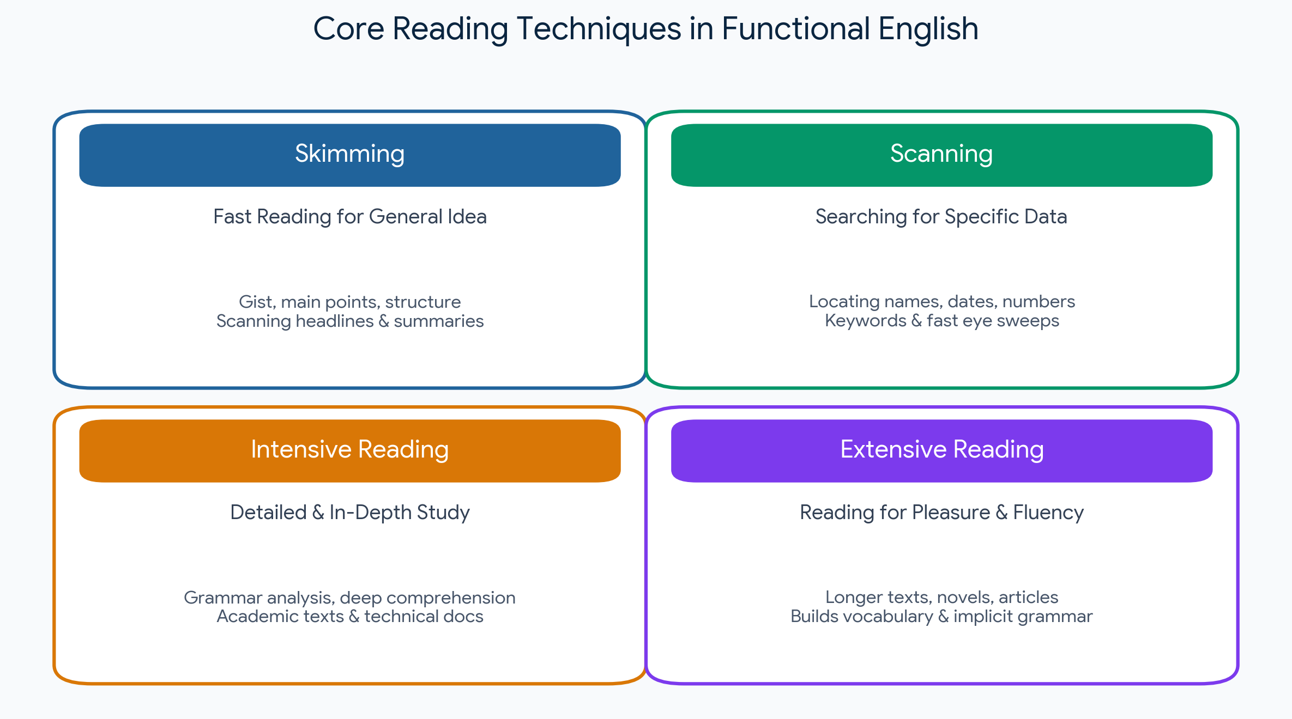
Figure 1.1: Visual Summary of Core Reading Techniques
QUESTION Q.2. (a):
What is the clause? Identify Phrase, Principal Clause, Subordinate Clause, Adverbial in the following sentences:
(i) Poetry is a constant reminder of all the things that can only be said in one language and are understandable.
(ii) In the imaginative process we form an opinion, we take a view, we form a hypothesis, we make an informed guess, about what the truth might be.

► Solution & Model Answer
Definition of Clause:
A clause is a structural grammatical unit consisting of a subject and a finite predicate (verb). It can function either as a complete independent sentence (Principal Clause) or as a dependent constituent (Subordinate Clause) modifying or completing another part of the sentence.
Analysis of Sentence (i):
• Principal (Main) Clause: “Poetry is a constant reminder of all the things”
• Subordinate Clause: “that can only be said in one language and are understandable” (Adjective / Relative clause modifying 'things')
• Phrases: • “a constant reminder” (Noun Phrase)
• “of all the things” (Prepositional Phrase)
• “in one language” (Prepositional Phrase)
• Adverbials: • “only” (Adverb modifying 'said')
• “in one language” (Prepositional Adverbial of manner/restriction modifying 'said')
Analysis of Sentence (ii):
• Principal (Main) Clauses: This sentence consists of a series of co-ordinate principal clauses presented paratactically:
1. “we form an opinion”
2. “we take a view”
3. “we form a hypothesis”
4. “we make an informed guess”
• Subordinate Clause: “what the truth might be” (Noun Clause functioning as the object of the preposition 'about')
• Phrases: • “In the imaginative process” (Prepositional Phrase)
• “an opinion” / “a view” / “a hypothesis” / “an informed guess” (Noun Phrases)
• “about what the truth might be” (Prepositional Phrase)
• Adverbial: “In the imaginative process” (Prepositional Adverbial of condition/domain modifying all the coordinate main actions)

QUESTION Q.2. (b):
Expand the idea contained in the following: "Speech is silver, silence is gold."

► Solution & Model Answer
Amplification / Idea Expansion:
The ancient proverb “Speech is silver, silence is gold” provides a profound reflection on the value of human expression versus the power of quiet contemplation. Speech is described as 'silver' because communication is undoubtedly a valuable and indispensable tool in human society. Through speech, individuals convey thoughts, share knowledge, establish relationships, resolve disputes, and advocate for justice. Effective speech possesses persuasive power and drives social and technological progress. Hence, speech holds great beauty, utility, and worth, much like silver.
However, the proverb elevates silence to 'gold'—a far more precious metal—to emphasize that restraint, active listening, and thoughtful reflection often carry far greater wisdom than hasty or excessive speech. In many critical situations, remaining silent prevents unnecessary conflicts, guards against careless or hurtful words, and allows time for objective evaluation. Silence is not mere absence of sound; it is an active state of mindfulness and self-control. True intellect lies not merely in knowing how to speak, but in knowing when to speak and when to maintain silence. In a world noisy with opinions, silent observation empowers individuals to process truth deeply before uttering words of genuine value.
QUESTION Q.3. (a):
Write short notes on the following:
(i) Phonetics (ii) Phonology (iii) Diphthong

► Solution & Model Answer
(i) Phonetics:
Phonetics is the branch of linguistics concerned with the empirical, physical study of speech sounds produced by the human vocal tract. It operates independently of any specific language grammar and is divided into three primary sub-fields:
• Articulatory Phonetics: Examines how vocal organs (tongue, lips, vocal cords, palate) produce speech sounds.
• Acoustic Phonetics: Analyzes the physical wave properties of sound (frequency, amplitude, duration) in transmission.
• Auditory Phonetics: Investigates how the human ear and brain perceive and decode sound signals.
(ii) Phonology:
Phonology is the sub-discipline of linguistics that investigates the abstract system, organization, and functional rules of speech sounds within a specific language or across languages. While phonetics deals with raw physical sounds (phones), phonology deals with phonemes—the smallest contrastive units of sound that distinguish meaning (e.g., /p/ and /b/ in 'pat' vs 'bat'). It encompasses rules of syllable structure, assimilation, stress patterns, and intonation.
(iii) Diphthong:
A diphthong (from Greek diphthongos, meaning 'two sounds') is a complex vowel sound in which there is a smooth, continuous glide from one vowel quality (the nucleus) to another within the same single syllable. Unlike a monophthong (pure single vowel sound), the acoustic quality changes during its production. English contains 8 major diphthongs, such as /aɪ/ (as in 'my'), /eɪ/ (as in 'day'), and /əʊ/ (as in 'go').

QUESTION Q.3. (b):
Write the IPA (International Phonetic Alphabet) phonetic transcription / symbols for the following words:
(i) Education (ii) Computer (iii) Thanks (iv) Want

► Solution & Model Answer
International Phonetic Alphabet (IPA) Transcriptions:
Word | IPA Transcription (UK / RP) | IPA Transcription (US / GA) | Phonetic Breakdown
Education | /ˌedʒuˈkeɪʃn/ | /ˌedʒʊˈkeɪʃn/ | 4 syllables; Primary stress on 3rd syllable (-ka-)
Computer | /kəmˈpjuːtə(r)/ | /kəmˈpjuːtər/ | 3 syllables; Schwa onset /kəm-/, stress on 2nd syllable
Thanks | /θæŋks/ | /θæŋks/ | 1 syllable; Voiceless dental fricative /θ/ + velar nasal /ŋ/
Want | /wɒnt/ | /wɑːnt/ | 1 syllable; Open back rounded vowel (UK) / unrounded (US)

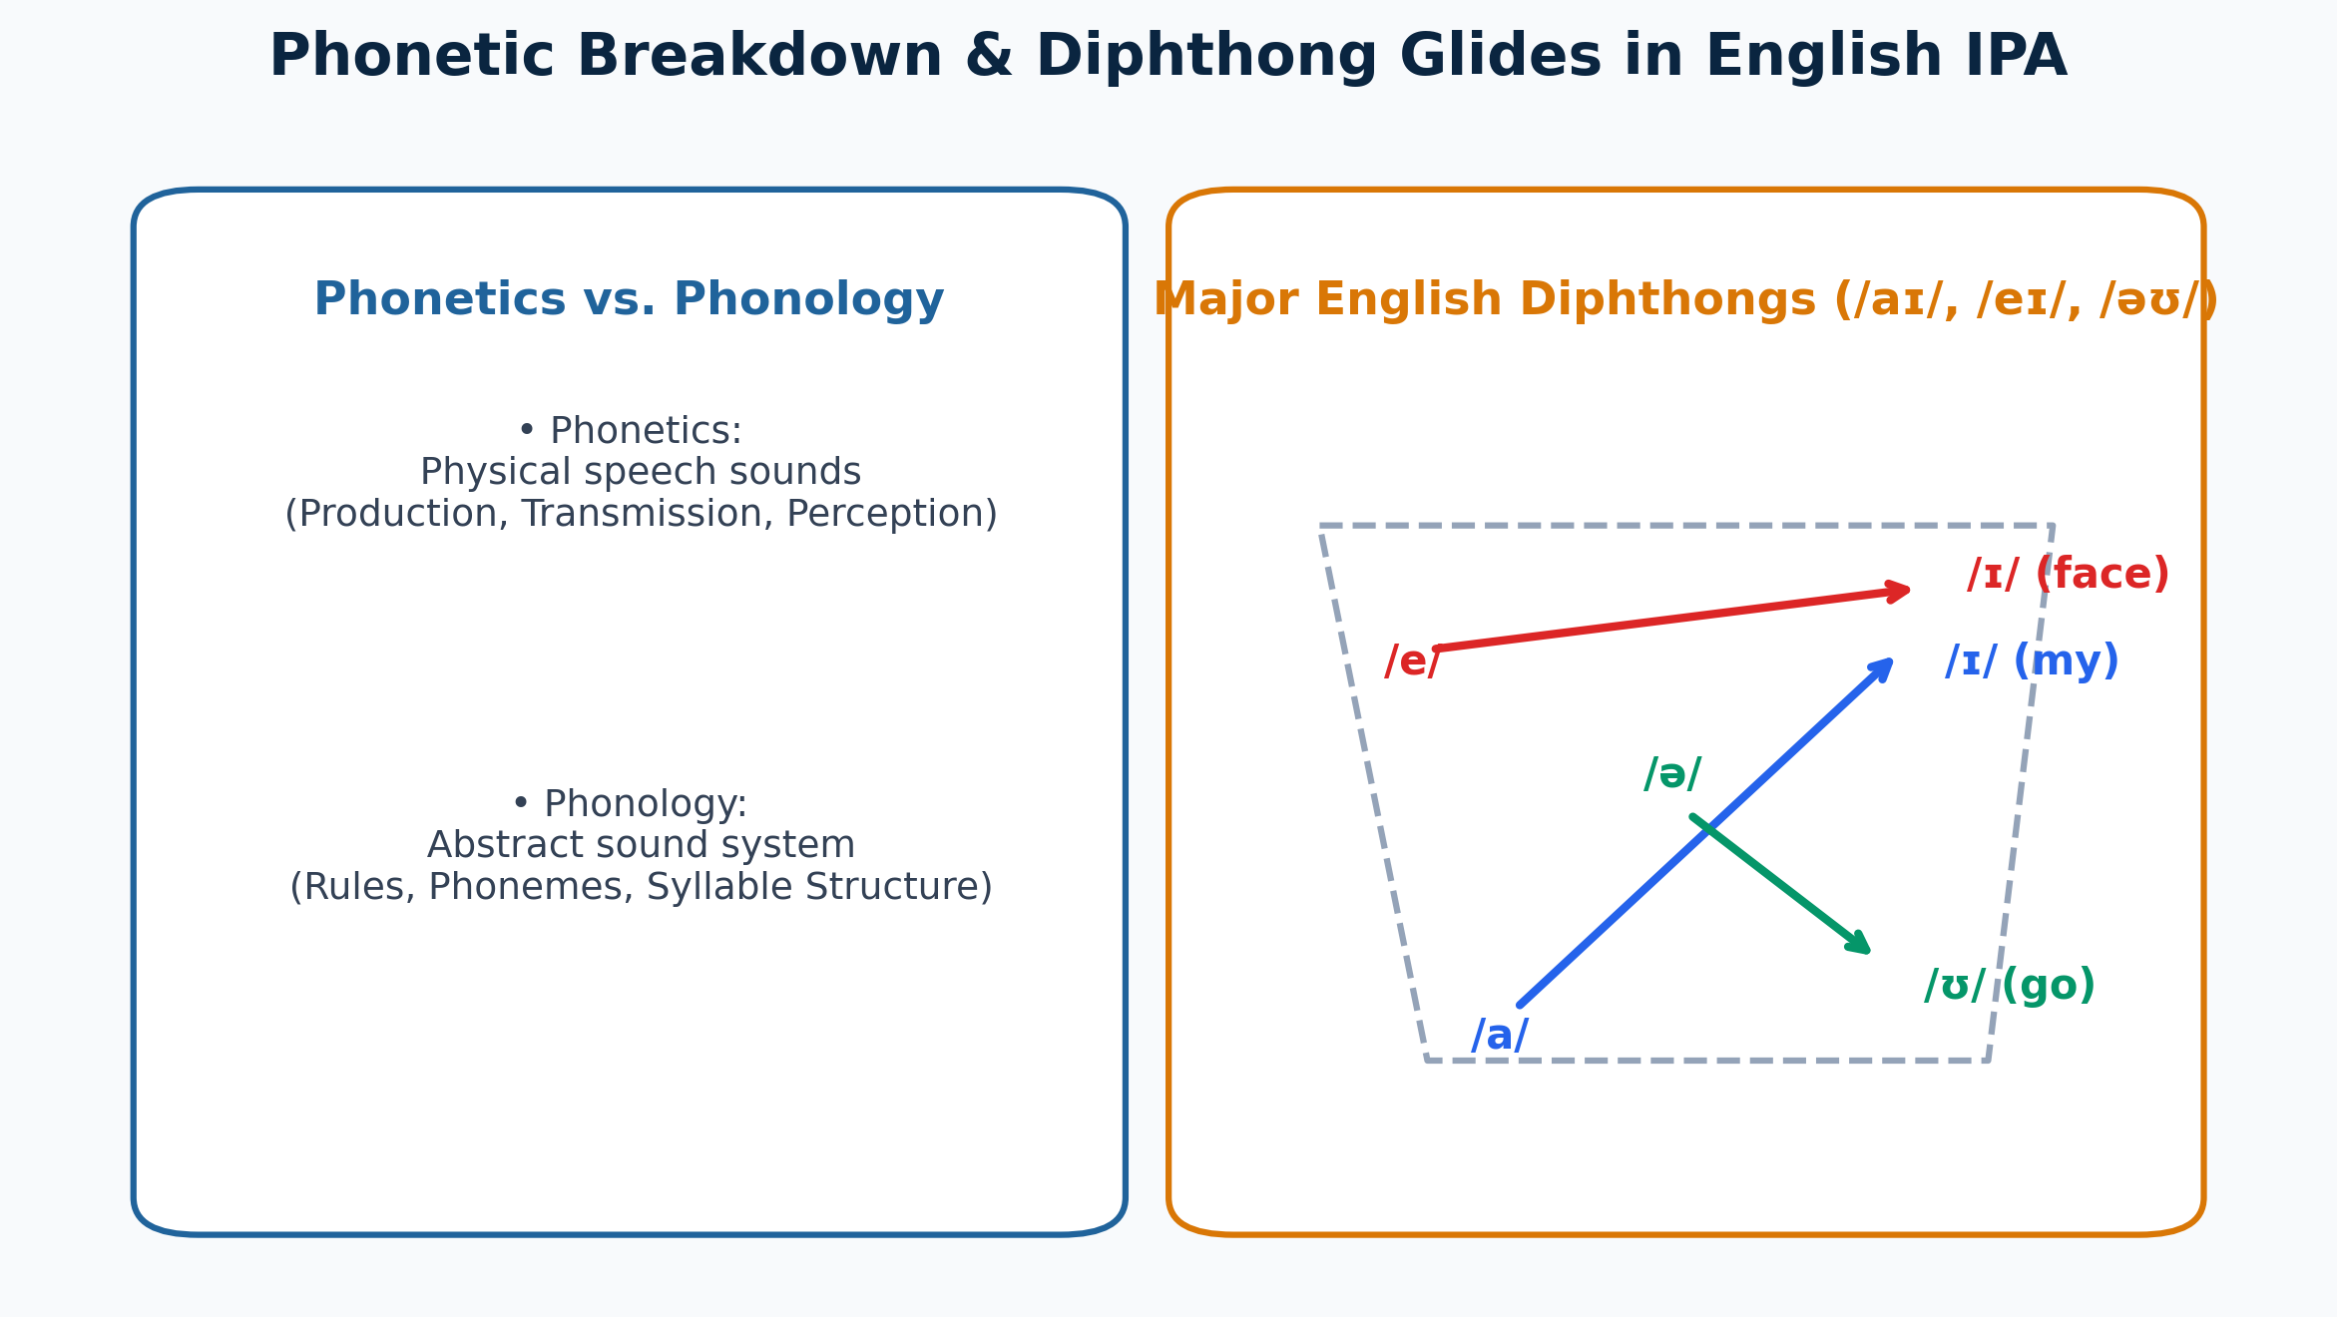
Figure 3.1: Phonetics vs. Phonology Framework & English Diphthong Glides
QUESTION Q.4. (a):
Write a paragraph on "Artificial Intelligence".

► Solution & Model Answer
Artificial Intelligence (AI) represents one of the most transformative frontiers of modern computer science and engineering, referring to the development of computational systems capable of performing tasks that traditionally require human intelligence. These tasks encompass logical reasoning, pattern recognition, natural language understanding, autonomous decision-making, and sensory perception. At its core, contemporary AI relies heavily on Machine Learning (ML) and Deep Learning algorithms, which enable machines to learn from vast volumes of data, identify complex trends, and continuously improve their predictive performance without explicit step-by-step programming. AI spans multiple specialized domains, including Natural Language Processing (NLP), Computer Vision, Robotics, and Expert Systems. Today, AI powers diverse applications ranging from medical diagnostic assistance and financial fraud detection to self-driving vehicles, intelligent virtual assistants, and automated industrial engineering processes. Despite its immense benefits in accelerating productivity and scientific discovery, the rapid growth of AI presents key ethical challenges, such as algorithmic bias, data privacy concerns, and workforce displacement. As AI continues to evolve, establishing robust ethical frameworks and human-centric engineering standards will be crucial to ensure that intelligent technologies advance societal welfare responsibly.
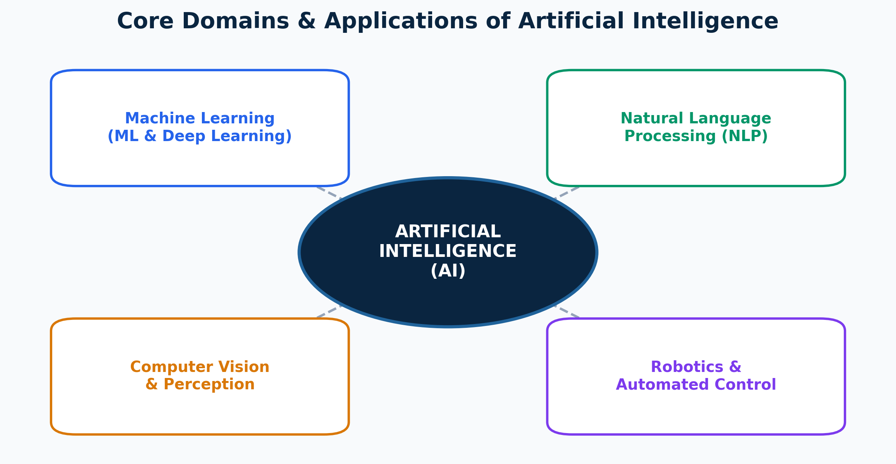
Figure 4.1: Interdisciplinary Domains and Functional Subfields of Artificial Intelligence
QUESTION Q.4. (b):
Re-write the following extract correctly:
"Acquisition and learning considered very different in linguistics. Language acquisition is the process by which language develop in humans. First language acquisition concern the development of language in children, while second language learning focuses on language development in adults as well. Acquisition is picking up from the environment and it only happens when human child are exposed to any language. People acquires mother tongue in this way."

► Solution & Model Answer
Corrected Passage:
“Acquisition and learning are considered very different in linguistics. Language acquisition is the process by which language develops in humans. First language acquisition concerns the development of language in children, while second language learning focuses on language development in adults as well. Acquisition is picking up language from the environment, and it only happens when human children are exposed to a language. People acquire their mother tongue in this way.”

Grammatical Errors Corrected:
• 1. Passive Auxiliary Missing: Original 'Acquisition and learning considered' missing auxiliary verb 'are' -> 'are considered'.
• 2. Subject-Verb Agreement: Original 'language develop' corrected to singular agreement 'language develops'.
• 3. Singular Verb Form: Original 'First language acquisition concern' corrected to singular verb 'concerns'.
• 4. Plurality Alignment: Original 'human child are' corrected to plural noun 'human children are' (or 'a human child is').
• 5. Pronoun & Plural Agreement: Original 'People acquires' corrected to plural agreement 'People acquire their mother tongue'.

SECTION B

QUESTION Q.5. (a):
Use the following Idioms meaningfully in your own sentences:
(i) A rainy day (ii) Under duress (iii) To put in a nutshell (iv) A heart of gold (v) Bury the hatchet

► Solution & Model Answer
1. A rainy day
Meaning: A period of financial hardship or unexpected emergency in the future.
Sentence: “Wise financial planners advise individuals to set aside at least six months of living expenses to prepare for a rainy day.”
2. Under duress
Meaning: Under compulsion, threat, or extreme pressure.
Sentence: “The court ruled that the contract was legally invalid because the manager had signed it under duress.”
3. To put in a nutshell
Meaning: To state or summarize something concisely in very few words.
Sentence: “To put it in a nutshell, the software failure was caused by an unhandled memory leak in the core module.”
4. A heart of gold
Meaning: An extraordinarily kind, generous, and compassionate nature.
Sentence: “Although the senior chief engineer appears strict and uncompromising, he possesses a heart of gold and quietly mentors struggling junior developers.”
5. Bury the hatchet
Meaning: To settle past quarrels, stop fighting, and make peace.
Sentence: “After months of legal disputes over patent rights, the two major tech conglomerates decided to bury the hatchet and launch a joint research project.”

QUESTION Q.5. (b):
Write a precis of the following extract and give a suitable title:
"Social networking expands the horizon and makes this world a village. Information technology has helped us explore various modes of entertainment. But sometimes these modes of entertainment may lead us to trouble. Social networking thus works as a mode of socialization. Yet sometimes this form of socialization may turn out to be a bane for some.
The connectivity and bonding lead to happiness for some. The one who are far from each other find it a very good medium to be in close interaction that does not cost much either time-wise or economically. The internet has done this wonders to us. We can be in touch with our acquaintances and friends that really bring us closer to each other. The feeling of joy and pleasure in meeting our old pals is immense. And we feel blessed that telecommunication has given us this wonderful opportunity."

► Solution & Model Answer
Title: Social Networking: The Dual Edges of Digital Connectivity
Precis Solution:
Information technology and social networking have transformed the globe into an interconnected village, offering affordable and convenient communication that bridges geographic distances. This digital connectivity brings immense joy by reconnecting long-lost friends and maintaining close social bonds. However, while social networking serves as an effective medium for socialization and entertainment, it can also lead to complications and prove detrimental if misused.

Precis Breakdown Metrics:
• Original Word Count: ~165 words
• Precis Word Count: ~58 words (approximately 1/3 of original length)
• Key Ideas Preserved: Global connectivity, low-cost interaction, emotional benefits of reconnecting, potential risks/bane of digital platforms.
QUESTION Q.6. (a):
Assume that you have just returned from a seminar to which you were deputed by the company. Write a memo to your immediate boss, reporting to him the important matters discussed at the seminar. Also point out their relevance to the company's business.

► Solution & Model Answer
MEMORANDUM
---------------------------------------------------------------------------------------------------------
TO: Mr. A. R. Rahman, Chief Technical Officer
FROM: Tanvir Ahmed, Senior Software Engineer
DATE: January 18, 2024
SUBJECT: Executive Report on National Seminar on Enterprise Cloud Security & AI Integration
---------------------------------------------------------------------------------------------------------
1. Executive Summary
As deputed by the company, I attended the National Tech Seminar on 'Next-Gen Cloud Architecture & Enterprise Security' held at Dhaka International Convention Center on January 16–17, 2024. The seminar brought together industry leaders to discuss emerging trends in zero-trust architecture, automated threat detection, and AI-driven cloud optimization.
2. Key Topics Discussed
• Implementation of Zero-Trust Network Architecture (ZTNA): Moving away from traditional perimeter defenses toward continuous identity verification for every endpoint.
• Automated Incident Response via Machine Learning: Utilizing predictive AI models to detect anomaly patterns in network traffic before data breaches occur.
• Regulatory Compliance & Data Sovereignty: New regional mandates regarding encrypted storage and audit trails for cloud hosting.
3. Relevance to Our Company’s Business
• Security Infrastructure Upgrade: Integrating ZTNA directly addresses our company's upcoming expansion into client-facing cloud services, ensuring compliance and robust client trust.
• Cost & Resource Optimization: Adopting ML-based automated threat detection will reduce our IT operations monitoring workload by an estimated 30%, allowing engineers to focus on product features.
4. Recommendations & Next Steps
I propose organizing an internal technical workshop next Friday to share key documentation and demonstrate ZTNA deployment frameworks with our DevOps team.
Submitted by:
Tanvir Ahmed (Deputed Delegate)

QUESTION Q.6. (b):
Imagine that you were the Secretary in attendance at the sixth meeting of the Management Committee of Pixels Computer Ltd. held on January 15, 2024. Write the minutes of this meeting assuming the agenda to be as follows:
i) Minutes of the last meeting
ii) Chairman's report
iii) Appointment of skilled technicians
iv) Complaints regarding the quality of products

► Solution & Model Answer
PIXELS COMPUTER LTD.
MINUTES OF THE 6TH MEETING OF THE MANAGEMENT COMMITTEE
Date: January 15, 2024 | Time: 10:00 AM – 1:00 PM | Venue: Boardroom, Pixels Headquarters
---------------------------------------------------------------------------------------------------------
PRESENT:
1. Mr. S. K. Roy (Chairman)
2. Ms. Nusrat Jahan (Managing Director)
3. Mr. Rafiqul Islam (Head of Production)
4. Mr. A. H. Malik (HR Director)
5. Tanvir Ahmed (Company Secretary / In Attendance)
APOLOGIES: Mr. Kabir Hossain (Finance Director)
---------------------------------------------------------------------------------------------------------
PROCEEDINGS & RESOLUTIONS:
Agenda Item i: Confirmation of Minutes of the Last Meeting
The minutes of the 5th Management Committee meeting held on December 10, 2023, having been circulated previously, were reviewed. No corrections were raised, and they were formally confirmed and signed by the Chairman.
Agenda Item ii: Chairman's Report
The Chairman presented a review of Q4 performance, highlighting a 12% revenue growth in computer hardware sales. He emphasized the necessity of maintaining stringent quality standards to sustain market expansion amidst growing competition.
Agenda Item iii: Appointment of Skilled Technicians
The HR Director reported a shortage of senior assembly technicians in the hardware division. After discussion, IT WAS RESOLVED THAT the HR Department be authorized to recruit 10 certified senior technicians by February 15, 2024, through competitive recruitment.
Agenda Item iv: Complaints Regarding the Quality of Products
The Production Manager presented a breakdown of recent customer returns regarding power supply stability in model PX-500. IT WAS RESOLVED THAT an immediate Quality Assurance audit be conducted across the assembly line, and all affected units be replaced free of cost under warranty.
ADJOURNMENT:
There being no further business, the meeting concluded at 1:00 PM with a vote of thanks to the Chair.
Signed:
Tanvir Ahmed (Company Secretary) Mr. S. K. Roy (Chairman)

QUESTION Q.7. (a):
Discuss the essential elements of an ideal memo.

► Solution & Model Answer
A memorandum (memo) is a concise internal business document used to communicate policy updates, operational decisions, project reports, or official instructions within an organization. An ideal memo must be structured logically, maintain a professional tone, and feature five essential elements:
1. Standard Header Block:
Contains the four core administrative lines:
• TO: Full name and official designation of the recipient(s).
• FROM: Full name and title of the sender.
• DATE: Complete formal date of issuance.
• SUBJECT: Clear, specific, and descriptive topic heading.
2. Clear Statement of Purpose (Opening):
The opening paragraph must immediately state the core objective of the memo without lengthy preamble. It answers why the memo is being written and why the recipient needs to read it.
3. Context and Background Information:
Provides necessary background details, current operational problems, or regulatory changes that justify the memo's recommendations or policy updates.
4. Well-Organized Body Paragraphs (Discussion):
Presents facts, analytical data, or argument points logically. The body should utilize bold subheadings, bulleted lists, and short paragraphs to enhance readability and visual hierarchy.
5. Action Plan & Call to Action (Closing):
Concludes with specific action steps, assigned responsibilities, explicit deadlines, and contact information for further inquiries or feedback.

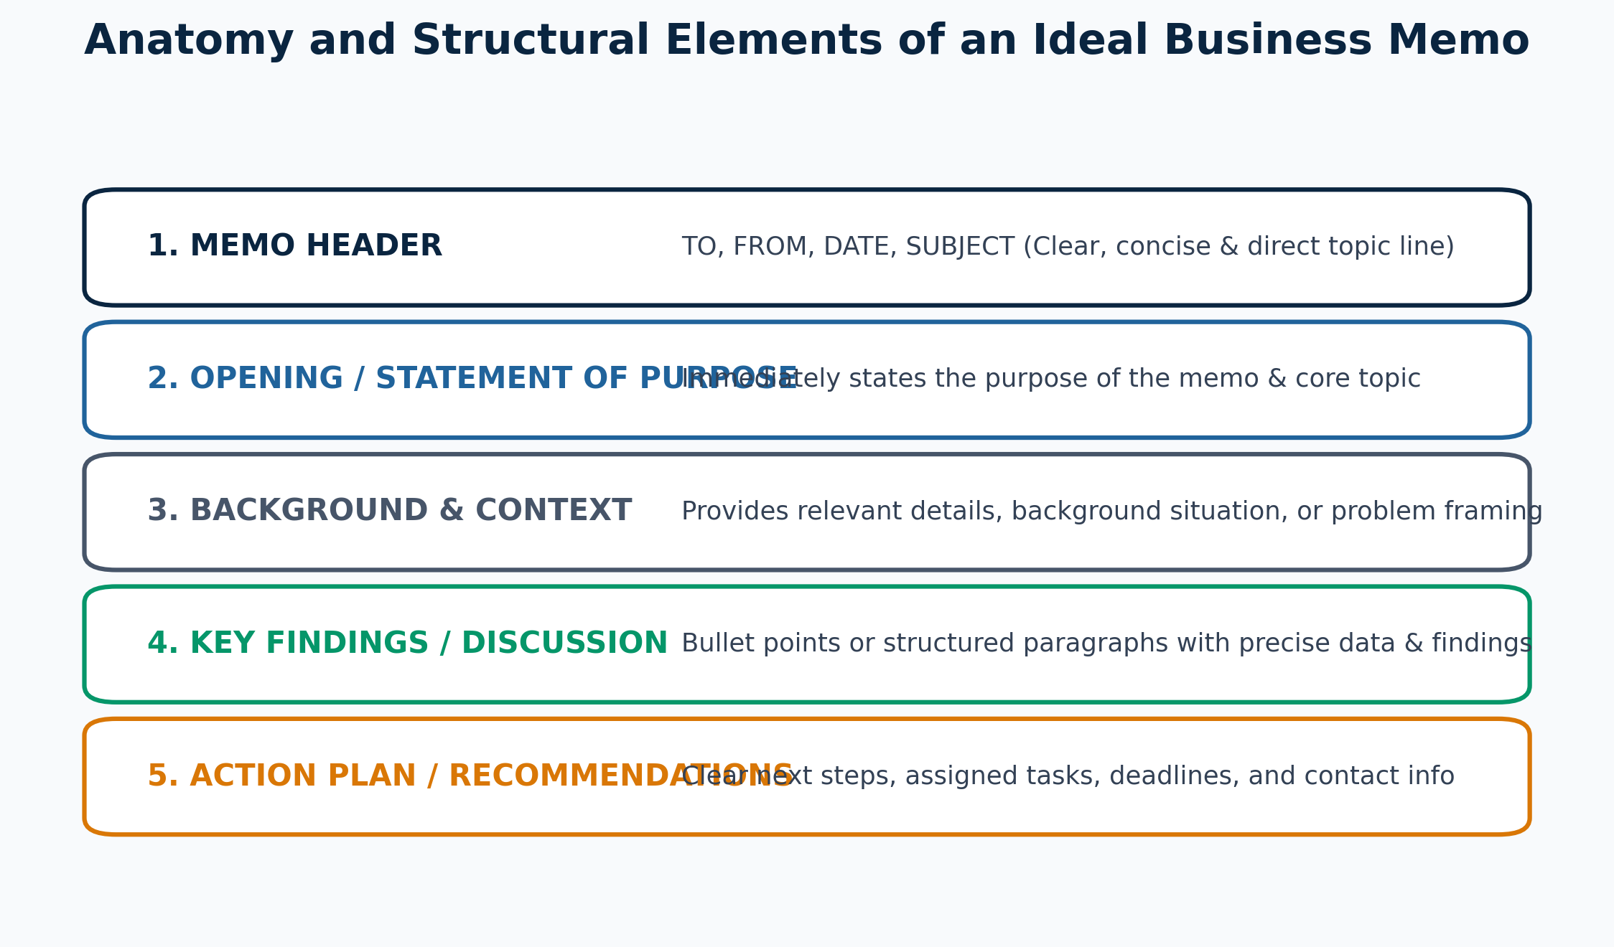
Figure 7.1: Anatomical Breakdown of an Ideal Business Memorandum
QUESTION Q.7. (b):
Following recent concerns about phishing attacks and data leaks, the IT department has implemented a new email policy and strengthened security protocols. Write a memo from the IT Department to all employees about this update.

► Solution & Model Answer
MEMORANDUM
---------------------------------------------------------------------------------------------------------
TO: All Staff & Departmental Employees
FROM: IT Security Department
DATE: January 18, 2024
SUBJECT: Mandatory Security Updates: New Email Policy & Anti-Phishing Protocols
---------------------------------------------------------------------------------------------------------
1. Purpose & Background
Following recent cybersecurity threat intelligence regarding industry-wide phishing attempts and unauthorized data leak vulnerabilities, the IT Department is implementing enhanced security protocols effective immediately. These measures are essential to safeguard proprietary enterprise data and employee privacy.
2. Key Updates & Mandatory Security Protocols
• Mandatory Multi-Factor Authentication (MFA): All staff must enable Microsoft Authenticator MFA on corporate accounts by January 22, 2024.
• Strict Password Complexity Policy: Passwords must now be a minimum of 14 characters, combining uppercase/lowercase letters, numbers, and symbols, and renewed every 90 days.
• External Email Warning Banners: All incoming emails from external domains will now display a yellow warning banner ([EXTERNAL EMAIL]). Exercise extreme caution before clicking links or downloading attachments.
• Restrictions on File Transfers: Corporate data must not be transferred to personal email accounts or unauthorized third-party cloud storage (e.g., personal Dropbox/Google Drive).
3. Phishing Incident Reporting
If you receive a suspicious email, do NOT click any links or reply. Immediately click the 'Report Phishing' button on your Outlook toolbar or forward the message to security-report@company.com.
4. Compliance & Support
Compliance with this security policy is mandatory across all departments. The IT Helpdesk will host drop-in support sessions daily from 2:00 PM – 4:00 PM to assist employees with MFA setup.
Issued by:
IT Security Taskforce

QUESTION Q.8. (a):
Draft a sales letter introducing a new software.

► Solution & Model Answer
NEXUS AI TECHNOLOGIES LTD.
Level 8, Tech Innovation Hub, Dhaka 1212 | Contact: contact@nexusai.com | Web: www.nexusai.com
---------------------------------------------------------------------------------------------------------
Date: January 18, 2024
To,
The Chief Information Officer / IT Director,
Leading Enterprise Solutions Ltd.
Dhaka, Bangladesh
SUBJECT: REVOLUTIONIZE YOUR WORKFLOW WITH NEXUS-FLOW AI™ ENTERPRISE SUITE
Dear Industry Leader,
Are repetitive administrative tasks and fragmented team communication slowing down your organization’s productivity? In today's hyper-competitive digital landscape, delayed workflows translate directly to lost revenue.
We are thrilled to introduce Nexus-Flow AI™—an all-in-one smart enterprise management platform engineered to automate workflow routing, streamline team collaboration, and deliver real-time predictive analytics.
Why Choose Nexus-Flow AI™?
• 40% Operational Efficiency Boost: Automated intelligent task routing reduces manual coordination bottlenecks.
• Seamless Cloud & API Integration: Connects effortlessly with your existing ERP, CRM, and SQL database infrastructure within hours.
• Enterprise-Grade Security: Built with end-to-end 256-bit encryption and ISO 27001 compliance.
• Real-Time Executive Dashboards: Interactive visual analytics provide actionable business insights at a glance.
Exclusive Launch Offer for Early Adopters:
As a valued corporate leader, we invite your organization to experience a 30-Day Free Trial along with complimentary onboarding setup and 24/7 dedicated tech support.
Transform your business operations today! Visit www.nexusai.com/demo or reply directly to this letter to schedule a live 15-minute product demonstration with our solutions architect.
Sincerely,
Tanvir Ahmed
Director of Software Solutions
Nexus AI Technologies Ltd.

QUESTION Q.8. (b):
Suppose you are a job-seeker. Now prepare your curriculum vitae for your dream job.

► Solution & Model Answer
CURRICULUM VITAE
=========================================================================================================
TANVIR AHMED
Address: Rajshahi 6204, Bangladesh | Phone: +880 1712-345678
Email: tanvir.cse@ruet.ac.bd | LinkedIn: linkedin.com/in/tanvir-cse | GitHub: github.com/tanvir-ruet
=========================================================================================================
CAREER OBJECTIVE
A highly motivated Computer Science and Engineering graduate seeking the position of Software Engineer in a dynamic tech firm. Aiming to leverage strong algorithmic skills, full-stack software development expertise, and a passion for scalable system design to build high-performance software solutions.
EDUCATION
• B.Sc. in Computer Science and Engineering (CSE)
Rajshahi University of Engineering & Technology (RUET), Bangladesh
Graduation Year: 2024 | CGPA: 3.85 / 4.00
• Higher Secondary Certificate (HSC)
Rajshahi College | Passing Year: 2019 | GPA: 5.00 / 5.00
TECHNICAL SKILLS
• Programming Languages: C, C++, Python, Java, JavaScript, SQL
• Web Technologies: React.js, Node.js, Express.js, HTML5, CSS3, REST APIs
• Databases & Tools: PostgreSQL, MongoDB, Git/GitHub, Docker, Linux
• Core Competencies: Data Structures & Algorithms, Object-Oriented Programming (OOP), System Architecture
KEY ACADEMIC PROJECTS
1. AI-Powered Smart Campus Management System (Capstone Project)
- Developed a full-stack automated portal using React, Node.js, and PostgreSQL.
- Implemented real-time facial recognition attendance using Python OpenCV.
2. Distributed E-Commerce Microservices Application
- Designed a scalable microservice back-end handling concurrent user transactions with Docker and MongoDB.
ACHIEVEMENTS & CERTIFICATIONS
• Champion - Inter-University National Programming Contest 2023.
• Meta Certified Front-End Developer (Coursera Professional Certificate).
• Solved 500+ competitive programming problems across Codeforces and LeetCode.
REFERENCES
1. Dr. Md. Nazrul Islam
Professor, Dept. of CSE, RUET
Email: nazrul@cse.ruet.ac.bd
2. Dr. S. M. Hossain
Associate Professor, Dept. of CSE, RUET
Email: hossain@cse.ruet.ac.bd

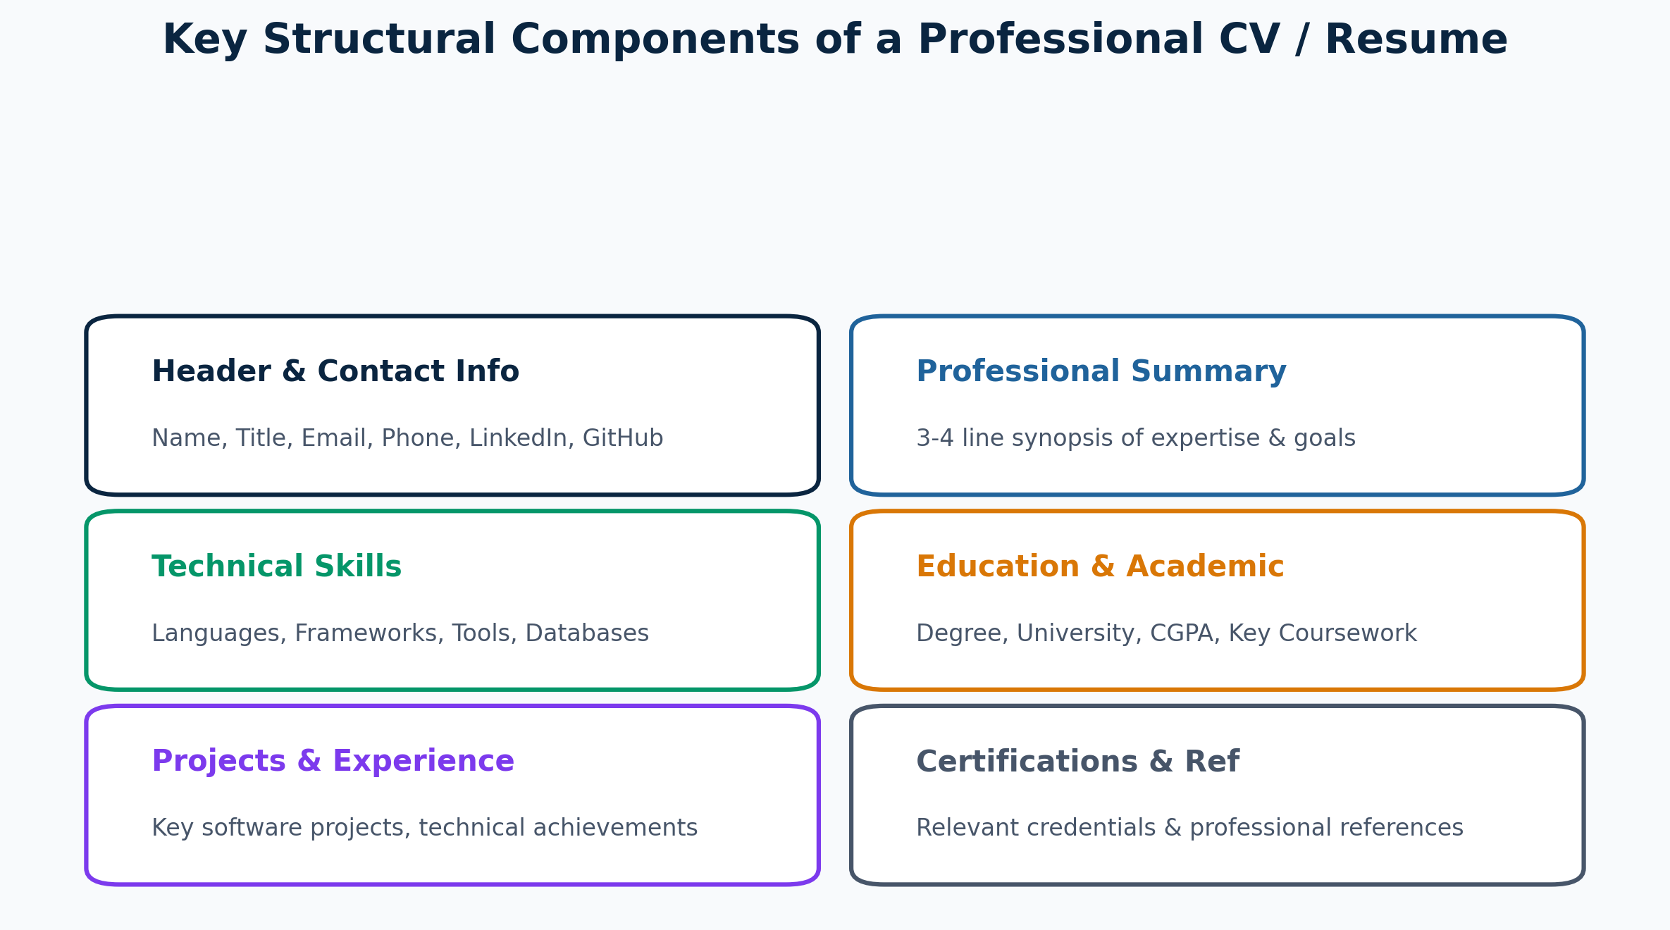
Figure 8.1: Structural Components and Layout Hierarchy of a Professional CV

