RAJSHAHI UNIVERSITY OF ENGINEERING & TECHNOLOGY
DEPARTMENT OF COMPUTER SCIENCE & ENGINEERING
1st Year Odd Semester Examination 2024
COURSE NO: HUM-1113 | COURSE TITLE: Functional English
FULL EXAM PAPER SOLUTIONS & DETAILED EXPLANATIONS
―――――――――――――――――――――――――――――――――――――――――――――――――――――――
SECTION A
Q.1. (a)
QUESTION: Define phonetics and phonology. How are these two fields related, and how do they differ? [Marks: 5]

Answer:
1. Definition of Phonetics:
Phonetics is the scientific branch of linguistics concerned with the physical properties, production, transmission, and acoustic perception of human speech sounds (termed 'phones'). It investigates speech sounds as empirical, physical phenomena without regard to their specific meaning or structural role within a given language. Phonetics is traditionally subdivided into three main branches:
• Articulatory Phonetics: Examines how speech sounds are physically produced by the vocal organs (lips, tongue, teeth, velum, vocal folds).
• Acoustic Phonetics: Analyzes the physical sound waves (frequency, amplitude, duration) transmitted through the air.
• Auditory Phonetics: Focuses on how human ears and the brain perceive and process speech sound signals.
2. Definition of Phonology:
Phonology is the subfield of linguistics that studies how speech sounds are organized, structured, and function systematically within a specific language or across languages. Unlike phonetics, phonology deals with the abstract cognitive system of sounds (termed 'phonemes') and the rules governing their combination, distribution, and contrastive meaning in words (e.g., syllable structure, stress patterns, intonation, and allophonic variations).
3. Interrelationship Between Phonetics and Phonology:
Phonetics and phonology are intimately connected and complementary disciplines within linguistics. Phonetics provides the raw physical data, articulatory descriptions, and acoustic measurements of all human speech capabilities. Phonology takes this phonetic raw material and applies cognitive and structural rules to determine which acoustic differences carry distinct meanings within a specific linguistic framework. In short, phonetics is the physical foundation upon which abstract phonological systems are built.
4. Key Differences Between Phonetics and Phonology:
Feature / Aspect | Phonetics | Phonology
Core Focus | Physical properties & production of speech sounds. | Abstract system & functional organization of sounds.
Basic Unit of Study | Phone [s], [t], [p] (enclosed in square brackets). | Phoneme /s/, /t/, /p/ (enclosed in forward slashes).
Scope of Inquiry | Universal (applies to all human languages). | Language-specific (analyzes specific rules of a language).
Nature of Data | Concrete, empirical, physiological, acoustic. | Abstract, cognitive, structural, rule-governed.
Primary Question | 'How is this sound physically articulated by the vocal tract?' | 'Does changing this sound change the word's meaning in English?'
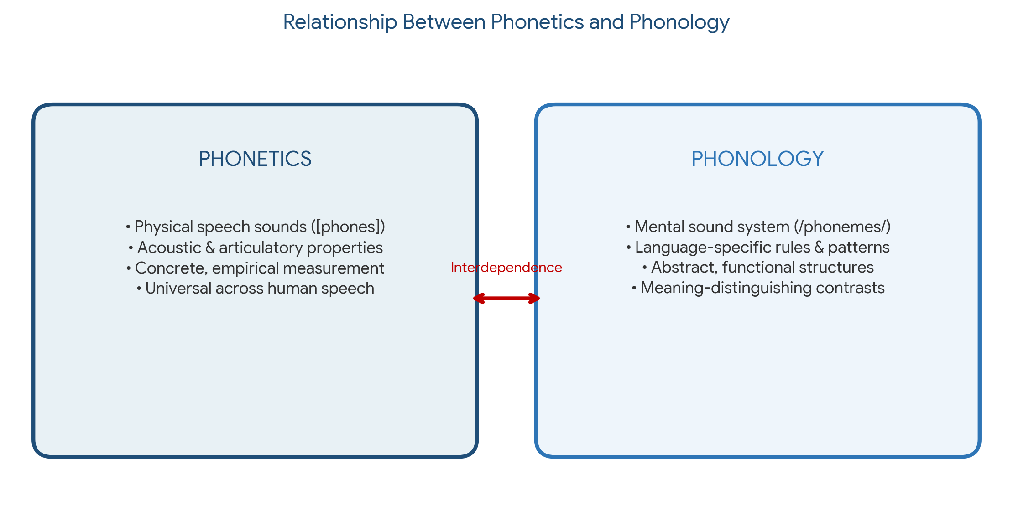
Figure 1.1: Interdependence and structural relationship between Phonetics and Phonology.
Q.1. (b)
QUESTION: Discuss different kinds of vowel sounds. [Marks: 5]

Answer:
A vowel sound is a speech sound produced with an open vocal tract, without any closure or significant constriction in the oral cavity that would produce friction. Vowels are inherently voiced and form the nucleus of syllables in human language. Vowel sounds are categorized based on sound complexity (monophthongs, diphthongs, triphthongs) as well as articulatory parameters (tongue position, height, and lip rounding).
1. Classification by Sound Complexity:
• Monophthongs (Pure Vowels): Vowel sounds that maintain a single, unchanged auditory quality throughout their articulation. English has 12 pure monophthongs (e.g., /i:/ as in 'see', /ɪ/ as in 'sit', /e/ as in 'bed', /æ/ as in 'cat', /ɑ:/ as in 'father', /ɒ/ as in 'hot', /ɔ:/ as in 'door', /ʊ/ as in 'put', /u:/ as in 'too', /ʌ/ as in 'cup', /ɜ:/ as in 'bird', and /ə/ as in 'about').
• Diphthongs (Gliding Vowels): Sounds that consist of a continuous, smooth glide from one vowel quality to another within a single syllable. English contains 8 primary diphthongs:
- Centering Diphthongs (gliding towards schwa /ə/): /ɪə/ (near), /eə/ (hair), /ʊə/ (pure).
- Closing Diphthongs (gliding towards close vowels /ɪ/ or /ʊ/): /eɪ/ (day), /aɪ/ (my), /ɔɪ/ (boy), /əʊ/ (go), /aʊ/ (how).
• Triphthongs: Complex vowel sounds where three vowel qualities glide smoothly within a single syllable (e.g., /eɪə/ as in 'player', /aɪə/ as in 'fire', /ɔɪə/ as in 'employer', /əʊə/ as in 'lower', /aʊə/ as in 'hour').
2. Classification by Articulatory Parameters (The Vowel Quadrilateral):
• Tongue Height (Vertical Axis): Refers to the vertical distance between the tongue surface and the roof of the mouth:
- High / Close Vowels: Tongue is positioned high (e.g., /i:/, /u:/).
- Mid Vowels: Tongue is at an intermediate height (e.g., /e/, /ə/, /ɔ:/).
- Low / Open Vowels: Tongue is positioned low, opening the mouth wide (e.g., /æ/, /ɑ:/).
• Tongue Backness (Horizontal Axis): Refers to the horizontal position of the highest point of the tongue:
- Front Vowels: Highest point of the tongue is in the front of the mouth (e.g., /i:/, /ɪ/, /e/, /æ/).
- Central Vowels: Tongue is relaxed in a central position (e.g., /ə/, /ɜ:/, /ʌ/).
- Back Vowels: Tongue is raised towards the back of the mouth (e.g., /u:/, /ʊ/, /ɔ:/, /ɑ:/).
• Lip Shape / Rounding: Vowels are classified as Rounded (lips rounded/puckered, e.g., /u:/, /ɔ:/) or Unrounded (lips spread/neutral, e.g., /i:/, /e/).
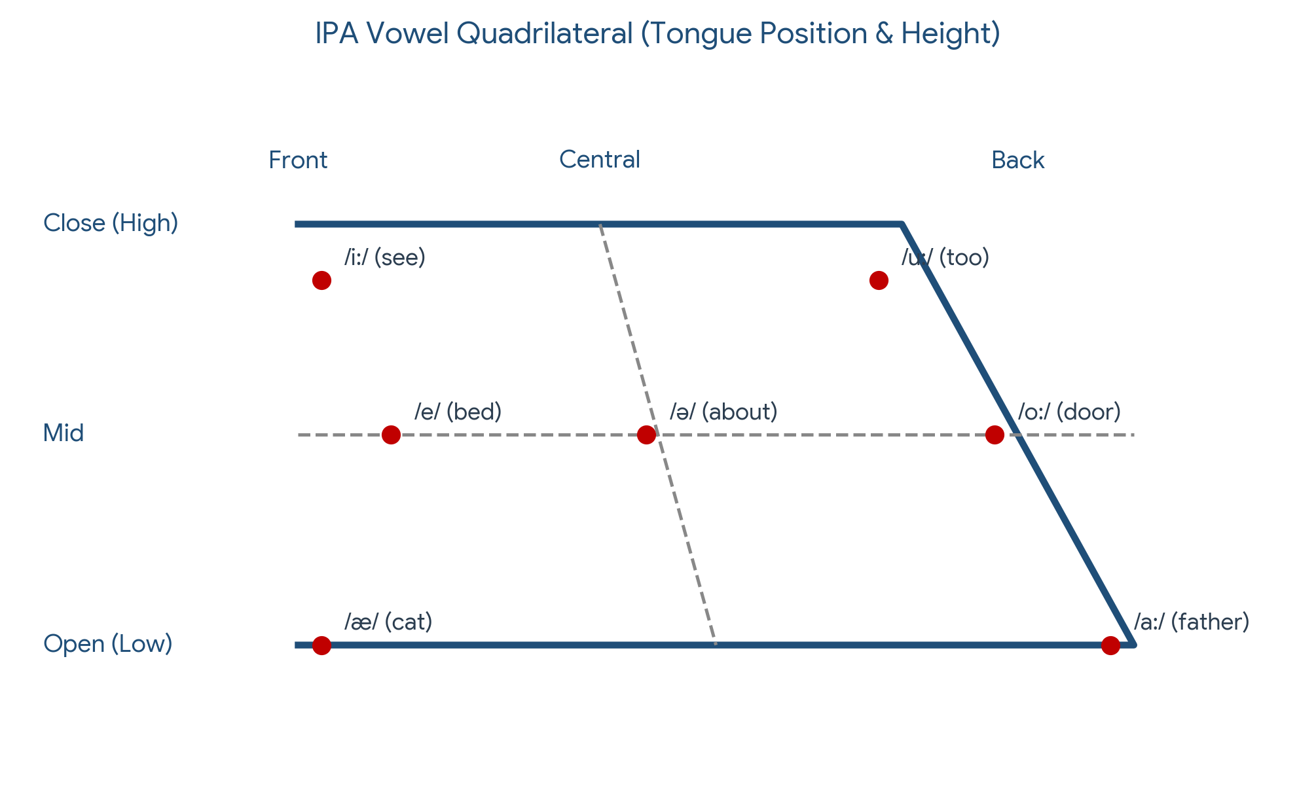
Figure 1.2: IPA Vowel Quadrilateral illustrating English monophthongs by tongue height and backness.
Q.2. (a)
QUESTION: How do sentence categories differ in structure and purpose? Explain the difference between simple, compound, complex sentences. Provide an example of each. [Marks: 5]

Answer:
1. Sentence Classification by Purpose (Communicative Function):
Sentences differ in their pragmatic purpose and communicative objective into four fundamental categories:
• Declarative Sentences: State facts, assertions, or opinions. Purpose: Convey information.
Example: 'The software engineer optimized the compiler algorithm.'
• Interrogative Sentences: Ask direct questions. Purpose: Request information.
Example: 'Did the production server complete the database migration?'
• Imperative Sentences: Issue commands, instructions, or requests. Purpose: Direct action.
Example: 'Refactor the source code to improve system readability.'
• Exclamatory Sentences: Express strong emotional feelings or emphasis. Purpose: Convey intense emotion.
Example: 'What an extraordinary breakthrough in quantum computing this is!'
2. Sentence Classification by Structure:
Structural classification depends on the number and arrangement of independent (main) clauses and dependent (subordinate) clauses:
A. Simple Sentence:
• Structural Definition: Consists of exactly one independent clause containing a single subject and predicate. It expresses a single, complete thought and contains no dependent clauses.
• Formula: [Independent Clause]
• Example: 'The cybersecurity analyst detected an unusual network anomaly.'
B. Compound Sentence:
• Structural Definition: Consists of two or more independent clauses joined together by a coordinating conjunction (FANBOYS: For, And, Nor, But, Or, Yet, So), a conjunctive adverb with proper punctuation, or a semicolon. Both clauses carry equal structural importance.
• Formula: [Independent Clause 1] + [Coordinating Conjunction] + [Independent Clause 2]
• Example: 'The database server crashed during peak hours, SO the network administrators executed emergency failover protocols.'
C. Complex Sentence:
• Structural Definition: Consists of one main independent clause combined with at least one dependent (subordinate) clause. The dependent clause is introduced by a subordinating conjunction (e.g., because, although, since, while, if, when) or a relative pronoun (who, which, that).
• Formula: [Independent Clause] + [Dependent Clause] OR [Dependent Clause], + [Independent Clause]
• Example: 'Although the initial unit testing passed successfully, the software application failed stress testing under high workload conditions.'
D. Compound-Complex Sentence (Structural Extension):
• Structural Definition: Combines elements of compound and complex sentences by containing two or more independent clauses and at least one dependent clause.
• Example: 'Because the network API response was delayed, the web client displayed a loading spinner, and the user waited patiently for the data rendering.'
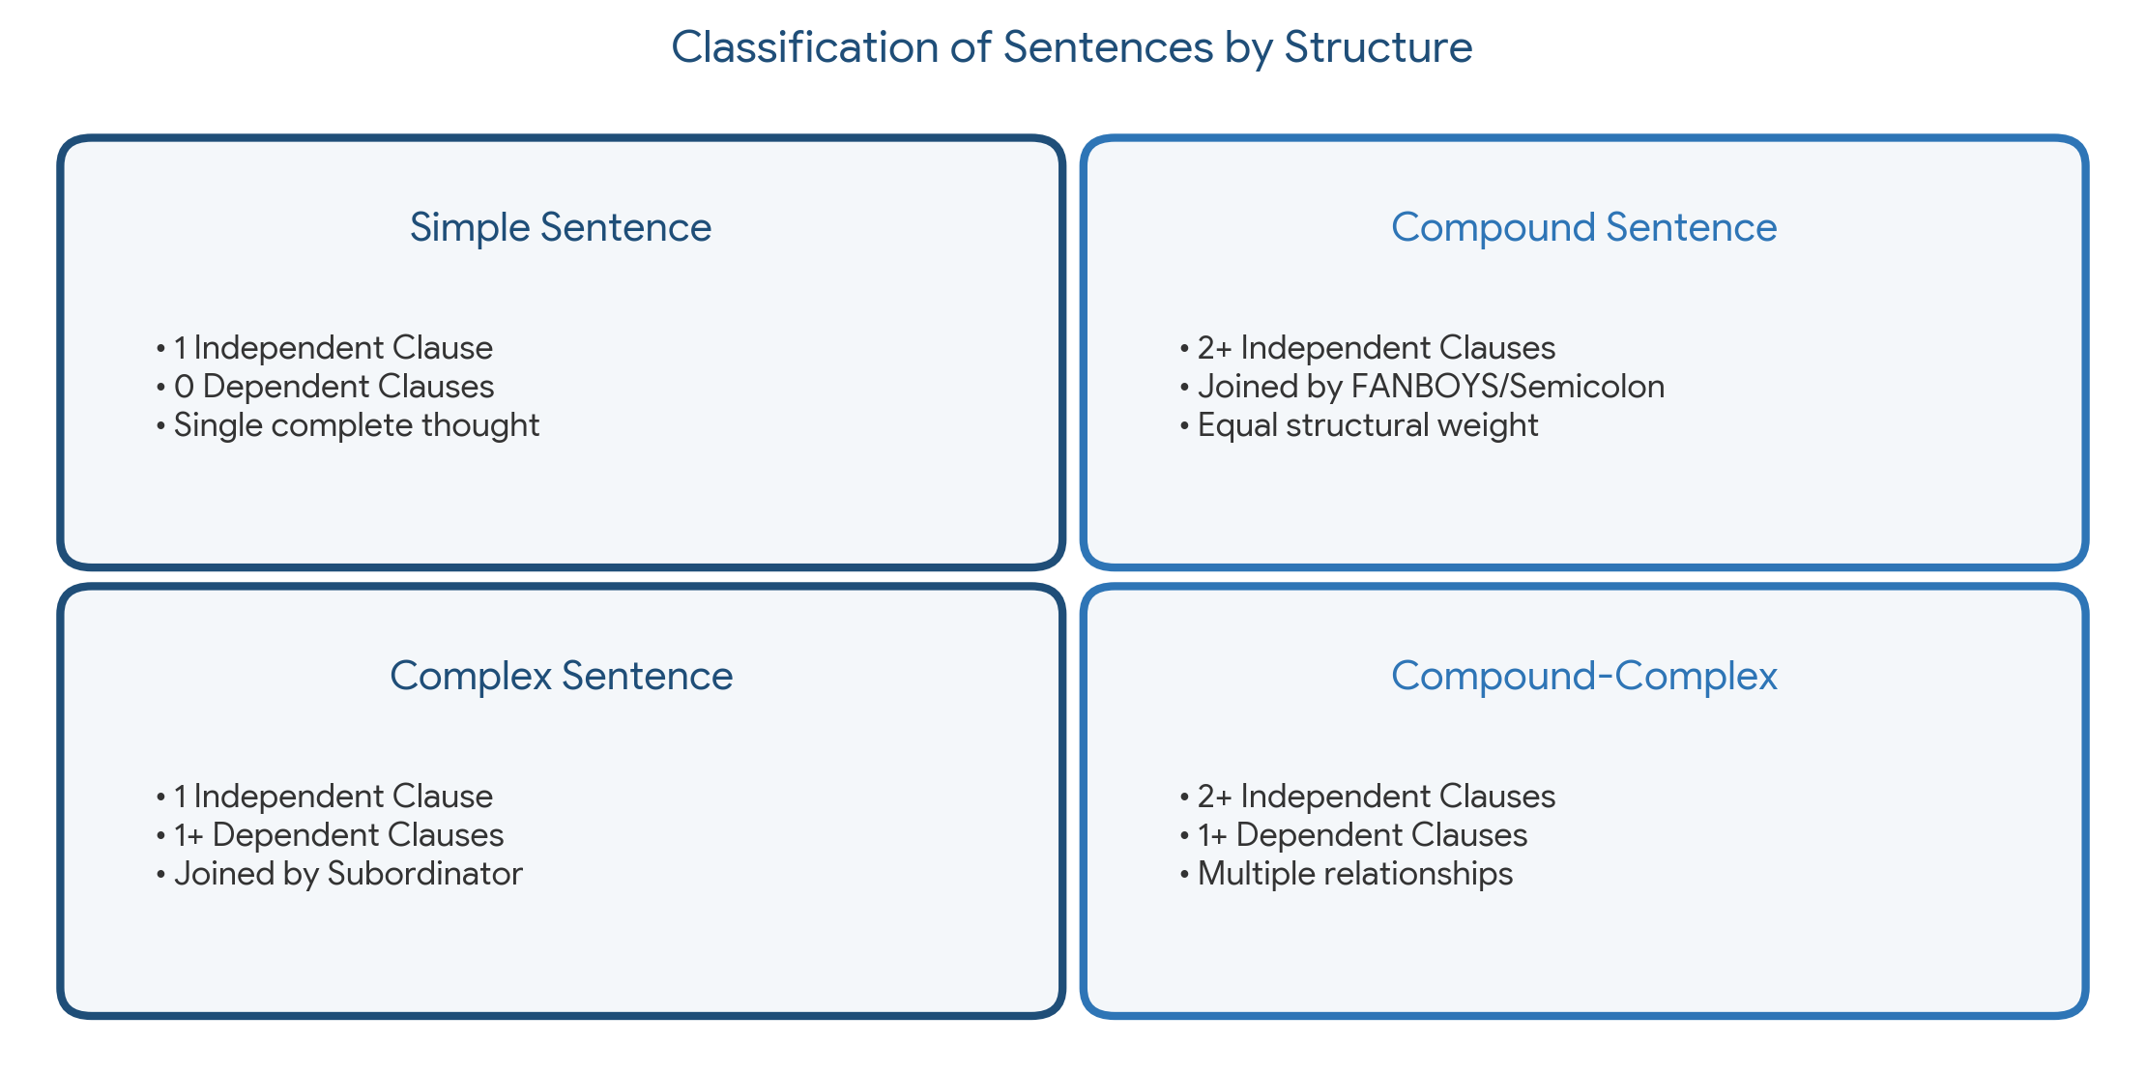
Figure 2.1: Structural classification matrix of English sentences.
Q.2. (b)
QUESTION: Read the passages below and select one passage and write a full argumentative paragraph responding to the same topic but presenting an opposing view point in no more than 300 words based on the structure of paragraph. Provide a title for your analysis and underline by the topic sentence. [Marks: 5]
Passage 1: Technology and Education
Online learning platforms have revolutionized higher education by providing greater accessibility. Students from remote areas now have access to quality education that was previously out of reach. According to a 2022 report by the World Economic Forum, online courses have increased educational participation by 30% globally. Critics argue that online education lacks the interpersonal interaction found in traditional classrooms. While this is a valid concerns, advancements in virtual collaboration tools are bridging this gap, enhancing student engagement.
Passage 2: Should Artificial Intelligence be used in hiring processes?
Artificial Intelligence (Al) should be used in hiring processes due to its efficiency and ability to reduce human bias. Al-powered tools can quickly analyze thousands of resumes, identify the most qualified candidates, and streamline recruitment, saving both time and resources. Furthermore, Al eliminates subjective factors like personal preferences, promoting a fairer selection processes. However, critics argue that Al can perpetuate biases embedded in its training data. While this is a valid concern, careful monitoring and diverse dataset can mitigate such issues. Ultimately when implemented responsibly, Al has the potential to revolutionize hiring by making it more efficient and equitable.

Answer:
Below are full argumentative paragraph solutions for BOTH passage choices. Students may select either passage option:
Option 1 Response (Opposing View to Passage 1: Technology and Education)
Title: The Indispensable Value of Traditional In-Person Education
While online learning platforms offer undeniable convenience and broad reach, traditional in-person education remains fundamentally superior because it fosters vital socio-emotional development, spontaneous collaborative problem-solving, and disciplined academic environments that digital screens cannot replicate. Physical classrooms create an immersive intellectual ecosystem where non-verbal feedback, real-time debates, and immediate mentorship thrive seamlessly. Unlike virtual tools that reduce human interaction to digital pixels, physical campus settings compel students to build essential interpersonal skills, emotional intelligence, and networking habits critical for future workplace leadership. Furthermore, technical fields such as Computer Science and Engineering heavily rely on hands-on laboratory experimentation, physical hardware manipulation, and peer-to-peer whiteboarding sessions that digital simulations struggle to match. Additionally, relying solely on online platforms exacerbates the global digital divide, as students in underprivileged areas often lack the high-speed internet infrastructure and hardware necessary for smooth virtual participation. Screen fatigue and high attrition rates in digital courses further underscore the motivational deficits inherent in isolated learning. Although proponents argue that advancements in virtual reality and online software are closing the engagement gap, technology functions merely as a supplementary aid rather than a replacement for human connection. Consequently, preserving campus-based traditional education is imperative to ensure comprehensive, equitable, and holistically grounded academic growth.
Option 2 Response (Opposing View to Passage 2: AI in Hiring Processes)
Title: The Imperative of Human Oversight: Why AI Should Not Dictate Recruitment
Despite claims of speed and objectivity, integrating artificial intelligence into hiring processes poses severe risks by institutionalizing algorithmic bias, reducing human candidates to rigid metrics, and removing essential empathetic judgment from talent acquisition. Automated hiring systems rely on historical recruitment datasets that inherently reflect past structural discrimination and societal prejudices. Consequently, when AI algorithms screen applications, they frequently perpetuate and amplify systemic exclusion by penalizing unconventional career trajectories, gaps in employment, or non-traditional educational backgrounds. Moreover, algorithmic filtering algorithms lack the emotional intelligence and intuition required to evaluate qualitative human traits such as resilience, adaptability, ethical integrity, and alignment with organizational culture. Qualified candidates who possess immense potential are often automatically rejected simply because their resumes lack specific keyword triggers. While advocates maintain that algorithmic audits and diverse training datasets can eliminate computational bias, software developers themselves acknowledge that total neutrality in machine learning is an unattainable goal. Entrusting recruitment decisions to opaque 'black-box' algorithms ultimately dehumanizes the hiring experience and exposes institutions to severe legal liabilities. Therefore, human talent acquisition professionals must retain full authority over recruitment to guarantee a fair, nuanced, and genuinely equitable evaluation of candidates.
Q.4. (a)
QUESTION: Discuss the qualities of an ideal paragraph. [Marks: 5]

Answer:
An ideal paragraph is a coherent, unified block of written discourse that effectively develops a single core idea. To achieve maximum clarity, professional impact, and academic rigor, a paragraph must possess five essential structural qualities:
1. Unity (Single Focus):
Unity requires that every single sentence in the paragraph directly relates to and supports the central controlling idea, which is explicitly declared in the topic sentence. Any irrelevant detail, tangential thought, or off-topic statement destroys unity and confuses the reader.
2. Coherence (Logical Flow of Thought):
Coherence refers to the logical and orderly arrangement of ideas. Sentences must be organized in a clear, sensible sequence (e.g., chronological order, order of importance, spatial arrangement, or general-to-specific structure) so that the reader can follow the writer's train of thought effortlessly.
3. Cohesion (Structural Connections):
Cohesion involves the linguistic devices used to glue sentences together smoothly. This is achieved through the strategic use of transitional expressions (e.g., 'furthermore', 'however', 'consequently', 'in addition'), pronoun references, key term repetition, and parallel grammatical structures.
4. Adequate Development (Completeness):
A well-developed paragraph must contain sufficient evidence, concrete examples, statistics, expert quotes, or analytical reasoning to thoroughly explain and validate the topic sentence. Superficial or under-developed paragraphs leave key claims unsubstantiated.
5. Emphasis and Balance:
Emphasis ensures that the most important ideas receive prominent visual and structural positioning—typically at the beginning (topic sentence) and the end (concluding statement) of the paragraph—highlighting key takeaways effectively.
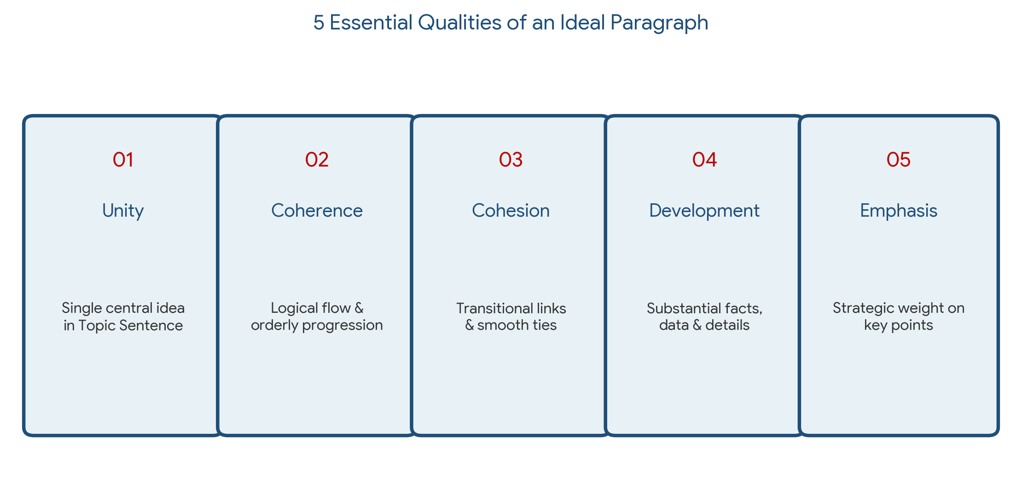
Figure 4.1: The 5 structural pillars defining an ideal paragraph.
Q.4. (b)
QUESTION: Develop the topic sentence into a paragraph: 'There are so many reasons why we should develop English proficiency.' [Marks: 5]

Answer:
There are so many reasons why we should develop English proficiency. First and foremost, English functions as the undisputed global lingua franca, enabling seamless communication across diverse international cultures, academic institutions, and multinational industries. In today's interconnected digital economy, acquiring high fluency in English opens doors to lucrative career opportunities, professional mobility, and global enterprise collaboration. Furthermore, for students and scholars in Computer Science and Engineering, English proficiency is indispensable because the vast majority of technical documentation, academic research publications, programming language libraries, and cutting-edge tech innovations are published in English. Beyond professional advancement, mastering English grants unrestricted access to a vast universe of global literature, media, and digital resources, thereby broadening one's intellectual horizons and cross-cultural understanding. Ultimately, developing English proficiency is not merely an academic requirement, but a transformative personal investment that empowers individuals to thrive in a globalized world.
SECTION B
Q.5. (a)
QUESTION: You are a 1st-Year CSE student looking for a part-time internship in a software company. Although you have no prior work experience, you have completed several academic projects and participated in coding competitions. Prepare a well-structured CV with cover letter for this internship application. [Marks: 5]

Answer:
Below is the complete, professional Internship Application Package comprising a formal Cover Letter followed by a structured Curriculum Vitae (CV).
PART 1: COVER LETTER
A. S. M. Tanvir Rahman
1st Year Student, Department of Computer Science & Engineering
Rajshahi University of Engineering & Technology (RUET)
Email: tanvir.cse.ruet@gmail.com | Phone: +880 1712-345678
GitHub: github.com/tanvir-ruet | LinkedIn: linkedin.com/in/tanvir-cse
September 13, 2026
Hiring Manager, Talent Acquisition Department
TechVision Software Solutions Ltd.
IDB Bhaban (8th Floor), Agargaon, Dhaka-1207
SUBJECT: Application for Part-Time Software Engineering Internship Position
Dear Hiring Manager,
I am writing to express my strong interest in the Part-Time Software Engineering Internship position at TechVision Software Solutions Ltd. As a dedicated 1st-Year Computer Science & Engineering student at Rajshahi University of Engineering & Technology (RUET), I have cultivated a solid foundation in structured programming, data structures, and algorithmic logic. I am eager to apply my technical problem-solving skills to real-world enterprise software development.
Although I am at the early stage of my academic career without formal industry experience, I have actively developed practical engineering competencies through rigorous coursework and hands-on projects. Recently, I built a modular Student Management System in C utilizing dynamic memory allocation and binary file I/O operations. Furthermore, I routinely participate in competitive programming contests on platforms like Codeforces and intra-RUET hackathons, which has sharpened my debugging agility and algorithmic efficiency.
TechVision's commitment to high-performance software systems aligns perfectly with my ambition to grow as a software engineer. I am confident that my strong work ethic, rapid learning ability, and dedication to code quality will make me a valuable asset to your team. Thank you for considering my application. I look forward to the opportunity to discuss how my skills align with your engineering goals.
Sincerely,
A. S. M. Tanvir Rahman
Department of Computer Science & Engineering, RUET

PART 2: CURRICULUM VITAE (CV)
A. S. M. TANVIR RAHMAN
Rajshahi-6204, Bangladesh | +880 1712-345678 | tanvir.cse.ruet@gmail.com
GitHub: github.com/tanvir-ruet | LinkedIn: linkedin.com/in/tanvir-cse
_________________________________________________________________________________
CAREER OBJECTIVE
Enthusiastic and analytical 1st-Year CSE undergraduate seeking a part-time Software Engineering Internship to leverage strong C/C++ programming skills, algorithmic thinking, and academic project experience in building efficient software applications.
EDUCATION
Bachelor of Science (B.Sc.) in Computer Science & Engineering
Rajshahi University of Engineering & Technology (RUET), Rajshahi, Bangladesh
• Current Status: 1st Year Odd Semester (Enrolled 2024)
• Key Coursework: Structured Programming (C), Functional English, Differential & Integral Calculus, Chemistry.
TECHNICAL SKILLS
• Programming Languages: C, C++, Python (Basic)
• Core Concepts: Data Structures, Algorithms, Modular Design, Memory Management, File I/O
• Tools & Version Control: Git, GitHub, Code::Blocks, VS Code, Linux Command Line
• Professional Skills: Technical Communication, Problem-Solving, Team Collaboration
ACADEMIC PROJECTS
1. Student Records Management System (C Language)
- Developed a CLI-based application handling CRUD operations for student academic records.
- Implemented dynamic memory structures and persistent binary file storage for record retention.
2. Matrix & Vector Mathematics Calculator (C / Pointers)
- Created a program using double pointers to execute matrix addition, multiplication, and transposition.
COMPETITIVE PROGRAMMING & ACHIEVEMENTS
• Active Contestant on Codeforces (Max Rating: 1240 - Pupil) | Solved 200+ algorithmic problems.
• Top 15 Finish – Intra-RUET Freshman Programming Contest 2024.
EXTRACURRICULAR ACTIVITIES
• Executive Member, RUET Career & Computing Club (2024 – Present)
• Volunteer, National High School Programming Contest (NHSPC) Regional Round
Q.5. (b)
QUESTION: Fill in the table by putting words in the empty cells according to their parts of speech: [Marks: 5]
Noun | Verb | Adjective
X | (a) | renewable
(b) | energize | X
certification | X | (c)
analysis | (d) | X
ability | X | (e)

Answer:
The complete table with filled missing cells (highlighted) and individual sub-part answers are provided below:
Noun | Verb | Adjective
renewal / renewability [X] | renew --- (a) | renewable
energy --- (b) | energize | energetic / energizing [X]
certification | certify --- [X] | certified --- (c)
analysis | analyze / analyse --- (d) | analytical / analytic [X]
ability | enable --- [X] | able --- (e)
Summary of Missing Cell Solutions:
• (a) = renew (Verb form of 'renewable')
• (b) = energy (Noun form of 'energize')
• (c) = certified / certificated (Adjective form of 'certification')
• (d) = analyze / analyse (Verb form of 'analysis')
• (e) = able (Adjective form of 'ability')
Q.6. (a)
QUESTION: Discuss the essential elements of a memo. [Marks: 5]

Answer:
A Memorandum (commonly termed 'Memo') is a specialized internal business document used for communicating decisions, policies, reports, or instructions within an organization. A professionally constructed memo must contain the following essential elements:
1. Standard Header Block:
The header identifies the administrative parameters of the memo:
• TO: Full name(s) and job title(s) of the intended recipient(s).
• FROM: Full name and official job title of the sender.
• DATE: Complete formal date of transmission.
• SUBJECT (or RE): A concise, specific summary of the memo's core topic.
2. Opening / Statement of Purpose:
Directly states the primary reason for writing in the first 1-2 sentences. It outlines the core issue, policy update, or directive immediately.
3. Context / Technical Discussion:
Provides background information, operational context, empirical findings, or situational analysis necessary for the reader to understand the problem fully.
4. Action Plan / Instructions:
Outlines specific actions required from the recipients, assigning responsibilities, operational steps, and firm deadlines. Use of bullet points enhances readability.
5. Summary / Closing Segment:
Concludes with a courteous summary, contact details for follow-up inquiries, and next steps or scheduled review meetings.
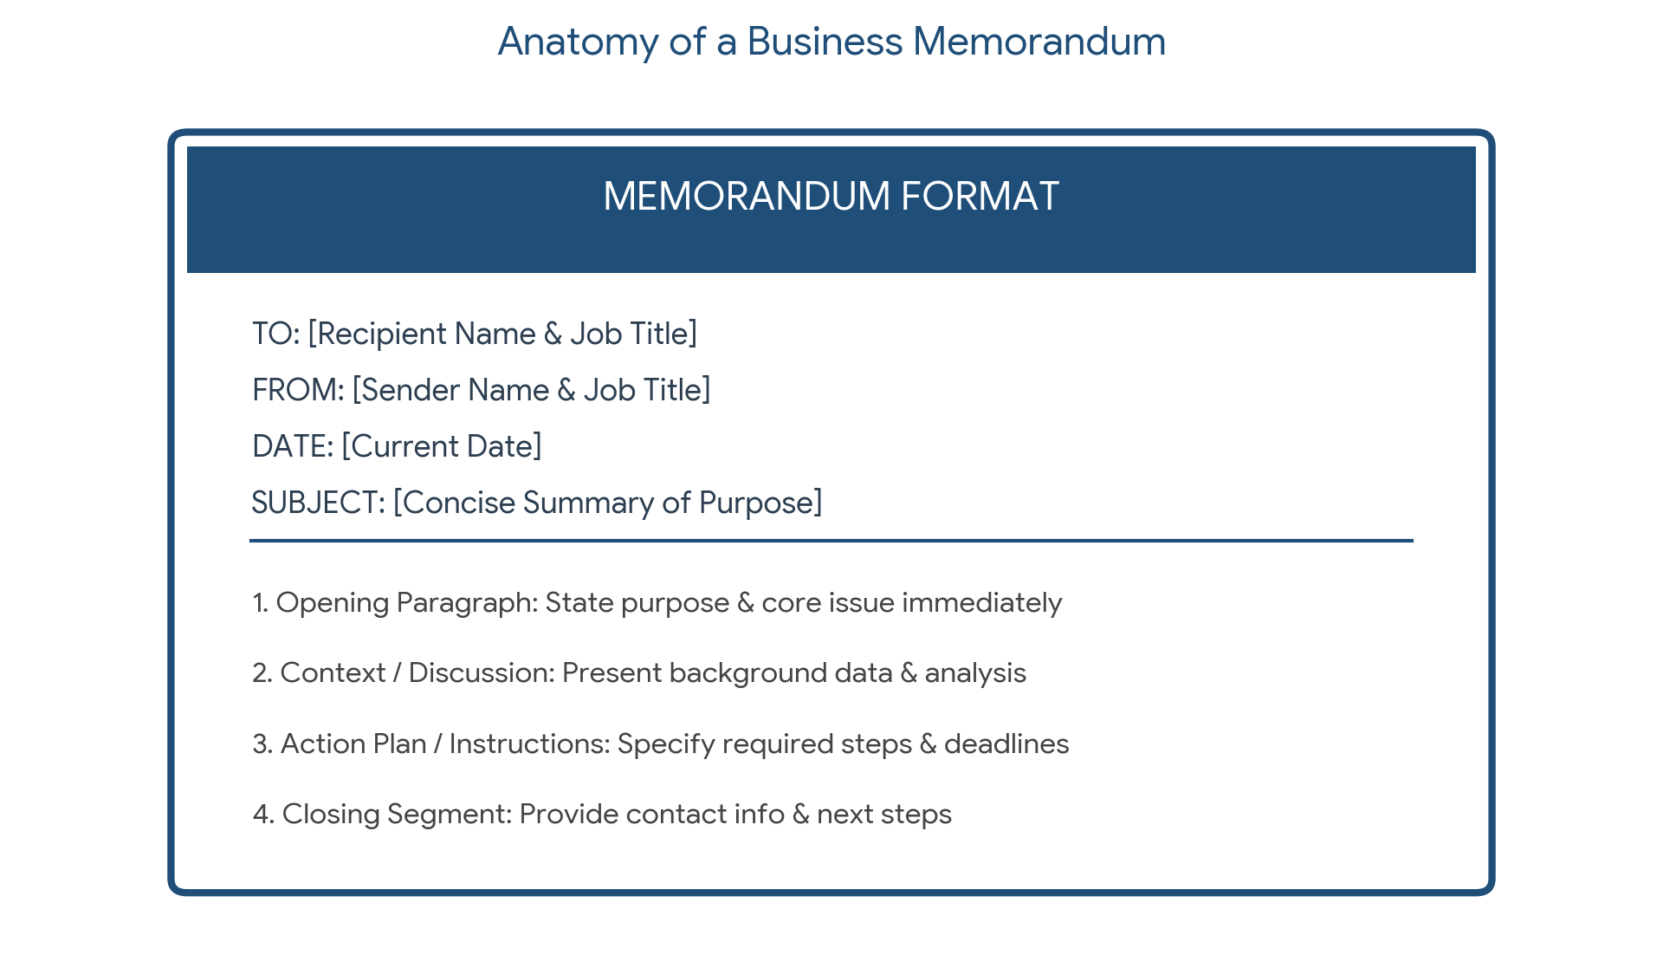
Figure 6.1: Structural template and header component layout of a corporate memorandum.
Q.6. (b)
QUESTION: You are a junior member of the IT security department. Recent scans have detected suspicious network activity on one of the company's critical servers. Write a memo to the network operations team informing them about the situation. [Marks: 5]

Answer:
MEMORANDUM
TO: Network Operations Team
FROM: Junior Security Analyst, IT Security Department
DATE: September 13, 2026
SUBJECT: URGENT: Detection of Suspicious Network Activity on Core Server DB-PROD-02
_________________________________________________________________________________
1. STATEMENT OF PURPOSE
This memorandum is to urgently alert the Network Operations Team regarding unauthorized and suspicious network traffic detected on our critical database server (DB-PROD-02) during routine automated security scans today at 14:15 UTC.
2. SITUATIONAL ANALYSIS & FINDINGS
Our Intrusion Detection System (IDS) flagged multiple anomalies originating from an external IP address (198.51.100.45):
• High-Frequency Port Scanning: 500+ connection requests per minute targeted at restricted database port 5432.
• Data Exfiltration Indicators: Outbound data transfers spiked to 4.2 GB within 15 minutes, exceeding baseline thresholds by 300%.
• Authentication Failures: 120 failed SSH root login attempts recorded in firewall access logs.
3. IMMEDIATE ACTION REQUIRED
To mitigate potential data leakage and system compromise, please execute the following emergency isolation protocols immediately:
1. Firewall Rule Isolation: Block all incoming and outgoing traffic from external IP 198.51.100.45.
2. Network Containment: Temporarily shift server DB-PROD-02 to the isolated Security Inspection VLAN-99.
3. Session Termination: Terminate all active administrative sessions on DB-PROD-02 and force password resets.
4. Log Preservation: Dump and preserve all raw firewall and syslog files from 14:00 UTC onward for forensic auditing.
4. NEXT STEPS & BRIEFING
An emergency incident response briefing will take place at 16:00 UTC in Conference Room B and via Teams. Please direct all technical queries to extension 4402 or security-incident@company.com.
Thank you for your prompt action on this critical threat.
Q.7. (a)
QUESTION: Discuss the essential parts of a business letter. [Marks: 5]

Answer:
A formal business letter is a standardized document used for external communication between organizations, clients, or vendors. A standard Full-Block business letter comprises eight essential structural components:
1. Sender's Information / Letterhead:
Includes company logo, official organization name, physical street address, phone number, and email address.
2. Date Line:
Placed below the letterhead in formal format (e.g., September 13, 2026). Never abbreviated in formal correspondence.
3. Inside Address (Recipient's Information):
Full name, official title, company name, and full mailing address of the recipient.
4. Formal Salutation:
Professional greeting followed by a colon (e.g., 'Dear Mr. Smith:' or 'Dear Dr. Rahman:').
5. Subject Line (Optional but Recommended):
A concise line summarizing the core intent of the letter (e.g., 'Subject: Acknowledgment of Project CloudSync Success').
6. Body Paragraphs:
Divided logically into:
• Opening Paragraph: States the specific purpose of the letter.
• Middle Paragraph(s): Provides detailed context, data, explanations, or proposals.
• Closing Paragraph: Summarizes expectations, next steps, or expresses goodwill.
7. Complimentary Close:
Formal closing phrase (e.g., 'Sincerely,', 'Respectfully yours,').
8. Signature Block:
Space for handwritten physical signature, followed by the typed full name and job title of the sender.
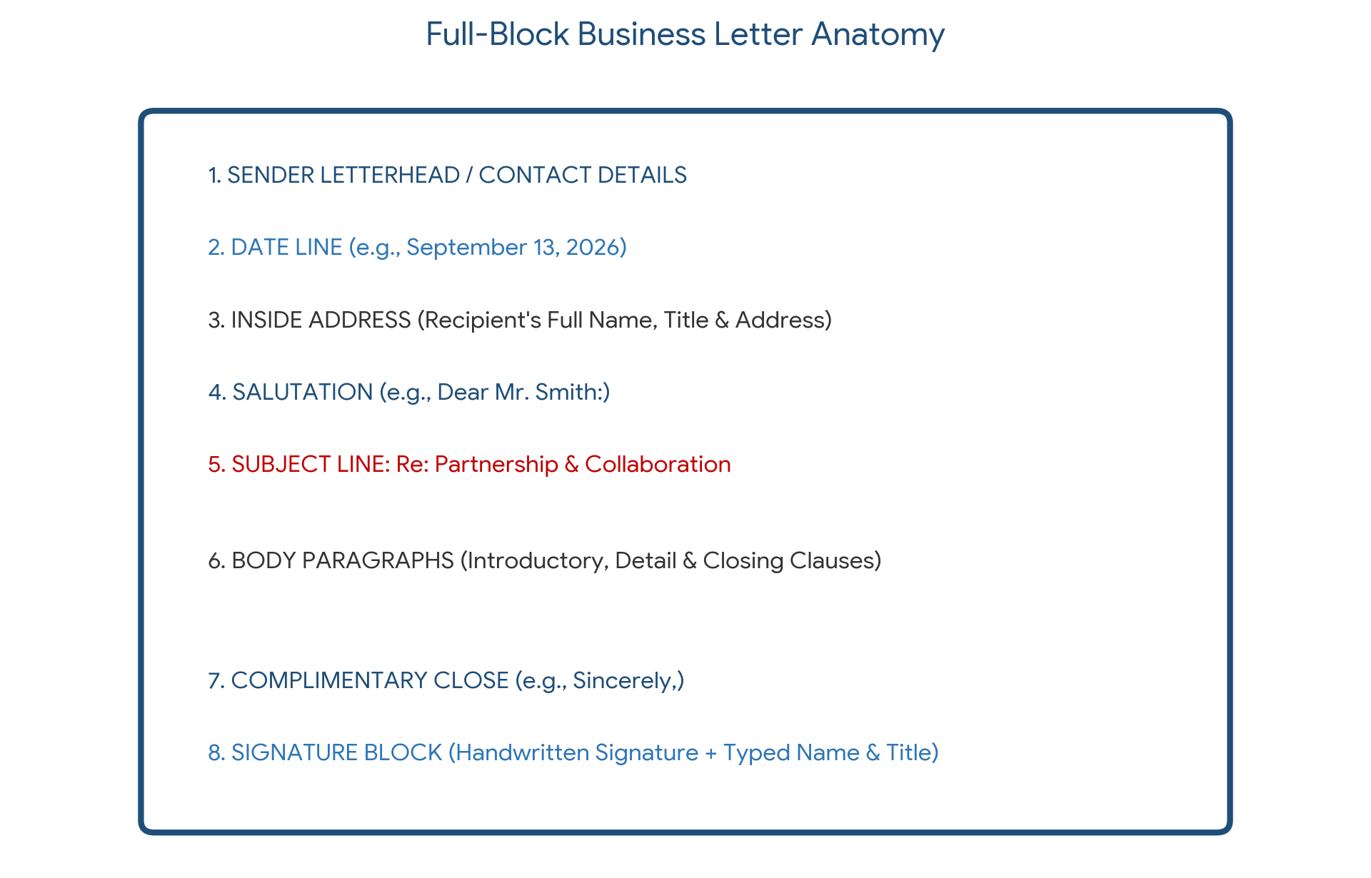
Figure 7.1: Anatomy and layout structure of a Full-Block Business Letter.
Q.7. (b)
QUESTION: Your company collaborated with another business partner on a successful joint project. Write a letter to acknowledge their contribution and express interest in future collaborations. [Marks: 5]

Answer:
APEX SOFTWARE TECHNOLOGIES LTD.
Plot 14, Level 5, Tech Park Avenue, Gulshan-2, Dhaka-1212
Phone: +880 2-9876543 | Web: www.apextech.com
_________________________________________________________________________________
September 13, 2026
Mr. Robert Chen
Managing Director
InnoTech Solutions Inc.
Suite 402, Innovation Tower, Banani, Dhaka-1213
SUBJECT: Formal Acknowledgment of Project CloudSync Success and Proposal for Future Collaboration
Dear Mr. Chen,
On behalf of Apex Software Technologies Ltd., I am writing to convey our sincere appreciation for the outstanding partnership and collaborative effort demonstrated by InnoTech Solutions Inc. during the development and execution of Project CloudSync.
The successful deployment of the enterprise cloud migration platform ahead of schedule is a direct result of your engineering team's exceptional technical expertise, meticulous quality assurance, and unwavering commitment to excellence. Your team's integration of microservices architecture was pivotal in ensuring system stability and high throughput.
Given the remarkable success of this venture, we are eager to explore future collaborative opportunities. We are currently planning our Q4 Enterprise Analytics Platform initiative and would be delighted to partner with InnoTech Solutions once again.
I welcome the opportunity to meet next week to discuss potential strategic partnerships. Thank you once again for a magnificent joint achievement.
Sincerely,
A. S. M. Tanvir Rahman
Chief Executive Officer
Apex Software Technologies Ltd.
Q.8. (a)
QUESTION: Imagine you are creating a user manual for a new software application designed for data visualization. One of the key features of the application is the ability to upload a dataset and generate a bar chart in the application. Write a process paragraph (200-250 words) that explains how a user can upload a dataset and generate a bar chart in the application. [Marks: 5]

Answer:
Generating a customized bar chart from a raw dataset in DataViz Studio is a straightforward, four-step process designed for seamless user experience. First, log in to your DataViz Studio workspace and navigate to the main dashboard panel, where you click the prominent 'Upload Dataset' button. Drag and drop your target CSV or XLSX file into the designated upload dropzone, or click 'Browse Files' to select the file from your local storage. Next, once the system parses the data, review the data preview table to ensure that column headers and data types (such as categorical strings and numerical values) are correctly recognized by the application parser. Subsequently, navigate to the 'Chart Builder' tab on the left navigation sidebar and select 'Bar Chart' from the visualization gallery. In the configuration panel, assign your desired categorical column to the X-Axis (such as 'Product Category') and map your target numerical metric to the Y-Axis (such as 'Total Sales Revenue'). Finally, customize your chart by applying color schemes, chart titles, and gridline preferences, and click 'Generate Chart' to render the visual bar chart instantly, which can then be exported in high-resolution PNG, SVG, or PDF formats.
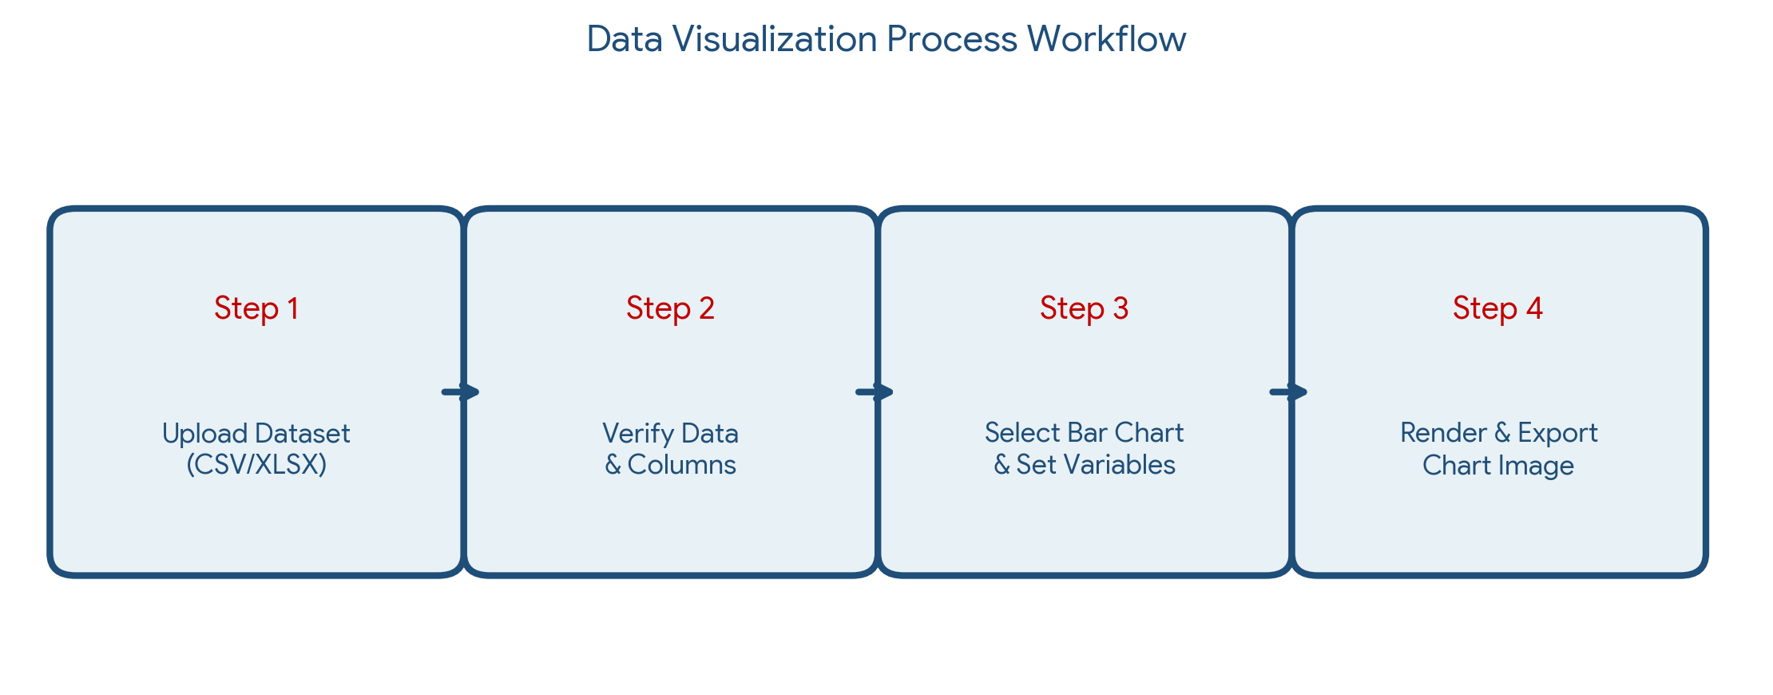
Figure 8.1: Step-by-step user workflow diagram for uploading dataset and rendering a bar chart.
Q.8. (b)
QUESTION: Your internet service provider charged you extra for the last month's bill without any valid reason. Write a complaint letter to the billing department, asking for clarification and a refund. [Marks: 5]

Answer:
A. S. M. Tanvir Rahman
House 45, Road 12, Sector 4, Uttara, Dhaka-1230
Phone: +880 1712-345678 | Email: tanvir.customer@gmail.com
Account Number: SB-884129 | Service ID: BB-1004592
_________________________________________________________________________________
September 13, 2026
Billing & Customer Support Department
SpeedNet Broadband Communications Ltd.
Level 4, SpeedNet Tower, Mohakhali C/A, Dhaka-1212
SUBJECT: Formal Complaint Regarding Unjustified Billing Charge on Account #SB-884129 and Request for Refund
Dear Billing Department,
I am writing to register a formal complaint regarding an unauthorized and unjustified extra charge appearing on my monthly internet invoice for August 2026 (Invoice #INV-2026-08-9941).
My subscribed package is the 'Home Premium 50 Mbps Unlimited Plan' at a fixed monthly rate of BDT 1,500. However, the August statement reflects a total charge of BDT 2,350, including an extra charge of BDT 850 listed as an 'Unspecified Value-Added Service Fee.' I have neither requested nor consented to any additional services, bandwidth upgrades, or premium subscriptions during this billing cycle.
I request an immediate investigation into this billing discrepancy, a formal written explanation for the unauthorized charge, and a full refund or credit adjustment of BDT 850 applied to my upcoming September 2026 bill.
Copies of the August invoice and bank payment receipt are attached for your verification. I expect a response within five business days.
Sincerely,
A. S. M. Tanvir Rahman
Account Holder (#SB-884129)

জীবনের মানে হলো: প্রতিটি ফারাক্কার প্রচণ্ড ধাক্কায়,
শত্রুর বুকে করা বুমেরাং

