Project name: dewe  
students: Shehab Abouelhassan (Leader) , Amin asjad (contributor )

Neptun code: YOOQ6Z , JDKQJC

Disclaimer  
the Idea of the project still the same – Social Media App, however for better practicing of the real world Application development process and life-cycle, we added a tiny modification to the main idea, to serve a real purpose.

Contents

page

1- Interaction design tips for mobile applications…………… 1

2- Target Market Research…………………………………………...2

3- Project Process………………………………………………………..3

4- The Project Brief………………………………………………………3

5- The Basic Elements Model………………………………………….4

6- Framework and the problem to be solved……………………4

7- Goals Definition……………………………………………………….5

8- Constraints……………………………………………………………...6

9- Layout Ideas& Sketches ………………………….…………………9

10- Programming Process………………………………………………10

Interaction design tips for mobile applications

The best apps –the ones most carefully constructed and thought out –feature such an intuitive setup that must users might not even recognize how smooth and easy to use they are. Great interaction design helps a user figure out how to operate a mobile app. It’s welcoming and instructive. It should feel second-nature. These qualities don’t come easy, however. They take hard work, lots of practice, and plenty of patience during the design development process.

this Interaction Design Tips for Your Mobile app’ provides to keep in mind when striving for an outstanding application. These tips can help the DEWE team to development the application for APPLIACATIONNAME .

I. Lead the user toward the next step.

II. Match your interactions to your platform. The DEWE group who programmed the application, studied and researched the specific interface conventions in the operating system, and then modified the application’s design to take the best advantage of the specific platform. The eautuitiveNutrition application is made in Android Studios.

III. Use clean, simple icons. A picture is worth 1.000 words, and a visual interface icon is worth 10.000 lines of code. When designing a mobile application, pictures are your friends. Icons take up less space than the text that would be required to explain a function, giving more room onscreen.

IV. Reduce, reduce, reduce. Mobile applications became the most frequently used, most user-friendly piece of technology people ever owned, but they also have very small screens that can’t display much information at a time. As a designer, these limitations need to be kept in mind.

Target Market Research

eautuitiveNutrition is aimed at those people who need a change in their food life, a change in their diet even improving it. Also, the service offers nutritional advice to nutrition advisors’ customers and clients, and associations, the option to resolve doubts instantly.

The user acquires the service that fits his characteristics Afterwards, a nutritionist connects with him and proposes some weekly challenges. From there, a system of daily monitoring and online coaching is implemented to achieve the desired goal.

Project Process

The following sections outline the main process stages undertaken by the team to complete the project. The stages include the following: Planning and Time Management, Designing, Programming, and Testing and Evaluation.

The Project Brief

The main brief specified by eautuitiveNutrition requires the DEWE team to create a mobile application that will incorporate an online chat feature. This is an essential feature, and the application should be based around this.

The online chat must allow for customers to receive advice and support easily. As a team, we have realized our project specification.

Using keywords to aid our specification we would like the application to 1) Motivate, 2) Support, 3) Encourage eautuitiveNutrition customers.

|  |  |
| --- | --- |
| Motivate | To motivate users of the application to think about their nutrition and be proactive |
| Support | To support users of the application with their nutritional needs, by providing them with essential and tailored information that will help them make educated decisions |
| Encourage | To encourage users of the application to be proactive in their daily life/routines and consciously think about nutrition to make better life choices |

The Basic Elements Model  
The brief set by eautuitiveNutrition is vague but broad. As a team, we had various thoughts and ideas on how the project could progress. We organized initial thoughts in a core elements model, that enabled us  
to organize these initial thoughts logically. Categories such as Brief, Purpose, Company and so on were  
used to list what we knew and questions on areas where more information was necessary.

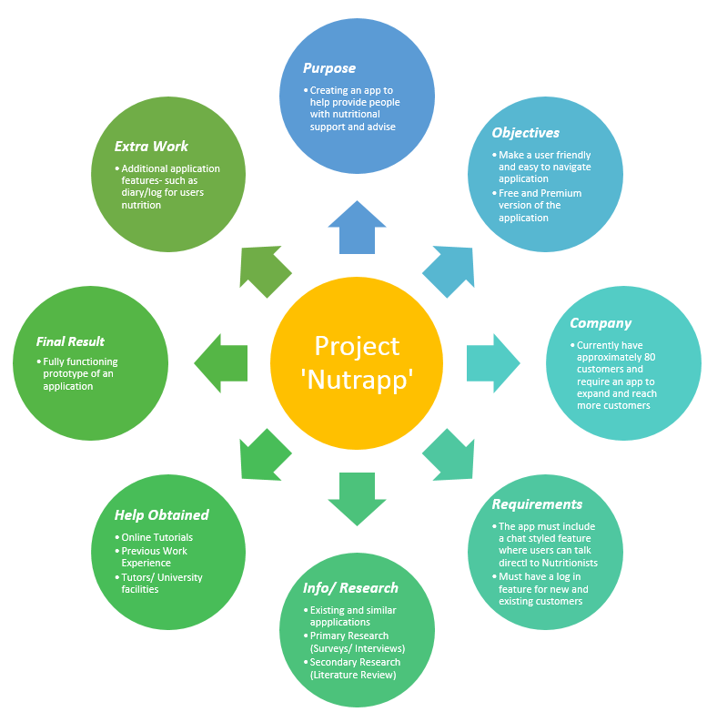

Framework and the problem to be solved  
We propose an online nutritional  
service that uses coaching techniques. The use of smartphones and Apps is increasing and is accessible to  
a clear majority of the population. More than 97,000 health Apps already exist.  
Moreover, text messaging has been demonstrated to be a useful tool in effecting behavior  
change. Recent publications on text messaging and health behavior changes highlight the need for  
interventions that are not limited to spread information and content but also incorporate social context,  
cultural values and strong elements unique to the intended population. Therefore this project is unique  
because we will use health coaching techniques to motivate, support and encourage and the text  
messages from the virtual nutritionist/coach are tailored to each patient’s individual needs and concerns

Goals Definition  
It is important, as a team, that we specify what our goal definition is, based on the brief from  
eautuitiveNutrition. Our goals and objectives must be realistic for the project to be realized within the given  
timeframe.  
Our project goal is to develop a prototype of an Android mobile application for eautuitiveNutrition

The application will include an online chat or messaging system, login database, connection the website’s blog(yet to come )  
as well as general settings of a mobile application. We will start researching the human interaction and  
impact of online coaching to the users, and then we continue with designing the application according to  
the company’s specifications and program it with Android Studio

Constraints  
Every project has its constraints, and this one is not an exception. There are several boundaries which determine the general shape of the final result. Every specified limit was assigned to the group.

The division of groups is shown below:  
● Business  
○ Type of the clinic does not allow project team members to change an industry  
specification. eautuitiveNutrition already has an existing base of around 20 customers. Due to that fact, the challenge is to write an application which will fit current ones and encourage more people.  
● Design  
○ The clinic website colors are variations of green hence the layout of an application should use them. The graphics are not provided therefore the challenge is to design all of them.  
● Facilities  
○ The clinic provided facilities that should be inserted into the application. All the rules  
that must be followed can be found in the report.  
● Human Resources  
○ Team members are not experienced programmers, and this is the first contact with  
Android Studio environment.  
● Methodology  
○ For proper working on the project, techniques learned during seminars will be used.  
● Physical  
○ The application should be as compact as possible - it should take the smallest possible  
size of memory.  
● Process  
○ Meetings with supervisors and the clinic stuff.  
○ Seminars and courses at the workplace ..  
● Quality  
○ The application will be a prototype. It allows the team to release updates. However, it  
should be fully usable application.  
● Risk Tolerance, lack of practical skills by the team members  
● Technical  
○ There is only one tool for the programming that the team will use - Android Studio.  
● Time  
○ The deadline for the release of the prototype is the end of Current semester

Layout Ideas  
The design process starts with research and individual brainstorming of each team members to  
get the best ideas of the eautuitiveNutrition app layout. There are a few criteria the team needs to fulfil.

First, the concept is flat, simple and visible, following Google Materials design guidelines The color scheme of  
the app is required to comply with clinic’s existing general color scheme which is green and black.  
Team members can modify the fill and transparency of the color and clinic’s logo. Lastly, the design  
should have a fluid user flow, and easy accessibility to the users avoiding clutters of graphic and  
information. These criteria are discussed and agreed in the second meeting with the clinic.  
Each team member needs to propose their ideas within a week and discuss it with the team. The  
required pages are a login screen, homepage, post feed, chat interface and setting.  
Sketches  
All the sketches are uploaded digitally, and we received different concepts from each team  
members

|  |  |  |
| --- | --- | --- |
| NO | Concepts | Sketch |
|  | 1. A simple login page  2. Homepage with circled  icons to access the  features  3. A WhatsApp look-alike  chat page.  4. Default android settings  5. Blog feed with articles  thumbnails  6. A profile page which  includes personal  information |
|  |  |

|  |  |  |  |  |
| --- | --- | --- | --- | --- |
| 1. Simple login page  2. Homepage with circled  icons.  3. Chat bubble  4.Login page with social media options 3.Dashboardmenu for easy access to other features 4. Speech bubble-style chat 5. Summarize article in the news feed  post feed with scrollable articles  6.Homepage with login and register buttons 7.Profile page with text fields for users to fill in their information |  | | | |
|  |  | | | |
|  | |  |  |

The common ideas among the team members are:  
1. Simple login page  
2. Circled icon on the homepage  
3. Speech bubble style in chat  
4. Profile screen will include user information and general settings

Determining the Design According to Market Analysis

Our approach is to be motivational and encouraging. The design must be psychologically attractive to users and avoid using any design that will lead to negative vibes. Light green and white are chosen to be the overall theme of the design as they will provide the positive mood for the users. We are  
avoiding using unpleasant colored graphics such as red and dark. To comply with the clinic’ color scheme, the color of the font will be black and white.  
As the users are ranging from 15 to 50 years old, our graphics need to be as simple as possible yet informational without sacrificing the attractive design. We are designing the user flow to be minimalistic and use less number of pages to avoid screen confusion to the users

Determination of the Layout

We create the general layout of the login page, homepage and blog feed. Other pages will be based on these four pages.  
The layout has five common criteria:  
1. Follow material design guidelines that have been released by Google.  
2. Every page has a top bar with page’s title and back button (except homepage) with a fix green background (#25EF0B). This color has been chosen from company’s text logo.  
3. Every page must facilitate on-screen Android navigation buttons (back, home and menu).  
4. Fix dimension of the top bar.  
5. The name of the font used is Roboto. The color and boldness of the font can be modified to  
differentiate the styles format.

**Programming Process**

Benefits of Android  
The application will use the operating system of Android. It will be written in the programming language, Java, using the software, Android Studio.  
We chose to program using Android operating systems (OS) rather than iOS (the operating system used on many Apple products) due to its open source platform and the ability to immediately publish applications Open source platforms allow developers to use the previously existing code in their applications, therefore eliminating some of the work and making advanced programming available to  
those lacking the skills. As most of our group members are only beginners in programming, we felt open source programming was a must for this project. However, although only beginners, a few group members  
have used the programming language Java. As Android is programmed in Java, and with limited time to familiarize ourselves with the software, we felt it would make for a shorter learning process to move forward with an operating system that used a familiar programming language. To improve the group’s  
programming knowledge, one group member took an online class on application development using Android Studio, while other members continuously updated their knowledge of Android development using online resources (videos, articles, etc.).

Features

1. User Registration and login and Google Sign In.
2. Recover Password
3. Setup User Profile
4. Show User Profile
5. Edit User Profile
6. Show All Registered Users
7. Block Unblock Users
8. Search Users
9. Chat (send text and image) whit notification
10. Chat List
11. Publish Post with Notification
12. Post List with Search
13. Other User's Profile
14. Edit, Delete, Share Posts
15. Like, Comment Posts
16. Likes and Comments List
17. Notifications Screen