Project name: dewe  
students: Shehab Abouelhassan (Leader) , Amin asjad (contributor )

Neptun code: YOOQ6Z , JDKQJC

Reading and exploring the README.dm file is Strongly suggested for better understanding, evaluation and assessment of this project. Along side with the Final_Report file*********

Client-side Application Logic (Parent)

Some of the #34 steps/parts of the development process and implementation for this App, Are being illustrated here, accompanied by some screenshots for both java and xml activities. i.e

*/*In this Part(06):  
 * Design user profile  
 * Get user info from firebase  
 * Show user info  
  
In this Part(07):  
 --Edit Profile:  
 1) Name  
 2) Phone  
 3) Profile Picture  
 4) Cover Photo  
 --Requirements:  
 1) Camera & Storage Permissions (to pick image from camera or gallery)  
 2) Firebase Storage libraries (to upload & receive profile/cover photo)  
 --UI Update:  
 1) Add ImageView (for cover photo)  
 2) Add FloatingActionButton to show dialog containing options to Edit Profile  
 3) Add Default Image for Profile Picture*/*

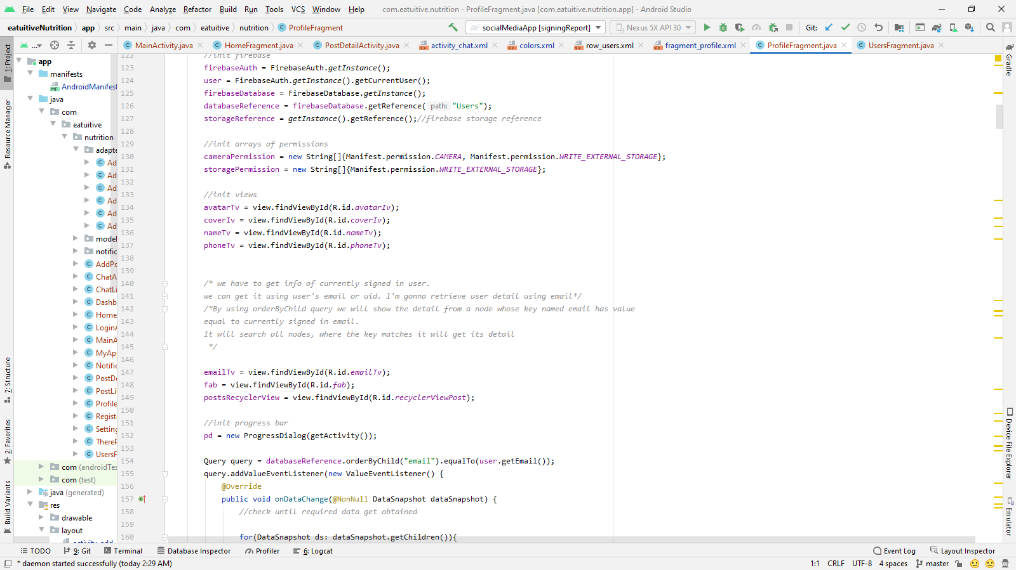  
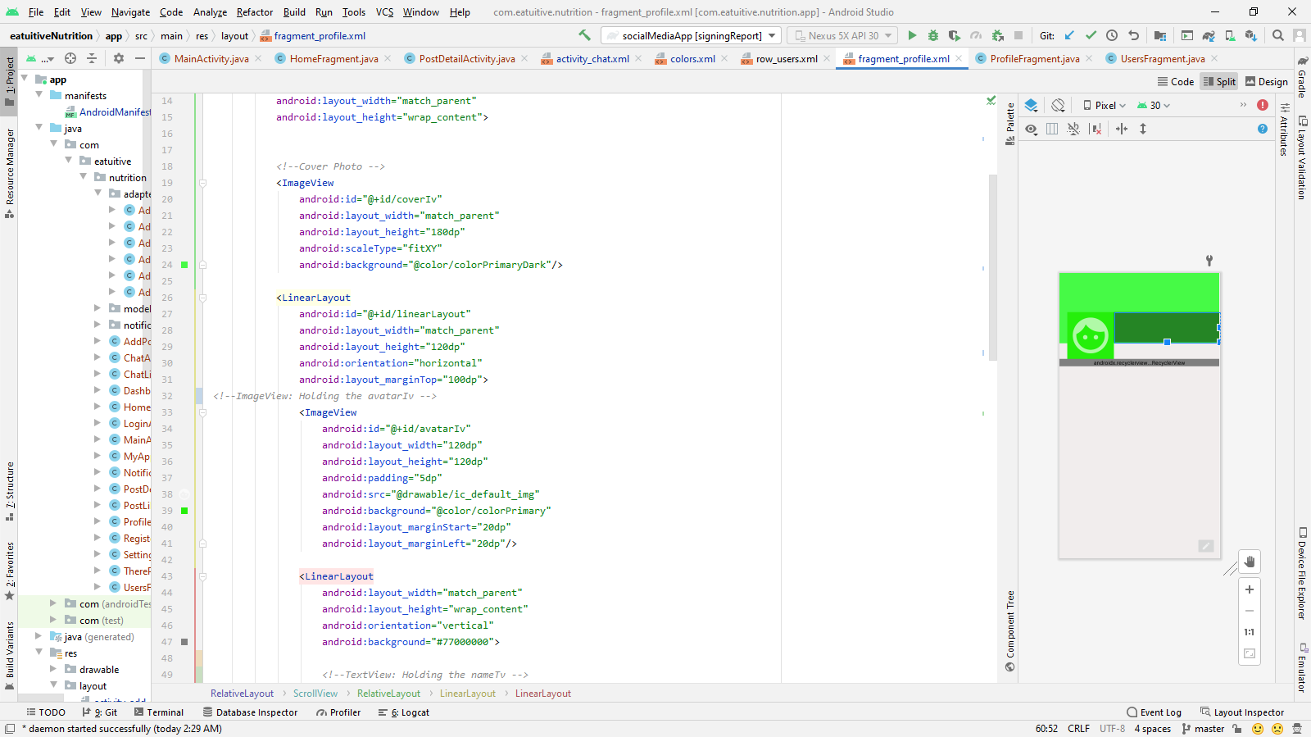

> (child)

## Overview

Our application is an Instagram-like App which supports below functions  
ω User identification by login, then retrieving posts from server  
ω Clients user profile  
ω View, comment, like and create posts  
ω Sending messages to friends

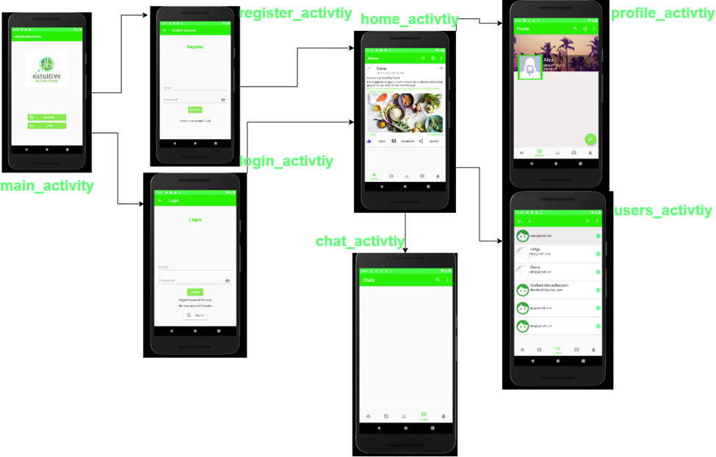

## User Identification and Retrieving Posts

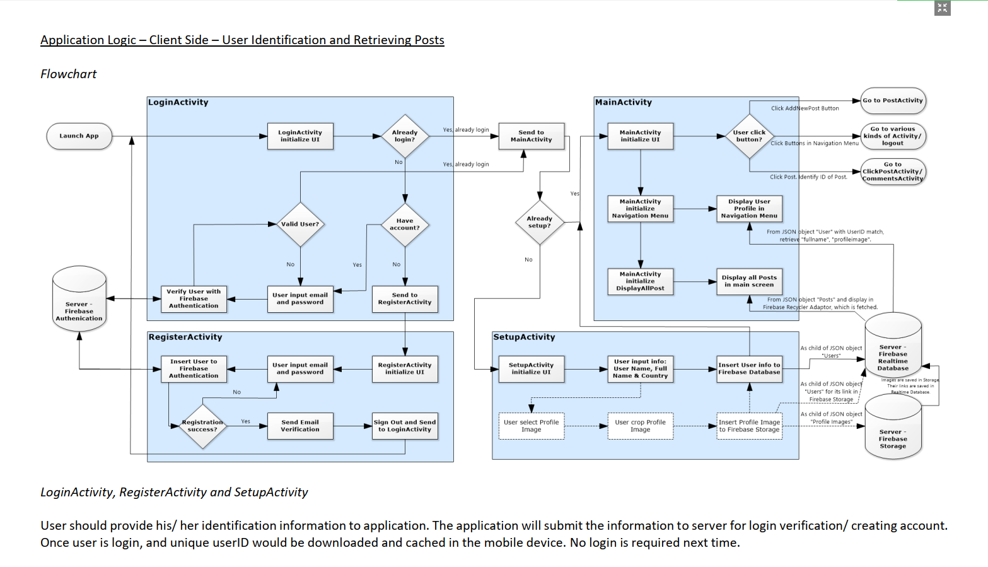

*LoginActivity, RegisterActivity and ProfileActivity*User should provide his/ her identification information to application. The application will submit the information to server for login verification/ creating account.  
Once user is login, and unique userID would be downloaded and cached in the mobile device. No login is required next time.  
*MainActivity*Application would download all posts if users submit a valid userID to server, i.e. user successfully login. The posts are fetched and showed using RecyclerView,  
which allows user to view posts even if the connection with server is lost.  
*MainActivity – Navigation Menu*User could access other functions by clicking the menu.

## Customize Profile

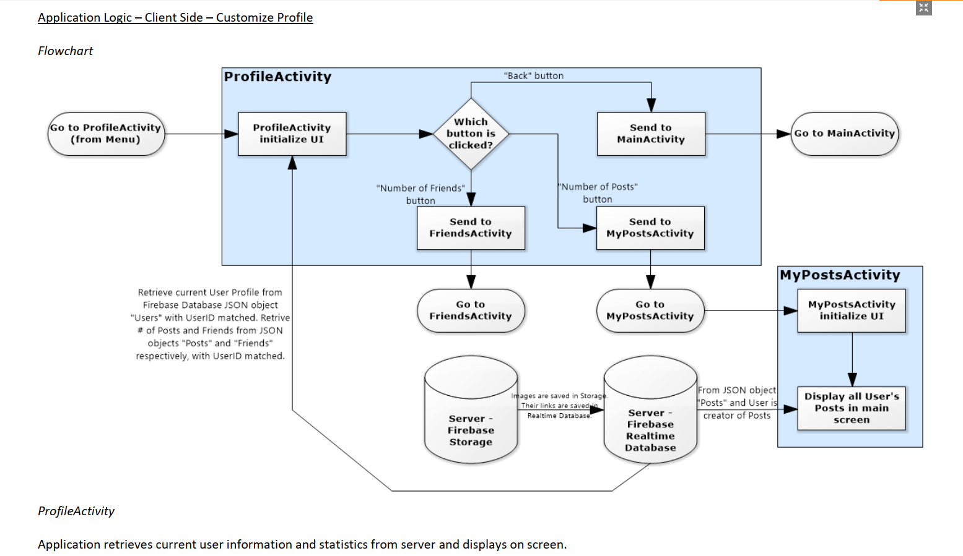

PostsActivity

Application requests information of post created by current user by query (supported by Firebase Server) and displays on screen.

## View, Comment, Like and Create Posts

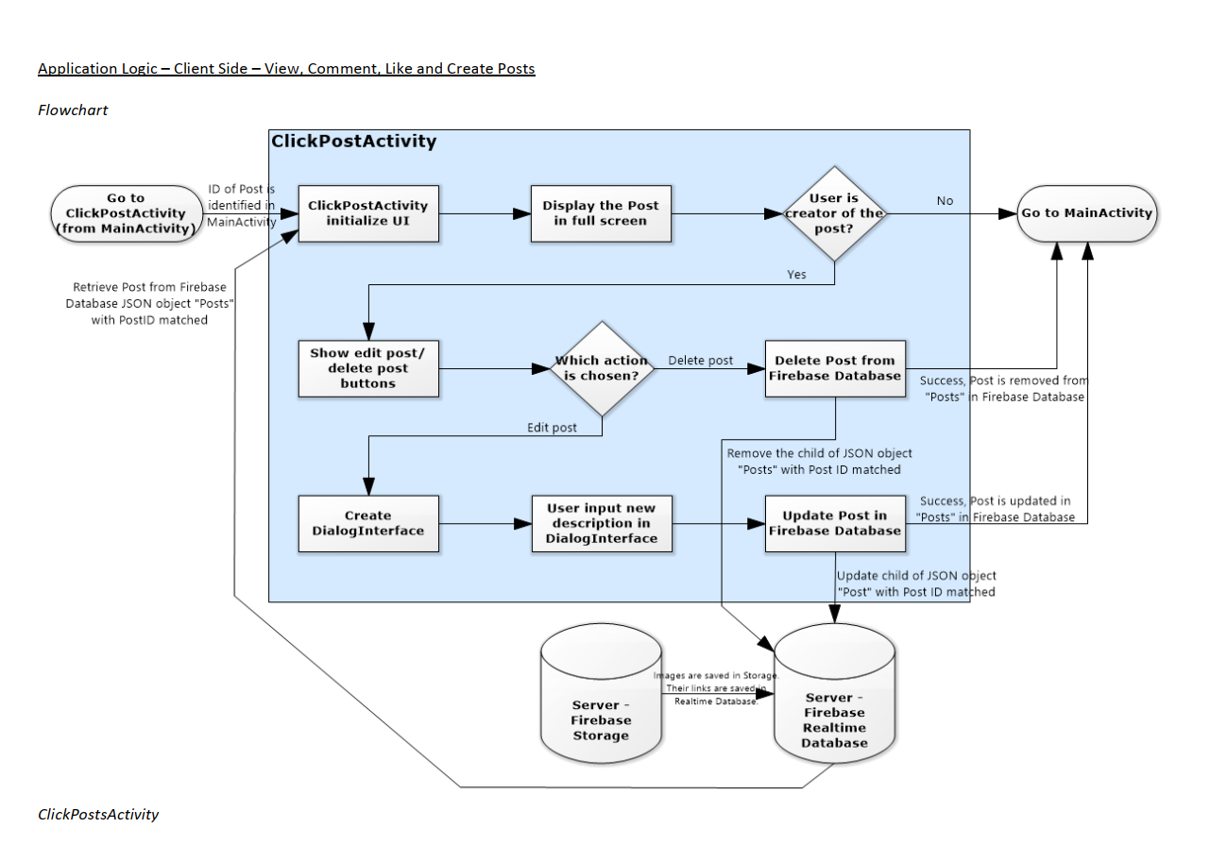

*PostsActivity*All posts are show in *MainActivity*. By clicking a post, creator of the post could send request to server for edit or delete the it. If other users click a post, they could  
see the post in full screen. Edit and deleted functions are invisible for them

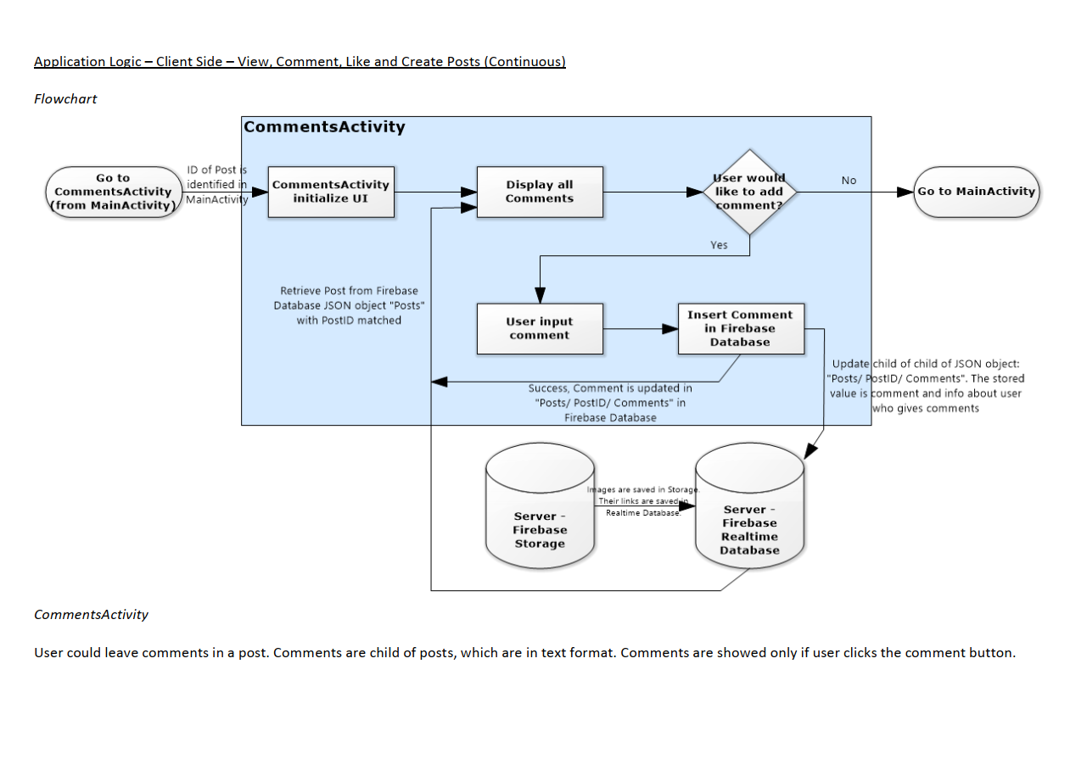

*CommentsActivity*User could leave comments in a post. Comments are child of posts, which are in text format. Comments are showed only if user clicks the comment button.

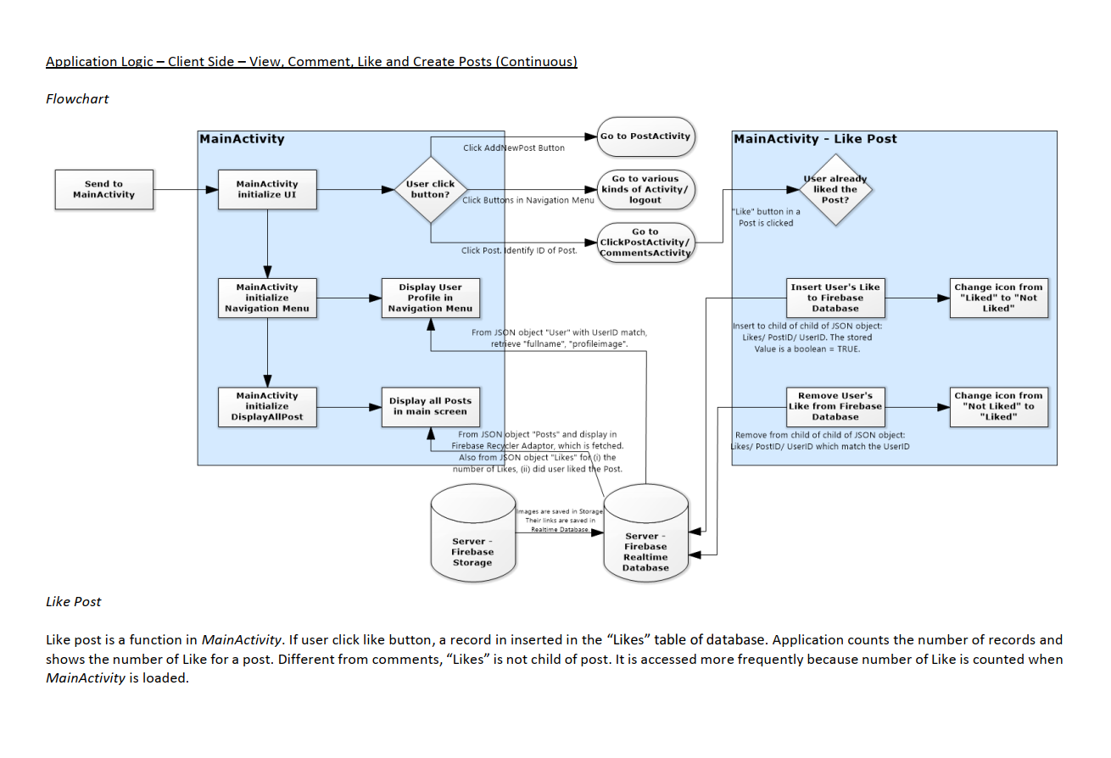

*Like Post*Like post is a function in *MainActivity*. If user click like button, a record in inserted in the “Likes” table of database. Application counts the number of records and  
shows the number of Like for a post. Different from comments, “Likes” is not child of post. It is accessed more frequently because number of Like is counted when  
*MainActivity* is loaded

## Friends and Message



## Disconnection Management

Application Logic – Client Side – Disconnection Management  
*Fetching in RecyclerView*The application is an Instagram-like application, which require users to have continuous connection with server to access all function. Powerful local data storage  
is unnecessary for this application. Hence, no local database is built for copying information from server. Instead some fetching techniques are used, which allows  
users to view the content even there is a short connection loss with the server.  
RecyclerView is a build-in library in android for display a scrolling list of elements based on large data sets (or data that frequently changes). It automatically cached  
data from server. To read the data, a RecyclerView.Adapter should be built. All data are temporary cached, and user could continuous browsing even connection  
is lost. However, creating new posts or changing profile information is not allowed in this offline mode.

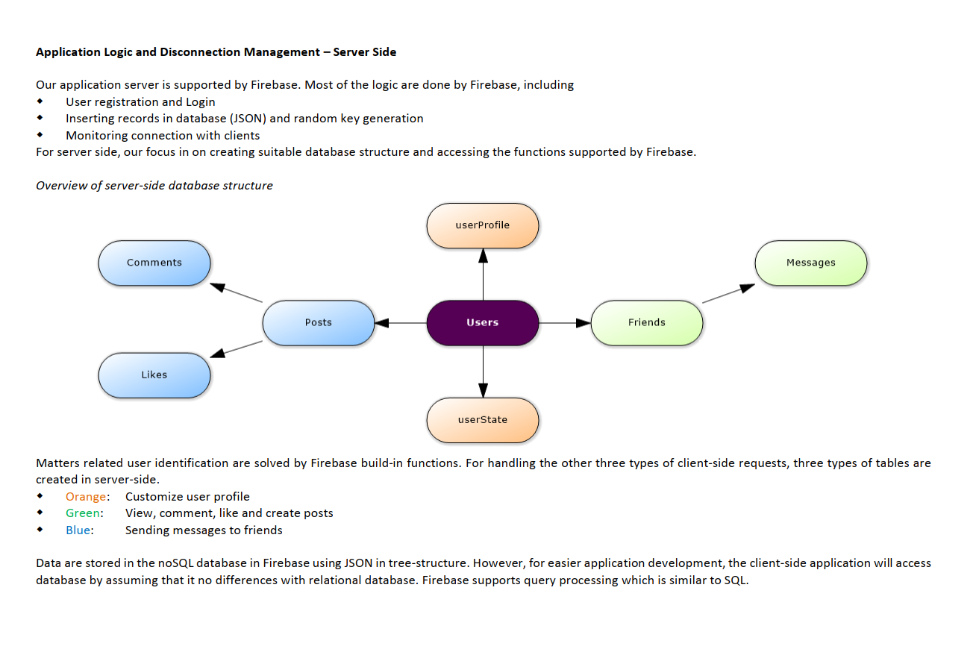



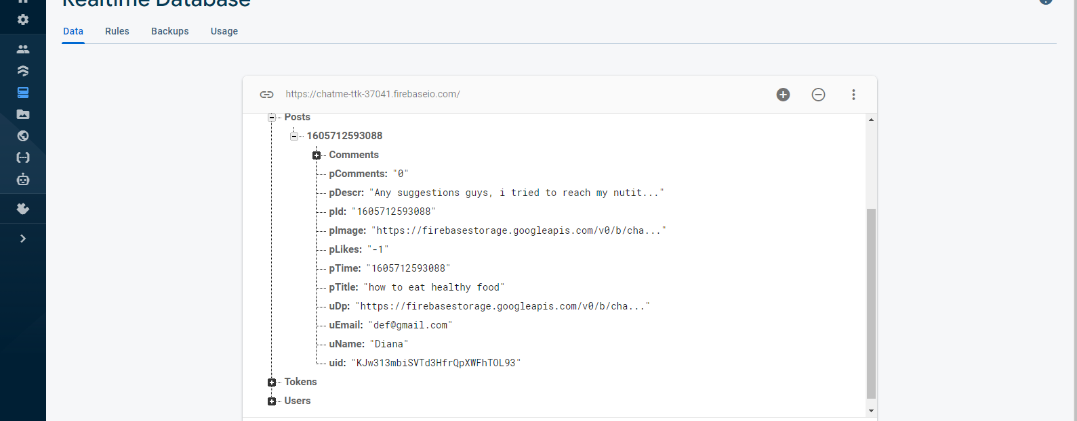

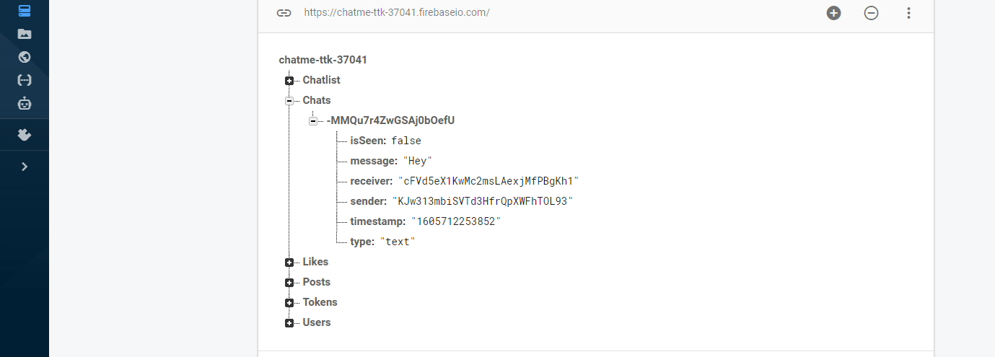

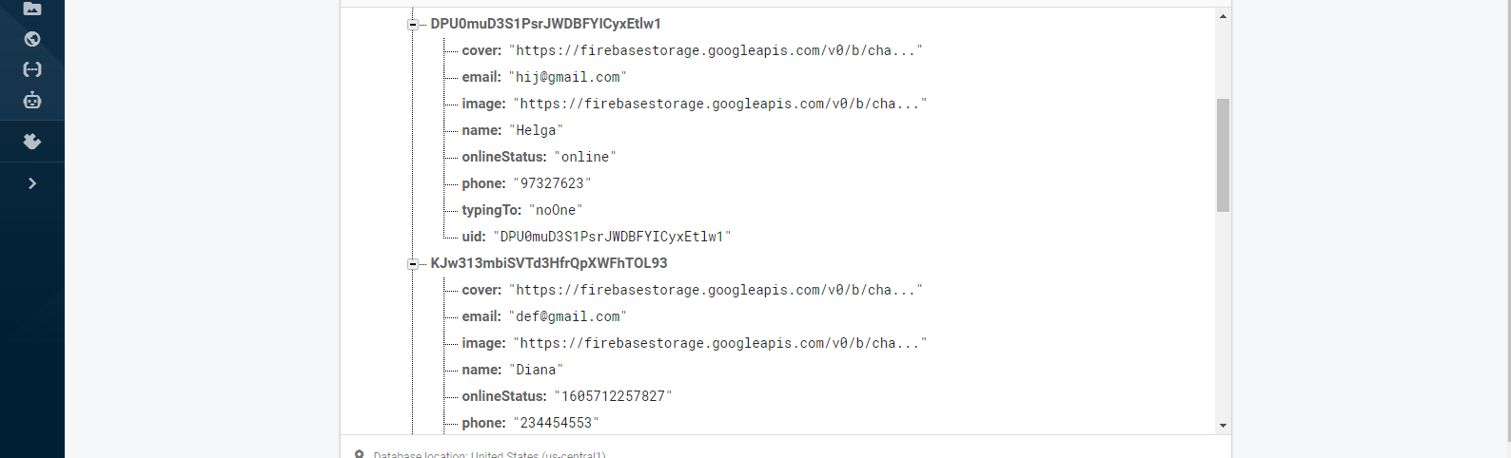

## Server-side Database

