Real-Time and Embedded Systems Design – Project

Team 17

Eman Khaled 18P9713

Omar Hussien 18P1265

Farah Essam 18P3448

Mohamed Mostafa 18P9474

Shehab El Din Adel 18P3863

# Project files link

# Video link

# Introduction

In this project, we will implement a temperature controllers

# Flowchart

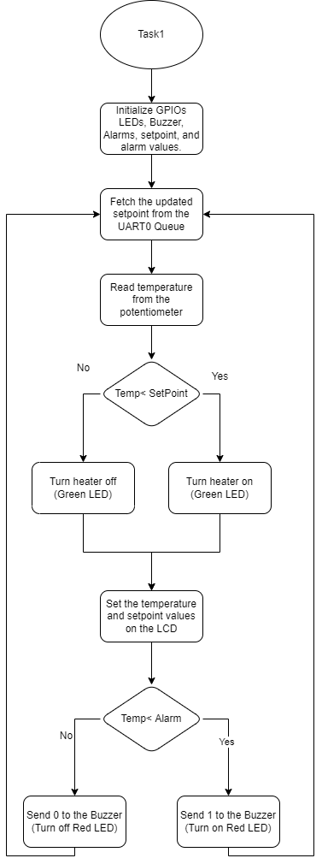

Figure - Task1 Flowchart

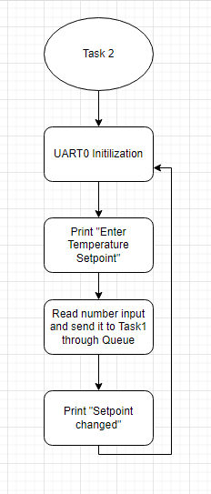

Figure - Task2 Flowchart

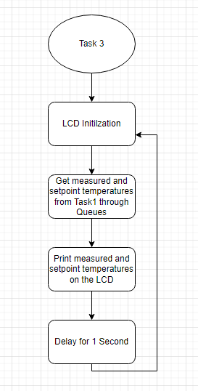

Figure - Task 3 Flowchart

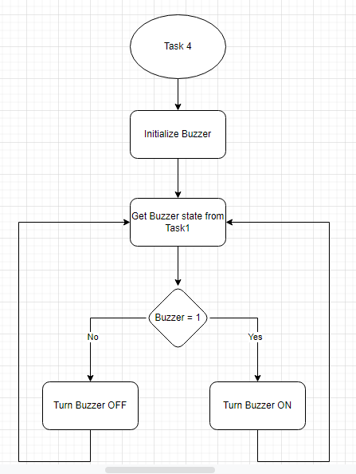

Figure - Task4 Flowchart

# Files & Tasks Description

* Task1
  + The main task that compares received temperature with the setpoint that was entered
  + Turn the Buzzer ON or OFF through Queue
  + Turn the heater ON or OFF through Queue
* Task2
  + UART0 that is used for communication between the TivaC and the computer device
  + Changing the setpoint temperature and send the updated setpoint temperature to main Task1 through the UART0 Queue.
* Task3
  + LCD that is used to show the measured temperature from the potentiometer.
  + Display the setpoint received from the main Task1 through the LCD queue.
* Task4
  + Buzzer that check if task1 has sent through the Buzzer Queue 1 or 0 in order to turn ON or OFF the buzzer respectively.
* gpiosInit
  + Initialize the GPIO ports and UART0
* Main
  + Creates the UART0, LCD, and Buzzer Queues.
  + Initializes the GPIOs and UART0 through gpiosInit function
  + Creates the Tasks mentioned above.