02/23/2020

-Doing some research according to the suggested procedures in the handout and found the following:

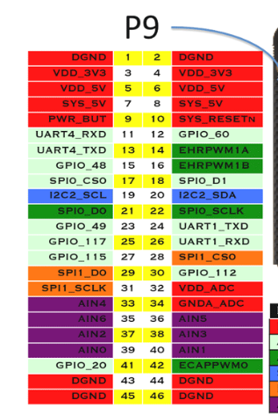

* I2C1_SCL: 19
* I2C1_SDA: 20
* conf_ spi0_cs0: OFFSET: 95Ch base: 0x44E1_0000
* conf_ spi0_d1: OFFSET: 958h base: 0x44E1_0000
* To turn on the clock on the I2C1:
  + CM_PER_I2C1_CLKCTRL: write 0x2 at OFFSET 48h base: 0x4802_A000
* *The high and low states of the data line can only change when the clock signal on the SCL line is LOW*
* *START condition is a high-to-low transition on the SDA line while SCL is high.*
* *STOP condition is a low-to-high transition on the SDA line while SCL is high.*
* *The data is transferred with the most significant bit (MSB) first*
* *7 MSB slave address bits and 1 LSB R/nW bit.*
* *If R/nW is 0, the master writes data into the selected slave; if it is 1, the master reads data out of the slave.*
* 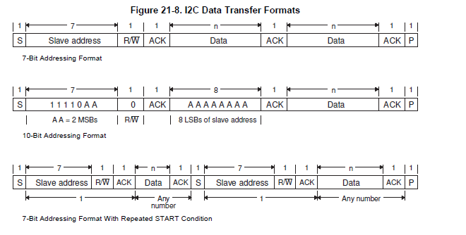
* I2C base 0x4802A000
* Have 12 MHz : I2C_PSC **B0h** [7:0]
  + x = SystemClockFreq / 12MHz
  + ICLK = SCLK/(psc + 1)
  + psc = (SCLK/ICLK) -1
* 400 Kbps SCL: SCLL, SCLH **B4h**, **B8h** [7:0]
  + *tLOW = (SCLL + 7) * ICLK time period*
  + *tHIGH = (SCLH + 5) * ICLK time period.*
* Configure its own address: I2C_OA **A8h**
  + *[6:0] when XOA (Expand Own Address, I2C_CON[7]) is cleared to 0.*
  + *[9:7] bits must be cleared to 000 by application software.*
* Take I2C out of reset: I2C_CON **A4h**:I2C_EN = 1 [15]
  + Bit 15 = 1
* Slave address: I2C_SA **Ach**
  + ??
* Number of bytes to be transferd: I2C_CNT
  + ???
* bus busy read only: I2C_IRQSTATUS_RAW **24h**
  + Bit 12 = 1
* Start bits: I2C_CON **A4h**
  + Write 0x00008601 (start, transmit, master, enable = 1)
* Transmit data ready: I2C_IRQSTATUS_RAW
  + Bit 4 = 1
* Write data: I2C_DATA
  + 7-0 data to be written
* Need to setup I2C for debugging

02/25/2020

* Started writing High and Low level algorithms
* Done writing the algorithms, but having problems understanding the following:
  + Value of SCLK to be used in dividing the clk
  + Value of tlow to be used to adjusting speed
  + How often should I trigger a stop and start condition? Is it after every byte sent I do a stop condition?

02/27/2020

* Figured out how to get tLow and tHigh from Tyler’s email
* Still do not have SCLK
* Started writing C program
* Does HWREG work also for reading regs?
* Done writing all functions required, except clock freq
* Not sure of the order of function calls, should I write to the buffer first or generate stop condition.
* Do I need to poll XDRY?
* 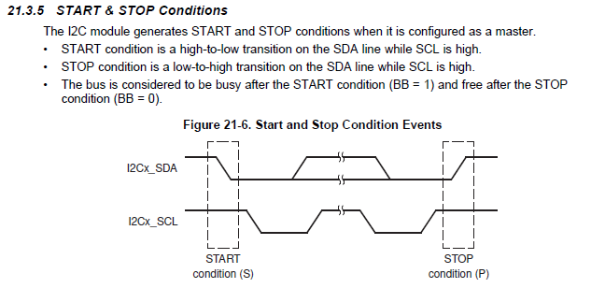
* Makes sense to stop after writing

02/26/2020

* Had to turn clk on
* Had to enable stop condition in con reg
* Understood how to set ICLK
* Had to adjust pin mux
* Logic analyzer is 1 indexed

3/6/2020

* Still a problem with the signals produced
* 0xFF + NAK is the result when loop over and write several times

3/7/2020

* Still same problem
* Tried reversing orders not working
* Tried creating a new project not working
* Tried changing stations not working
* Tried putting everything outside the functions and throw in the main not working
* Tired creating an array of data and looping on inside a function WORKING
* PART 1 DONE