Blood Bank Inventory & Allocation Tracker System

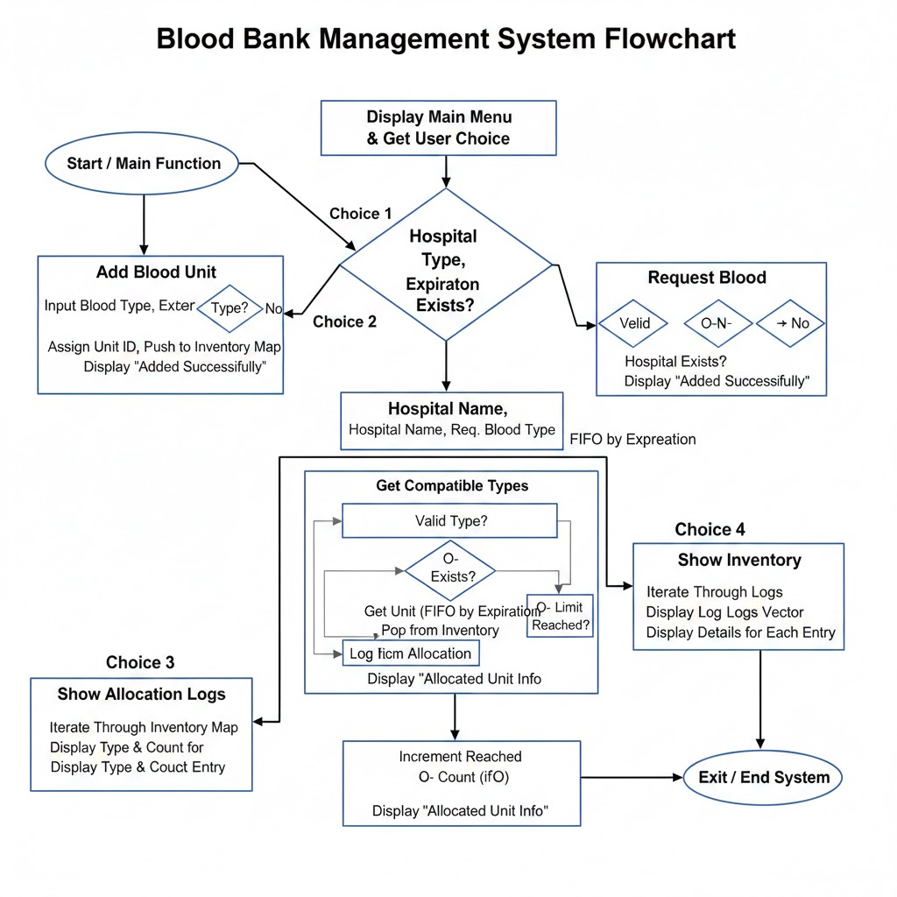

1. Introduction
The provided C++ code implements a Blood Bank Management System designed to handle inventory, validate blood compatibility, and manage hospital requests using advanced data structures. The system prioritizes units based on their expiration dates using a FIFO (First-In, First-Out) approach facilitated by a Priority Queue.

2. Data Structures & Global Variables
Before diving into functions, it is essential to understand the core structures:
- Blood Unit: Stores individual unit details (ID, Type, Expiration).
- Hospital: Tracks hospital-specific data, specifically the count of O- units received.
- inventory: A std::map where each key is a blood type, and the value is a priority queue. This ensures that for any blood type, the unit closest to expiration is always at the top.

3. Detailed Function Analysis
A. Validation and Compatibility Functions
These functions ensure data integrity and medical accuracy.
- isValidBloodType(string type)
- Purpose: Checks if the user input matches one of the 8 standard blood groups (A+, A-, B+, B-, AB+, AB-, O+, O-).
- Logic: It iterates through a predefined vector of valid types and returns a boolean value.
- getCompatible(string type)
- Purpose: Implements the medical logic of blood compatibility.
- Logic: Based on the requested type, it returns a list (vector) of types that the patient can safely receive. For example, if "A+" is requested, it returns {A+, A-, O+, O-}.

B. Core Operational Functions
These functions handle the primary business logic of the system.
- addBlood()
- Purpose: Allows the user to deposit a new blood unit into the bank.
- Process: 1. Validates the blood type input. 2. Accepts an expiration date. 3. Assigns a unique unitCounter ID. 4. Pushes the unit into the corresponding priority_queue in the inventory map.
- requestBlood()
- Purpose: Manages the allocation of blood to a specific hospital.
- Key Logic:
  - Compatibility Search: It loops through the list of compatible blood types for the requested group.
  - O- Negative Limit: It checks if the hospital has exceeded the O_NEG_LIMIT (5 units) before giving O- blood, preserving this "universal donor" type for emergencies.
  - FIFO Allocation: It retrieves the unit with the earliest expiration date using inventory[type].top().
  - Logging: Records the transaction in the logs vector.

C. Information Retrieval Functions
- showInventory()
- Purpose: Provides a snapshot of the current stock.
- Logic: Iterates through the inventory map and prints the number of available units for each blood type.
- showLogs()
- Purpose: Displays the history of all successful blood allocations.
- Logic: Iterates through the logs vector and prints the hospital name, requested vs. allocated type, and the unique Unit ID.

4. System Logic Flow
The overall flow of the program is managed by the main() function, which utilizes a Do-While loop and a Switch-Case menu. This allows the system to remain active until the user explicitly chooses to exit (Choice 0).

5. Conclusion
The system effectively combines Maps for quick access to blood categories and Priority Queues for automated expiration management. The inclusion of the O- Negative limit demonstrates an understanding of resource scarcity in medical environments.

