● Create a new project on your local machine, then push it your remote repo.
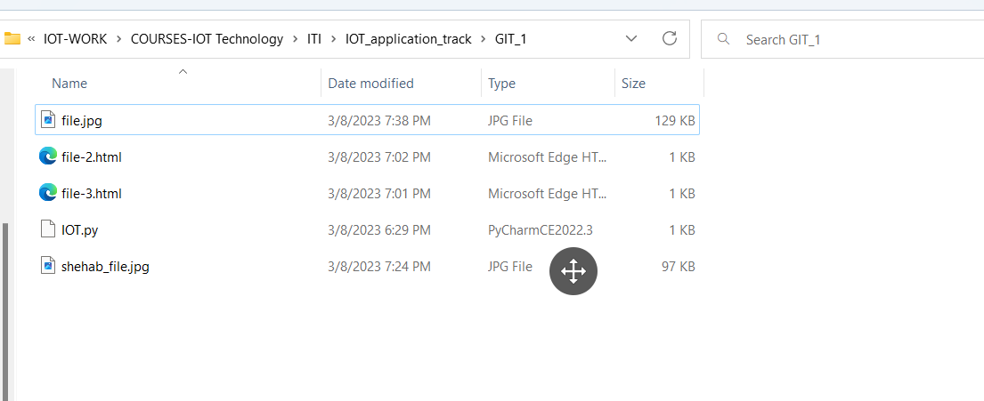
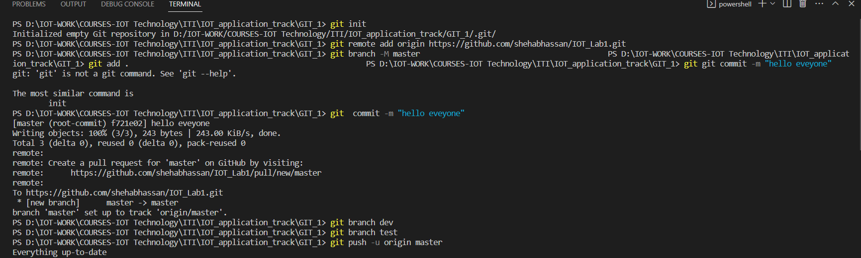
● Create two branches dev test then create one file on each branch,push changes to the remote repo.
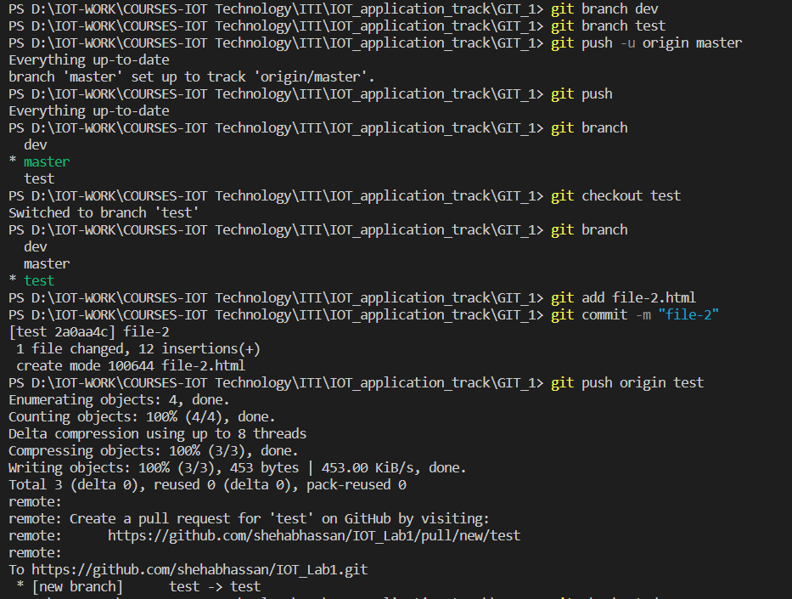
● Merge this changes on Master branch and then push it to your remote master branch.
● Tell me how to remove them locally and remotely.
Local :
Remotely :
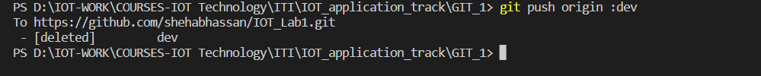
● Send an invitation to me (mahmoudhelmy31@gmail.com).
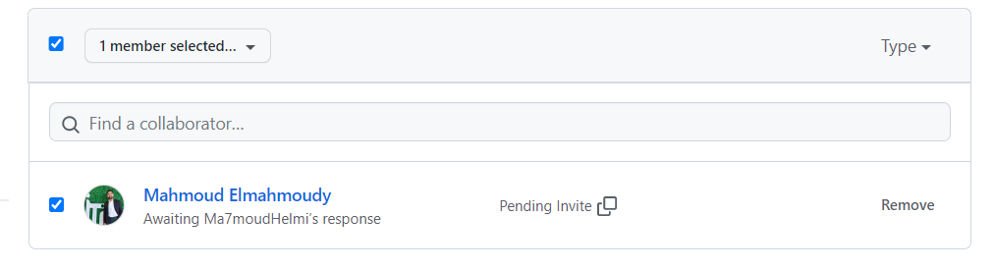
Create an annotated tag with tagname (v1.7) .

● Push it to the remote repository.
● Tell me how to list tags.
● Tell me how to delete tag locally and remotely.
Local :
Remotely :
● Add an image in the README.md file.
