Household-Level Water Distribution Optimization Using a Geospatially Informed Memetic Algorithm: A Case Study of Iligan City, Philippines
Leave this box blank
Please submit online http://joiv.org/index.php/joiv/login in DOC file
Editor will not receive submission by email
Please be sure to check for spelling and grammar before submitting your paper.
Shehab Doro Ibrahim#, Second Author*
# Department of Information Technology, Mindanao State University – Iligan Institute of Technology, Tibanga, Iligan City, 9200, Philippines
E-mail: shehab.ibrahim@g.msuiit.edu.ph
*Second Institution, Address, City, ZIP Code, Country
E-mail: xxx@yyy.zzz

Abstract— Urban water distribution faces challenges in balancing geographical efficiency, water supply adequacy, and equitable allocation. This study proposes a geospatially informed Memetic Algorithm (MA) to optimize individual water-service connection assignments to pumping stations in Iligan City, Philippines. Using 35,866 service connections, the proposed approach integrates geographical distances, pumping station capacities, estimated water requirements, and service eligibility constraints through evolutionary optimization and local search. Compared with a simulated baseline, the MA reduced the fitness value by 31.9%, mean assignment distance from 7.38 km to 5.94 km (19.5%), and median distance from 7.69 km to 5.51 km (28.3%). Modeled undersupplied connections decreased from 7,946 (22.2%) to zero, while oversupplied connections declined from 776 (2.2%) to zero. These findings demonstrate the potential of household-level geospatial optimization to improve allocation efficiency and water supply equity. However, as connection locations and baseline assignments were estimated, the results represent modeled improvements rather than verified operational performance.

Keywords— Memetic Algorithm, Water Distribution Optimization, Geospatial Optimization, Water Supply Adequacy

- Introduction
Ensuring adequate and equitable urban water services requires more than increasing water production. Distribution decisions must reconcile geographically dispersed demand, finite source capacity, infrastructure constraints, and inequalities in access. The WHO/UNICEF Joint Monitoring Programme reports persistent disparities in safely managed drinking-water services, underscoring the need for locally appropriate planning methods [4]. In water distribution systems, optimization has traditionally emphasized network cost, hydraulic reliability, leakage, and operational efficiency [5]–[9]. These objectives are essential but do not by themselves establish whether individual service connections are assigned to appropriate sources when geographical proximity and available supply must be considered jointly.
The allocation problem is especially relevant in Iligan City, Philippines, where geographically separated barangays are served by multiple pumping stations and spring sources. Ibrahim et al. [1] documented uneven water availability and geographically inefficient service relationships in the Iligan City Waterworks System (ICWS). Their GIS-based analysis provided an important spatial characterization of existing service arrangements, but it operated principally at the barangay-area level. Subsequently, Ibrahim et al. [2] applied a Genetic Algorithm (GA) to improve supply adequacy and equity through revised pumping-station allocations. Although this approach addressed imbalances in estimated water availability, household-level geographical distance was not an explicit optimization objective.
A further comparative investigation by Ibrahim et al. [3] evaluated Genetic, Memetic, and Cellular Memetic Algorithms for equitable urban water allocation. Its findings supported the value of combining evolutionary search with local refinement. Nevertheless, demand and allocation were represented at an aggregated geographical level, limiting the ability to evaluate differences among individual connections within the same barangay. These three studies establish the local evidence base for the present work, while identifying a remaining methodological need: connection-level assignment optimization that integrates supply adequacy, station eligibility, and spatial distance in a single decision framework.
Extensive research has demonstrated the usefulness of optimization in water systems. Early genetic-algorithm studies investigated least-cost network design [12], [25], [26], while later approaches incorporated reliability and multiple competing objectives [14], [20], [22]–[24]. Reviews of evolutionary and heuristic methods emphasize their ability to navigate large, nonlinear, and constrained search spaces [5]–[7], [13], [19]. Recent applications and reviews also highlight leakage management, energy use, resilience, and demand uncertainty [6], [8], [9]. However, network topology design, hydraulic operation, and customer-to-source assignment represent related but distinct decision problems. A configuration that is favorable in one respect may not minimize the distance of service assignments or distribute estimated water availability equitably.
Geospatial representation is important because aggregating connections by administrative area may conceal variation in proximity to alternative water sources. The distance between a connection and an eligible pumping station can serve as a transparent proxy for geographical allocation efficiency, although it should not be interpreted as measured pipeline length, pressure, head loss, or delivered flow. Spatial allocation concepts [30]–[32] help explain how proximity and eligibility can shape assignment decisions. At the same time, water demand is uncertain and unevenly distributed, as reflected in recent scenario-based and data-driven water-network studies [9]–[11]. Therefore, selecting the nearest station alone is insufficient when its usable supply is constrained and reassignment changes the estimated availability for all connections served by that station.
Memetic Algorithms provide a suitable computational strategy for exploring this coupled allocation problem. Building on evolutionary computation [15], [16], they combine population-based exploration with solution-level improvement [17]–[19]. Multi-objective evolutionary methods further show how competing performance criteria can be incorporated into optimization [14], [20]. For household-to-station assignments, a reassignment that shortens distance may increase the population dependent on a capacity-limited source; conversely, reducing undersupply may require accepting longer assignments. A feasible search procedure must consequently consider these effects together and preserve documented station-service eligibility constraints.
The present study develops and evaluates a geospatially informed Memetic Algorithm for assigning individual ICWS water-service connections to eligible pumping stations and spring sources in Iligan City. Using 35,866 modeled service connections, the framework represents estimated connection locations, station eligibility, geographical assignment distances, usable station supply, and population-based water requirements. A weighted objective combines distance efficiency with penalties for insufficient and excessive estimated per-capita availability. The algorithm employs evolutionary operators and local refinement to search for improved configurations while maintaining service eligibility. The study evaluates changes in assignment distance, modeled water adequacy, and the distribution of water availability relative to a simulated baseline.
This research contributes a finer-grained allocation representation than the previous barangay-level Iligan City studies [1]–[3] and demonstrates how geospatial information can be integrated with capacity-aware memetic search. Importantly, the baseline assignments and connection coordinates are inferred from available service and geographical records rather than verified customer-level network measurements. Estimated straight-line distances are not hydraulic simulation results, and the adequacy categories reflect modeled water availability rather than observed delivery or consumption. Accordingly, the findings should be interpreted as evidence of potential planning improvements under stated assumptions, not proof of operational improvements in the physical ICWS network. This distinction positions the proposed method as a decision-support framework and identifies the need for subsequent validation using verified connections, pipe networks, and hydraulic measurements [21].

- The Material and Method
- Research Design and Study Area
The study adopts a quantitative, experimental optimization research design to develop and evaluate a geospatially informed Memetic Algorithm (MA) for improving household-to-pumping station assignments in Iligan City, Philippines. Previous studies identified water allocation disparities and geographical inefficiencies [1] and explored Genetic Algorithms and memetic approaches to improve water supply adequacy and equity [2], [3], but primarily focused on barangay-level allocations. Unlike these approaches, the proposed MA integrates evolutionary search and local refinement [4], [5], [8], [9] to optimize individual household assignments while considering pumping station discharge capacities, geographical distances, documented service relationships, and estimated household water requirements. Using records from the Iligan City Waterworks System (ICWS), household locations and baseline assignments are estimated from available geographical and service information due to the absence of precise coordinates and verified household connections. The optimized configurations are compared with the estimated baseline in terms of water supply adequacy, allocation equity, undersupply, excessive allocation, geographical efficiency, and optimization performance. Given the uncertainties in the estimated data, the findings represent potential improvements under modeled conditions rather than verified changes to the actual water distribution network.
- Data Collection, Preprocessing, and Household Representation
The study utilizes ICWS connection records, pumping station locations, discharge capacities, service relationships, and supporting geographical and demographic data to develop a household-level water distribution model. Data preprocessing includes removing duplicates, standardizing records, resolving inconsistencies, and estimating household coordinates using street information, barangay boundaries, and geographical references. These coordinates represent estimated rather than verified locations. Each connection is represented by a unique identifier, barangay, estimated coordinates, population, daily water demand, and eligible pumping stations based on documented ICWS service areas. Each connection is assigned to one eligible station, allowing households within the same barangay to receive allocations from different stations. This representation supports the proposed Memetic Algorithm in evaluating geographical efficiency, pumping station utilization, and estimated water availability.
- Geospatial Modeling of Household-to-Pumping Station Connections
Household-to-pumping station distances are calculated using the Haversine method [16], based on estimated household coordinates and recorded station locations. These distances indicate geographical efficiency rather than actual pipeline lengths or hydraulic performance. Assignments are restricted to eligible stations based on documented ICWS service relationships. Since actual household assignments are unavailable, a simulated baseline is generated using an 80% probability of assignment to the nearest eligible station and 20% to another eligible station, informed by spatial interaction and discrete choice principles [14], [15]. During optimization, households with multiple eligible stations may be reassigned, while those with only one eligible station retain their assignments. The simulated baseline represents estimated rather than verified ICWS connections.
- Water Supply and Household Demand Estimation
The estimated daily usable water supply of each pumping station is calculated from its discharge capacity, an assumed operating duration of 6.7008 hours per day [3], [13], and a 64% non-revenue water (NRW) adjustment, leaving 36% available for allocation [1]. Household demand is estimated using population size and a minimum requirement of 48 L/person/day, based on Inocencio et al. [12], who reported 48, 58, and 108 L/person/day for low-, middle-, and high-income households, respectively. Per-capita water availability is calculated by dividing each station's usable supply by its assigned population, which is updated as household assignments change during optimization. Connections are classified as undersupplied (below 48 L/person/day), adequately supplied (48–150 L/person/day), or excessively allocated (above 150 L/person/day). These classifications assess modeled allocation adequacy rather than actual consumption or delivery, as hydraulic conditions, water pressure, and intermittent supply are not considered.
- Optimization Problem Formulation
The household-to-pumping station allocation problem is formulated as a constrained optimization problem to improve geographical efficiency, water supply adequacy, and allocation equity. Each household is assigned to one eligible pumping station, forming a candidate solution evaluated against the simulated baseline. The objectives are to minimize mean assignment distance, undersupply, and excessive allocation. Water availability is classified as undersupplied (<48 L/person/day), low-income reference (48–<58), middle-income reference (58–<108), high-income reference (108–150), or oversupplied (>150), adapted from Inocencio et al. [12]. These categories reflect estimated water availability rather than actual consumption or household income.
The weighted fitness function is F = 0.35D + 0.65W, where D is the mean assignment distance normalized by 10 km and W is the water allocation penalty, defined as W = 0.65U + 0.25S + 0.10O. Thus, F = 0.65D + 0.2275U + 0.0875S + 0.035O, where U represents undersupply frequency, S normalized shortage severity, and O normalized oversupply severity. The algorithm minimizes fitness while maintaining pumping station eligibility constraints, prioritizing geographical efficiency while penalizing water allocation imbalances.
- Memetic Algorithm Development
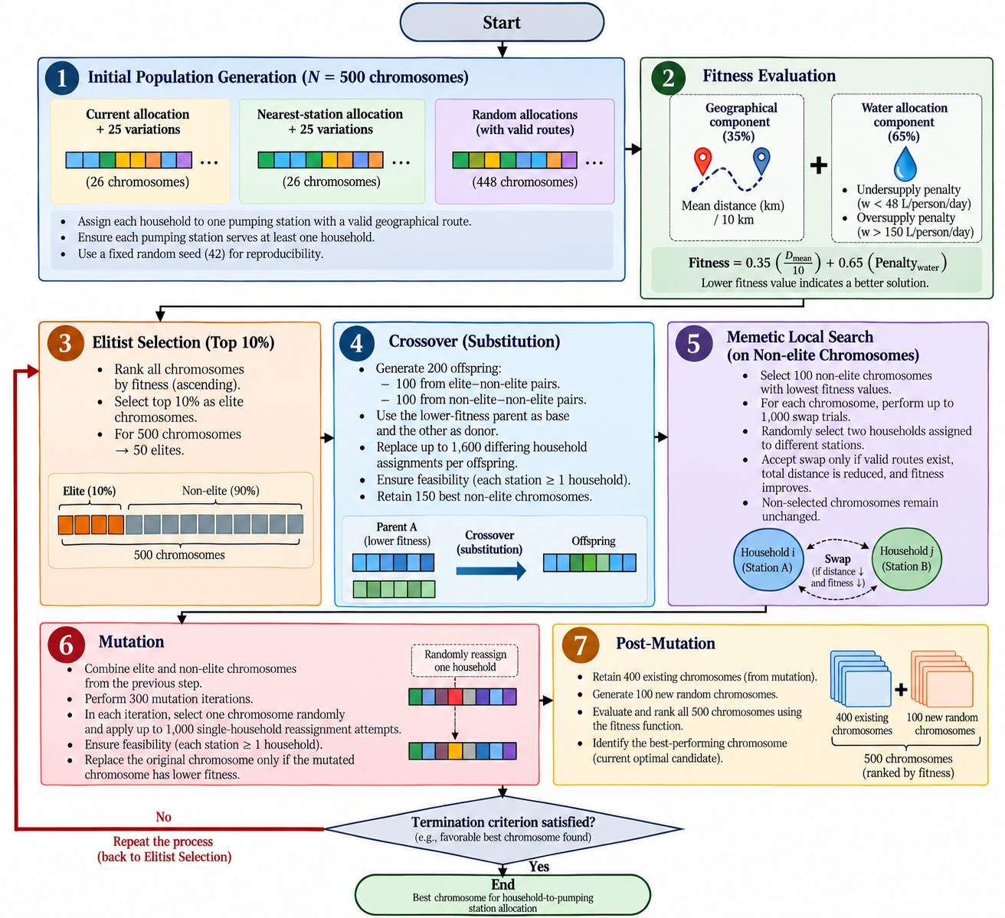
Fig. 1 Memetic Algorithm Development

Figure 1 illustrates the methodological framework of the Memetic Algorithm developed to optimize household-to-pumping station allocations in Iligan City. The process begins with the generation of 500 chromosomes representing alternative household allocation configurations, followed by fitness evaluation based on geographical efficiency (35%) and water allocation adequacy (65%). The highest-performing 10% of chromosomes are selected through elitism, while crossover generates new offspring from elite–non-elite and non-elite–non-elite parent combinations. A memetic local search subsequently refines selected non-elite chromosomes through feasible household assignment exchanges that reduce geographical distance and improve overall fitness. Mutation introduces further allocation variations through randomized household reassignments, retaining only configurations that achieve improved fitness values. During post-mutation, 400 existing chromosomes are combined with 100 newly generated chromosomes, and the resulting population is reevaluated and ranked. The evolutionary cycle then returns to elitist selection, repeating crossover, local search, mutation, and post-mutation until the termination criterion is satisfied. The chromosome with the lowest fitness value is identified as the best allocation configuration obtained, representing a solution that balances geographical efficiency and water supply adequacy while satisfying the defined allocation constraints.
- Results and Discussion
  - Baseline Geospatial Allocation, Distance, and Water Supply Conditions

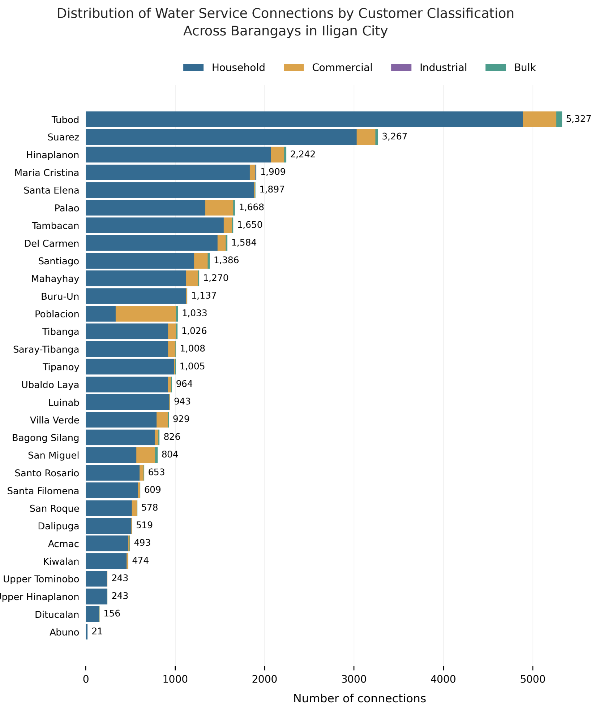
Fig. 2. Distribution of Water Service Connections by Customer Classification Across Barangays in Iligan City

The distribution of water service connections across 30 barangays in Iligan City reveals a predominance of household connections, alongside varying proportions of commercial, industrial, and bulk connections (Figure 2). These variations influence estimated water demand and the population served, with implications for pumping station capacity and water supply adequacy. The observed distribution serves as a baseline for the proposed Memetic Algorithm, which optimizes service connection assignments to pumping stations by considering geographical distance, supply capacity, and water requirements to improve allocation efficiency, supply adequacy, and equity.
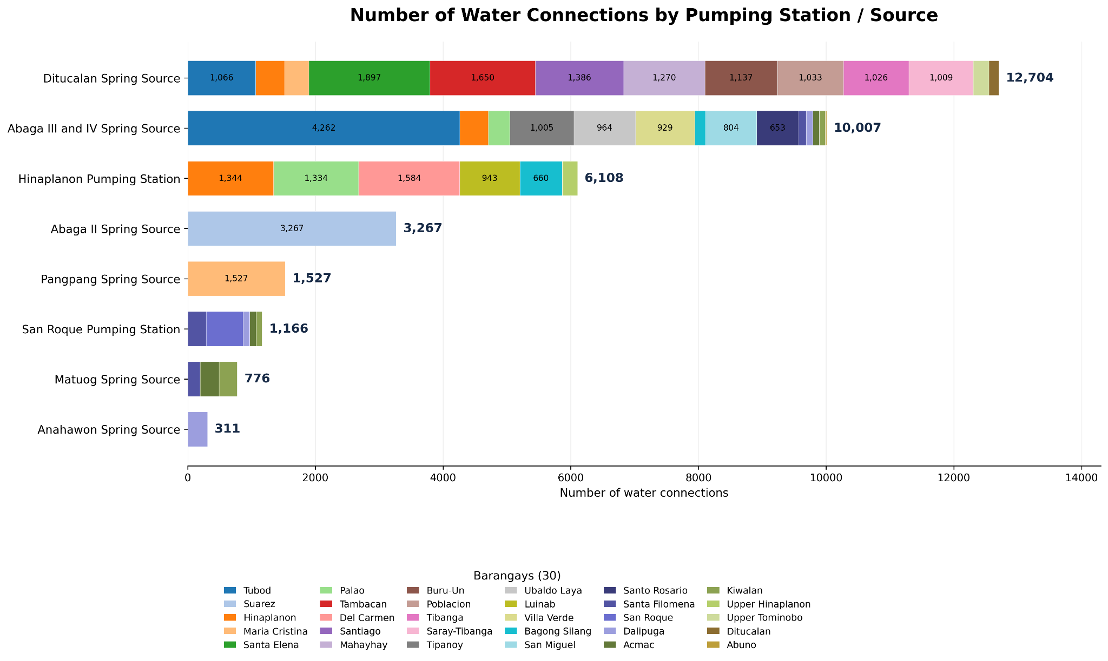
Fig. 3. Number of Water Connections by Pumping Station/ Source

The distribution of water service connections across eight pumping stations and water sources in Iligan City reveals variations in connection density and estimated service demand (Figure 3). These differences provide baseline information for the proposed Memetic Algorithm, which optimizes service connection assignments by considering geographical distance, pumping station supply capacity, estimated population served, and documented service eligibility constraints to improve water allocation efficiency and supply adequacy.

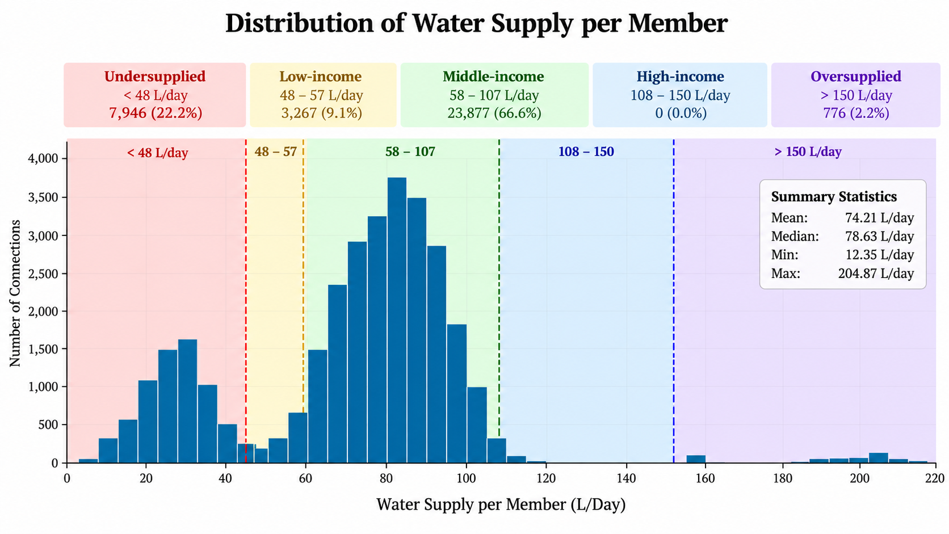
Fig. 4. Distribution Water Supply per Member

The baseline distribution of estimated daily water supply across 35,866 ICWS service connections, classified according to the criteria adapted from Inocencio et al. [12], reveals variations in supply adequacy (Figure 4). The presence of undersupplied and oversupplied connections suggests potential imbalances in water allocation, emphasizing the need for optimization. This baseline provides a reference for evaluating the effectiveness of the proposed Memetic Algorithm in improving water supply adequacy and allocation equity while considering geographical efficiency and pumping station eligibility constraints.

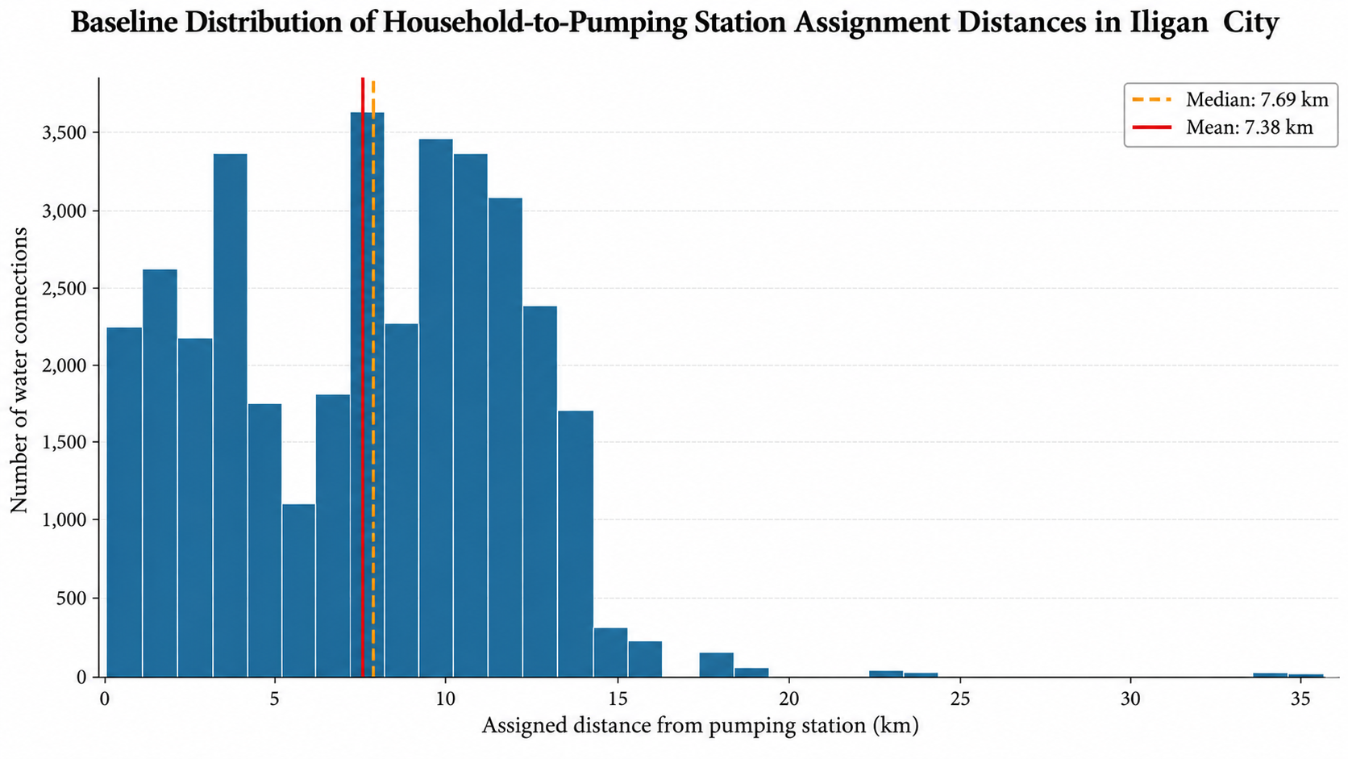
Fig. 5. Baseline Distribution of Household-to-Pumping Station Assignment Distances in Iligan City

The baseline distribution of household-to-pumping station assignment distances in Iligan City indicates a mean distance of 7.38 km and a median of 7.69 km (Figure 5). The observed variability suggests opportunities to improve geographical efficiency by reducing assignment distances. These findings provide a reference for evaluating the effectiveness of the proposed Memetic Algorithm in minimizing assignment distances while maintaining water supply adequacy and complying with documented pumping station eligibility constraints.

  - Memetic Algorithm Convergence and Optimization Performance

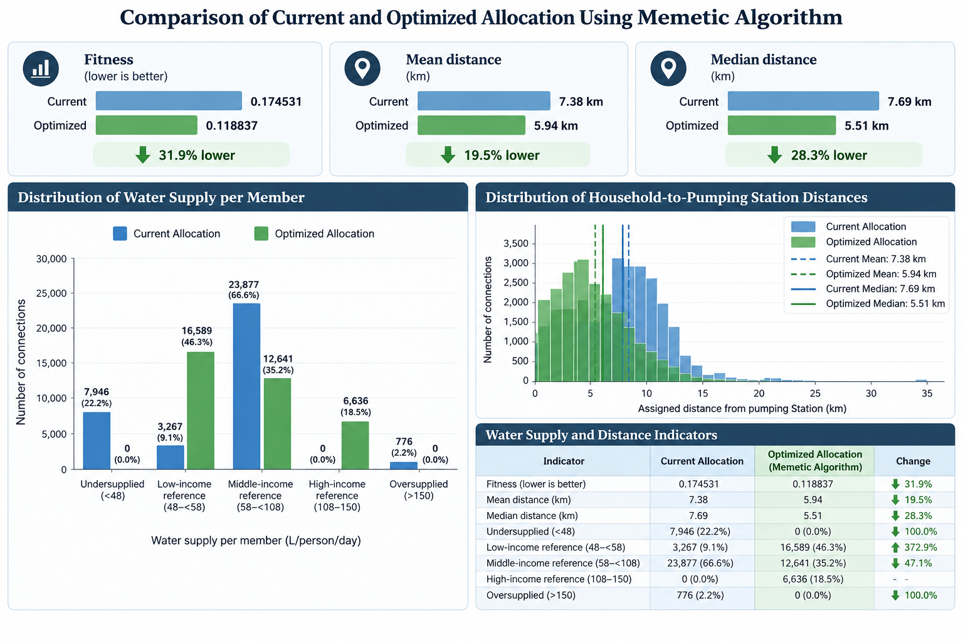
Fig. 6. Comparison of Current and Optimized Allocation using Memetic Algorithm

The comparison between the simulated baseline and optimized household-to-pumping station allocations demonstrates improvements achieved by the proposed Memetic Algorithm (Figure 6). Following 1,000 iterations, with an average computational time of approximately 15 minutes per iteration (250 hours or 10.4 days), the fitness value decreased from 0.174531 to 0.118837, representing a 31.9% improvement. The mean assignment distance was reduced from 7.38 km to 5.94 km (19.5%), while the median distance decreased from 7.69 km to 5.51 km (28.3%). Moreover, the optimized allocation eliminated modeled undersupply across 7,946 service connections (22.2%) and oversupply across 776 connections (2.2%), achieving water distribution within the adopted adequacy thresholds. These results demonstrate the potential of the proposed Memetic Algorithm to simultaneously improve geographical allocation efficiency and water supply adequacy while satisfying documented pumping station eligibility constraints.

  - Improvements in Geographical Allocation Efficiency

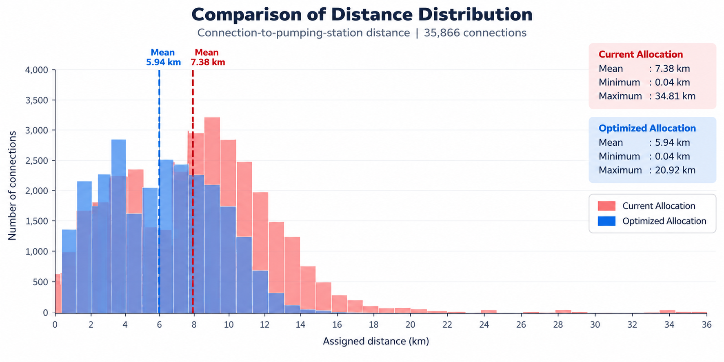
Fig. 7. Comparison of Distance Distribution

The comparison of geographical assignment distances between the simulated baseline and optimized configurations demonstrates improved allocation efficiency following the application of the proposed Memetic Algorithm (Figure 7). The mean assignment distance decreased from 7.38 km to 5.94 km (19.5%), while the maximum distance was reduced from 34.81 km to 20.92 km (39.9%). The optimized distribution exhibits a greater concentration of service connections at shorter assignment distances, indicating improved geographical efficiency in household-to-pumping station allocations.

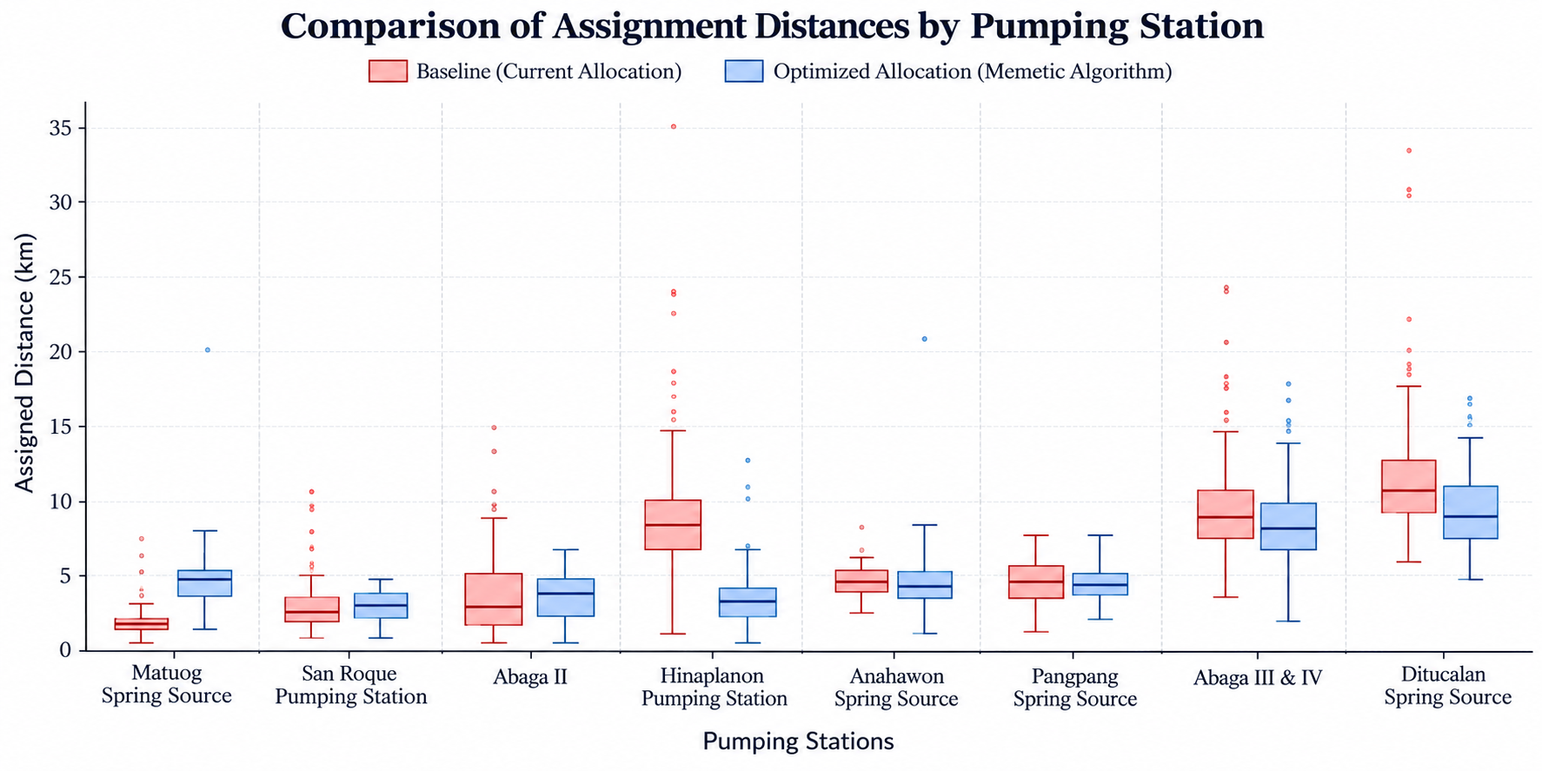
Fig. 8. Comparison of Assignment Distances by Pumping Station

The comparison of baseline and optimized assignment distances across eight pumping stations reveals variations in geographical allocation efficiency, as reflected by differences in median distances, interquartile ranges, and outliers (Figure 8). The proposed Memetic Algorithm reduced median assignment distances and distance variability at several stations, particularly Hinaplanon and Abaga III and IV. However, slight increases observed at other stations suggest trade-offs between geographical proximity and water supply adequacy, highlighting the algorithm’s consideration of multiple allocation objectives.

  - Improvements in Water Supply Adequacy and Allocation Equity

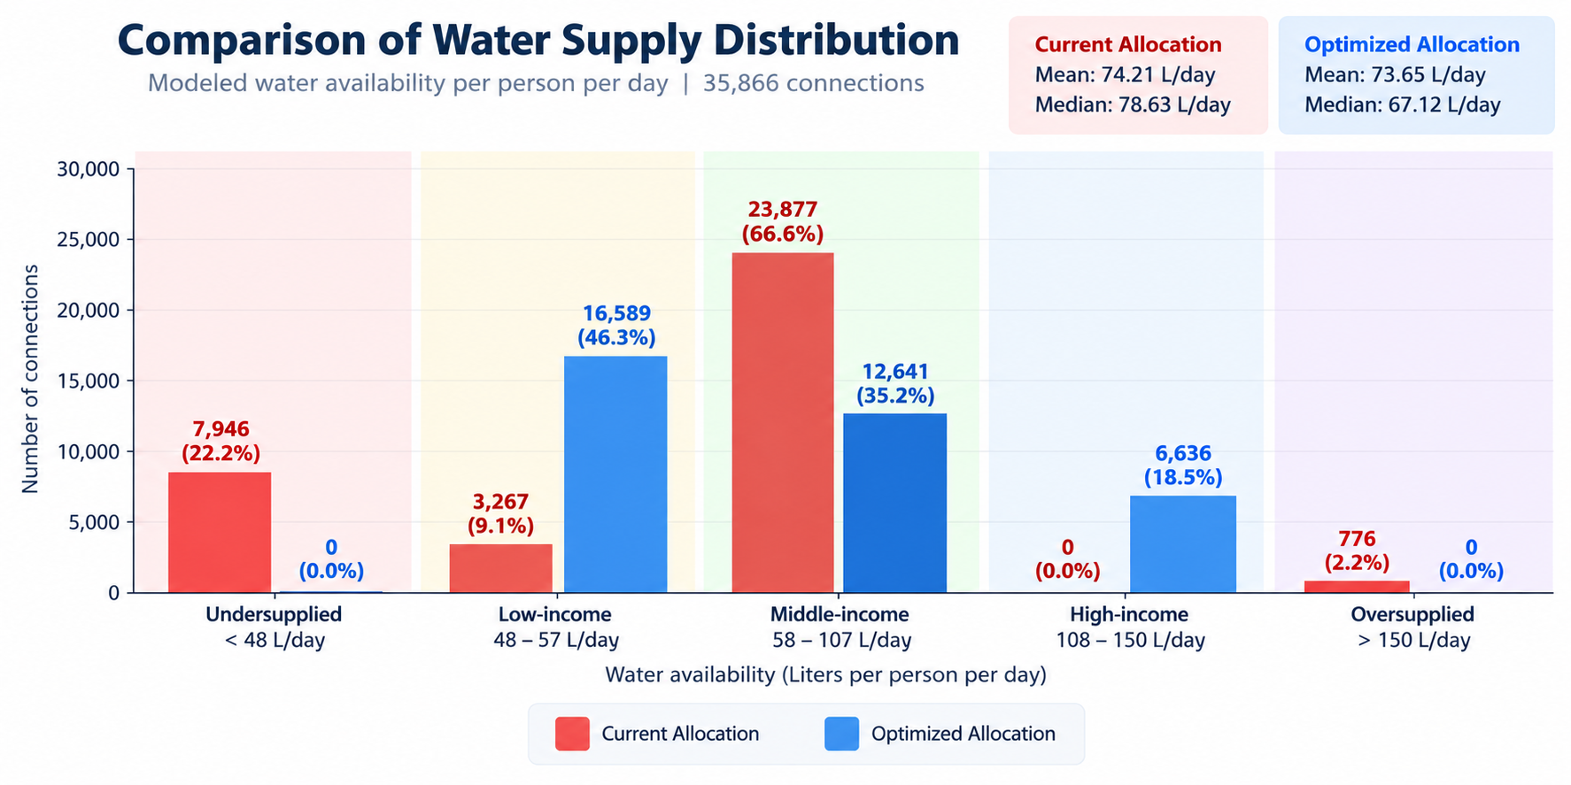
Fig. 9. Comparison of Water Supply Distribution

The comparison of estimated water availability between the baseline and optimized allocations demonstrates substantial improvements in water supply adequacy following the application of the proposed Memetic Algorithm (Figure 9). Undersupplied connections decreased from 7,946 (22.2%) to zero, while oversupplied connections were reduced from 776 (2.2%) to zero. The resulting redistribution of service connections within the adopted adequacy thresholds indicates the algorithm’s potential to improve water supply adequacy and promote more equitable water allocation across Iligan City.

  - Discussion of Findings, Practical Implications, and Study Limitations

The findings demonstrate the potential of the proposed Memetic Algorithm to improve geographical allocation efficiency and estimated water supply adequacy in Iligan City. Compared with the simulated baseline, the optimized configuration reduced mean assignment distance by 19.5% and eliminated modeled undersupply and oversupply, indicating a more balanced distribution of available water. Unlike previous studies [1]–[3] that primarily examined barangay-level allocations, this study introduces household-level optimization, enabling more precise evaluation of geographical distances, pumping station capacities, and population distribution. The integration of evolutionary search and local refinement further supports the identification of improved allocation configurations within documented service constraints. These findings provide a potential decision-support approach for ICWS water distribution planning. However, because household coordinates and baseline assignments were estimated, and actual pipeline networks and hydraulic conditions were not incorporated, the results represent modeled improvements rather than verified changes in water delivery. Future research should validate the proposed approach using actual household connections, pipeline networks, and hydraulic performance data.
- Conclusion
This study demonstrated the potential of a geospatially informed Memetic Algorithm (MA) to improve water distribution adequacy, allocation equity, and geographical efficiency in Iligan City, Philippines. By optimizing 35,866 individual water-service connections while considering pumping station capacities, geographical distances, estimated water requirements, and service eligibility constraints, the proposed approach achieved a 31.9% reduction in fitness value and reduced mean assignment distance from 7.38 km to 5.94 km (19.5%). Furthermore, modeled undersupplied connections decreased from 22.2% to zero, while oversupplied connections declined from 2.2% to zero, indicating improved allocation balance. Unlike previous barangay-level approaches, the proposed framework enables more detailed optimization at the individual connection level. However, because household locations and baseline assignments were estimated, the findings represent potential improvements under simulated conditions rather than verified operational outcomes. Future research should incorporate actual pipeline networks, hydraulic characteristics, and verified connection data to validate the framework's practical applicability. Overall, the study provides a promising decision-support approach for more efficient and equitable urban water distribution planning.
Acknowledgment
The authors gratefully acknowledge the Tan Sri Leo Moggie (TLSM) Distinguished Chair in Energy Informatics, Univerisiti Tenaga Nasional(UNITEN), for its financial support towards the publication of this research in the Internation Journal on Informatics Visualization (JOIV). Also, the authors acknowledge the Water Data Analysis Team at MSU-IIT, under the leadership of Asst. Prof. Jennifer Montemayor, as well as the Iligan City Waterworks System for their valuable collaboration and support.

References
- S. M. Metev and V. P. Veiko, Laser Assisted Microtechnology, 2nd ed., R. M. Osgood, Jr., Ed. Berlin, Germany: Springer-Verlag, 1998.
- J. Breckling, Ed., The Analysis of Directional Time Series: Applications to Wind Speed and Direction, ser. Lecture Notes in Statistics. Berlin, Germany: Springer, 1989, vol. 61.
- S. Zhang, C. Zhu, J. K. O. Sin, and P. K. T. Mok, “A novel ultrathin elevated channel low-temperature poly-Si TFT,” IEEE Electron Device Lett., vol. 20, pp. 569–571, Nov. 1999.
- M. Wegmuller, J. P. von der Weid, P. Oberson, and N. Gisin, “High resolution fiber distributed measurements with coherent OFDR,” in Proc. ECOC’00, 2000, paper 11.3.4, p. 109.
- R. E. Sorace, V. S. Reinhardt, and S. A. Vaughn, “High-speed digital-to-RF converter,” U.S. Patent 5 668 842, Sept. 16, 1997.
- (2002) The IEEE website. [Online]. Available: http://www.ieee.org/
- M. Shell. (2002) IEEEtran homepage on CTAN. [Online]. Available: http://www.ctan.org/tex-archive/macros/latex/contrib/supported/IEEEtran/
- FLEXChip Signal Processor (MC68175/D), Motorola, 1996.
- “PDCA12-70 data sheet,” Opto Speed SA, Mezzovico, Switzerland.
- A. Karnik, “Performance of TCP congestion control with rate feedback: TCP/ABR and rate adaptive TCP/IP,” M. Eng. thesis, Indian Institute of Science, Bangalore, India, Jan. 1999.
- J. Padhye, V. Firoiu, and D. Towsley, “A stochastic model of TCP Reno congestion avoidance and control,” Univ. of Massachusetts, Amherst, MA, CMPSCI Tech. Rep. 99-02, 1999.
- Wireless LAN Medium Access Control (MAC) and Physical Layer (PHY) Specification, IEEE Std. 802.11, 1997.

Please be sure that the manuscript is up to date. Reference minimal its 12 reference. It is expected that 20 to 30% of references are to recent papers.

