Application

**Name**

**Address**

**Email**

**Mobile**

**Degree**

**Graduation date Birthdate**

**Skills**

**Courses**

IQ

**Which number should come next in this series?**

**10, 17, 26, 37, ?**

1. **46**
2. **52**
3. **50**
4. **56**

**Which number should replace the question mark "?"**

|  |  |  |  |
| --- | --- | --- | --- |
| **17** | **8** | **5** | **5** |
| **13** | **7** | **5** | **4** |
| **6** | **12** | **6** | **3** |
| **10** | **6** | **4** | **?** |

1. **4**
2. **5**
3. **6**
4. **7**

**If 10 people can do a piece of work in 5 days, working 2 hours a day, how long will 2 people take to do the same work, working 5 hours a day?**

* **8**
* **5**
* **10**
* **12**

PHP / Laravel

**What is the difference between "echo" and "print" in PHP?**

**How a variable is declared in PHP?**

**What is the use of count () function in PHP?**

**Differentiate between require and include?**

**What is X-CSRF-TOKEN?**

**How To Use Delete Statement In Laravel ?**

**What Are Bundles, reverse Routing And The Ioc Container?**

**How do you create a session, add data to a session and remove data from a session?**

MySql

**What is the difference between CHAR and VARCHAR?**

### What is the syntax for concatenating tables in MySQL?

**What is the difference between the DELETE TABLE and TRUNCATE TABLE commands in MySQL?**

**What are the types of joins in MySQL?**

**What is the difference between primary key and unique key?**

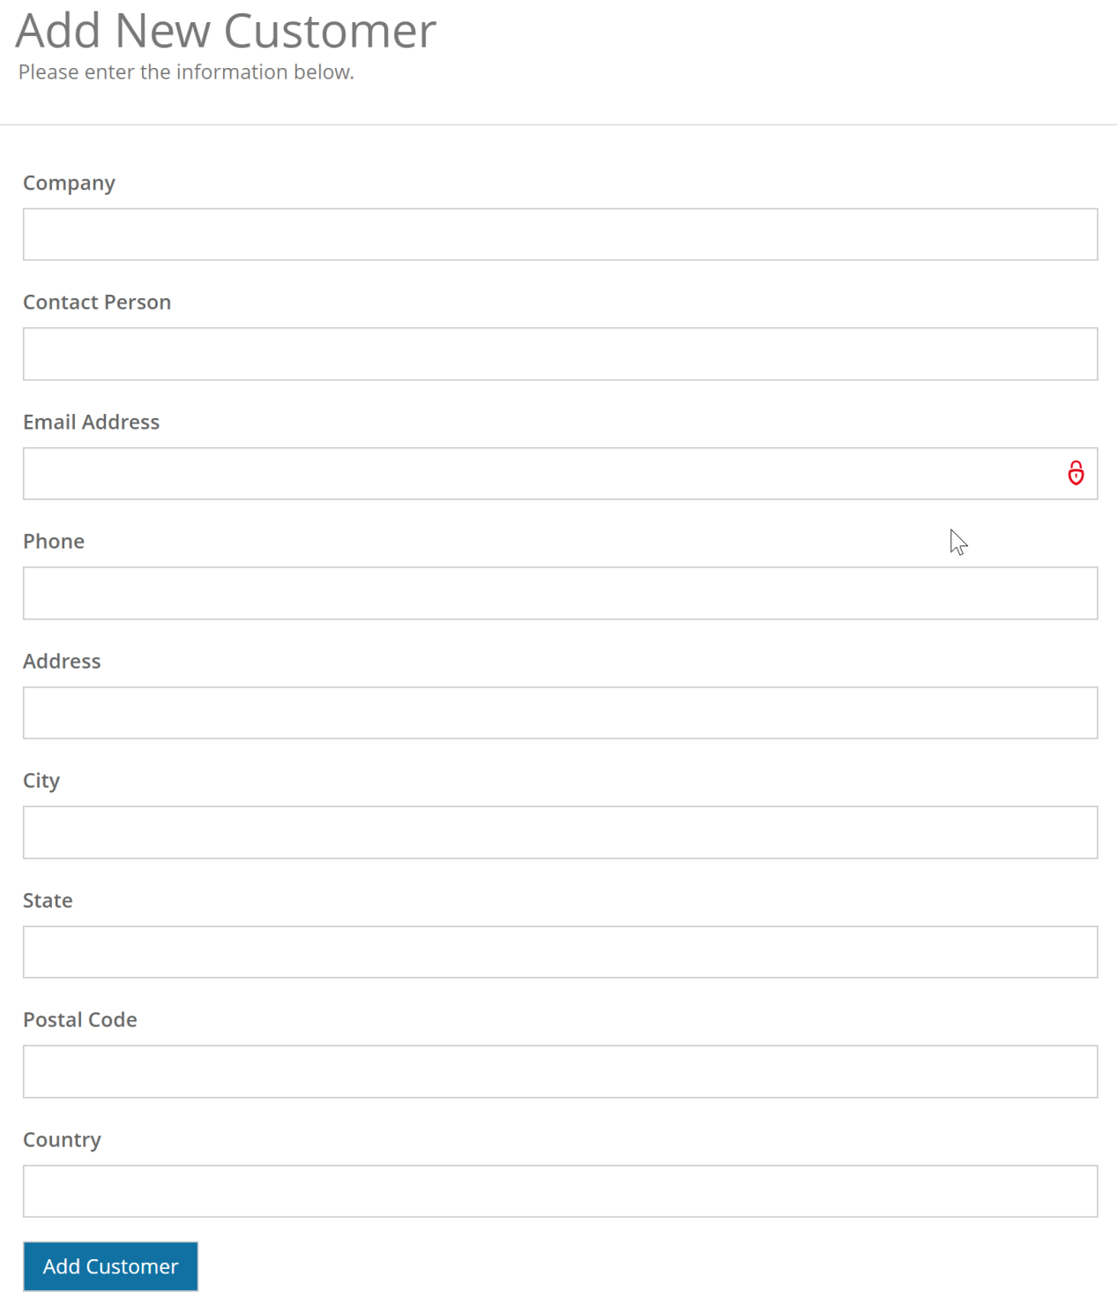Home assignment

