London Dataset

- Profiling of Dataset

- Calendar.csv.gz

Column Name | Data Type | Total Rows | Null Count | Duplicates Exist (Cardinality)
listing_id | BIGINT | 35357974 | 0 | Yes
date | DATE | 35357974 | 0 | Yes
available | BOOLEAN | 35357974 | 0 | Yes
price | VARCHAR | 35357974 | 35357974 | No
adjusted_price | VARCHAR | 35357974 | 35357974 | No
minimum_nights | BIGINT | 35357974 | 0 | Yes
maximum_nights | BIGINT | 35357974 | 0 | Yes

- listings.csv.gz

Column Name | Data Type | Total Rows | Null Count | Duplicates Exist (Cardinality)
id | BIGINT | 96871 | 0 | No
listing_url | VARCHAR | 96871 | 0 | No
scrape_id | BIGINT | 96871 | 0 | Yes
last_scraped | DATE | 96871 | 0 | Yes
source | VARCHAR | 96871 | 0 | Yes
name | VARCHAR | 96871 | 0 | Yes
description | VARCHAR | 96871 | 2450 | Yes
neighborhood_overview | VARCHAR | 96871 | 55662 | Yes
picture_url | VARCHAR | 96871 | 6 | Yes
host_id | BIGINT | 96871 | 0 | Yes
host_url | VARCHAR | 96871 | 0 | Yes
host_name | VARCHAR | 96871 | 43 | Yes
host_since | DATE | 96871 | 41 | Yes
host_location | VARCHAR | 96871 | 23771 | Yes
host_about | VARCHAR | 96871 | 47032 | Yes
host_response_time | VARCHAR | 96871 | 41 | Yes
host_response_rate | VARCHAR | 96871 | 41 | Yes
host_acceptance_rate | VARCHAR | 96871 | 41 | Yes
host_is_superhost | BOOLEAN | 96871 | 1766 | Yes
host_thumbnail_url | VARCHAR | 96871 | 41 | Yes
host_picture_url | VARCHAR | 96871 | 41 | Yes
host_neighbourhood | VARCHAR | 96871 | 51021 | Yes
host_listings_count | BIGINT | 96871 | 41 | Yes
host_total_listings_count | BIGINT | 96871 | 41 | Yes
host_verifications | VARCHAR | 96871 | 0 | Yes
host_has_profile_pic | BOOLEAN | 96871 | 41 | Yes
host_identity_verified | BOOLEAN | 96871 | 41 | Yes
neighbourhood | VARCHAR | 96871 | 55662 | Yes
neighbourhood_cleansed | VARCHAR | 96871 | 0 | Yes
neighbourhood_group_cleansed | VARCHAR | 96871 | 96871 | No
latitude | DOUBLE | 96871 | 0 | Yes
longitude | DOUBLE | 96871 | 0 | Yes
property_type | VARCHAR | 96871 | 0 | Yes
room_type | VARCHAR | 96871 | 0 | Yes
accommodates | BIGINT | 96871 | 0 | Yes
bathrooms | DOUBLE | 96871 | 34846 | Yes
bathrooms_text | VARCHAR | 96871 | 153 | Yes
bedrooms | BIGINT | 96871 | 12775 | Yes
beds | BIGINT | 96871 | 34920 | Yes
amenities | VARCHAR | 96871 | 0 | Yes
price | VARCHAR | 96871 | 34908 | Yes
minimum_nights | BIGINT | 96871 | 0 | Yes
maximum_nights | BIGINT | 96871 | 0 | Yes
minimum_minimum_nights | BIGINT | 96871 | 3 | Yes
maximum_minimum_nights | BIGINT | 96871 | 3 | Yes
minimum_maximum_nights | BIGINT | 96871 | 3 | Yes
maximum_maximum_nights | BIGINT | 96871 | 3 | Yes
minimum_nights_avg_ntm | DOUBLE | 96871 | 0 | Yes
maximum_nights_avg_ntm | DOUBLE | 96871 | 0 | Yes
calendar_updated | VARCHAR | 96871 | 96871 | No
has_availability | BOOLEAN | 96871 | 4249 | Yes
availability_30 | BIGINT | 96871 | 0 | Yes
availability_60 | BIGINT | 96871 | 0 | Yes
availability_90 | BIGINT | 96871 | 0 | Yes
availability_365 | BIGINT | 96871 | 0 | Yes
calendar_last_scraped | DATE | 96871 | 0 | Yes
number_of_reviews | BIGINT | 96871 | 0 | Yes
number_of_reviews_ltm | BIGINT | 96871 | 0 | Yes
number_of_reviews_l30d | BIGINT | 96871 | 0 | Yes
availability_eoy | BIGINT | 96871 | 0 | Yes
number_of_reviews_ly | BIGINT | 96871 | 0 | Yes
estimated_occupancy_l365d | BIGINT | 96871 | 0 | Yes
estimated_revenue_l365d | BIGINT | 96871 | 34908 | Yes
first_review | DATE | 96871 | 24122 | Yes
last_review | DATE | 96871 | 24122 | Yes
review_scores_rating | DOUBLE | 96871 | 24122 | Yes
review_scores_accuracy | DOUBLE | 96871 | 24137 | Yes
review_scores_cleanliness | DOUBLE | 96871 | 24131 | Yes
review_scores_checkin | DOUBLE | 96871 | 24165 | Yes
review_scores_communication | DOUBLE | 96871 | 24142 | Yes
review_scores_location | DOUBLE | 96871 | 24166 | Yes
review_scores_value | DOUBLE | 96871 | 24166 | Yes
license | VARCHAR | 96871 | 96871 | No
instant_bookable | BOOLEAN | 96871 | 0 | Yes
calculated_host_listings_count | BIGINT | 96871 | 0 | Yes
calculated_host_listings_count_entire_homes | BIGINT | 96871 | 0 | Yes
calculated_host_listings_count_private_rooms | BIGINT | 96871 | 0 | Yes
calculated_host_listings_count_shared_rooms | BIGINT | 96871 | 0 | Yes
reviews_per_month | DOUBLE | 96871 | 24122 | Yes

- reviews.csv.gz

Column Name | Data Type | Total Rows | Null Count | Duplicates Exist (Cardinality)
listing_id | BIGINT | 2097996 | 0 | Yes
id | BIGINT | 2097996 | 0 | No
date | DATE | 2097996 | 0 | Yes
reviewer_id | BIGINT | 2097996 | 0 | Yes
reviewer_name | VARCHAR | 2097996 | 2 | Yes
comments | VARCHAR | 2097996 | 0 | Yes

- reviews.csv

Column Name | Data Type | Total Rows | Null Count | Duplicates Exist (Cardinality)
listing_id | BIGINT | 2097996 | 0 | Yes
date | DATE | 2097996 | 0 | Yes

- listings.csv

Column Name | Data Type | Total Rows | Null Count | Duplicates Exist (Cardinality)
listing_id | BIGINT | 2097996 | 0 | Yes
date | DATE | 2097996 | 0 | Yes

- neighbourhoods.csv

Column Name | Data Type | Total Rows | Null Count | Duplicates Exist (Cardinality)
neighbourhood_group | VARCHAR | 33 | 33 | No
neighbourhood | VARCHAR | 33 | 0 | No

The occurrences of duplicate values can assist in deciding which fields should be used primary keys, foreign keys etc (except for .csv files). This also could assist in deciding on which fields should be used filters etc. The presence of Null values tell us that there could be a certain level of impact on the prediction model in producing accurate predictions.

- Data Quality Report

This section focuses on visualizing the quality of data of the dataset

Null Rates

Shows few of the Important data elements of the dataset.

Y Axis represents the column name.filename
X Axis represents the values

Row Count

Shows the row counts of each file of the dataset

As shown in the above 2 charts, we can observe certain quality issues in the dataset. From NULL values being observed in critical fields such as Price, to the data count difference in Listings, reviews and calendar , we can observer certain issues with the dataset. Although, as a whole the number of issues present are low, issues arising from critical fields such as Price could mean an accurate statistical model will not be able to be created unless data is cleansed properly.

- Data Visualization

Prices x Location

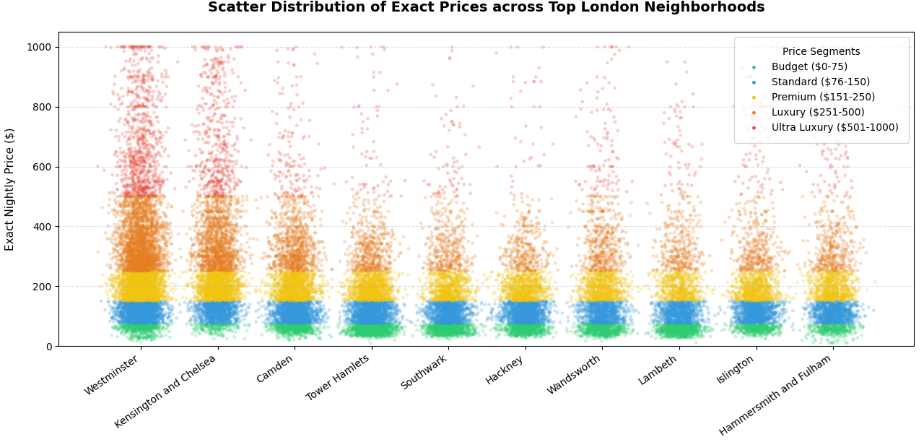
Prices x Listings
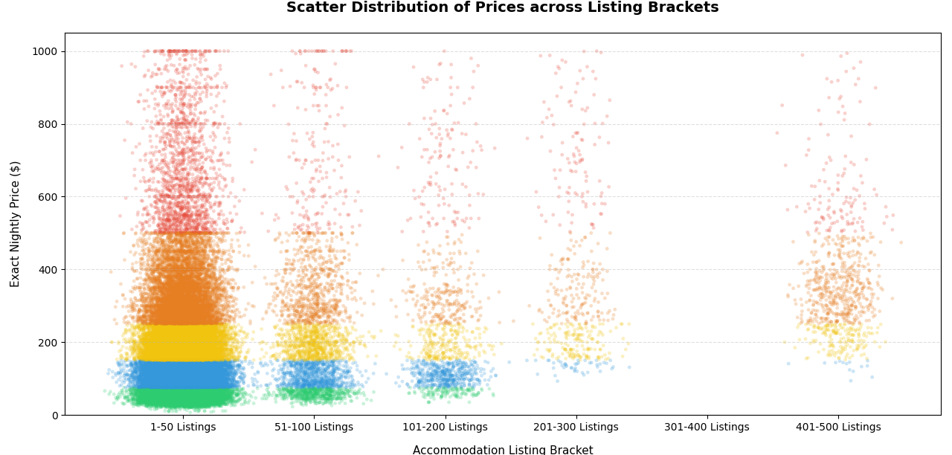

Listings x Locations
