1. Scope

A library management system is used to record all books so that they can be borrowed by members. New books may be added to the library collection but some old books which have deteriorated beyond reading will be removed. The books can be borrowed from the library by a member and in case the member is unable to return the book within the time frame a fine will be issued for the member. The history of who borrows what book is also recorded.

1. Class Diagram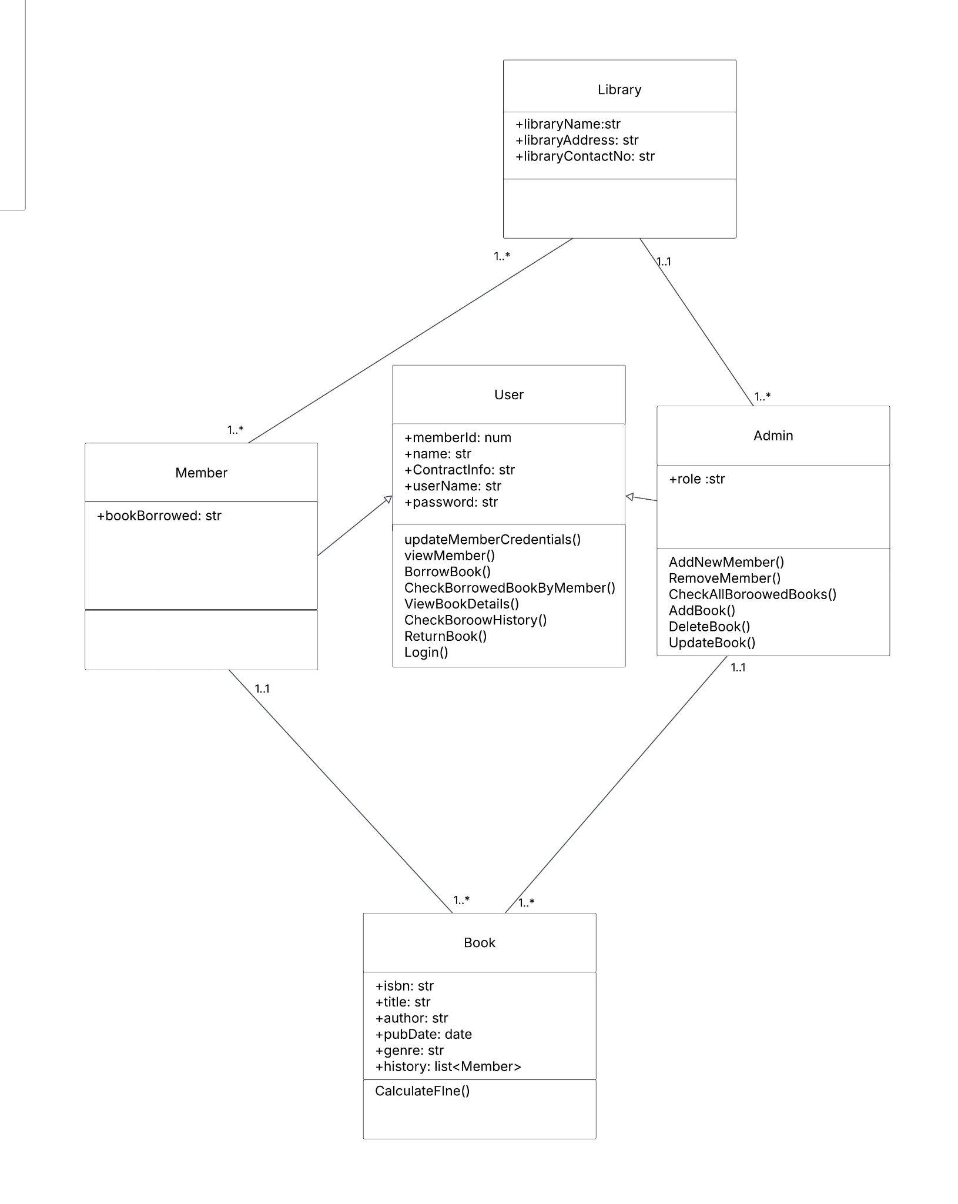

This class diagram shows what the main entities of the library system are. The attributes and functions used by each entity.

Book:  
 Attributes:

ISBN

Title

Author

PubDate

Genre

History

Method:

CalculateFine

Member:

Attribute:

BookBorrowed

Admin:

Attribute:

Role

Method:

AddNewMember()

RemoveMember()

CheckAllBoroowedBooks()

AddBook()

DeleteBook()

UpdateBook()

User:

Attribute:

MemberId

Name

ContractInfo

UserName

Password

Method:

updateMemberCredentials()

viewMember()

BorrowBook()

CheckBorrowedBookByMember()

ViewBookDetails()

CheckBorrowHistory()

ReturnBook()

Login()

Library:

Attribute:

libraryName

libraryAddress

libraryContactNo

3.Use case diagram  
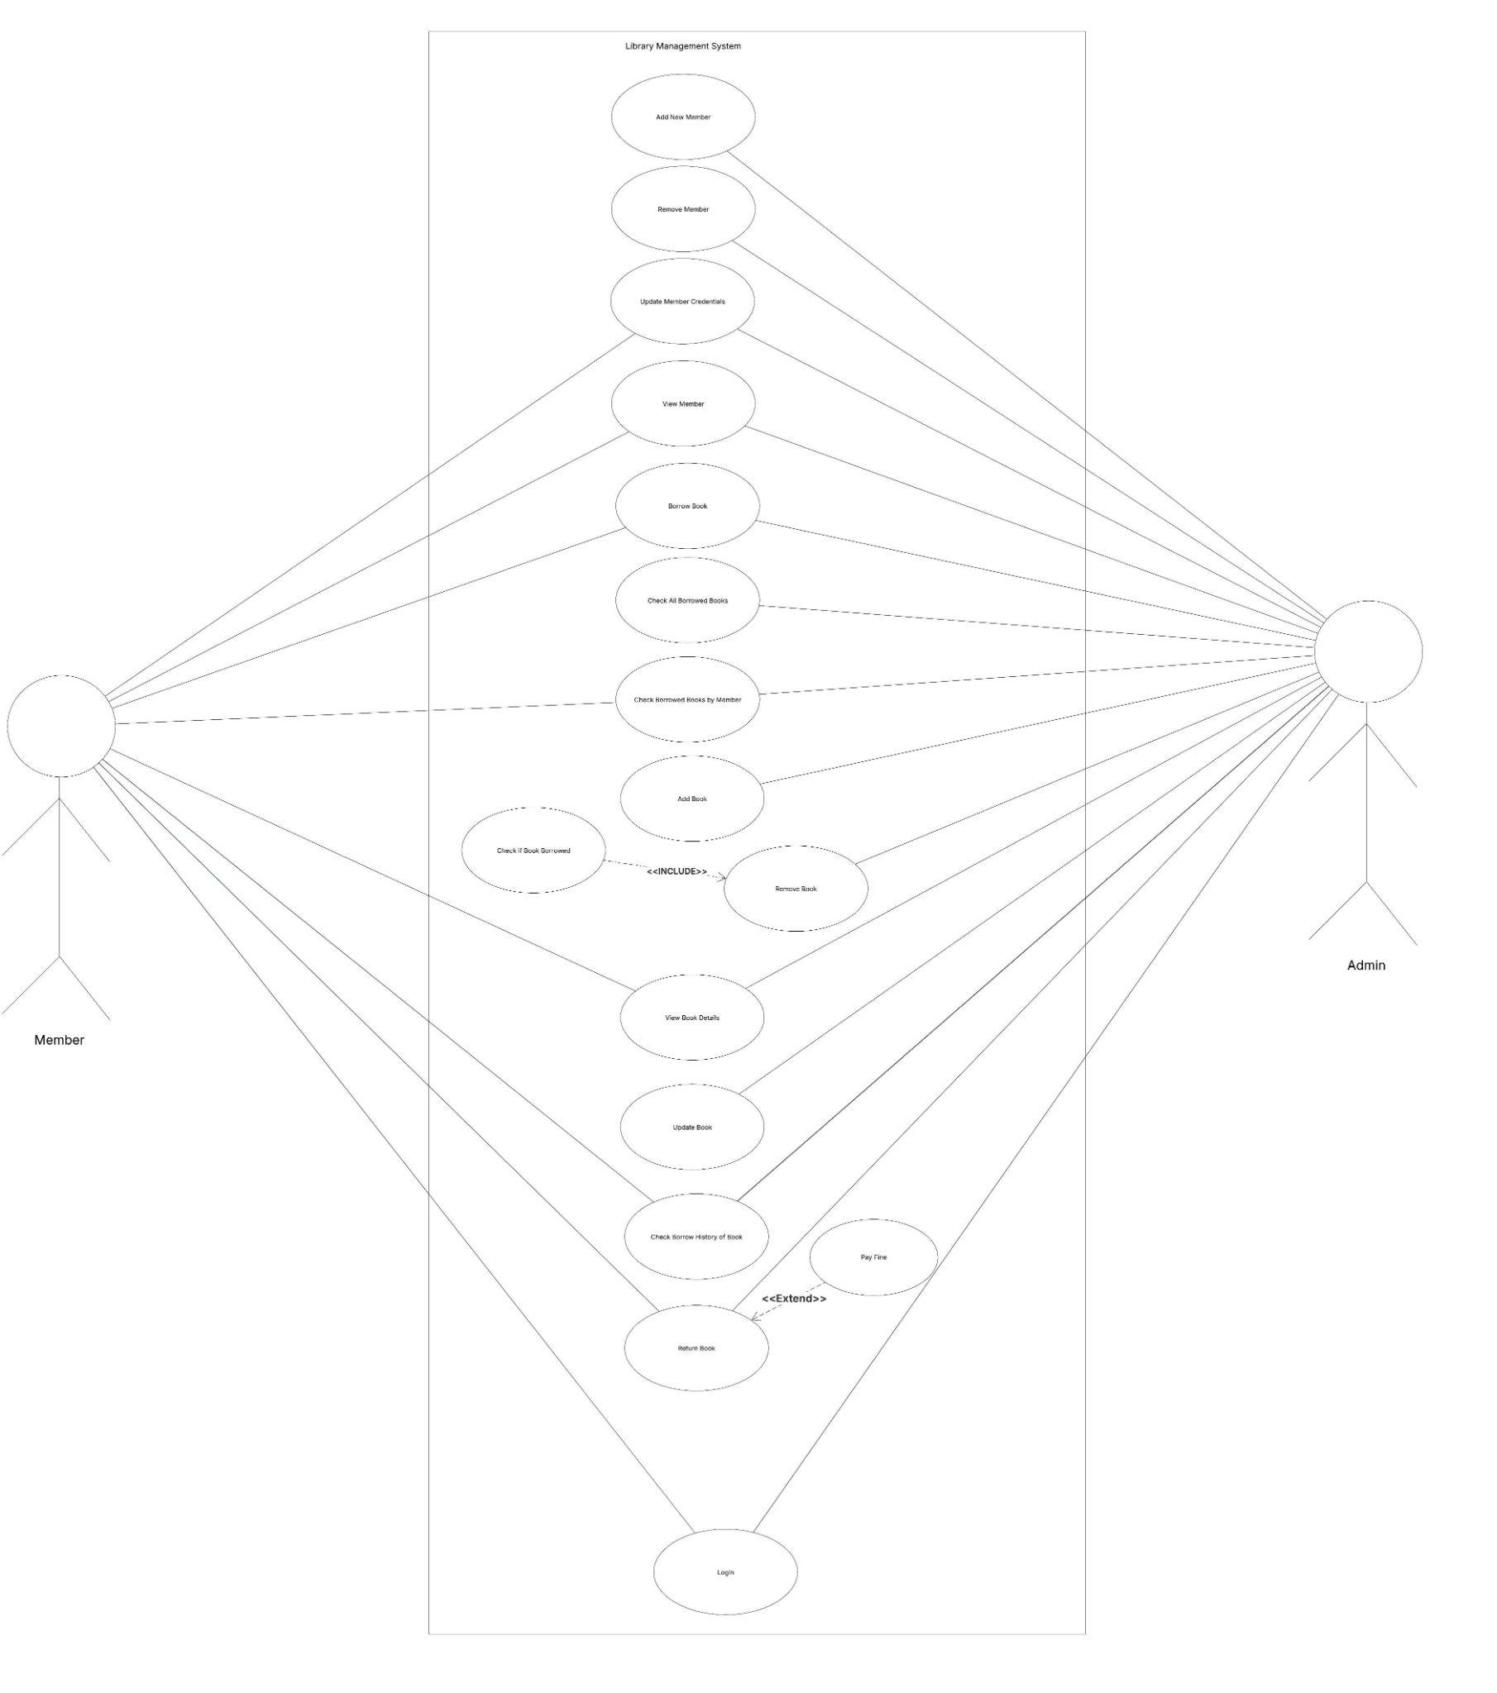

| **Use Case** | **Use Case Description** |
| --- | --- |
| Add New Member | Admin adds new member to system |
| Remove Member | Admin Removes member form system |
| Update Member Credentials | Admin or user updates member credentials |
| View Member | Admin or user views the information of the member |
| Borrow Book | Admin or Member is able to borrow a book from the library |
| Check all borrowed books | Admin is able to check all borrowed books in the system |
| Add Book | Admin is able to add a book to the system |
| Remove Book | Admin is able to remove books from the system. It also checks if the book is borrowed from the system if it is the book will not be deleted until it is returned. |
| View Book Details | Get information on the book by the admin |
| Check borrow History of Book | Admin or member is able to view the history log of the book. |
| Return Book | Admin or User is able to return the book and if the book return date is passed the member must pay a fine. |
| Login | Admin or user is able to login to system |
| Check borrow history by member | Admin or user is able to see what books the member has borrowed |

1. Sequence Diagram

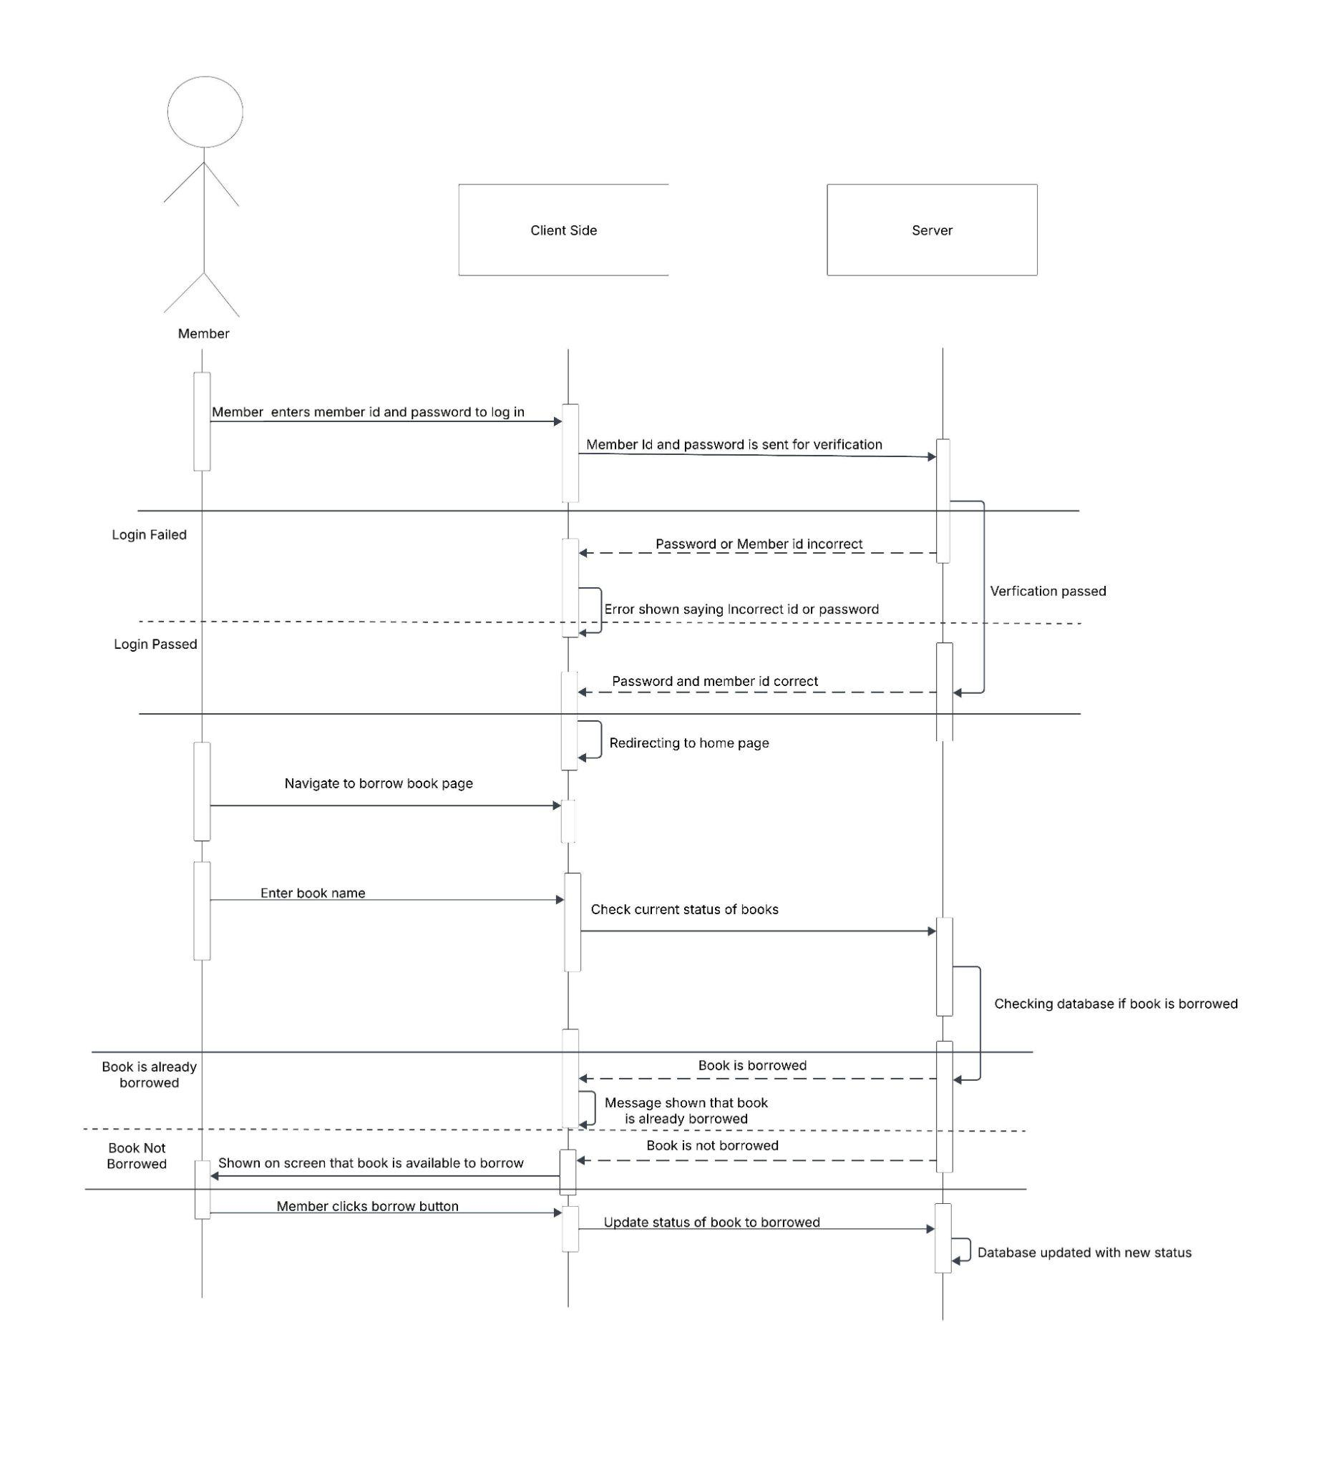  
This diagram shows the sequence of steps the user needs to take in order to borrow a book from the library. The user logs in to the system. Then navigate to the borrow section. The user then enters the book name. If the book is already borrowed an error will be shown otherwise the new status will be updated as book borrowed.

1. Activity Diagram  
   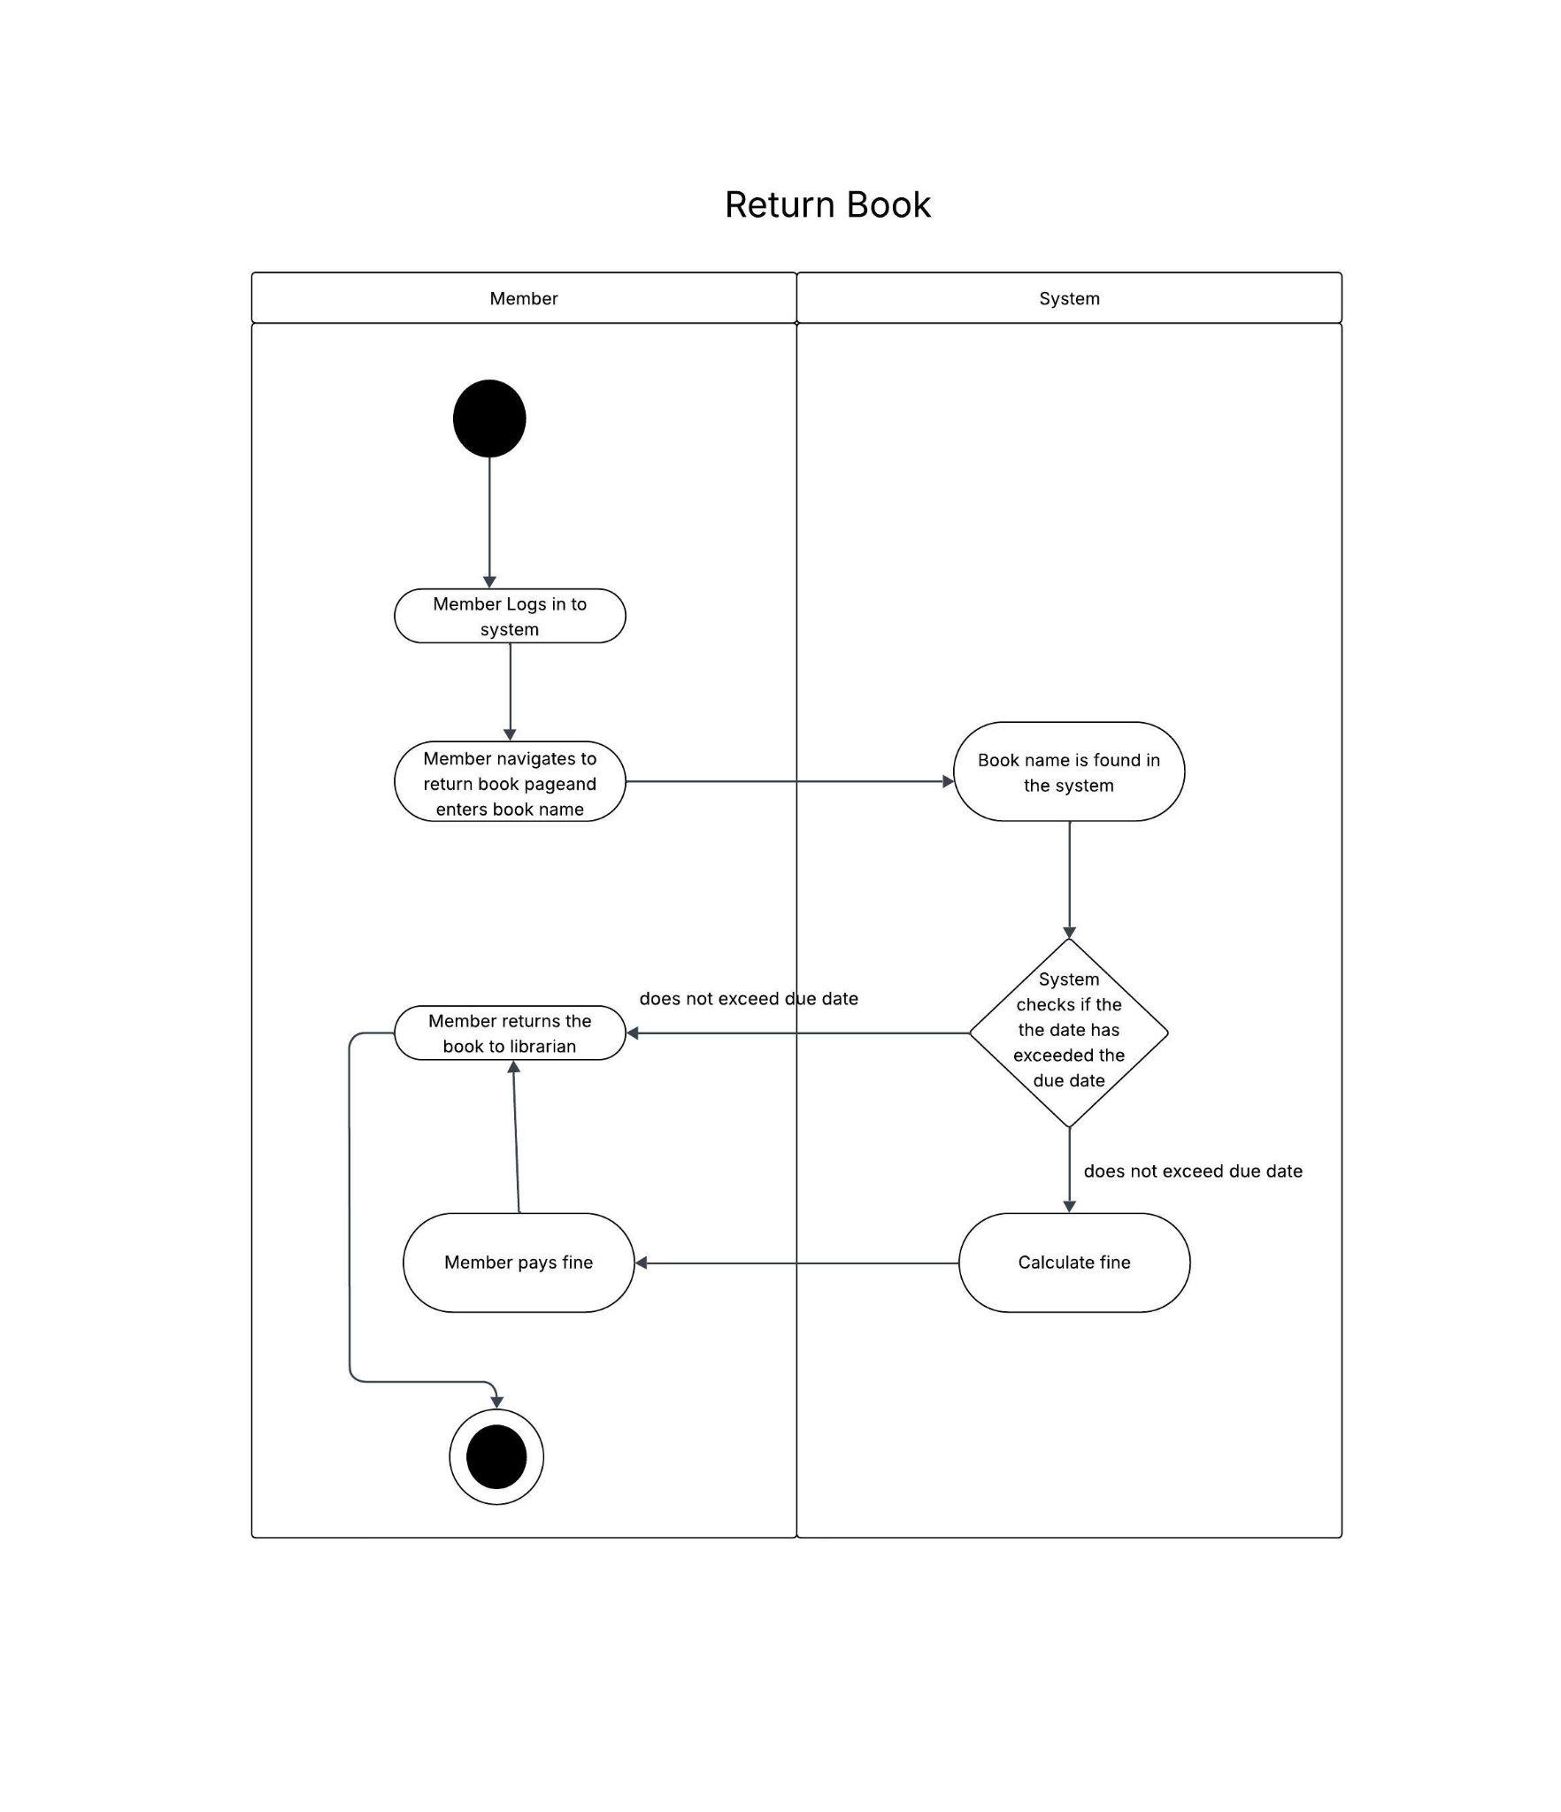

This activity diagram shows the steps a member needs to take in order to return the book to the library. Members log in and navigate to the page. The member returns the book. The system checks whether the date has passed. If yes then he has to pay a fine otherwise the book is returned.