




{date} {ref_no}

Director of Customs
BOI Coordination Directorate
Customs House
No 40, Main Street
Colombo 11

Dear Sir

OBTAINING BANK GUARANTEE ON IMPORTS BY M/S.{company_name}

As requested by the enterprise, we recommend the extension of the validity period of the following bank guarantees for a further period, {extension_date}.
No. | Cusedc No. | Bank Guarantee No | Prior Expiry Date | Amount (Rs.)
{#rows}{no} | {cusdec_no} | {bg_no} | {prior_expiry} | {amount}{/rows}

Please note that the terms and conditions of the letters pertaining to the bank guarantees will remain unchanged.
Your attention on the above would be appreciated.

Yours faithfully,

Sarath Ranathunga
DIRECTOR (INVESTOR SERVICES)
BOARD OF INVESTMENT OF SRI LANKA

CC: {company_name}
File

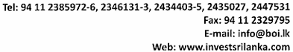

Prepared by Thilona K

