**Question #01:** For given ODE,



The initial conditions are 

Where

And (10+ last three digit of your reg#)/1000 

Develop a Simulink model and show the output response ***y(t)*** of system for 12-N step input ***u(t).***

**Solution (Q1)**

1. **Simulink model (block diagram) 4 Point**

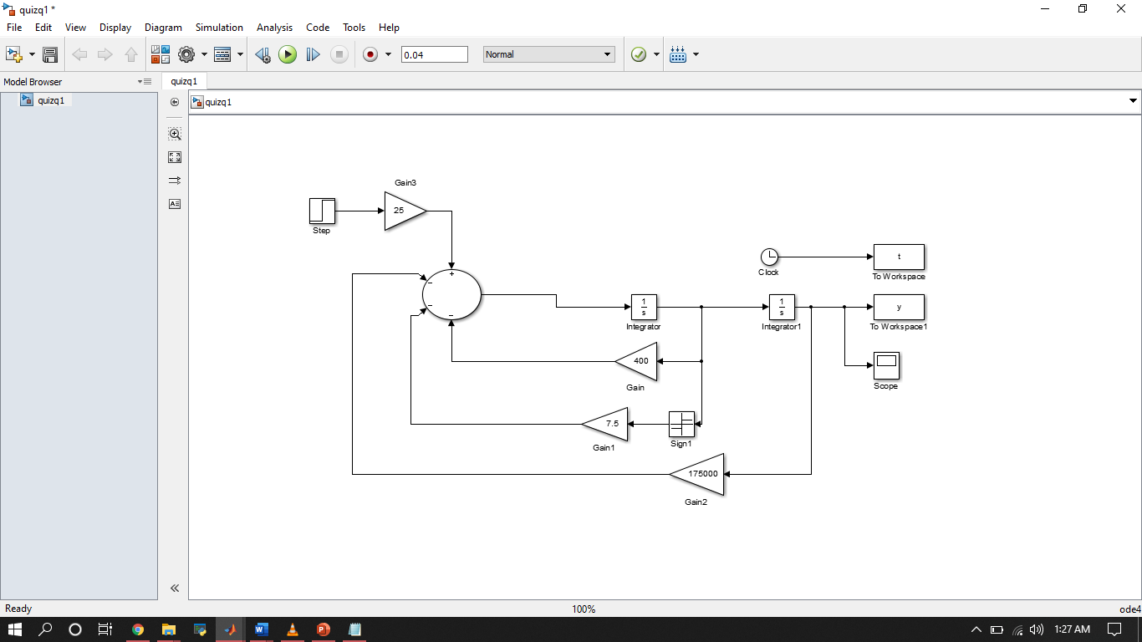

1. **Output response (results) 4 Point**

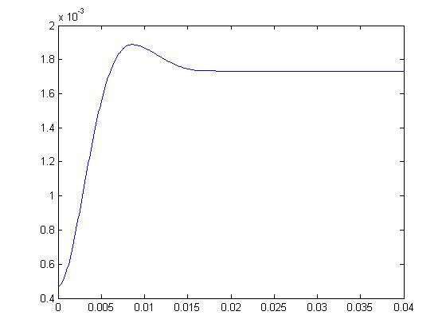

1. **Compute Key parameters from plot 2 Point**

RiseTime: 0.0041

SettlingTime: 0.0143

SettlingMin: 0.0016

SettlingMax: 0.0019

Overshoot: 9.1386

Undershoot: 0

Peak: 0.0019

PeakTime: 0.0086