**Question #02:** Fig. 1 represent the railroad-car system. The system parameters are

Locomotive mass kg



Car mass kg



Coupler stiffness N/m



Coupler friction N-s/m



Rolling friction N-s/m



Assume that, there is no friction for cart and system is initially at rest.



Develop mathematical model and solve for state space representation. Based on SSR, develop a Simulink model and obtain the system response for a given locomotive force. Plot the **velocity of locomotive vs time and the relative displacement of vs time.**



The locomotive force is given as

1. The locomotive force is modeled by a 200-kN step function applied at time s plus a quadratic term:





1. The locomotive force is modeled by pulse input



Where K=(last three digit of reg#)

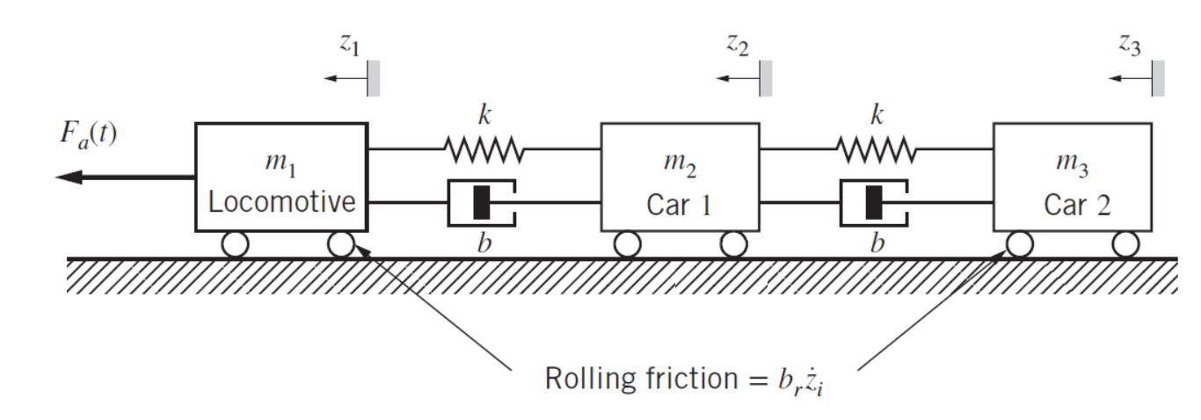

Figure 1:

**Solution. Q2.**

1. **State space representation. 4 Point**

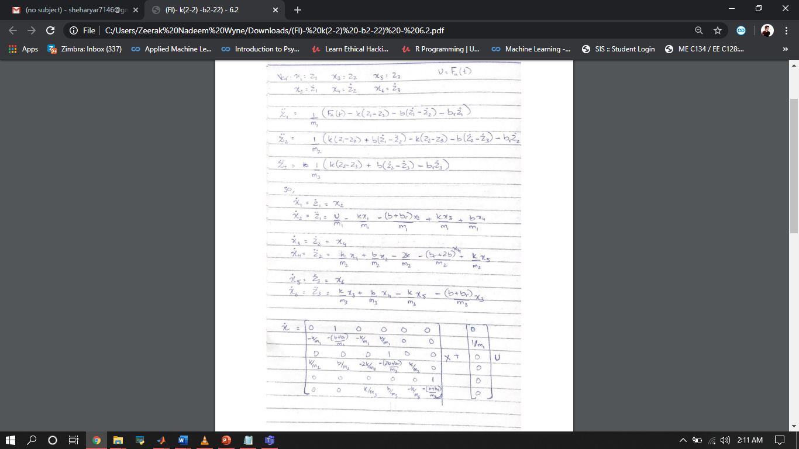

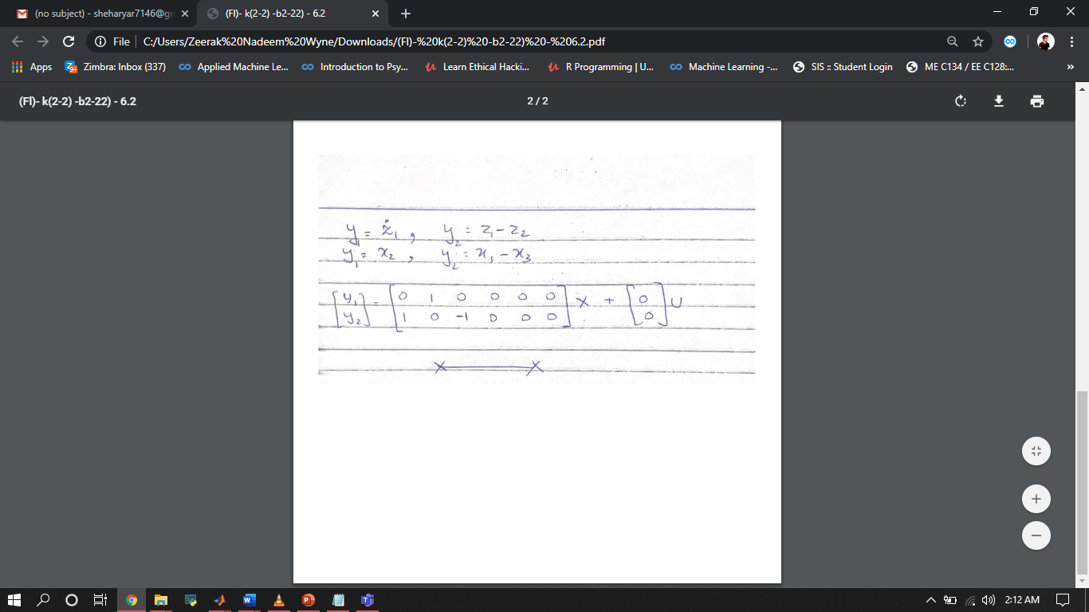

1. **Block diagram (Simulink model) 5 Point**

**(a)**

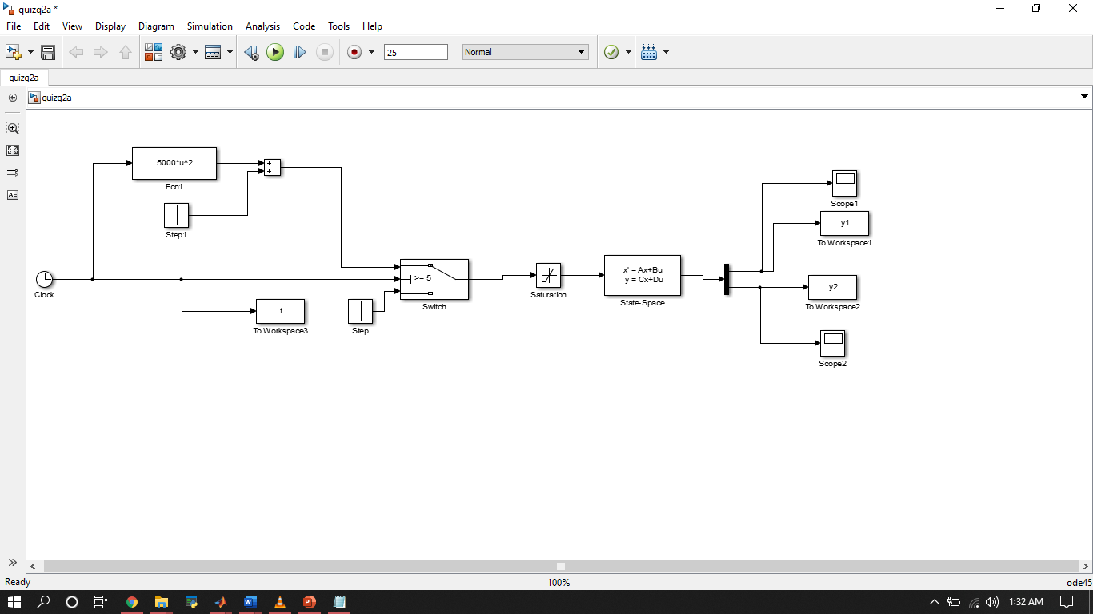

**(b)**

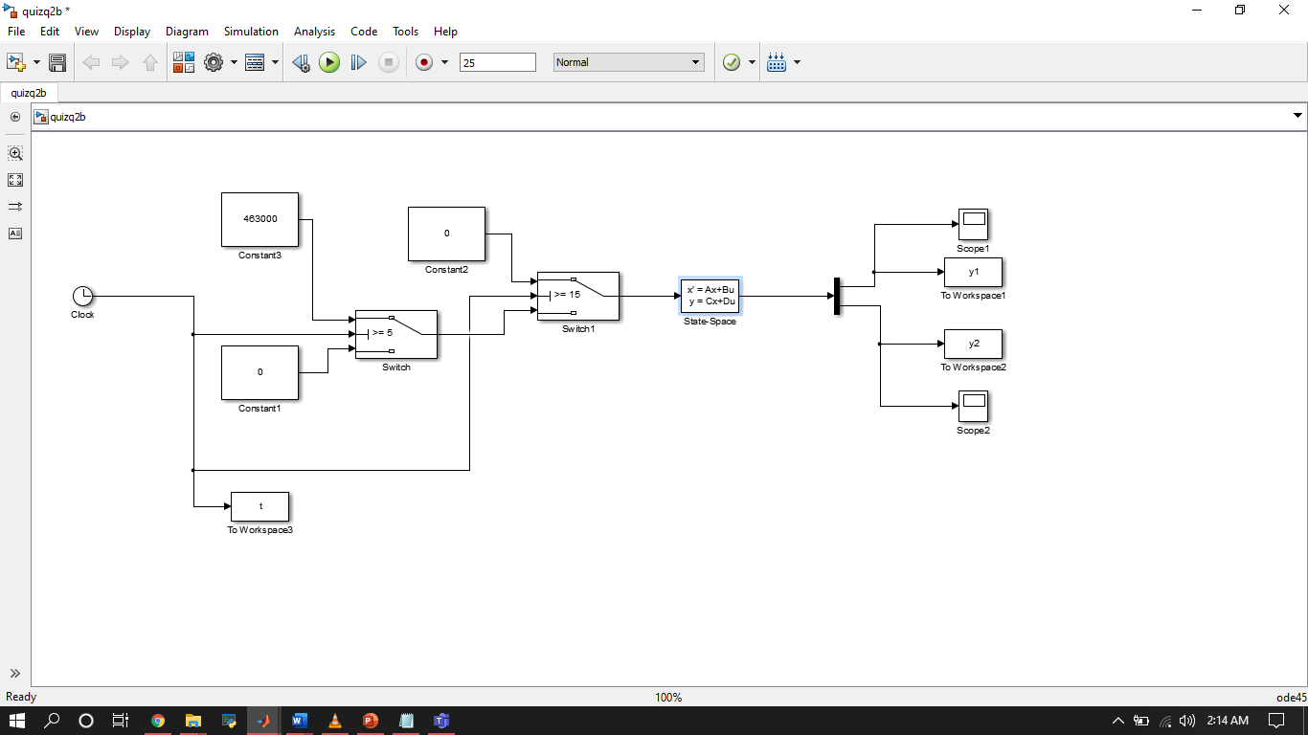

1. **Results part (a) 8 point**

**Results part (b)**

