This project can be completed in two phases, Part 1 and Part 2, as described below:
Instruction
This project will make use of a variety of tools and techniques you have seen throughout this course. Read and understand all requirements before starting, to determine which tools you will need to use.

Part 1 Network Scans and Information Collection
The first part of the project will focus on scanning networks and collecting information, and can be completed in three steps as described below.
Warning
For this project, you will need all of your virtual machines turned on so you can scan and collect information from each of them. However, you will be running all your Nmap scans, and Wireshark captures from the Kali OpenVas VM.

Part 1A Turning on Machines
In VirtualBox/Vmware, turn on all of your machines (Windows11, Linux Server, and KaliOpenVAS). Ensure you have booted up successfully before proceeding to the next step.
Note
If turning on all your machines does not work, that is okay. You will have to scan devices individually later, rather than scanning all devices at once.

Part 1B Performing Scans & Collecting Information
Open Wireshark: On your Kali OpenVas, open Wireshark. You want to make sure you are using it to capture all network traffic while using Nmap to scan your Virtual Lab network.
Use Nmap to Perform Scans: Use Nmap to perform scans of the Main Lab network to collect information about each of your machines.
Record in Wireshark: Start recording in Wireshark on Ethernet0.
Discover & Collect Information: With Wireshark capturing all traffic on Ethernet0, use Nmap on your Kali OpenVAS machine to discover and collect the following information about each of the machines on your Virtual Network.
Warning
Remember to stop the Wireshark scan after the Nmap scan finishes!
Note
Hint: You should be able to collect the following information except the Machine Designation from the output of an Intense scan. You can get the command for this from one of your cheat sheets, or by using Nmap to set up your scan.
- Machine designation (ex. Windows11, LinuxServer, etc)
- Device Host Name (ex. DESKTOP-JE9II55, etc)
- IP address
- MAC address
- Operating System & version
- Open ports with associated services
- ARP Ping Scan elapsed time

Nmap Samples
Here is an example of what you would expect to see if you use Nmap:
Note
Some information, like the MAC address, you may have to get from your Wireshark capture.
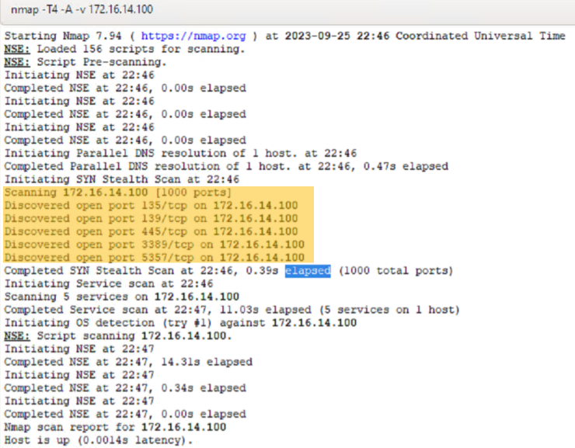
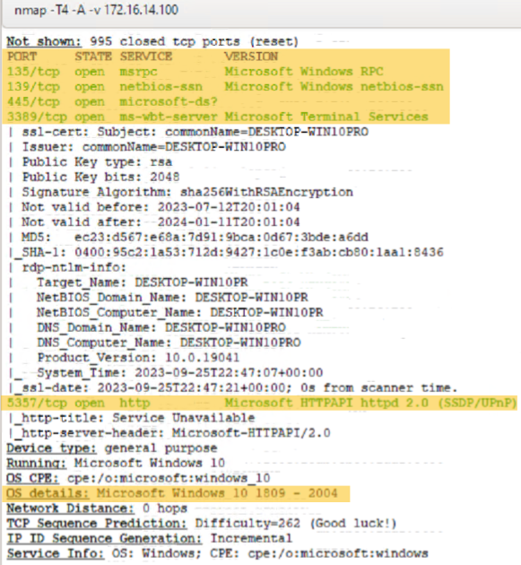
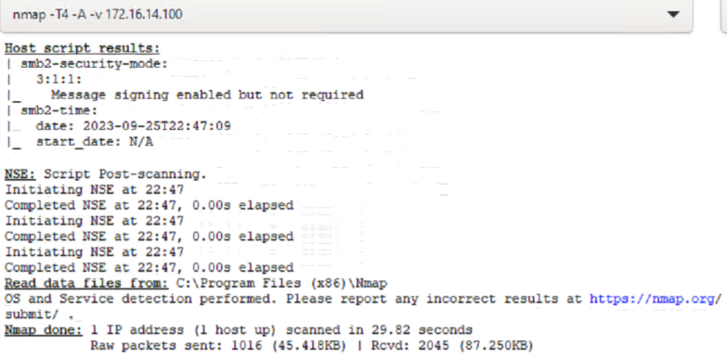

Part 1C Verifying Collected Information
Make sure you double check that the information you collected using Nmap is correct by verifying it against what is actually on each machine as much as possible.

Part 2 Creating Report
In the second part of the project, you need to create a report that documents all the information that you captured in the first part of the project.
Here are some examples of what a Cyber Security Esecutive Summary: * https://www.bitsight.com/glossary/cybersecurity-executive-summary-example * https://www.upguard.com/blog/writing-a-cybersecurity-executive-summary

Sample Report
Here is a sample report you can use as a template for your project submission.

Part 2A Documenting Devices Information
Create documentation for the devices in your Lab. Ensure that it is clear, easy to read and interpret, and includes all the information you have collected and verified from each device. Use your space wisely and organize the information for quick and efficient reference and use (including point form notes and tables to organize information for each machine).
You can document the following information:
- Machine designation (ex. Windows11, LinuxServer, etc)
- Device Host Name (ex. DESKTOP-JE9II55, etc)
- IP address
- MAC address
- Operating System & version
- Open ports with associated services
- ARP Ping Scan elapsed tim
- List what OSI Layer header each of the addresses and port #’s is found in and include screen captures showing the information captured using Wireshark
- A fully labeled topology diagram that includes your recommendation on how network segmentation (both IP address ranges & VLANs) should be added to the network in order to improve the network security posture. Make your decisions based on what services are on each machine.

Part 2B Documenting Information Collection Process
- Document how you collected your information.
- Analyze the Wireshark capture(s) you took to see where you can see each of the scans you did being performed.
- Take screen captures of each portion/type of scan and document how you know that was the scan that you completed.

Part 2C Creating Report
Organize all the information you have collected and put together in a 3-5 pager report. In your report:
- Include your documentation of the network devices
- Share details of your information collection methodologies
- Present the information in your report in the following (suggested) format:
  - Table of contents
  - Introduction section
  - Network Devices Information
  - Information Collection Methodology
  - References and Citation
Note
Report Recommendation: You should utilize half a page per device for documentation, one page for your topology diagram showing network segmentation recommendations, and maximum 2 pages for your methodology documentation.

Project Learning Outcomes
In completing this project, learners will be able to:
- Explore what processes and software are running on Windows and Linux systems
- Select appropriate virtual machine connectivity to other virtual machines and the outside world given a scenario
- Interpret captured network traffic using packet sniffing software
- Plan an IPv4 addressing scheme and basic network segmentation approach given a scenario

Submission Guidelines
- Submit a link to a Google doc that contains your report. This report will be evaluated according the evaluation rubric.
- Make sure you change the share settings to the doc to allow and access to all.
- To submit your project, use the Project Submission button given at the top and follow the instructions.
- your project should follow an Executive Summary format
Note
There is more than one way to approach this problem.
After you have submitted your workflow, you may also want to share it with your peers on Discord, and take a look at the various approaches your peers used.

Evaluation Guidelines
- Familiarize yourself with the Eval Rubric tab so you can read about the competencies you will be evaluated on for this particular project, and review what the different levels of each competency require.
- If you receive Unsatisfactory for any competency, your project will be given feedback to implement before it is accepted. Review the feedback provided, make changes to your project, and aim to resubmit your updated project within 48 hours.
This is not a bad thing; having to resubmit is an opportunity for you to improve and it is common for students to need to implement feedback on their projects before being accepted.

Project Requirements
- Documentation of the network devices discovered through network scans and direct device exploration
- Includes table of contents, introduction, network devices information, and references
- Evidence of findings with labels with labeled screenshots that are tied to description within report
- Details of information collection methods
- Performed wireshark transfers and scans

