Project Submission
Computer Communication and Network

Submitted By
M shehroz saeed
03-135232-029

Project Framework: Cisco Packet Tracer Network Design

1. Network Design and Planning
Network Topology:
- - Use Cisco Packet Tracer to create a diagram of the network with:
- - Routers, switches, PCs, and any other required devices.
- - Connections between the Head Office, Branch Office 1, and Branch Office 2.

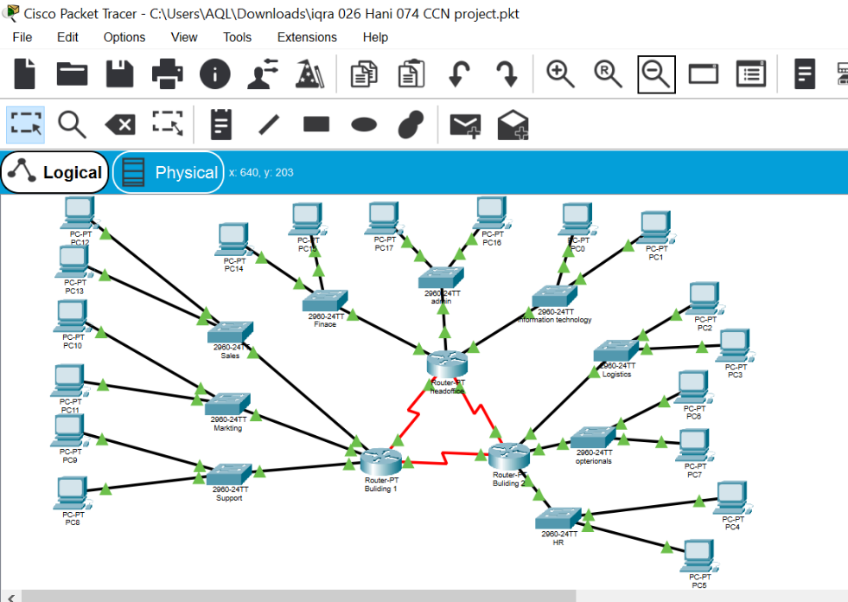

IP Addressing Scheme :
Use Subnetting to divide a single network block into smaller subnets.

Device | Interface | IP Address | Subnet Mask | Default Gateway
R1 | Fa0/0 | 192.168.1.1 | 255.255.255.192 | N/A
R1 | Fa0/1 | 192.168.2.1 | 255.255.255.192 | N/A
R2 | Fa0/0 | 192.168.2.2 | 255.255.255.192 | N/A
R2 | S0/0/0 | 192.168.3.1 | 255.255.255.192 | N/A
R2 | S0/0/1 | 192.168.3.1 | 255.255.255.192 | N/A
R3 | Fa0/0 | 192.168.4.1 | 255.255.255.192 | N/A
R3 | S0/0/0 | 192.168.4.1 | 255.255.255.192 | N/A
R3 | S0/0/1 | 192.168.3.2 | 255.255.255.192 | N/A
PC1 | NIC | 192.168.1.2 | 255.255.255.192 | 192.168.1.1
PC2 | NIC | 192.168.2.2. | 255.255.255.192 | 192.168.2.1

Switch Configuration:
Admin:

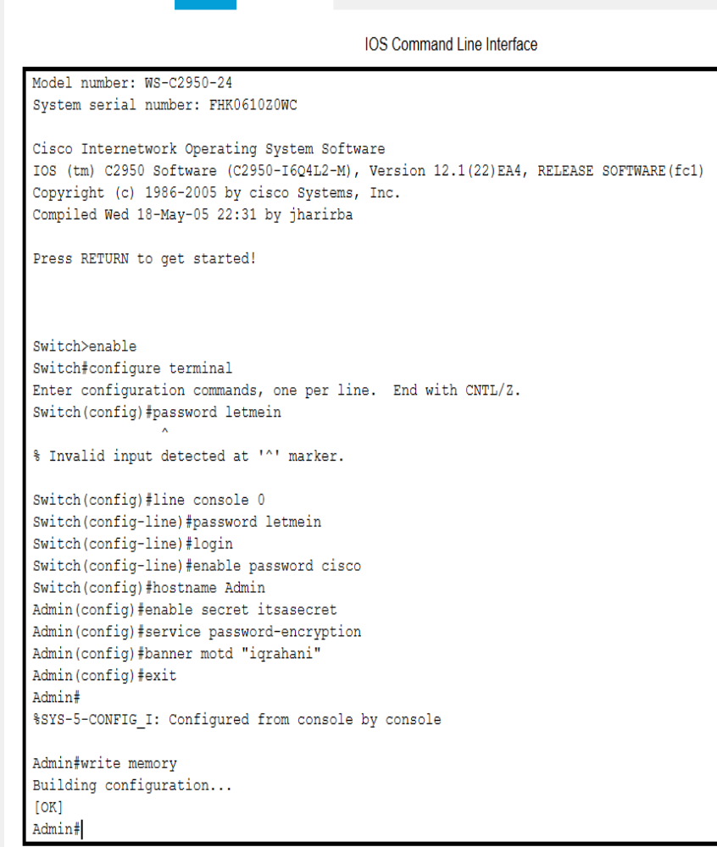
Information Technology:
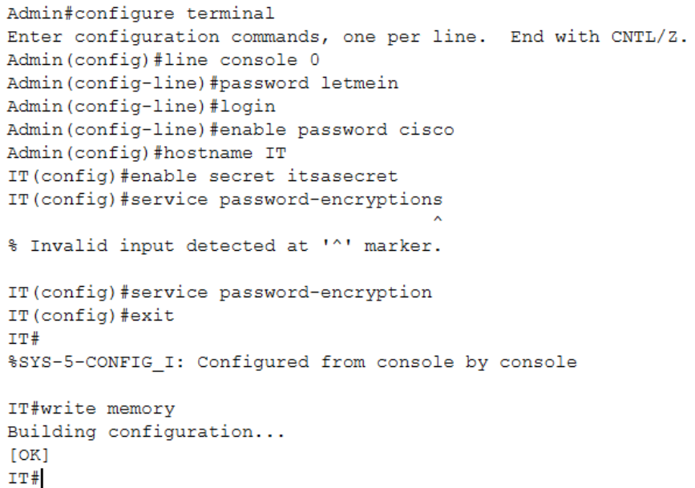
HR :
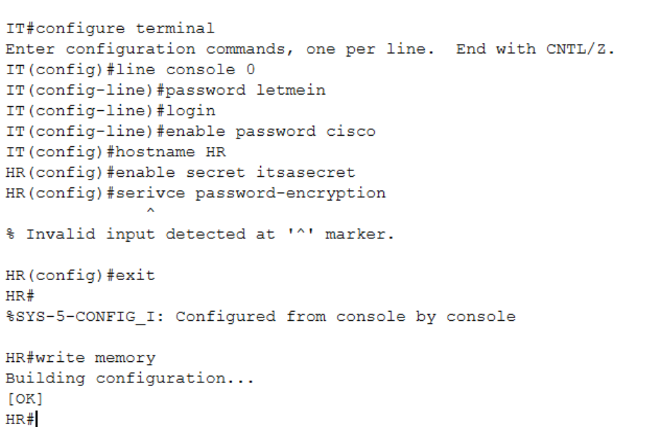

VLAN Configuration:

Admin:
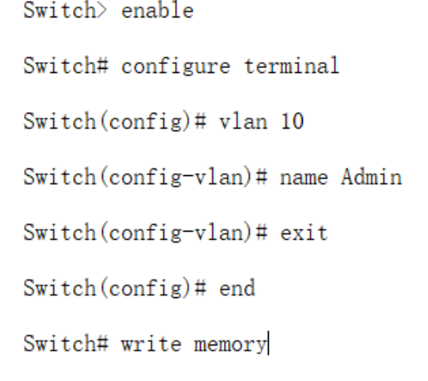
Finance:
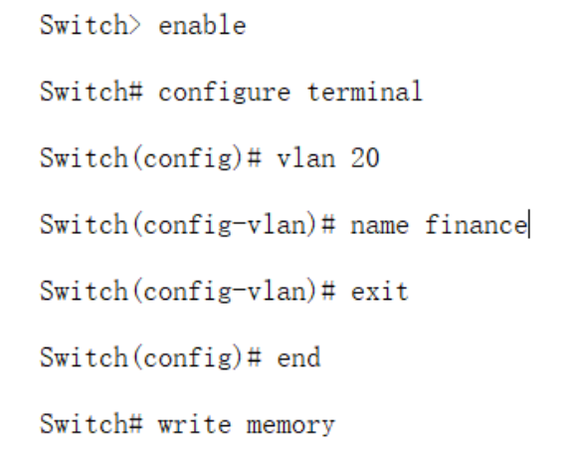

HR:
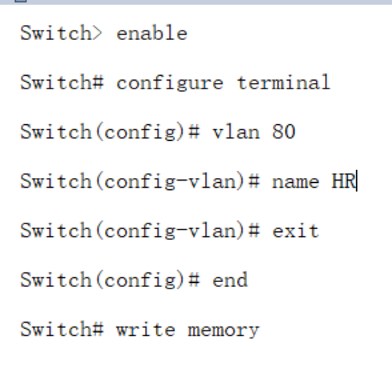

Support:
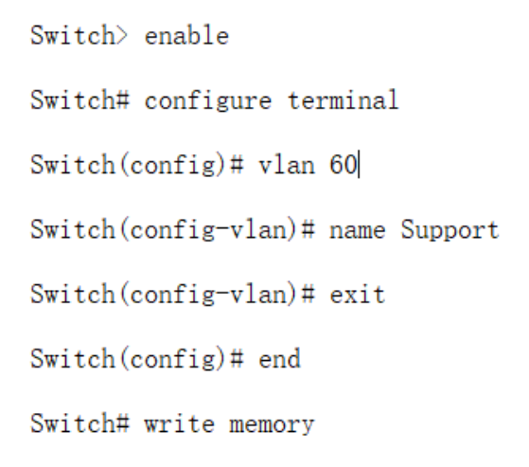

Inter-VLAN Configuration:

Router Configuration :
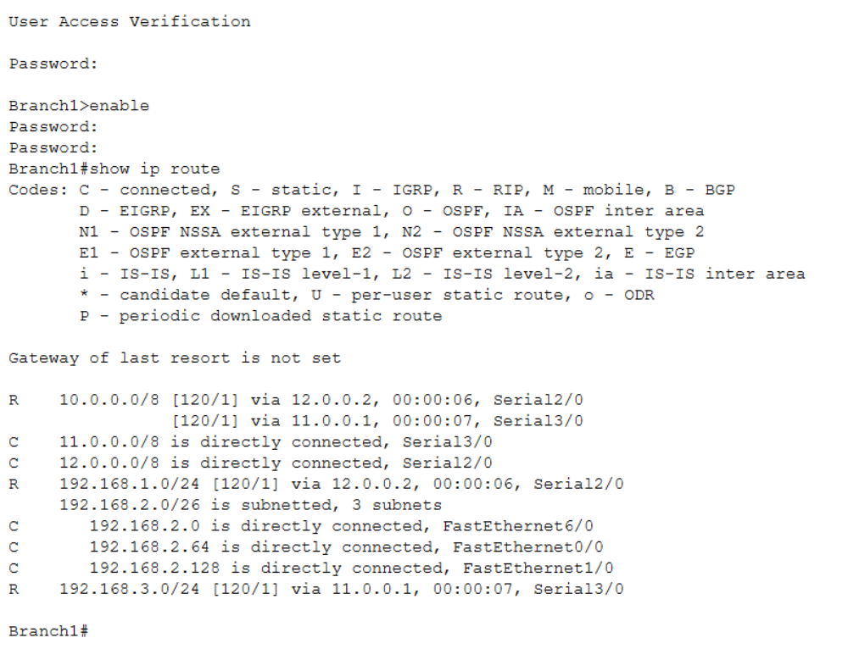

Dynamic Routing:
