Project

Report

Wumpus World

Game

Friday, 16 July 2021

**Prepared by:**

**Shehroz Hayder Qureshi ( Cosc19111068)**

**BSCS 4A**

Table of Contents

**About Project & Platform:** 3

**Working of Project:** 4

**GUI Screen Shots:** 5

# **About Project & Platform:**

This is a visual studio based project that contains the game which is **wumpus world problem.** I have used GUI interface for this project that has a visual representation of every objects that I have used in this. This report contains the information of every detail which is have used to build the game. Moreover it contain the working of my player that is an agent which is autonomous it moves through the specific path and looks in for the search of gold and then return to its initial position. The picture boxes which is a built-in visual studio class contains the pictures of objects (wumpus, stench, breeze, pit safe zone and the agent) mentioned below.

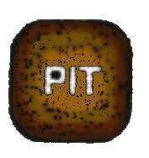

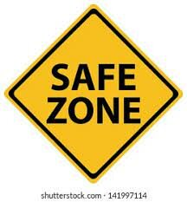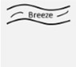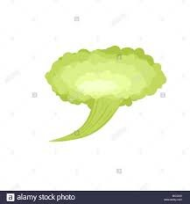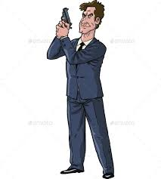

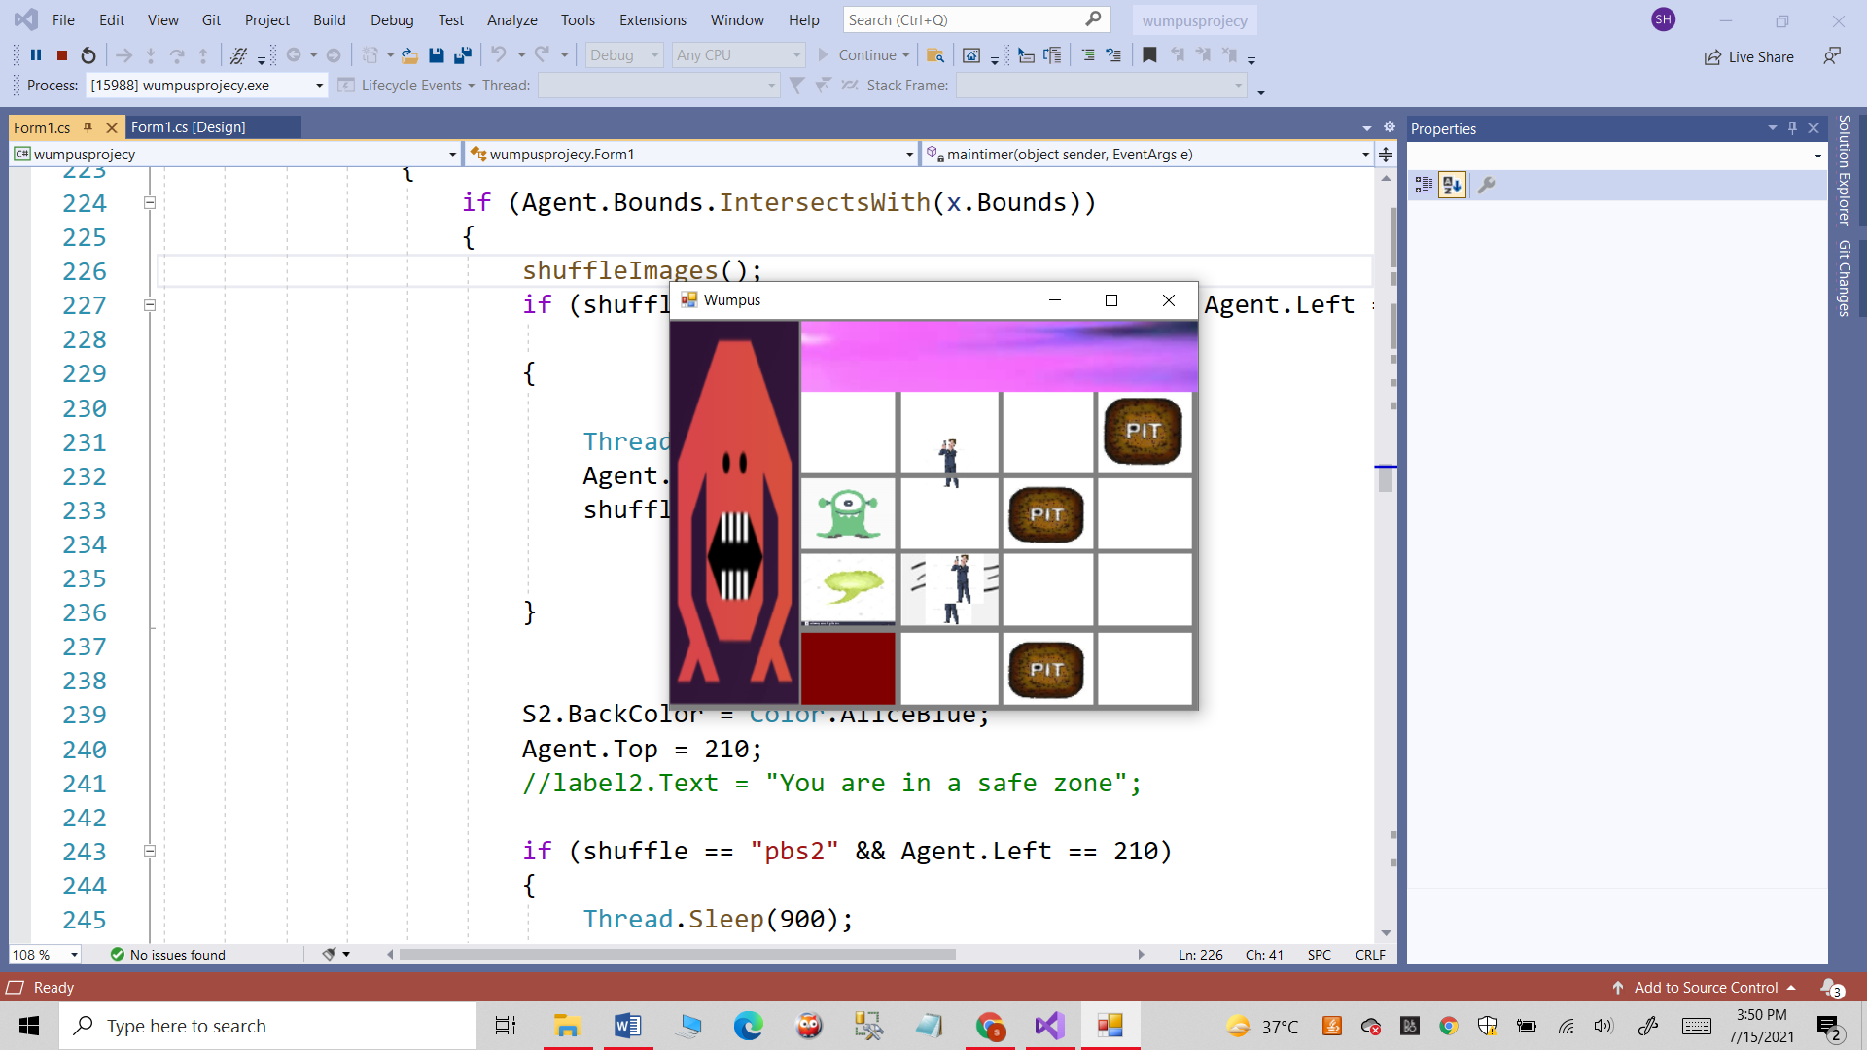

This is a basic overview of the project rest of the details will be explained in the working of the project.

## **Working of Project:**

PEAS Description of game is below

**Environment:**

* A 4*4 grid of picture boxes.
* The agent initially in room square [1, 1].
* Location of Wumpus, Breeze, and Safe Zone are chosen randomly.

**Actuators:**

* Left turn,
* Right turn.
* Move forward.
* Move Downward.

**Sensors:**

* The agent will perceive the **stench** if he is in the room adjacent to the Wumpus. (Not diagonally).
* The agent will perceive **breeze** if he is in the room directly adjacent to the Pit.
* The agent will perceive the **glitter** in the room where the gold is present.

**Performance measure:**

* The game performance is totally dependent to find the gold somehow.
* The game ends when agent finds the gold and return to its initial location.

Working:

In the game the stench, breeze and safe zone are placed randomly and agent moves autonomously through the specific path to find the gold when it passes through the stench it gets the idea that wumpus is near to box so it moves to another location and moves until it find the gold. When it find the sound plays by the visual studio that indicates it has collected the gold as soon as it collects the gold the agent follows the same path (as followed earlier to look for gold) to move backward and return to its initial position which is a start point and again sound plays that indicates the victory then it takes a little pause and close the form window by using built-in class (this.Close()).

# **GUI Screen Shots:**

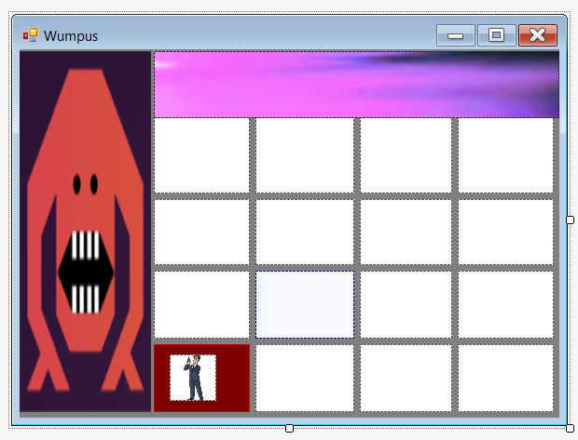

In this pic the agent it at initial position which is a start point.

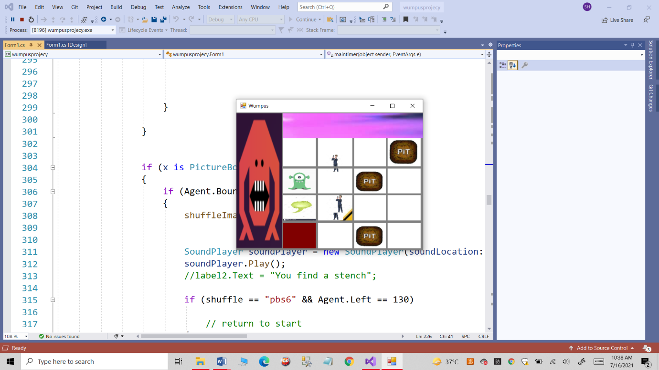

In the next step it has first moved to the box adjacent to the stench then it moves upward

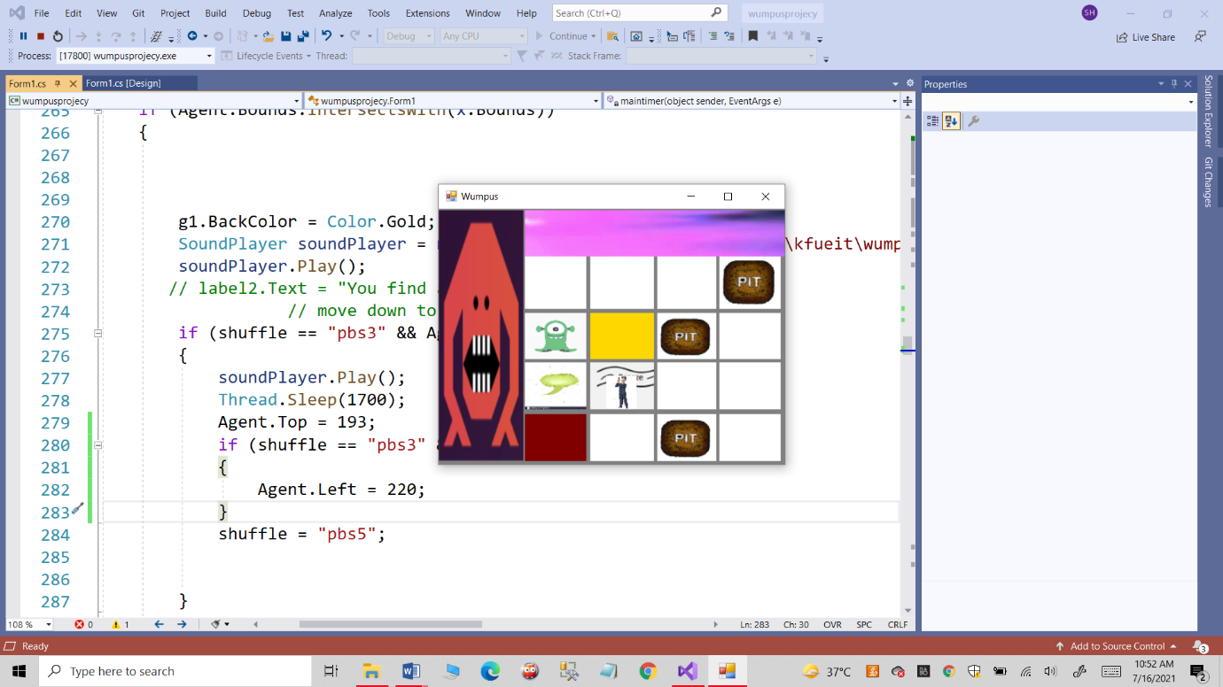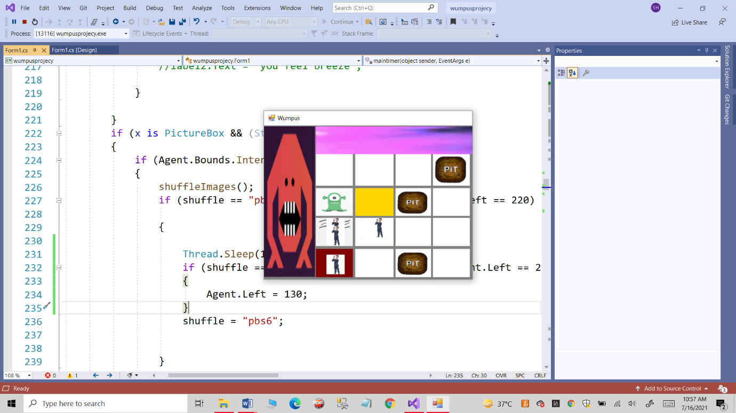

In the next step when it finds a goal now it is heading backwards to its initial point

In this step the agent has moves to its start point.