Supply Chain Management DApp
using Polygon and Hardhat
Short Project Report
Prepared by
Shehryar Ahmed
Course Assignment Submission

Technology stack | Solidity, Hardhat, Polygon Amoy, Ethers.js
Main feature | Role-based product tracking with an audit trail
Frontend | Simple HTML/JS interface

Figure 1. System workflow diagram
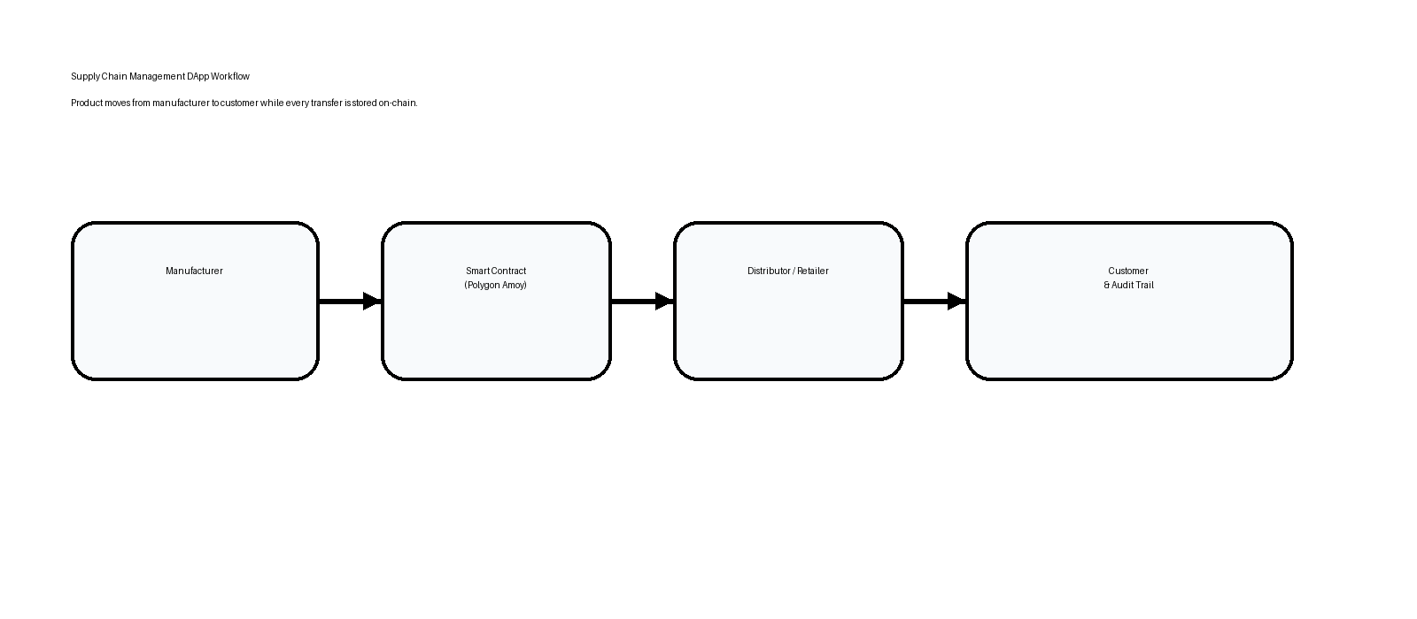

1. Objective
The goal of this project is to build a blockchain-based supply chain system that records each movement of a product from manufacturer to distributor, retailer, and customer. Every action is written to the blockchain so that the product history is transparent and tamper-resistant.

2. Tools and Technologies
Tool | Purpose
Solidity | Smart contract development
Hardhat | Compilation, testing, and deployment
Polygon Amoy | Current Polygon test network
Ethers.js | Frontend blockchain interaction
HTML/CSS/Tailwind | User interface

3. Smart Contract Design
The contract is named ShehryarAhmedSupplyChain.sol as required by the assignment. It uses role-based access control to separate the responsibilities of manufacturer, distributor, retailer, and customer.
Role | Allowed Action | Reason
Manufacturer | Register new products | Only the source of goods can create a product record.
Distributor | Receive products from manufacturer | Ensures controlled handoff to the next stage.
Retailer | Receive products from distributor | Keeps retail transfer separate from manufacturing.
Customer | Receive the final product | Marks the end of the supply chain.
Each product stores a unique ID, product name, description, current owner, and status. The contract also stores an on-chain history array so the audit trail can be viewed later.
Key functions: registerProduct, transferToDistributor, transferToRetailer, transferToCustomer, getProduct, getHistoryEntry, and getAllProductIds.

4. Deployment and Testing Steps
- Install dependencies with npm install.
- Create a .env file containing Polygon Amoy RPC URL, private key, and Polygonscan API key.
- Compile the contract with hardhat compile.
- Run tests with hardhat test to confirm registration and transfer logic.
- Deploy to Polygon Amoy with hardhat run scripts/deploy.js --network amoy.
- Copy the deployed address and transaction hash from the console output.
- Verify the contract source code on Polygonscan using hardhat verify.

5. Frontend Working
The frontend is a simple HTML/JavaScript page that connects MetaMask using Ethers.js. It allows the user to register a product, transfer it to the correct next role, and view the full history for any product ID.
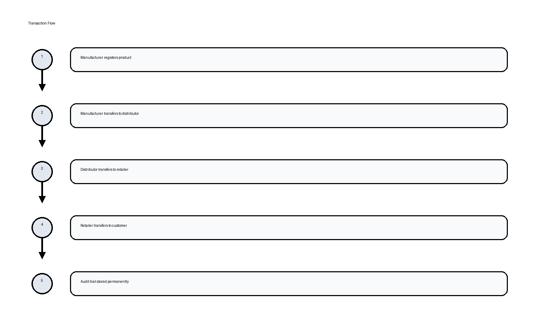

6. Test Results
Test Case | Expected Result | Status
Register product | Product appears with status Manufactured | Pass
Transfer to distributor | Owner changes and history count increases | Pass
Transfer to retailer | Owner changes and status remains InTransit | Pass
Transfer to customer | Final owner becomes customer and status becomes Delivered | Pass

7. Deployment Details
Deployment address: ________________________________
Deployment transaction hash: ________________________
Network: Polygon Amoy testnet (current Polygon testnet recommended by the official docs)

8. Conclusion
This project demonstrates a full supply chain DApp with role-based access, product registration, transfers, and an immutable audit trail. The code is structured for Hardhat deployment and the frontend is ready to connect to the deployed Polygon contract.

