**Personal Budget Management System**



**Session: 2016-2020**

Submitted by:

**Shehryar Kamran**

Registration No:

161-nun-0086

**Program: BSCS**

# Faculty of Engineering and Information Technology

# Northern University, Nowshera

**Personal Budget Management System**

**APPROVAL**

This **project proposal** is submitted to the Faculty of Engineering and Information Technology. Northern University, Nowshera as partial fulfillment of the requirement for the Bachelors/Master’s degree in computer science as on.

Date ________________

**Author** Shehryar Kamran, ____________________

[Author Name & Signature]

**Supervisor**  Syed Atif Ali Shah, ________________________

[Supervisor Name & Signature]

**HOD** Muhammad Asif, ______________________

[HOD Name & Signature]

**Table of Content**

|  |  |  |
| --- | --- | --- |
| **SR.NO** | **DESCRIPTION** | **PAGE** |
| **1** | **Introduction** | **4** |
| **2** | **Problem Statement** | **4** |
| **3** | **Planning(Objectives, Tool)** | **5** |
| **4** | **Analysis(Requirement Analysis)** | **6** |
| **5** | **Logical Design(ER/DFD/Network**  **Hierarchy if Needed)** | **7** |
| **6** | **Preliminary Design** | **9** |

**Personal Budget Management System**

**Introduction:**

Budgeting is the most basic and effective tool for managing our monthly income. But most people avoid doing it because they think keeping record of budget or expense is hectic task. A person will not know how much he has spent as monthly expenses. If there is an application that will allow the user to maintain the record of such expenses then why not use it? The applications that are used in android phone are user friendly, flexible, durable and available at reasonable cost with great ease.

A personal budget management is a finance plan that allocates future personal income towards expenses, savings and debt repayment. Past spending and personal debts are considered when creating a personal budget.

In olden days people were maintaining the daily monthly, weekly or yearly expenses through the pen paper method. But nowadays people will not have patience to record the expenses through such pen paper work. But people will be having an android phone always in their pocket. They love to use a lot of trending android applications.

This is an android app which helps user to track his monthly expenses and alert him if he crosses budget. This app also helps user to have analyze his spending trend through the month.  Better solution is to use this mobile application to keep record of every expense easily at any location.

**Problem statement:**

Managing expenses is important for our rapidly-growing daily life. Long gone are the days when you had to sit down with a notepad and a sky-high stack of bills and receipts to figure out your income, expenses, and overall budgetary plan. These days there are all kinds of spreadsheets and programs that are meant to make your financial planning a lot easier and more efficient. But short of carrying your laptop around with you or have to note all expenses on paper then later record them all on tool installed on computer, these comprehensive budgeting and tracking measures are largely confined to your home.

Managing personal expenses and incomes by an automated system really helps you stay disciplined to organize your finances, which is the first step of knowing your overall financial health. Maintaining a budget is like maintaining a bridge; Looking through your finances at regular intervals will allow to spot trends and see areas that can be improved way before it becomes a problem. Knowing your exact financial situation lifts a tremendous amount of stress off your shoulders because you don’t have to worry about the unknown. But the Problem is how to maintain the budget efficiently and with ease and how to avoid overdraft fees, unexpected shortages, the minimum payment treadmill, and that sinking dread when you realize you actually couldn't afford to go out.

To solve this problem, we are developing this android application. This project reduces people time.  By using this application user can more efficiently plan their budget and lets you create customized categories in which it simply subtract from as you spend. Just add your expenses to the various categories and this app will tell you when you're running low on cash.

You can also break them down into several categories such as mortgage/rent, utilities (complete with subcategories like gas and electric), food, entertainment, and so on.

**Planning (Objectives, Tools):**

**Objectives:**

The project will seek to prove the below objectives:

* Create a monthly budget.
* Add expenses related to specific budget.
* Add revenue related to specific budget
* Remove any expense which is related to some specific budget.
* Expense can be updated in future.
* Revenue can be updated or deleted in future.
* Details of revenue can be seen.
* Specific expense and revenue can be search
* Expense which was created before with its information can be viewed later on.
* Data can be backup for future use.

**Development Tools:**

In this project I will use following tools to make the project more efficient & effective.

**Platform**: Android

**Language**: Java, Xml

**Database**: SqLite

**IDE:**  Android Studio

**Software Process Model:**

The following prototype model will be used in this project.

**Prototyping Model:**

The prototyping model should be used when the system needs to have a lot of communication with end user. In this application there are many meetings among developers, user and supervisor. There may be chance of many changes in development place in this application. To keep their functionalities in mind, we have found that prototyping ensure that the end user constantly work with the system and provide a feedback which is incorporated in the prototype to result in a useable system. They are excellent for designing good human computer interface system.

**Why I used prototype model:**

* Prototyping model should be used when the desired system needs to have a lot of interaction with the end user.
* Prototyping ensures that the end users constantly work with the system and provide a feedback which is incorporated in the prototype to result in a useable system.
* It might take a while for a system to be built that allows ease of use and needs minimal training for the end user.
* They are excellent for designing good human computer interface systems.
* It is usually used when a system does not exist or in case of a large and complex system.
* The prototype gives the user an actual feel of the system.
* **Early user acceptance testing**
* **Realize requirements and constraints that were not previously considered**
* **Better cost, time, and complexity estimates**

**Requirement (Requirement Analysis)**:

I gather my requirements for my project from different sources such as I visited different budget management system apps and another source is from my senior. Budget management experts also help me in this project. **Network Hierarchy:**

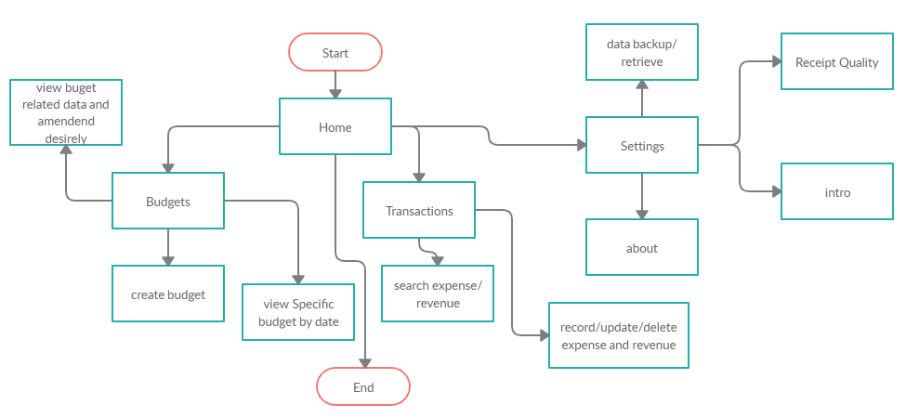

**Figure 1: Network Model**

**ERD:**

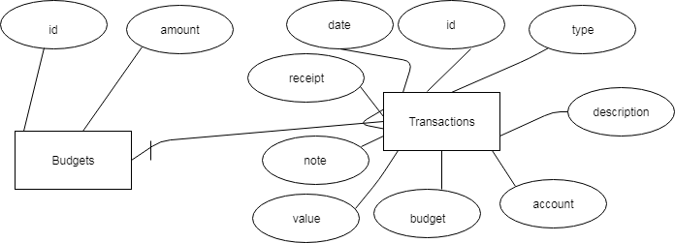

**Figure 2: ER-Diagram**

**Preliminary Design:**

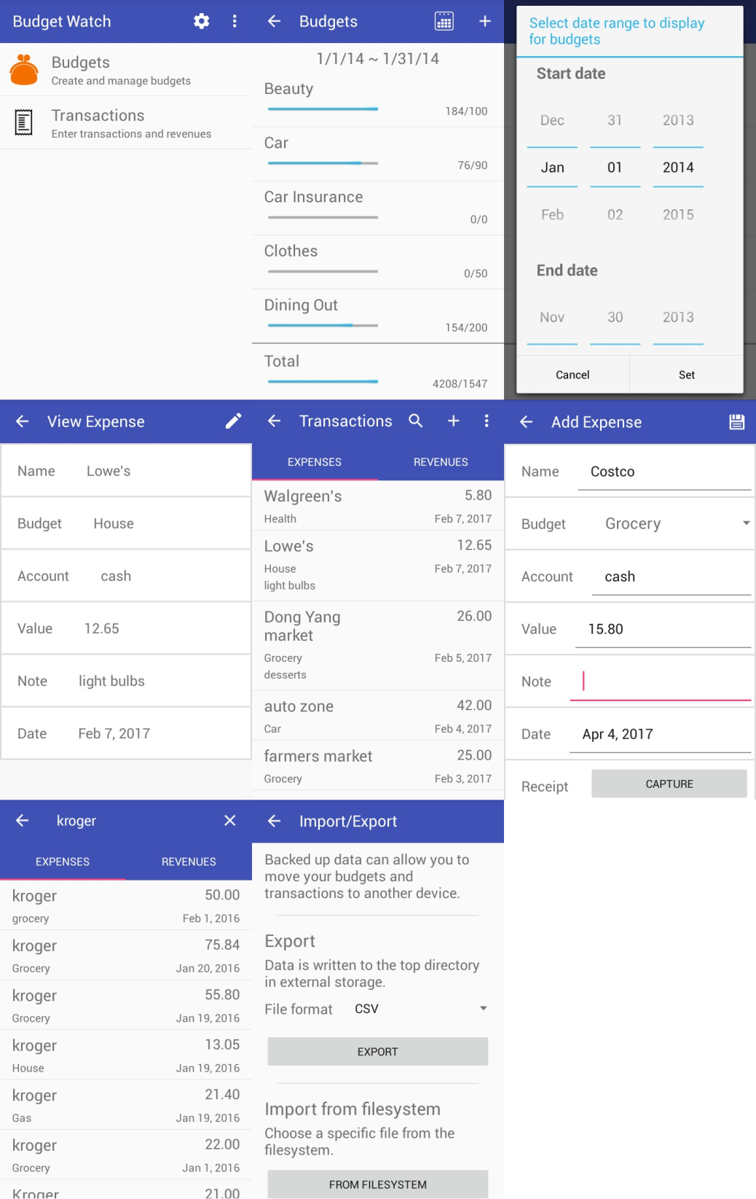

**Figure 3: Preliminary Design**