FAST Student Facilitator (FSF)
Software Architecture Document (SAD)

Senior Software Architect
University Project Submission
Date: May 8, 2026
Version: 1.0

Table of Contents
1. Architecture Context Diagram (ArCD)....................................................................... 3
2. Box And Arrow Diagram....................................................................................... 4
3. Description......................................................................................................... 5
4. Rationale........................................................................................................... 6

1. Architecture Context Diagram (ArCD)
The Architecture Context Diagram (ArCD) provides a high-level view of the FSF system and its interactions with external entities. This diagram defines the system boundaries and identifies the key stakeholders and external systems that interface with the application.
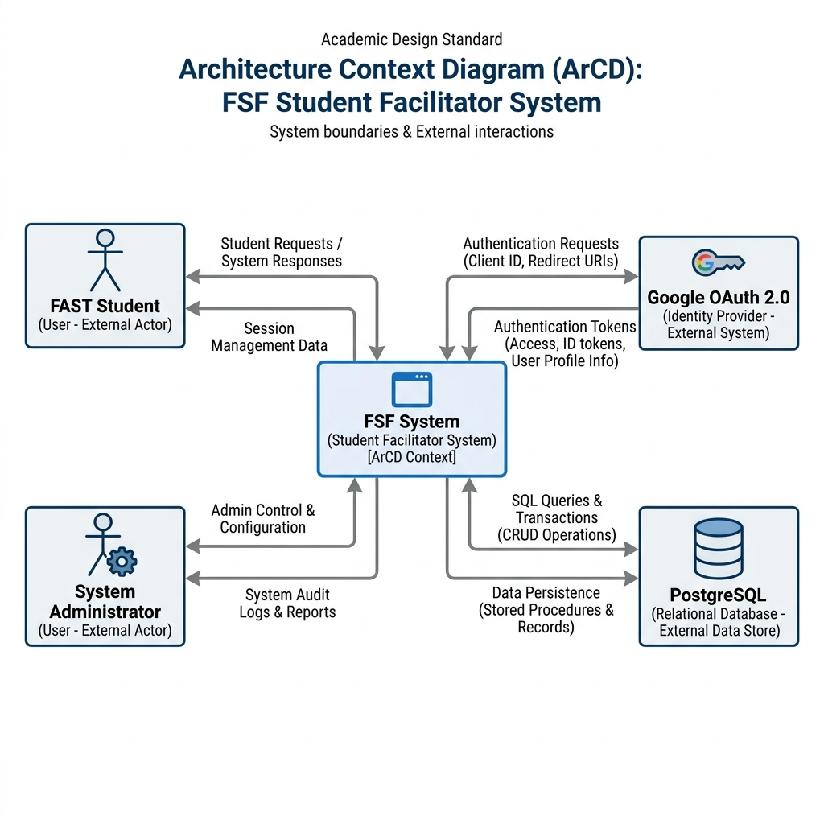

2. Box And Arrow Diagram
The Box and Arrow diagram details the internal decomposition of the FSF system. It highlights the layered architecture and the modular organization of services, showing how the frontend, security layer, business logic, and persistence layer interact.
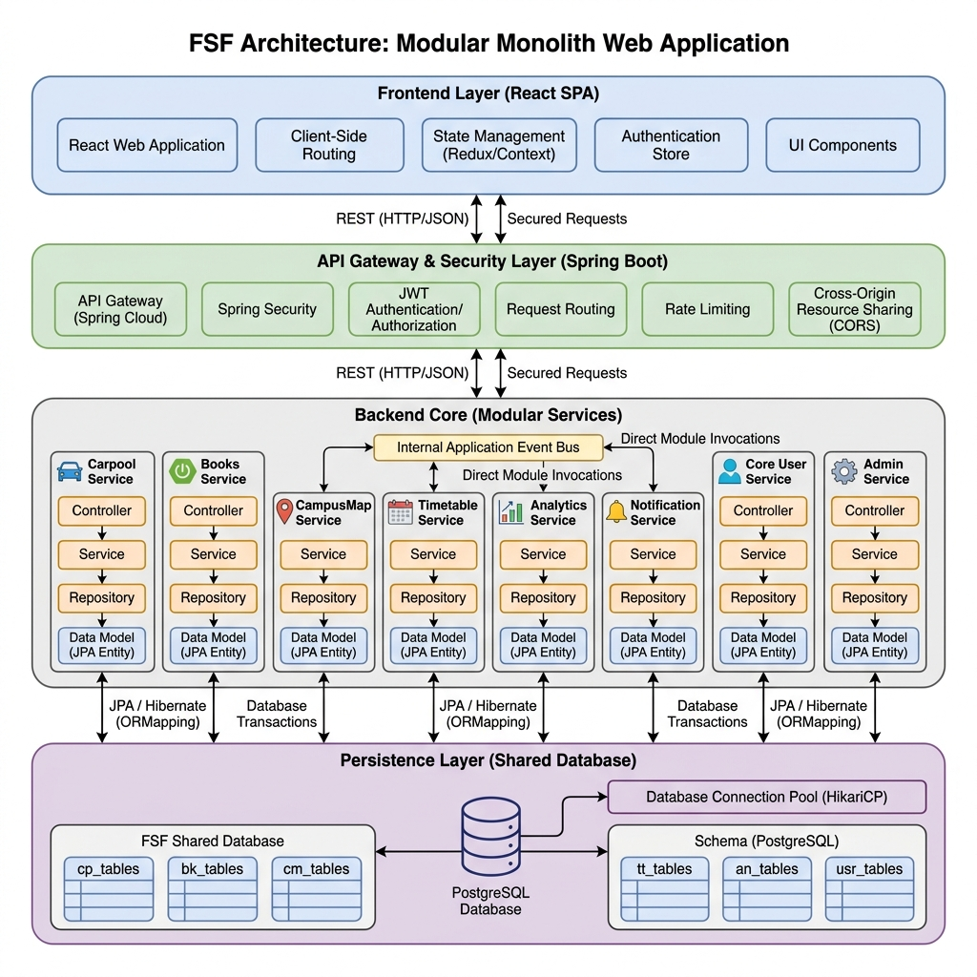

3. Description
The following table summarizes the primary architectural components of the FSF system, their responsibilities, and their mapping to functional and non-functional requirements.
Sr# | Component Name | Component Description | Requirement Ref
1 | Auth Module | Manages user authentication via Google OAuth2 and session handling. | UC-01, UC-02
2 | Carpool Module | Facilitates ride-sharing among students, including ride posting and searching. | UC-03, NFR-Security
3 | Books Module | A marketplace for students to buy, sell, or trade academic books. | UC-04, UC-05
4 | Past Papers | Moderated repository for uploading and downloading previous exam papers. | UC-06, NFR-Moderation
5 | Campus Map | Provides indoor and outdoor navigation for the FAST campus. | UC-07, NFR-Usability
6 | Timetable Mgr | Parses Excel timetables and provides personalized schedules to students. | UC-08, NFR-Performance
7 | Analytics | Tracks system usage and provides insights via visual charts (Recharts). | UC-09, NFR-Scalability
8 | Admin Center | Unified dashboard for moderation, user management, and content control. | UC-10, NFR-Security
9 | Notification | Manages reminders and alerts for events and updates. | UC-11, NFR-Reliability

4. Rationale

Architectural Style: Modular Monolith
The decision to use a Modular Monolith architecture was driven by the need for high maintainability and logical separation of concerns without the operational complexity of microservices. Each feature (e.g., Carpool, Campus Map) is encapsulated within its own package, ensuring that changes in one module have minimal impact on others.

Design Rationale and Trade-offs
- Scalability: The modular design ensures that the system is "cloud-ready." If specific modules (like Analytics or Timetable) experience high load, they can be extracted into microservices with minimal refactoring.
- Security: Leveraging Spring Security with OAuth2 provides a robust, industry-standard authentication mechanism. Restricting access to @nu.edu.pk domains ensures a closed, secure community for FAST students.
- Maintainability: By employing design patterns such as Factory, Observer, and Template Method, the system remains extensible. For instance, new navigation algorithms can be added to the Campus Map module without altering existing code.
- Performance: In-process communication between modules avoids the network latency and serialization overhead inherent in distributed systems, providing a snappier user experience.
- Data Integrity: A centralized PostgreSQL database allows for complex queries and cross-module reporting while maintaining ACID compliance, which is vital for the integrity of user-posted content and marketplace transactions.

