DB-Lab-11 (Forward Engineering)
Step:1 ER-Diagram
(Type is for uni students or staff)
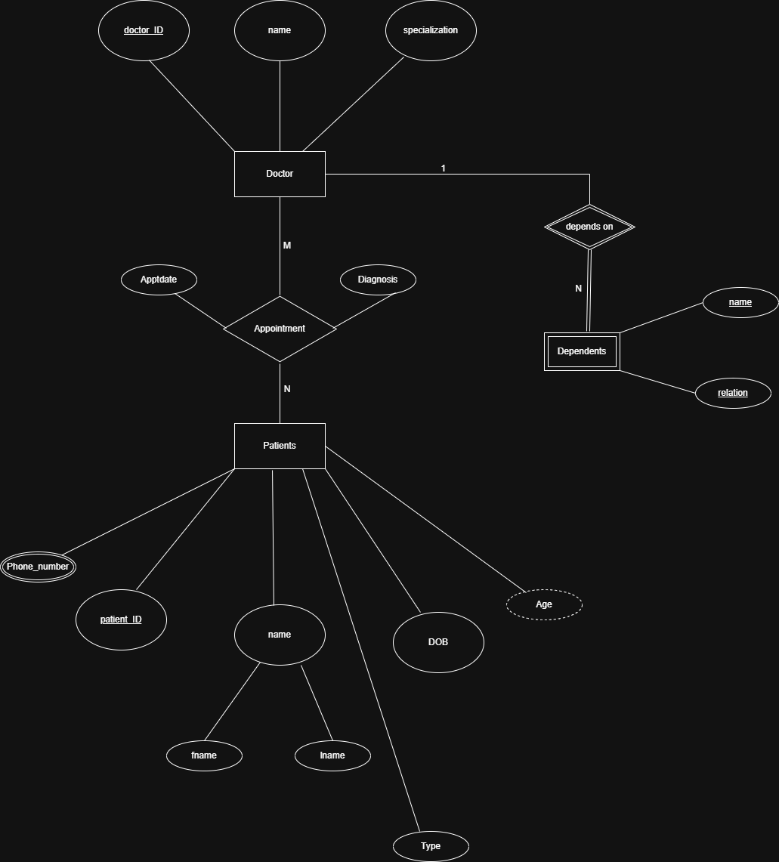

Step: 2 Relational Schema
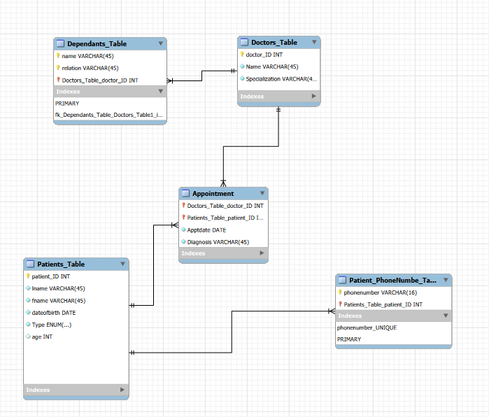

Step:3 (Forward Engineer the MySql Script)
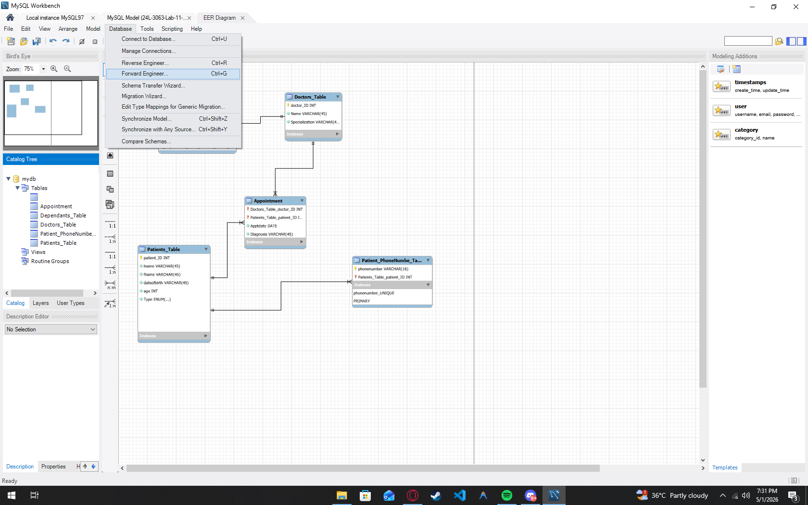

Leaving the checkboxes default
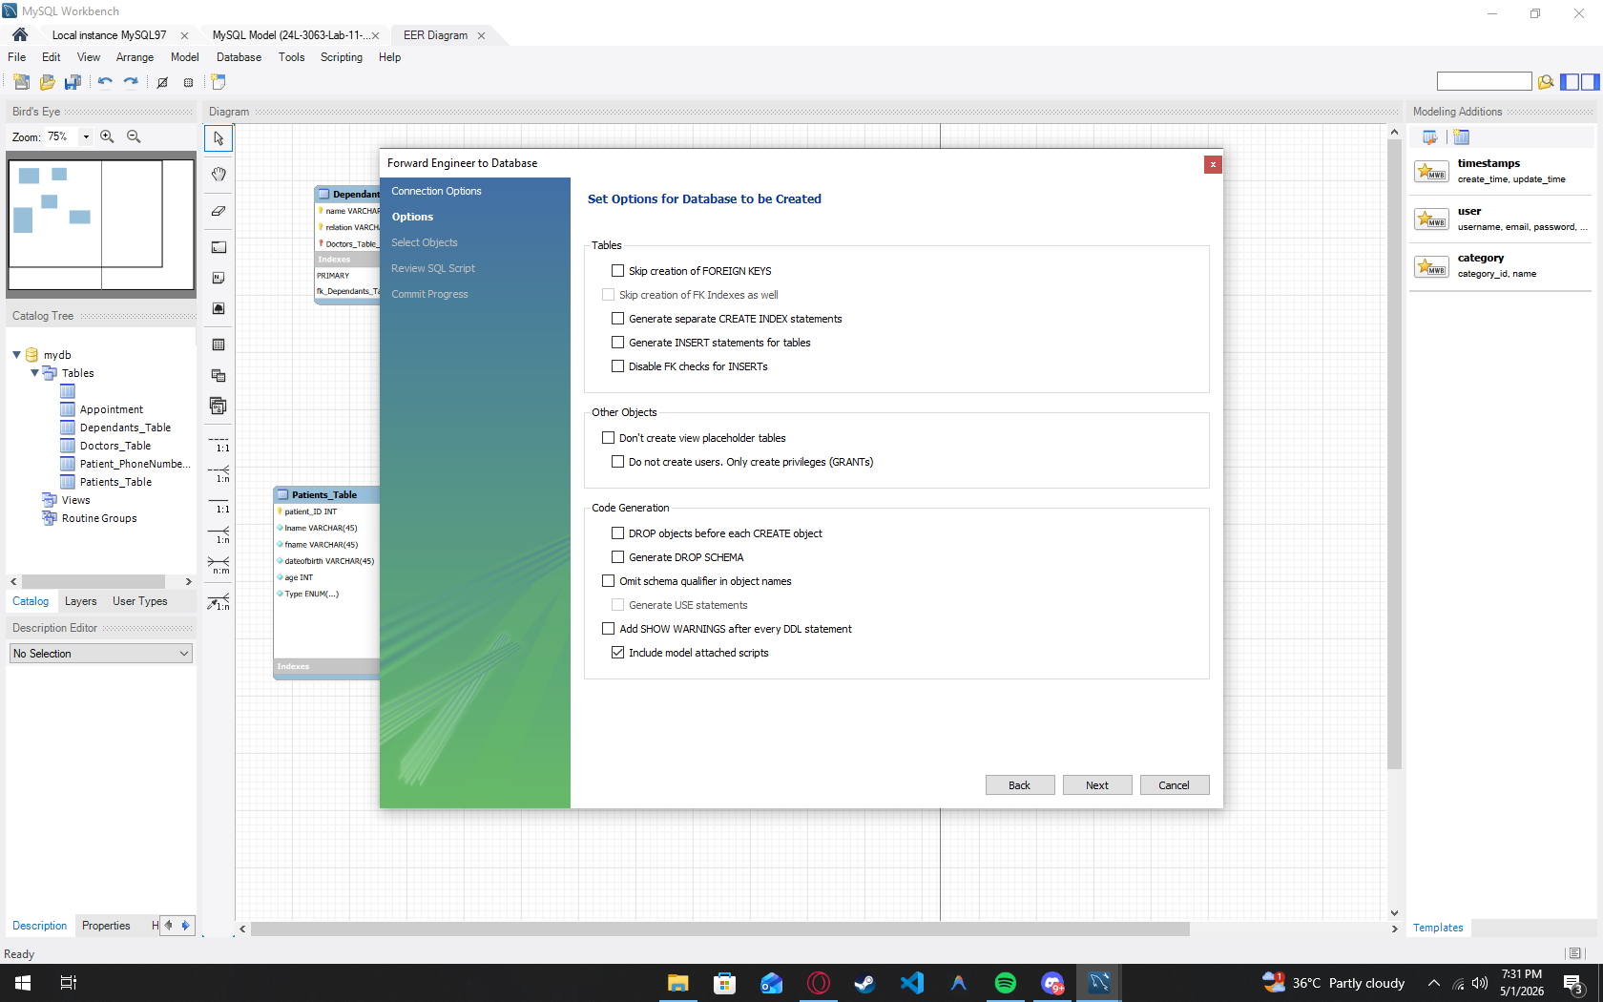

Next Part:
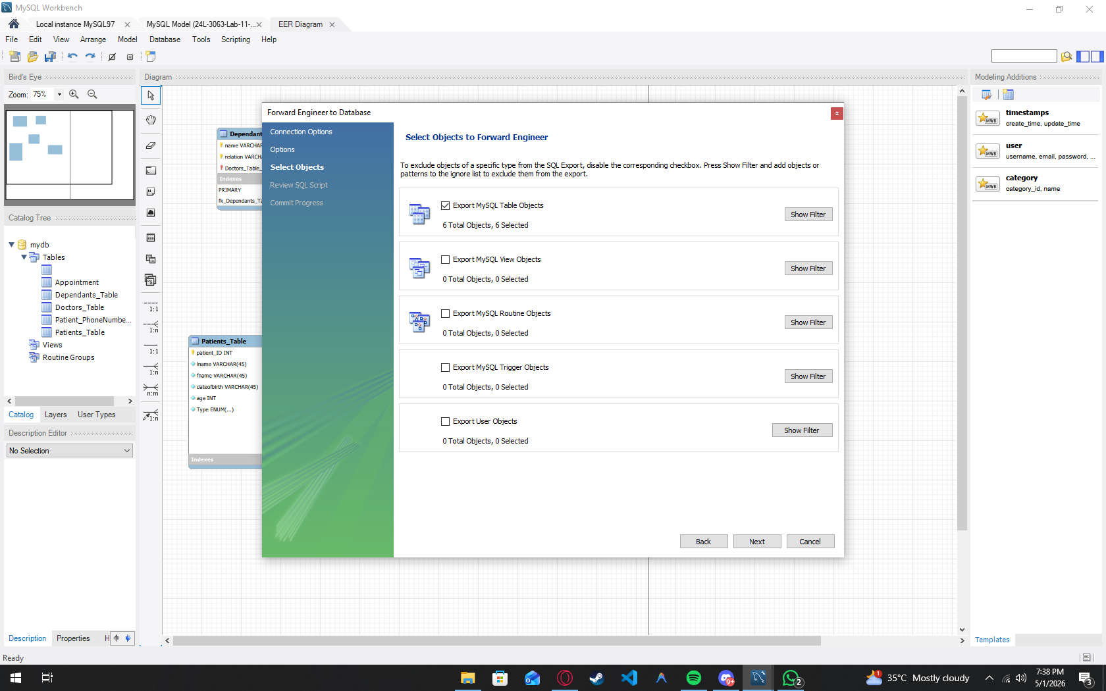
Generation of Script Part:
(AGE is derived and mysql workbench does not have TIMESTAMPDIFF so we can calculate it from DOB so i used simple INT to store it )
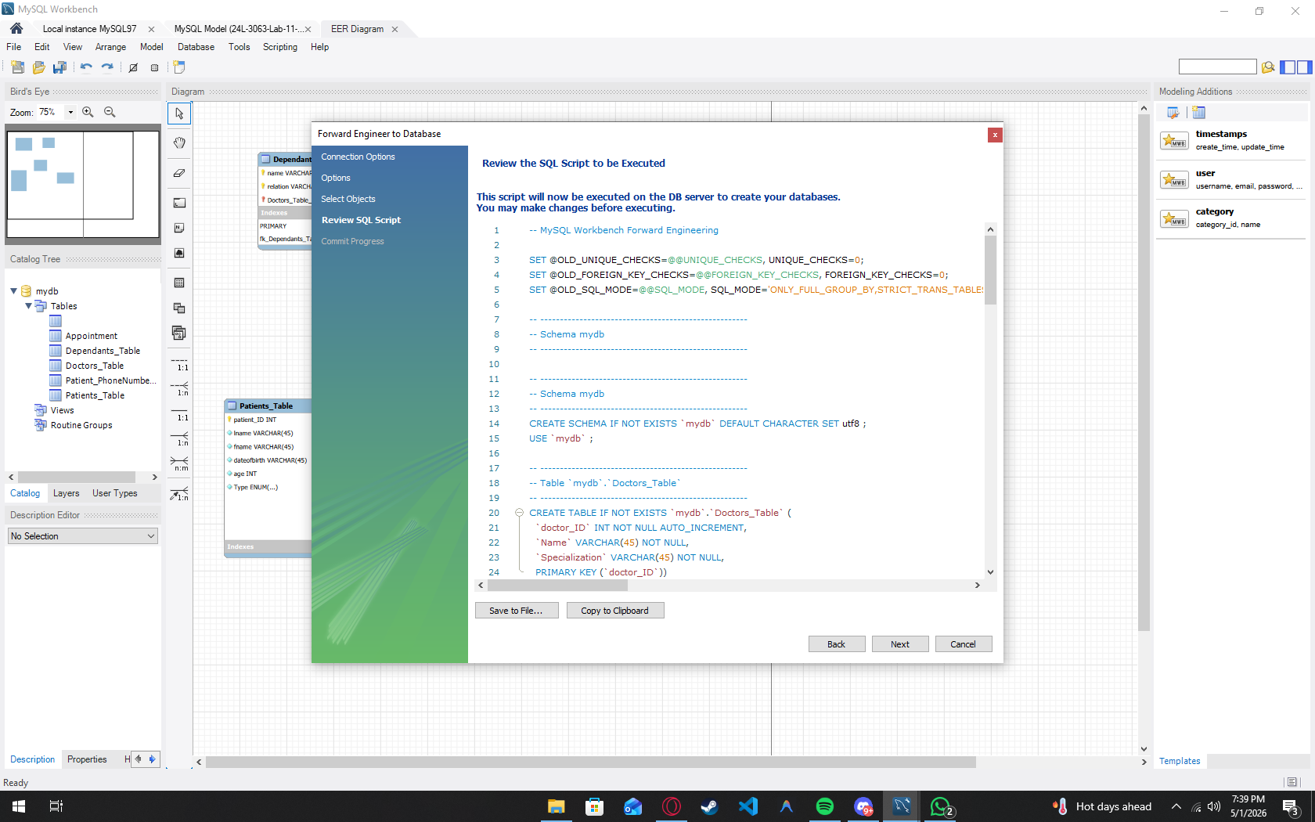

Now running the generated script:
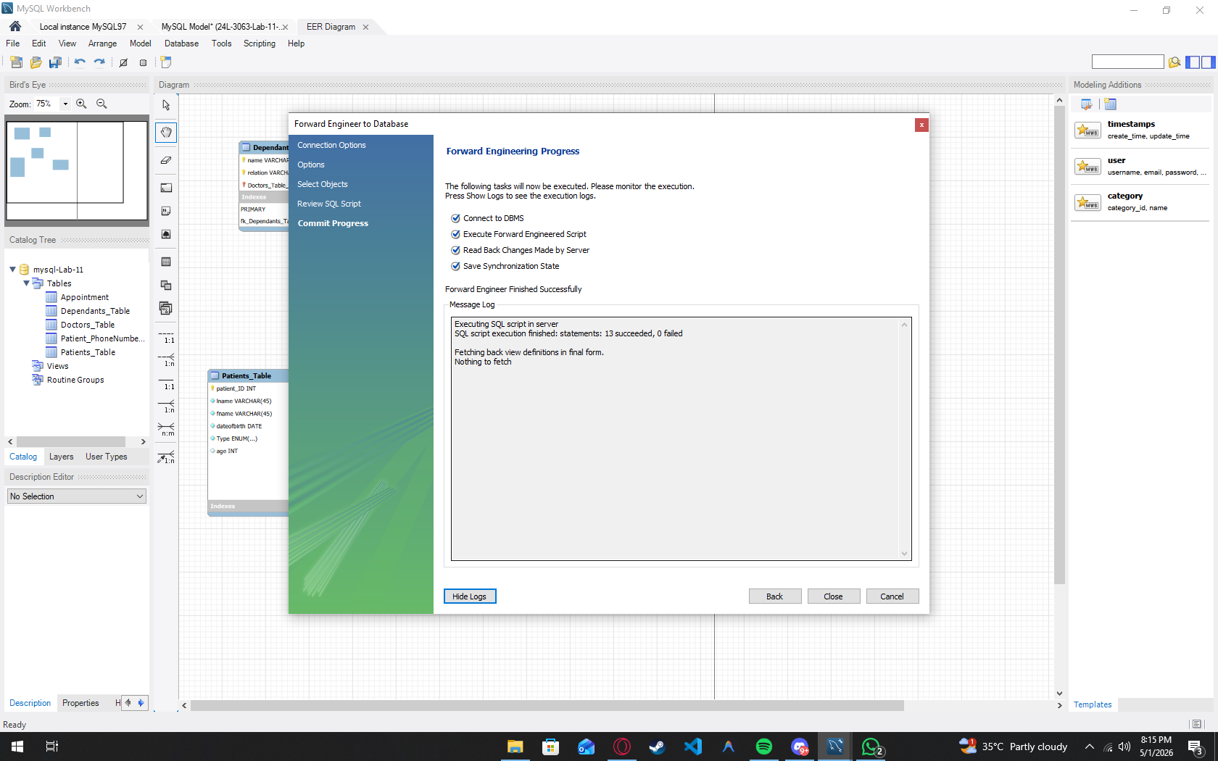
Schema and table exists in the server:

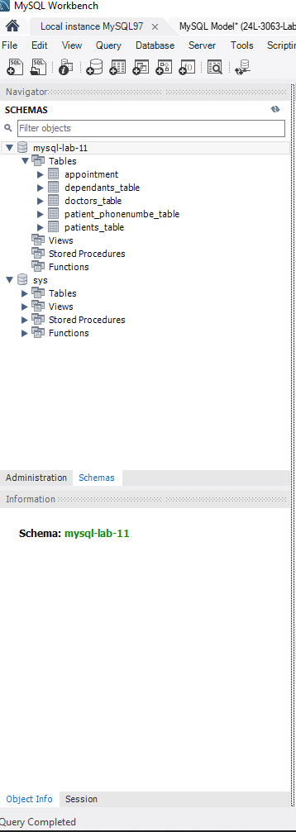

Converted from mysql syntax to mssql then run on ssms:
