

information security system design for the british university in egypt

The BRITISH UNIVERSITY IN EGYPT
Faculty of Informatics and Computer Science
Comprehensive Information Security System Design
Final Project – 25CSCN05I
Module: Introduction to Cryptography and Systems Security
Module Leader: Dr. Ahmad Mostafa
Semester Two – Academic Year 2025/2026

ID:243700
Name: Abdelrahman Shehta

- Organizational and Environmental Context:
The British University in Egypt (BUE) is in a highly digital academic environment where the information systems are important for producing educational services, managing administrative operations and supporting research activities the university depend on interconnected systems including student information systems (SIS), learning management system (LMS), financial systems and email communication systems in addition to these BUE uses platforms like student registration system (srs) and E-learning which are the core of the academic operation or the BUE, the srs manages students important data such as course registration, grades, and personal student information, making it the most important system in the BUE and that it needs strong protection, while the e-learning provides the learning material like tutorials or lectures, assignments and projects submissions, and communication between faculty members and students, also the communication in the BUE can be done through the Outlook all of that technology is important and support the organization to provide its education but it also increases the exposure for the cyber attacks and it operates within an international academic freamework, therefore it requires a good security system that ensures confidentiality, integrity, availability, and privacy while remaining scalable and adaptable [4], [5].
Universities have a very dynamic environment with thousands of users accessing systems at a time and in various locations. This poses a special problem in achieving the balance between accessibility and security. Systems like the SRS and E-learning platforms should be constantly accessible and at the same time safeguard confidential information like the student records and academic resources. Also, due to the heterogeneity of users, such as students, faculty, and administrative staff, access control and security management is more complicated.
Information security is vital in universities not just in terms of data protection. Security incidents may interfere with academic activities, tarnish the reputation of the institution and cause financial and legal repercussions. Thus, executing a holistic security system is a technical need as well as a strategic need in terms of ensuring trust and continuity of operations.

- Security Design Methodology:
The proposed system adopts a hybrid approach uses both risk based security design, defense in depth and zero trust architecture.
The risk based security design is about prioritizing risks based on the probability of occurrence and the impact from when it happen providing a system like the srs with a stronger protection, it aligns with the NIST Risk Management Framework, which emphasizes continuous monitoring and improvement [1].
Furthermore, defense in depth is a multiple layers of security controls implemented across the network, system and user levels if one layer fails additional controls provide protection which reduces the likelihood of a successful attack [2].
Zero trust architecture ensures that no user is trusted until verified means reducing the inside threats and prevents lateral movement [3].

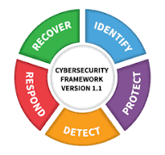
Figure 1: NIST Cybersecurity Framework Core Functions [4]

Justification of Combined Approach:
this hybrid approach is better than the traditional perimeter-based security. Zero Trust eliminates implicit trust, Defense-in-Depth ensures redundancy, and Risk-Based Design prioritizes critical assets. Together, they provide a scalable and efficient solution suitable for dynamic environments such as universities [1], [3], [4].
A major feature of the suggested methodology is that it is flexible to operational constraints in the real world. The integration of Risk-Based Design, Defense-in-Depth, and Zero Trust Architecture enables the university to strike a balance between security and usability unlike the purely theoretical security models. To illustrate, unlike Zero Trust which focuses heavily on access controls, Risk-Based Design provides the systems that are of utmost importance, like SRS, with a higher level of protection without overloading other less critical services. This balance plays a critical role in study settings where accessibility is one of the critical factors. The layered Defense-in-Depth also provides greater resilience and fault tolerance by ensuring that a failure in any control does not result in total compromise of the system.

- Threat and Risk Assessment
Threats:
- Phishing attacks targeting credentials:
involves attackers sending fake emails that seem to be sent by trusted sources in the university, convincing users to disclose their credentials. This is quite risky especially to systems like SRS and E-learning where a compromised credential can result in an unauthorized access to confidential academic information.
- Ransomware attacks encrypting university data:
Encrypts the university data and system making it unusable or accessible until the asked ransom is paid such attack can hinder the learning process by a lot which forces the institution to pay the ransom.
- Distributed Denial-of-Service (DDoS) attacks:
DDoS happens when a number of requests overwhelm the system with excessive requests causes downtime this is critical during exam periods or submissions.
- Insider threats:
Insider threats involves a staff member misusing their access privilege to leak data.
Vulnerabilities:
- Weak passwords:
Weak password make it easier for the attacker to figure it out whether by brute force or credential stuffing attacks and the users use the same password in multiple accounts which can risk not only one account.
- Lack of MFA:
Multiple factor authentication is about asking for more than just the password to authenticate the user so the lack of MFA can make the credentials easier to get stolen.
- Unpatched systems:
contain known vulnerabilities that attackers can exploit to gain unauthorized access or execute malicious code.
- Limited user awareness:
Limited user awareness is the most critical vulnerability can happen through social engineering or phishing attempts.
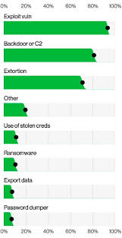
Figure 3: Common Cyberattack Types in Organizations [10]

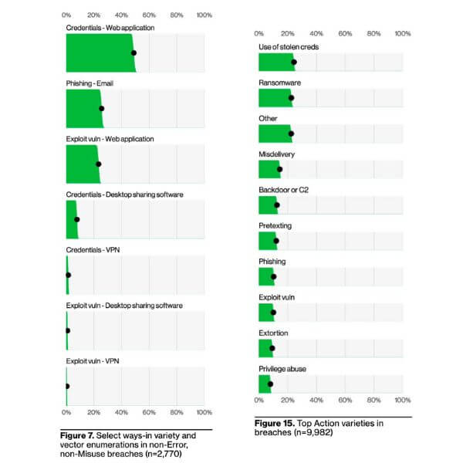

System-Specific Risks (SRS & E-learning):
System | Risk | Control
SRS | Unauthorized access to student data | MFA + RBAC
E-learning | SQL injection / XSS | WAF
E-learning | Downtime during exams | Load balancing

Risk:
Risk: | Impact: | Control: | Explanation:
Phishing | Credential theft | MFA + Training | Prevents unauthorized access
Ransomware | Data loss | Backup + Endpoint Protection | Enables recovery
Insider misuse | Data leakage | RBAC + Monitoring | Limits access
DDoS | System downtime | Firewall + Load balancing | Maintains availability

Real world attack scenarios:
A phishing attack can happen by someone sending a fake email via e-learning or outlook impersonating a staff member to acquire important data or even steal the students credentials. However, multi factor authentication (MFA) prevents access even with stolen credentials, while awareness training helps users recognize such attacks [10].
Another scenario can be about ransomware attack targeting the srs database an attacker can find a vulnerability and use it to upload the ransomware or trick a student or a faculty member in downloading it then it encrypts the critical data. However, endpoint protection detects abnormal behavior, and backups allow the university to restore data without paying ransom, ensuring operational continuity [10].
In addition to the mentioned threats it is better not to only stop there but look at the future of the evolving cyberattacks against educational institutions like the BUE and they are often targeted due to their open environments and the large amount of sensitive data, attackers often exploit the balance between accessibility and security as the academic system must be accessible to students but also have a strong security system.
One emerging threat is credential stuffing, where attackers use previously leaked username and password combinations to gain unauthorized access this is relevant in the academic environment as the students reuse their password in multiple platforms. The solve for this is MFA.
Another concern is lateral movement within the network once an attacker gains access to a single system, they move across the network to access more sensitive resources such as databases. The solve for this is Network segmentation and Zero Trust Architecture.
Furthermore, third-party risks must be considered as external services implemented with the E-learning platform such as video conferencing tools or cloud storage may introduce additional vulnerabilities if not properly secured.

- Security Controls and System Design:
All the controls are chosen on the basis of their capabilities to deal with certain risk factors found during the threat analysis. An example is MFA which is applied to credential theft, and load balancing that is applied to make sure the system is available during peak demand times like when exams are on. This direct mapping of risks and controls in place will facilitate effective and specific security design.
Technical Controls:
Multi-Factor Authentication (MFA):
enhances security by requiring multiple verification factors such as OTP this ensures that the stolen credentials alone are not enough to access the account.
Firewalls:
acts as the first line of defense by filtering the incoming traffic according to set of rules preventing unauthorized access.
SIEM:
systems collect and analyze logs from various systems in real time. They detect suspicious activities such as repeated failed login attempts or unusual access patterns, enabling rapid response to threats [11].

Endpoint protection:
systems use techniques such as behavioral analysis and machine learning to detect malware. For example, ransomware can be identified by unusual file encryption activity and blocked before it occurs.

Web Application Firewalls (WAF):
protect web based systems such as SRS and E-learning platforms from attacks like SQL injection and cross site scripting (XXS).
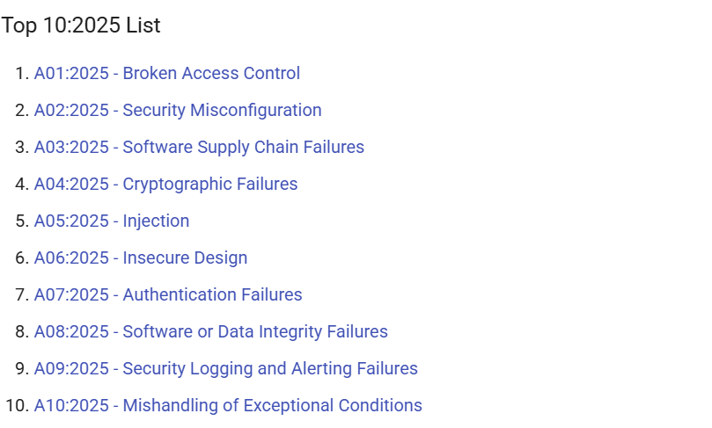
Figure 2: OWASP Top 10 Web Application Security Risks [9]
Load balancers:
distribute incoming traffic across multiple servers, ensuring system availability and preventing overload during peak usage periods (DDos).

Administrative Controls:
Security policies:
define the rules and guidelines for system usage, ensuring consistent security practices across the university.
Access control procedures:
ensure that users only have access to the resources authorized for their roles, reducing the risk of unauthorized access.
User awareness training:
Educates users about cybersecurity threats and safe practices reducing the risk of human error.
Incident response planning:
Establishes a structured plan to react to attacks to reduce the damage.

Physical Controls:
Access cards and biometric systems:
restrict entry to sensitive areas such as data centers, ensuring only authorized personnel can access these areas.
CCTV monitoring systems should be strategically placed in critical areas within the university to maximize security effectiveness. These locations include:
- Data center entrances and server rooms, to monitor access to critical infrastructure
- Main building entrances and exits, to track movement of individuals entering and leaving the premises
- Network operation centers (NOC), where sensitive monitoring systems are located
- Hallways leading to restricted areas, to detect unauthorized access attempts
The purpose of placing CCTV systems in these locations is to provide continuous surveillance, prevent unauthorized activities, and support incident investigations. In case of a security breach, recorded footage can be used to identify the source of the incident and support response actions

- Data Protection and Privacy:
The system ensures confidentiality, integrity, and availability through Encryption techniques such as AES and TLS protect data both at rest and in transit and hashing algorithms such as SHA-256 ensure data integrity by detecting unauthorized modifications.
The system is based on the current cryptographic methods in order to guarantee the protection of data. Encryption of sensitive data at rest is done with Advanced Encryption Standard (AES-256) like student record stored in the SRS database. In case of data in transit, there is the Transport Layer Security (TLS 1.3) which is used to ensure communication between users and servers is secure so that there is no possibility of interception and data leaking. Also, passwords are not stored in plain text and instead hashing algorithms like the SHA-256 are employed in password storage. Such cryptographic schemes offer high security against data intrusions and unauthorized access.
Cryptographic security is crucial in key management. To avoid being compromised, encryption keys should be created, stored and periodically rotated. The system will be able to use centralized key management solutions to manage access to the encryption keys and to ensure that only the authorized systems can access them. This minimizes the chances of key leakage and helps to enhance the general data protection.
Role Based Access Control (RBAC) ensures that users can only access data needed to their roles. Data minimization reduces exposure by limiting the amount of stored data.

Data classification:
Data is categorized into levels such as public, internal, confidential, and highly confidential. For example, general announcements are public, student records in the SRS are highly confidential. This classification ensures that appropriate security measures are applied based on data sensitivity.

- Network Architecture Design:
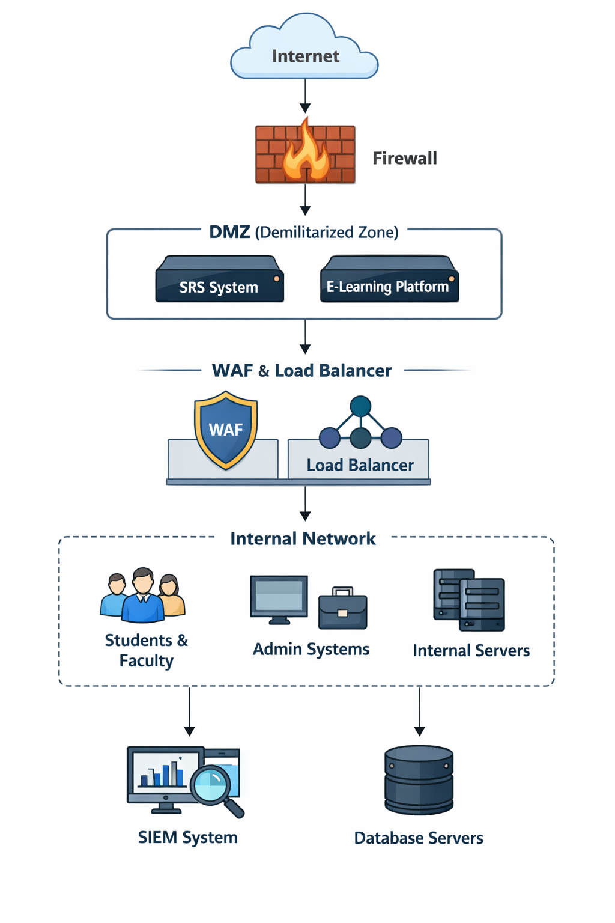
Security elements in the architecture are positioning so as to get the best protection. The firewall is placed at the edge of the network to censor the incoming traffic prior to it accessing internal systems. Public facing services like SRS and E-learning are isolated in the DMZ where they are less likely to be attacked directly causing a compromise to internal resources. The Web Application Firewall (WAF) is put in the front of web servers to specifically guard against application-layer assaults. Moreover, SIEM is built centrally to observe all the activities in the network, and threats are detected in real time in all layers.

The suggested network architecture is based on the segmented methodology of designing a network that is more secure and faster. The architecture ensures a smaller attack surface by isolating public facing systems like the SRS and E-learning platforms into a demilitarized zone (DMZ), and does not give direct access to internal systems. Also, internal segmentation is done to make sure that users including students, faculty and administrators are in controlled environments with restricted access privileges. This segmentation enhances security as well as efficiency of the network.
Also, encrypted channels ensure that all communication between the components of the system cannot be intercepted and accessed by unauthorized parties. This covers both user to web server and internal system (application server and database) communication.

- Existing Solutions and Tools:
Requirement | Solution | Purpose
Authentication | Microsoft Authenticator | Secure login
Monitoring | Splunk / ELK | Threat detection
Web security | Cloudflare WAF | Protect applications
Network Security | Cisco Firewall | Traffic control

These tools are widely used in enterprise environments and provide scalable and reliable security solutions.

- Scalability and Future Improvements:
The system supports scalability through cloud integration and modular design as the number of users grows resources can be expanded without a lot of redesigns.
Future improvements may include AI-based threat detection and automated response systems, which enhance detection accuracy and reduce response time to the attacks.

- Budget Estimate:
Component: | Tool: | Version: | Cost: | Justificatoin
Firewall | Cisco ASA | 5506-X | $8K–$15K | Suitable for medium-sized university networks and provides advanced threat protection with reliable performance
SIEM | Splunk Enterprise | 9.x | $10K–$25K/year | Offers powerful log analysis, real-time monitoring, and scalability for large volumes of data
Endpoint Security | Microsoft defender for endpoint | P2 | $3K–$8K/year | Provides advanced threat detection and integrates efficiently with Windows systems used in universities
MFA | Microsoft Authenticator | Latest version | $0–$6/user/month | Easy to use, widely supported, and effective in preventing unauthorized access
WAF | CloudFlare | Pro/Business plan | $2K–$10K/year | Protects against common web attacks such as SQL injection and XSS, aligning with OWASP Top 10
Load Balancer | AWS Elastic load balancer | Latest version | $2K–$5K/year | Ensures high availability and scalability during peak usage periods such as exams
Training | KnowBe4 | Latest version | $1.5K–$5K/year | Provides user awareness training to reduce phishing and human-related risks
Cloud | AWS / Microsoft Azure | Latest version | $5K–$15K/year | Offers scalable infrastructure suitable for growing university systems

Certain tools and version are selected on grounds of compatibility, scalability, and how they can fit a university environment and these versions doesn’t contain vulnerabilities that can be exploited so it is secure to use. An example is Cisco ASA 5506-X which is selected due to its capability to offer firewall protection at enterprise level and at the same time is affordable to use in the middle scale deployments. Equally, Splunk Enterprise 9.x is chosen because its advanced analytics and capacity to process high volumes of log data. Cloudflare’s Pro/Business plan is used to protect web applications such as the SRS and E-learning platforms from common vulnerabilities identified by OWASP. Also, the cloud services like AWS and Microsoft Azure are chosen due to their flexibility and resource scaling in demand.
The total cost is estimated at $30K–$70K initially and $20K–$60K annually. This flexible budget allows the university to choose between premium and cost-effective solutions.

10.Evaluation and Continuous Improvement:
Monitoring is achieved through SIEM systems and log analysis, which detect suspicious activities in real time.
Metrics such as incident detection rate, response time, and system uptime are used to evaluate performance.
Continuous improvement is achieved through regular audits, penetration testing, and updating security controls to address new threats.
Besides technical assessment organizational preparedness is significant to maintain the efficient security stance, routine training and awareness exercises ought to occur regularly to guarantee the continues update on any emerging security danger this minimizes any human related security danger.
Compliance with international standards and regulations is another factor of evaluation that is important. The university needs to periodically align its security controls with standards such as ISO/IEC 27001 and the NIST Cybersecurity Framework so that it remains in line with the best practices. This not only improves security but also reputation and credibility of the institution.
In addition, continuous improvement should incorporate the use of new technologies and strategies. With the changing nature of cyber threats the security system needs to keep up with the changes by using new advanced solutions like systems that detect threats through artificial intelligence and automated systems to respond to incidents. Such technologies allow quicker detection and reaction to threats, minimizing the possible damage.
Back-up systems are put in place to guarantee recovery of data in case of a system failure or in case of a ransomware attack. To avoid any unauthorized access or alteration, the backups are encrypted and stored in different locations. Back-up testing is regularly done to make sure that in case of need, data can be restored effectively. This will increase the resilience of the system and business continuity in case of security breach.

References:
[1] NIST, Risk Management Framework, 2020.
https://nvlpubs.nist.gov/nistpubs/SpecialPublications/NIST.SP.800-37r2.pdf
[2] M. Bishop, Computer Security, 2003.
https://www.cs.ucdavis.edu/~rogaway/classes/227/spring05/book/main.pdf
[3] NIST, Zero Trust Architecture, 2020.
https://nvlpubs.nist.gov/nistpubs/SpecialPublications/NIST.SP.800-207.pdf
[4] NIST, Cybersecurity Framework, 2018.
https://nvlpubs.nist.gov/nistpubs/CSWP/NIST.CSWP.04162018.pdf
[5] ISO, ISO/IEC 27001, 2013.
https://www.iso.org/files/live/sites/isoorg/files/store/en/PUB100324.pdf
[6] S. Furnell, Human Aspects of Information Security, 2007.
https://www.sciencedirect.com/science/article/pii/S1361372307000287
[7] ENISA, Cybersecurity in Education, 2021.
https://www.enisa.europa.eu/publications/cybersecurity-in-education
[8] A. Shostack, Threat Modeling, 2014.
https://www.microsoft.com/en-us/securityengineering/sdl/threatmodeling
[9] OWASP, Top 10 Web Risks, 2021.
https://owasp.org/Top10/
[10] Verizon, Data Breach Investigations Report, 2023.
https://www.verizon.com/business/resources/reports/dbir/
[11] CISA, Cybersecurity Best Practices, 2022.
https://www.cisa.gov/resources-tools/resources/cybersecurity-best-practices

